Atika Mughal

SAP ID: 5000000280

Database Systems Lab-11

Run SQL statement to create a table projects and student.
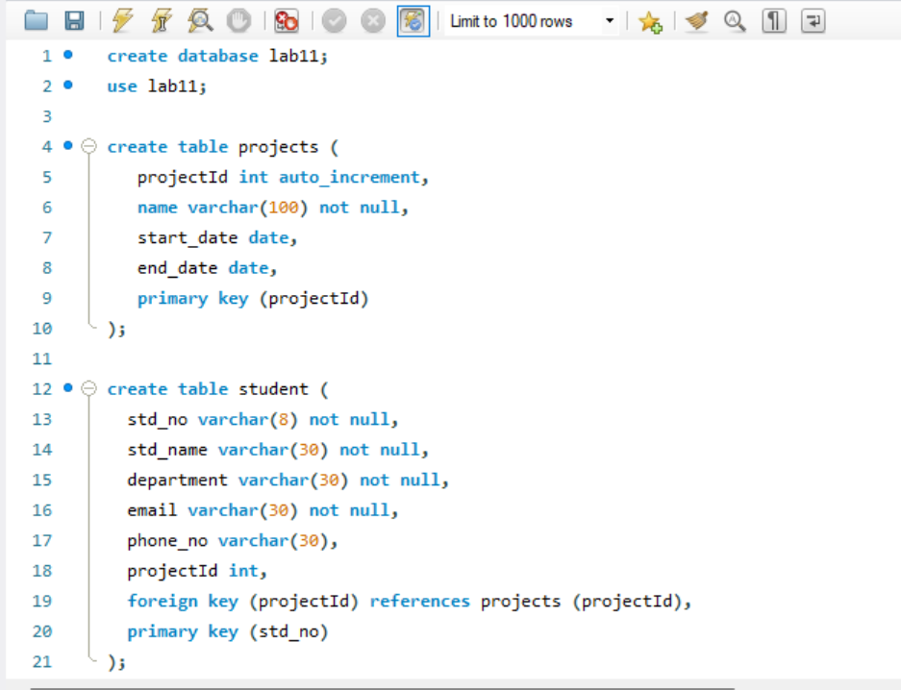
Task 1: Write a SQL statement to insert 4 rows in project table and 4 rows in student table below by a single insert statement.
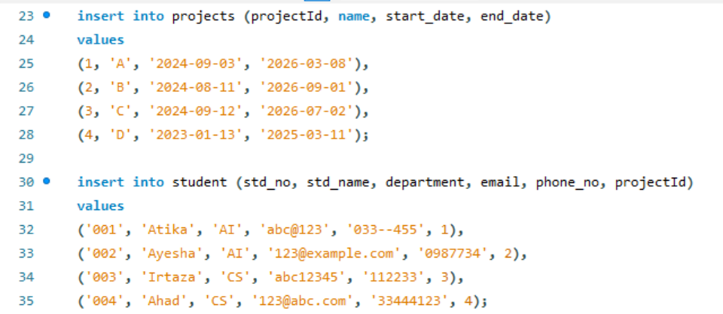
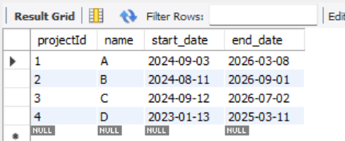
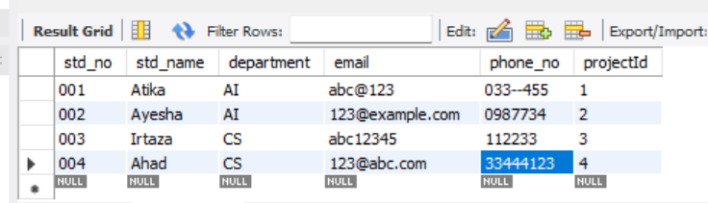
Now Create duplicate of projects table named projects_copy with all structure and data
CREATE TABLE IF NOT EXISTS projects_copy
SELECT * FROM projects;
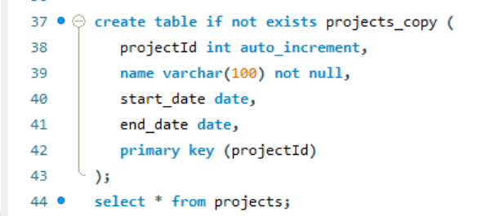
Task 2: Write a SQL statement to delete all records from projects table.
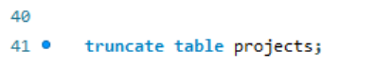
Task 3: Write a SQL statement to insert rows from projects_copy table to projects table.
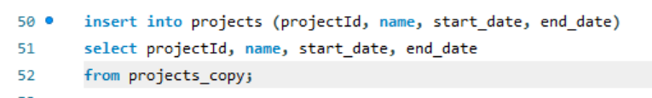

Task 4: Write a SQL statement to update start_date to ‘2023-02-01’ of a project name CS for IT.
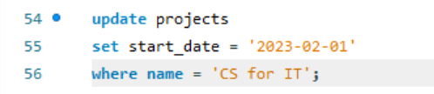
Now add a column in table project by following command.
ALTER TABLE projects
ADD cost INT;
ALTER TABLE student
ADD daysToComplete INT;
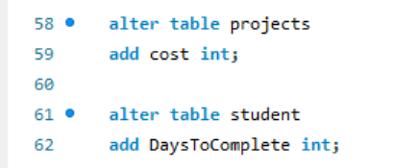
Task 5: Write a SQL statement to update cost of project to 90000 where cost are null.
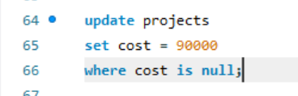
Task 6: Write a SQL statement to update daysToComplete column from student by calculating difference from project start_date and end_date.
