Atika Mughal

SAP ID: 5000000280

Database Systems Lab-12

Task 1: Create a view call employee_vu based on the employee numbers, employee names and department numbers from the emp table. Change the heading for the ename to EMPLOYEE.
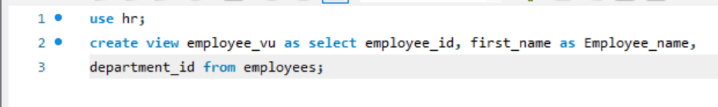
Task 2: Display the contents of the employee_vu view.
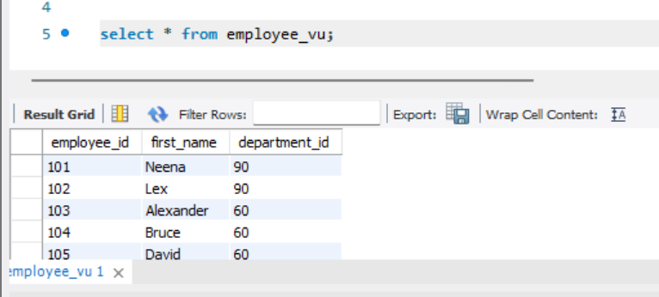
Task 3: Create a view called SALARY_VU based on the employee names, salaries and salary grades for all employees. Use the EMP and SALGRADE tables. Label the columns Employee, salary and grade respectively.
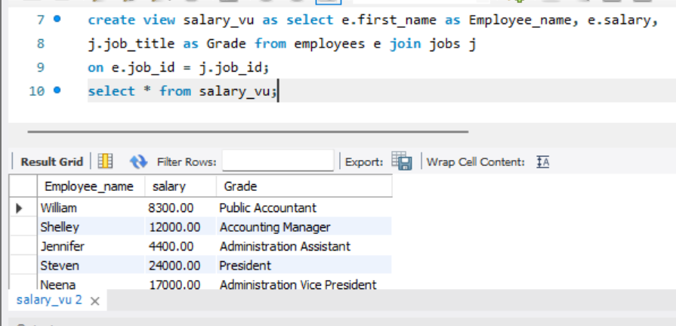
Task 4: Create a view named DEPT10 that contains the emp numbers, enames and department numbers for all employees in department 10. Do not allow an employee to be reassigned to another department through the view.
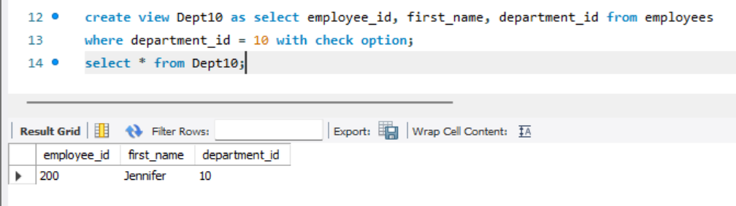
Task 5: Create an index on the deptno of the Emp table. Drop the newly created index.
