Atika Mughal

SAP ID: 5000000280

Database Systems Lab-13

Task 1: Install MongoDB on your system.
Task 2: Create a database and a collection.
Task 3: Insert the following documents into a collection named "users":
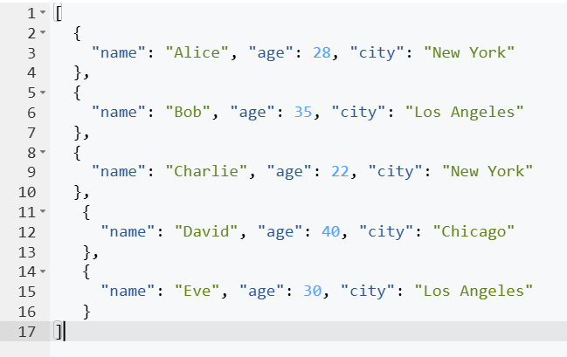
Task 4: Find all users in the "users" collection.
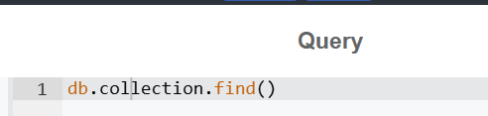
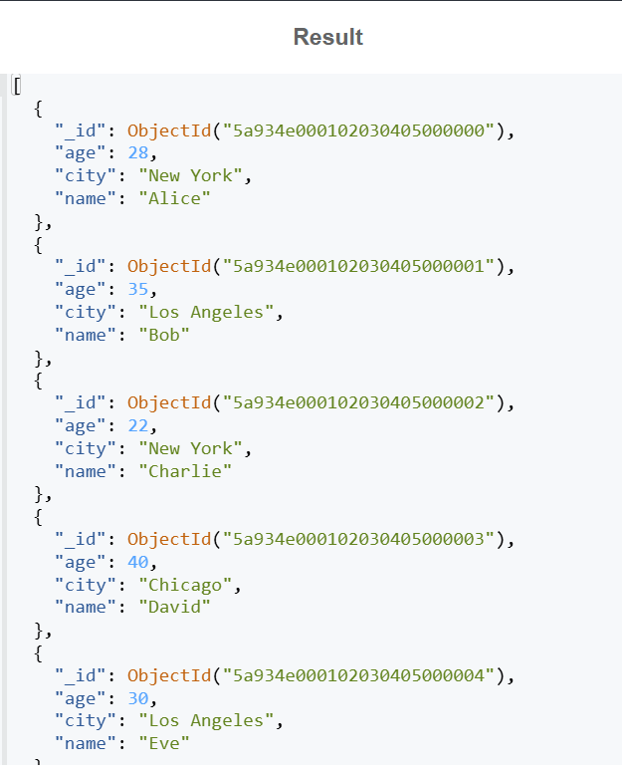
Task 5: Find users in the "users" collection who are older than 30.
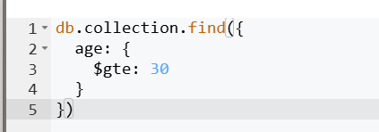
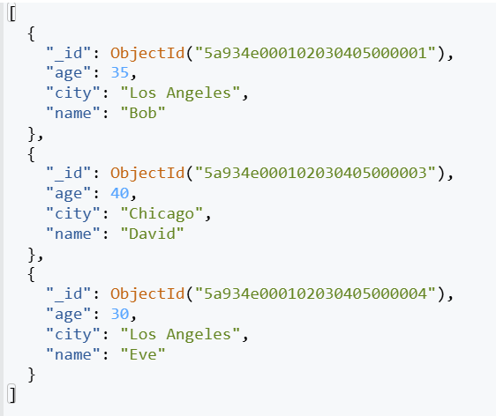
Task 6: Find users in the "users" collection who live in "New York".
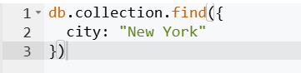
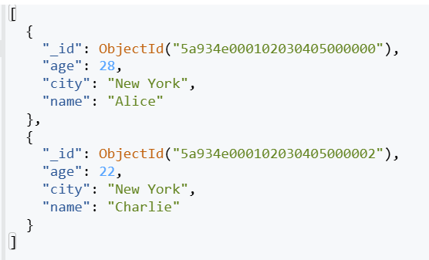

Task 7: Update the age of "Alice" to 29 in the "users" collection.
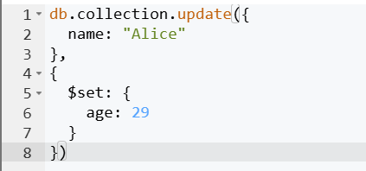
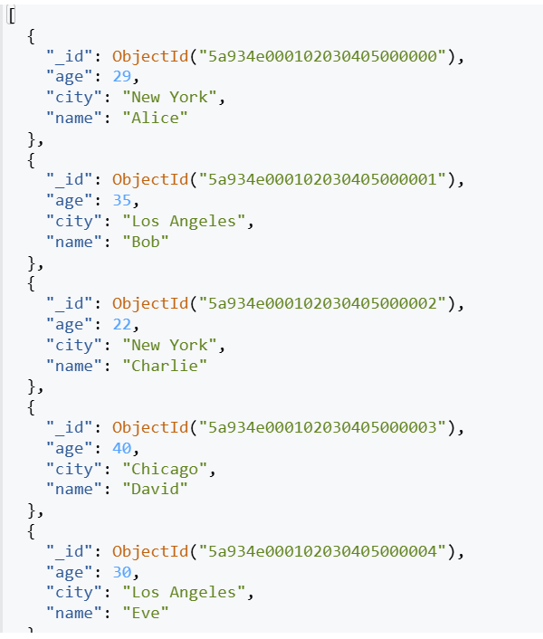
Task 8: Update the city of all users in "Los Angeles" to "San Francisco".
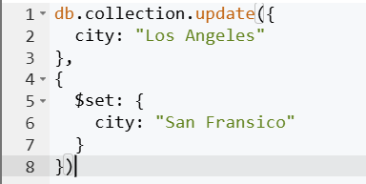
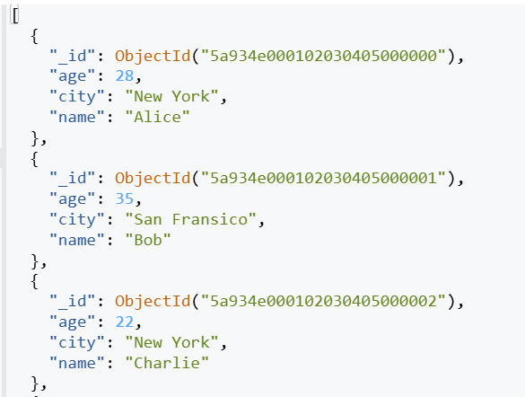
Task 9: Delete the user named "Charlie" from the "users" collection.
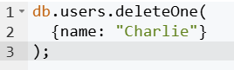
Task 10: Delete all users from the "users" collection who are younger than 25.
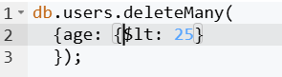
Task 11: Create a new collection named "products" and insert the following documents:
[
{ "name": "Laptop", "price": 1200, "category": "Electronics" },
{ "name": "T-Shirt", "price": 25, "category": "Clothing" },
{ "name": "Smartphone", "price": 800, "category": "Electronics" },
{ "name": "Jeans", "price": 60, "category": "Clothing" },
{ "name": "Book", "price": 15, "category": "Books" }
]
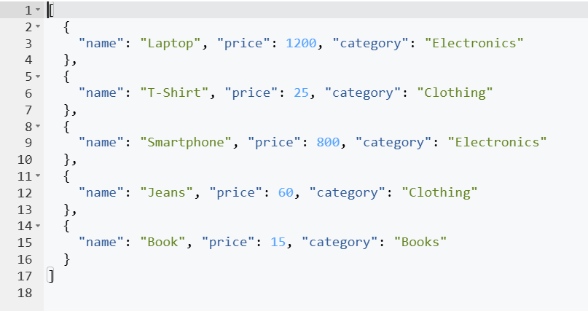
Task 12: Find all products in the "products" collection that belong to the "Electronics" category.
