Atika Mughal

SAP ID: 5000000280

Database Systems Lab 2

Task 1: Two Apps Using Customer Order and HR Datasets.
- HR Dataset:
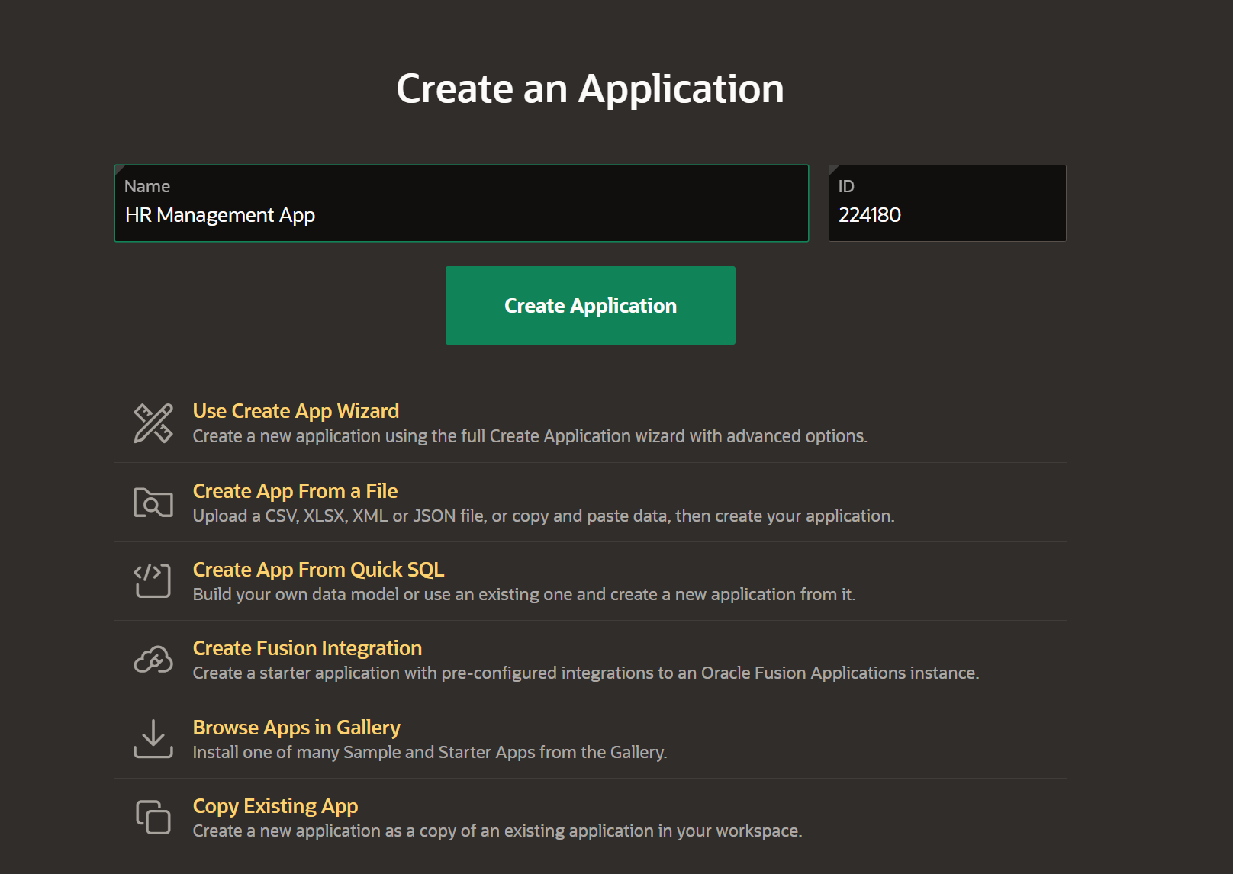
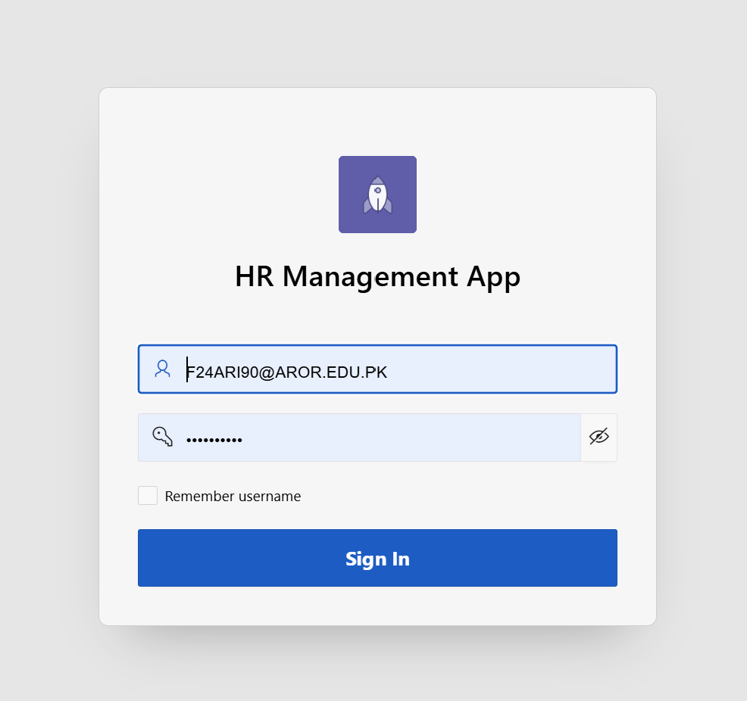
- Customer Order:
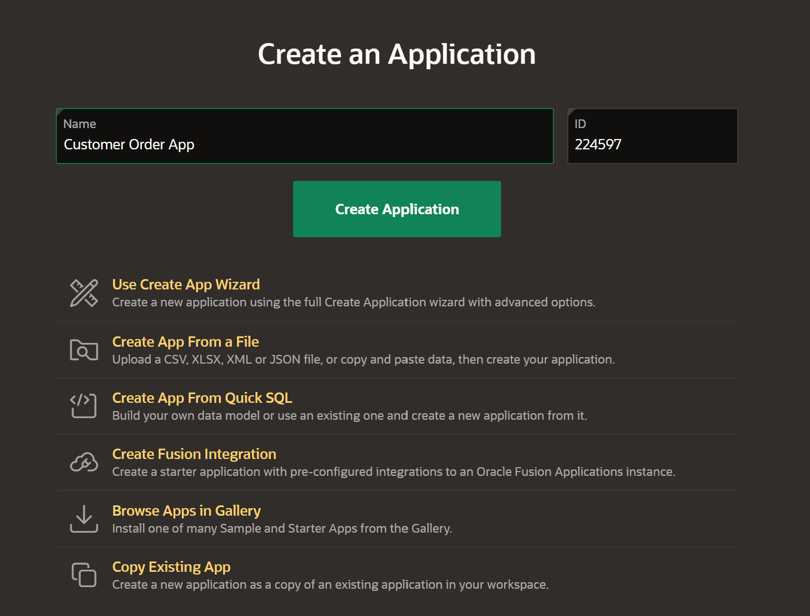
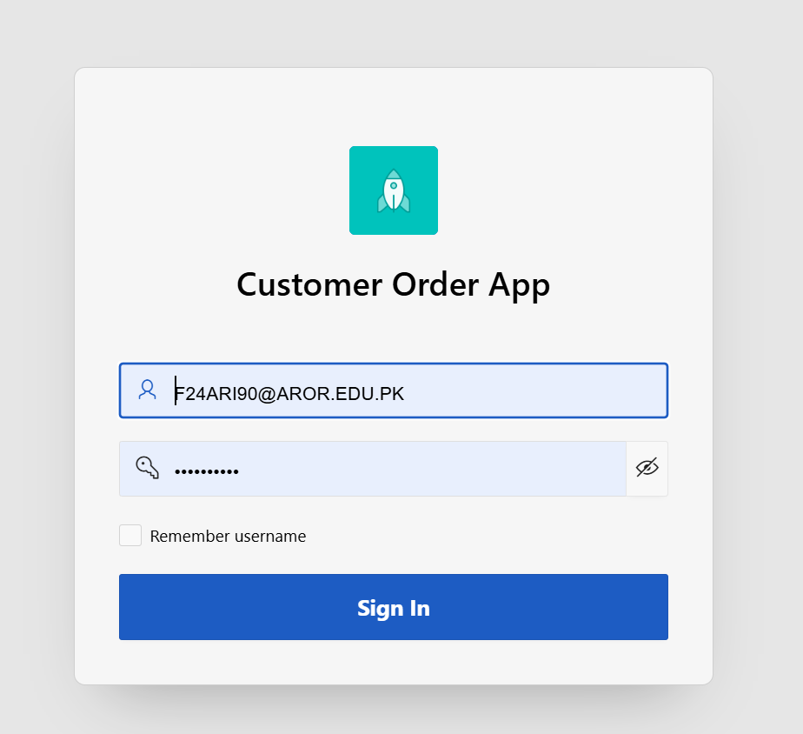

Task 2: Explore Sample as well as Starter Apps.
- Sample Apps:
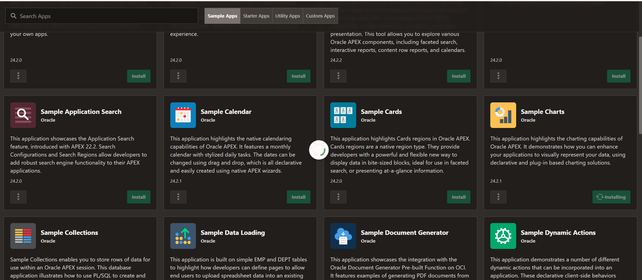
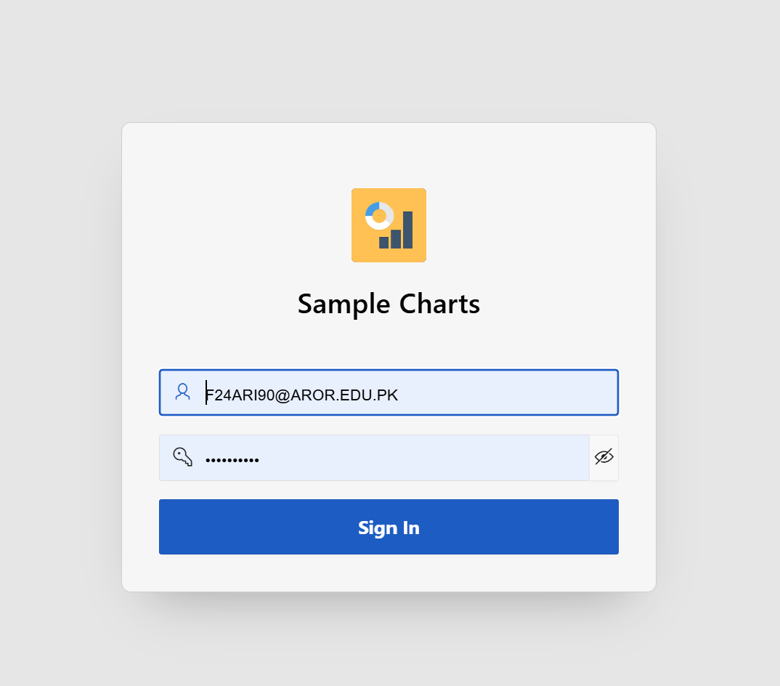
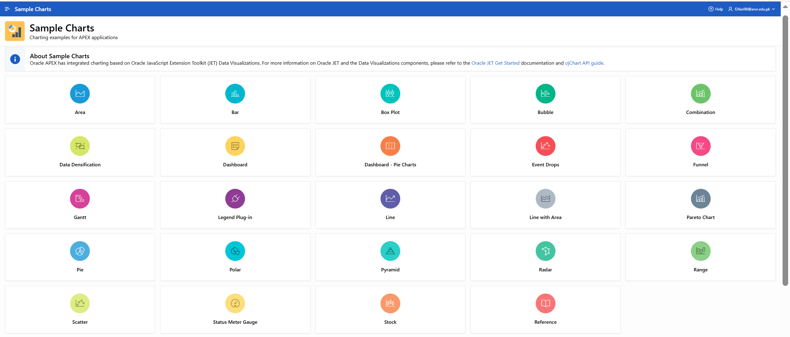
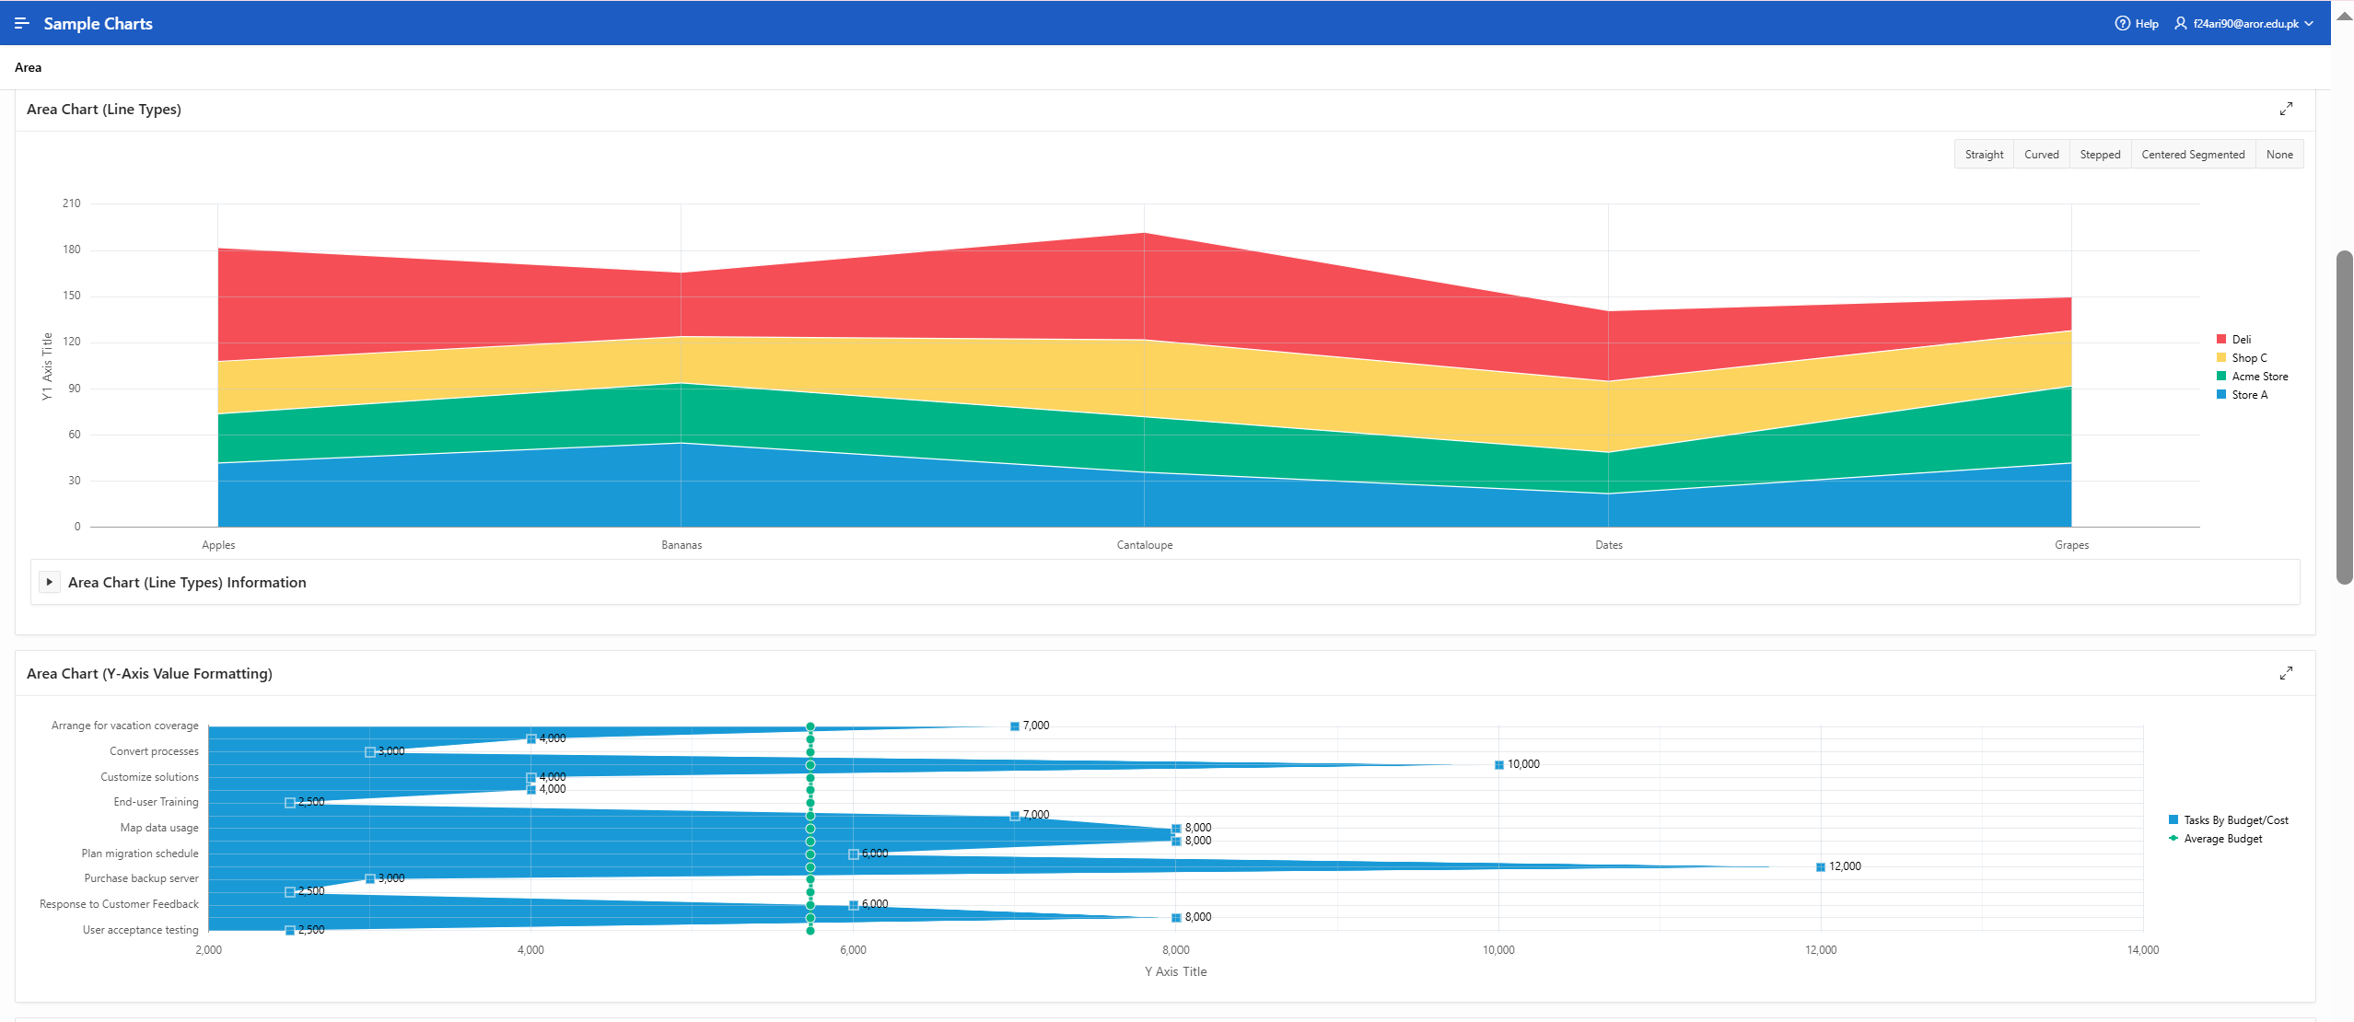
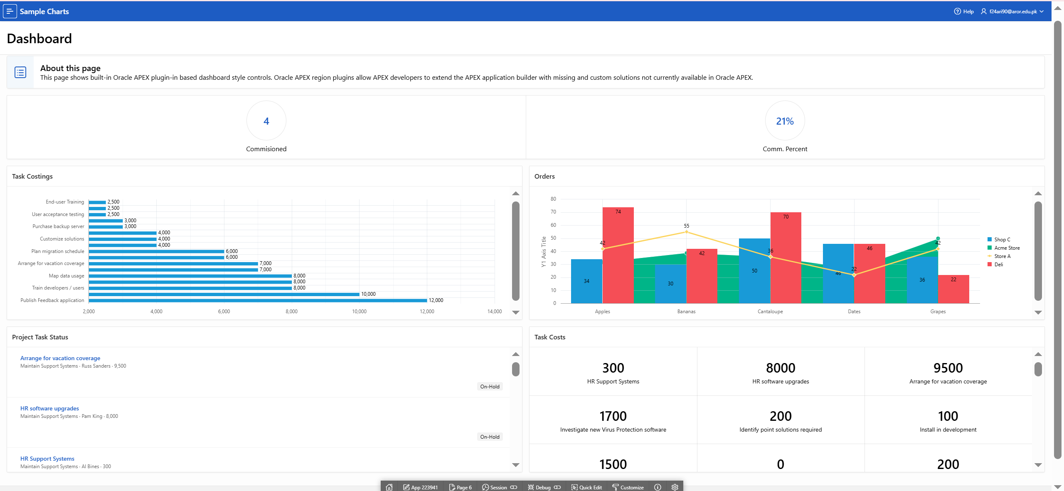
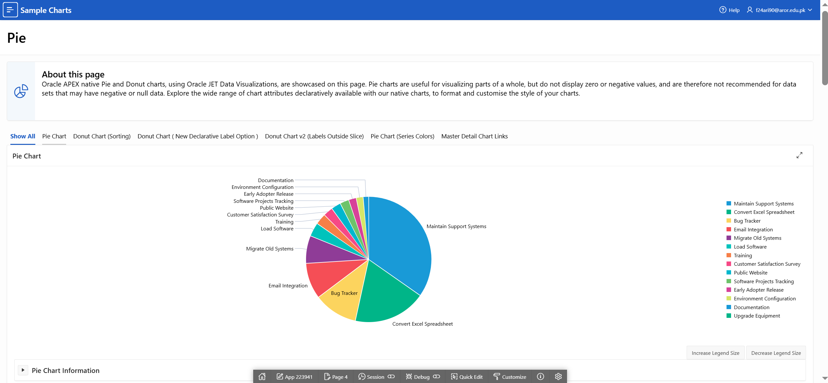
I explored Sample Apps to understand reports, forms, and dashboards provided by Oracle APEX.

- Starter Apps:
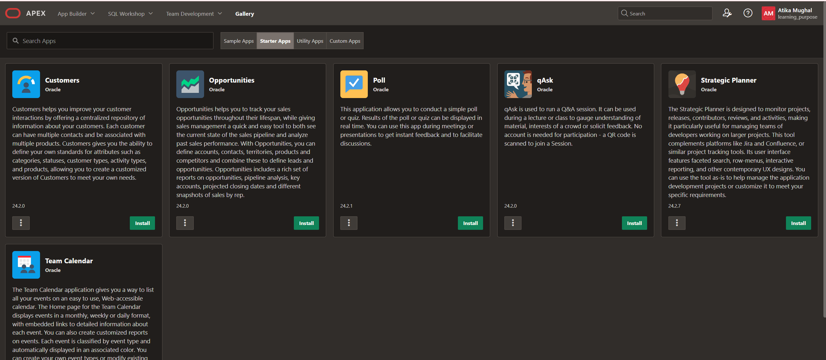
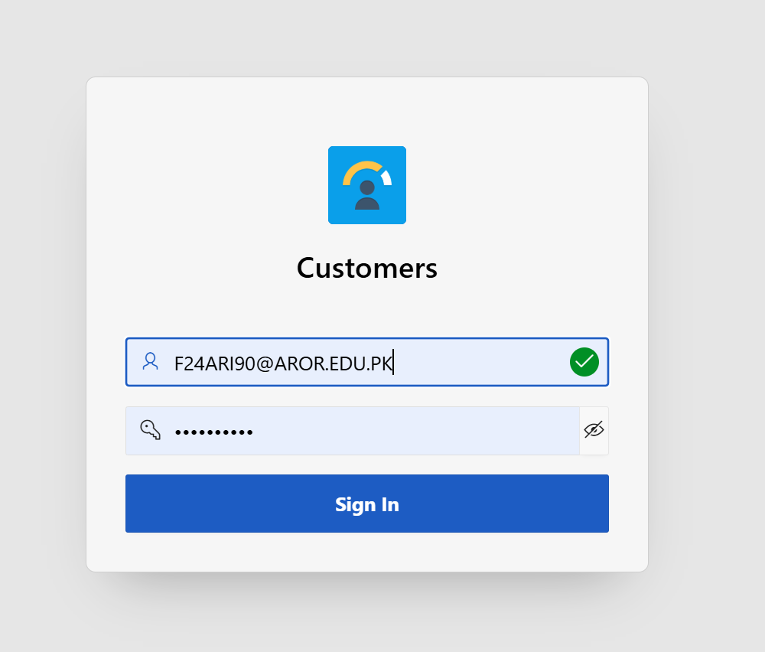
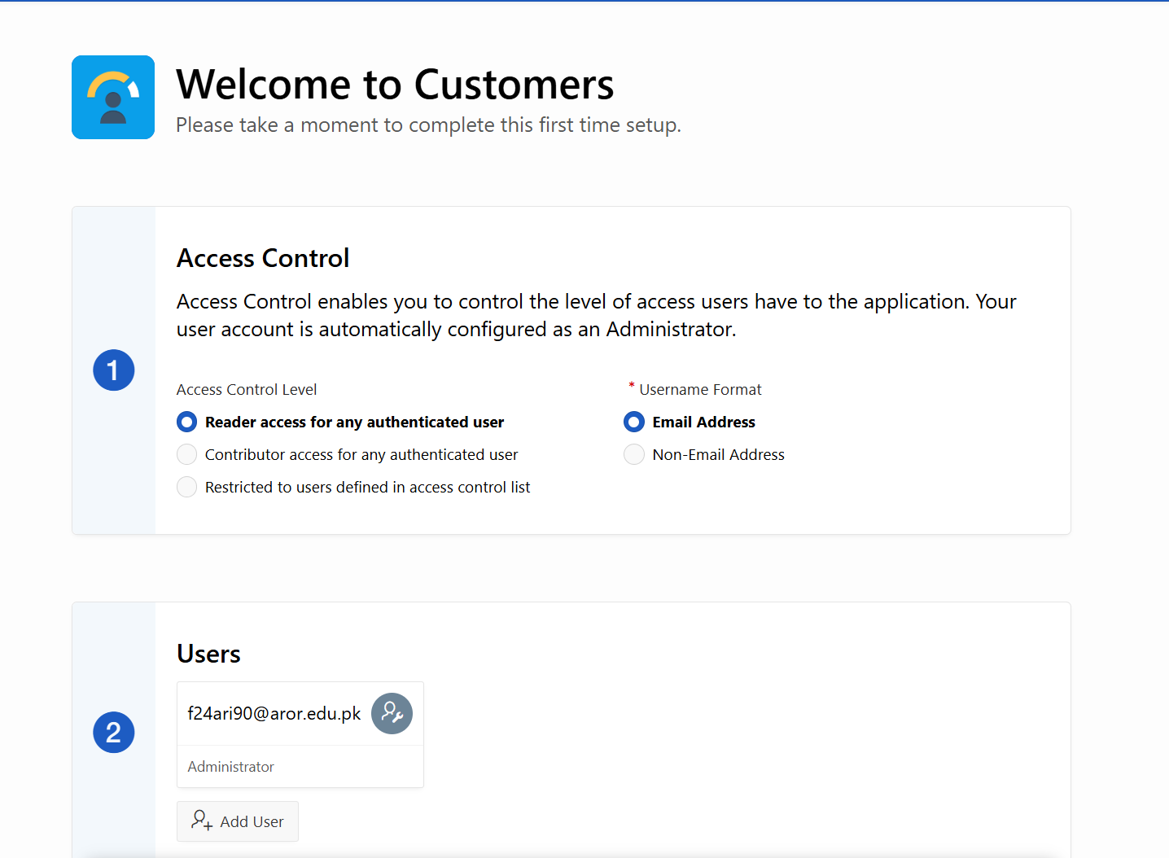
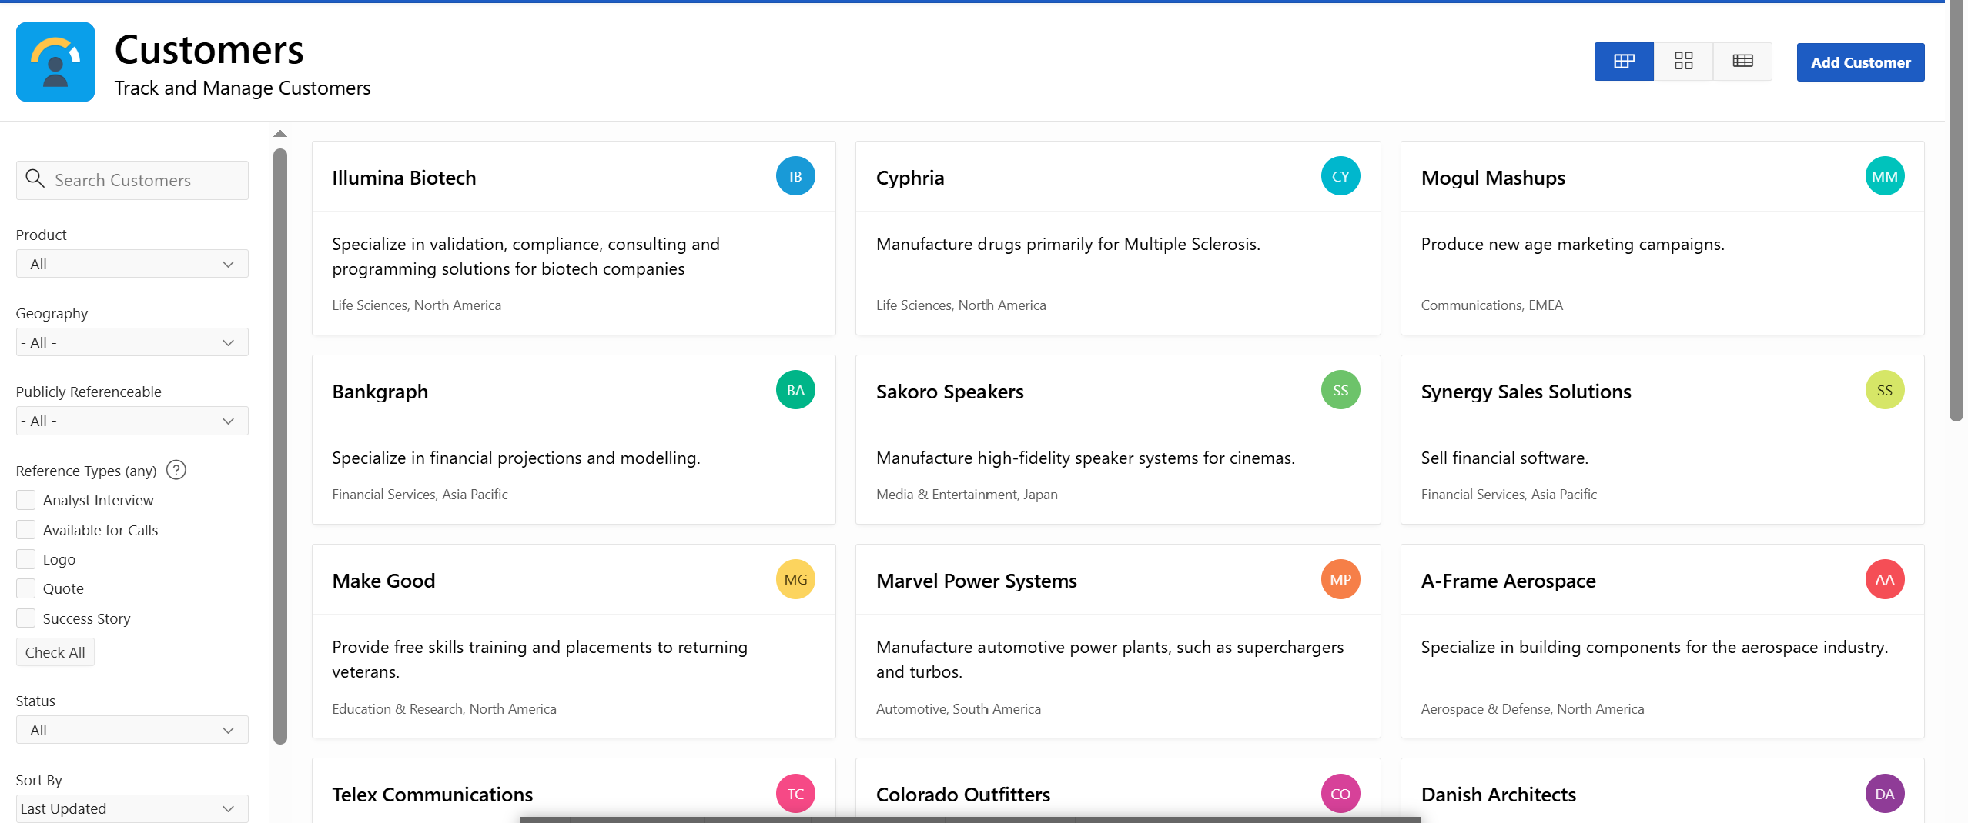
Starter Apps helped me understand basic application structure and navigation.

Task 3: Faceted Report for Filtering Employee Data.
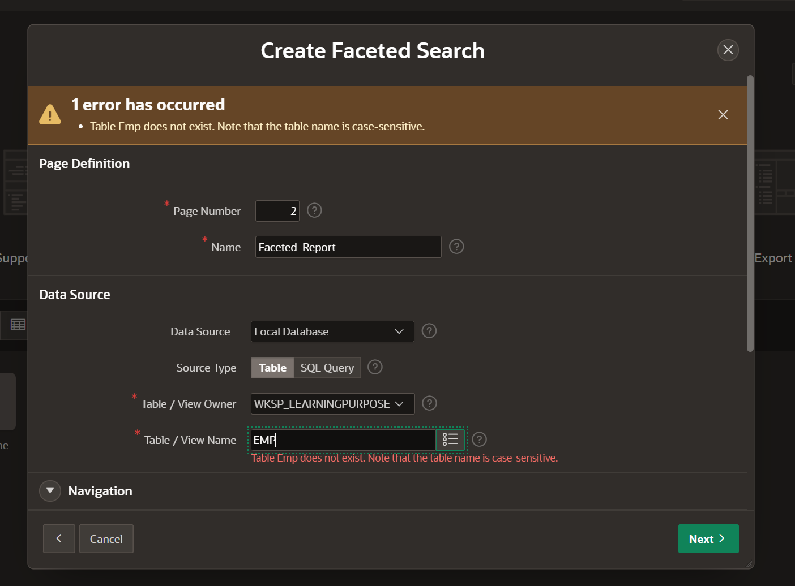
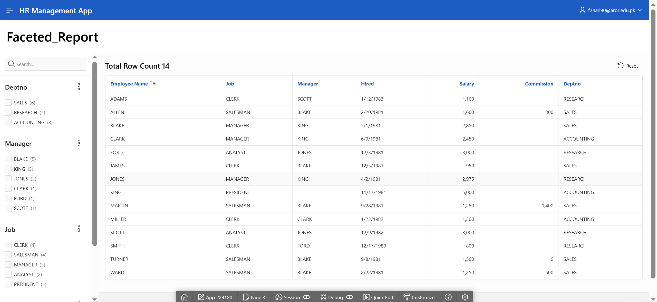
This faceted report allows filtering employees by department, job title, and salary range.
Task 4: Develop a Master-Detail Report.
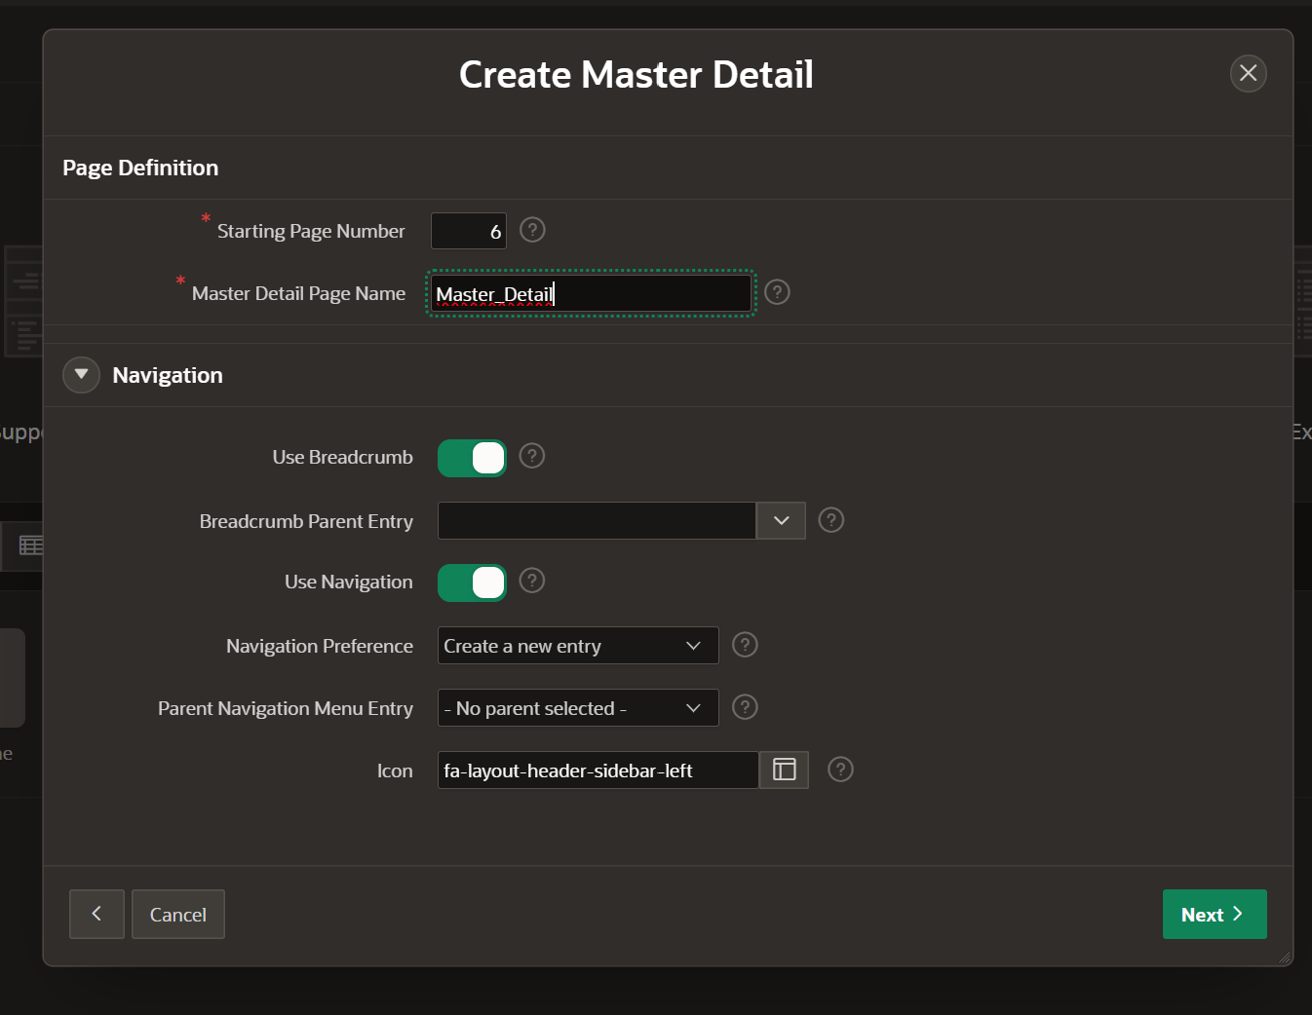
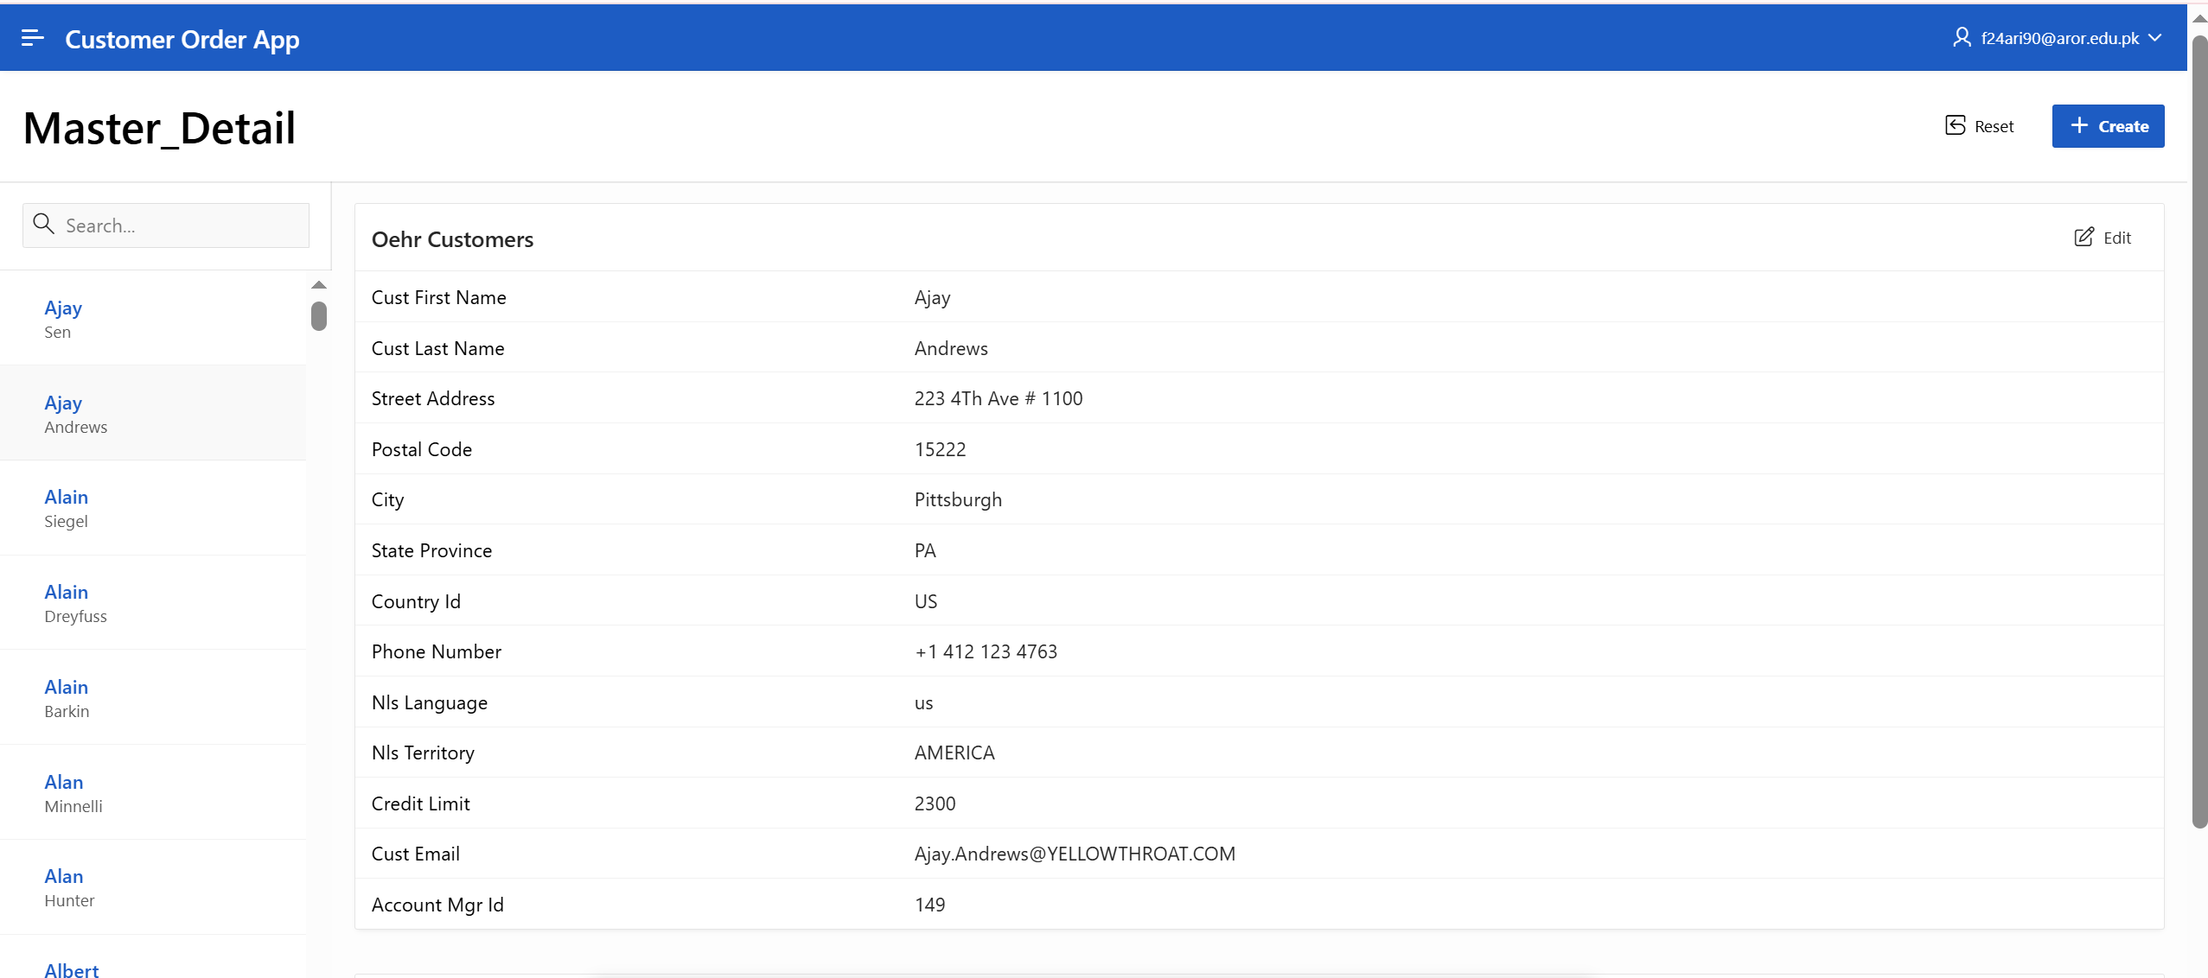
Master-Detail report displays customers as master and their orders as detail.
Task 5: Interactive Grid and Classic Reports and describe the Difference between them.
- Classic Report:
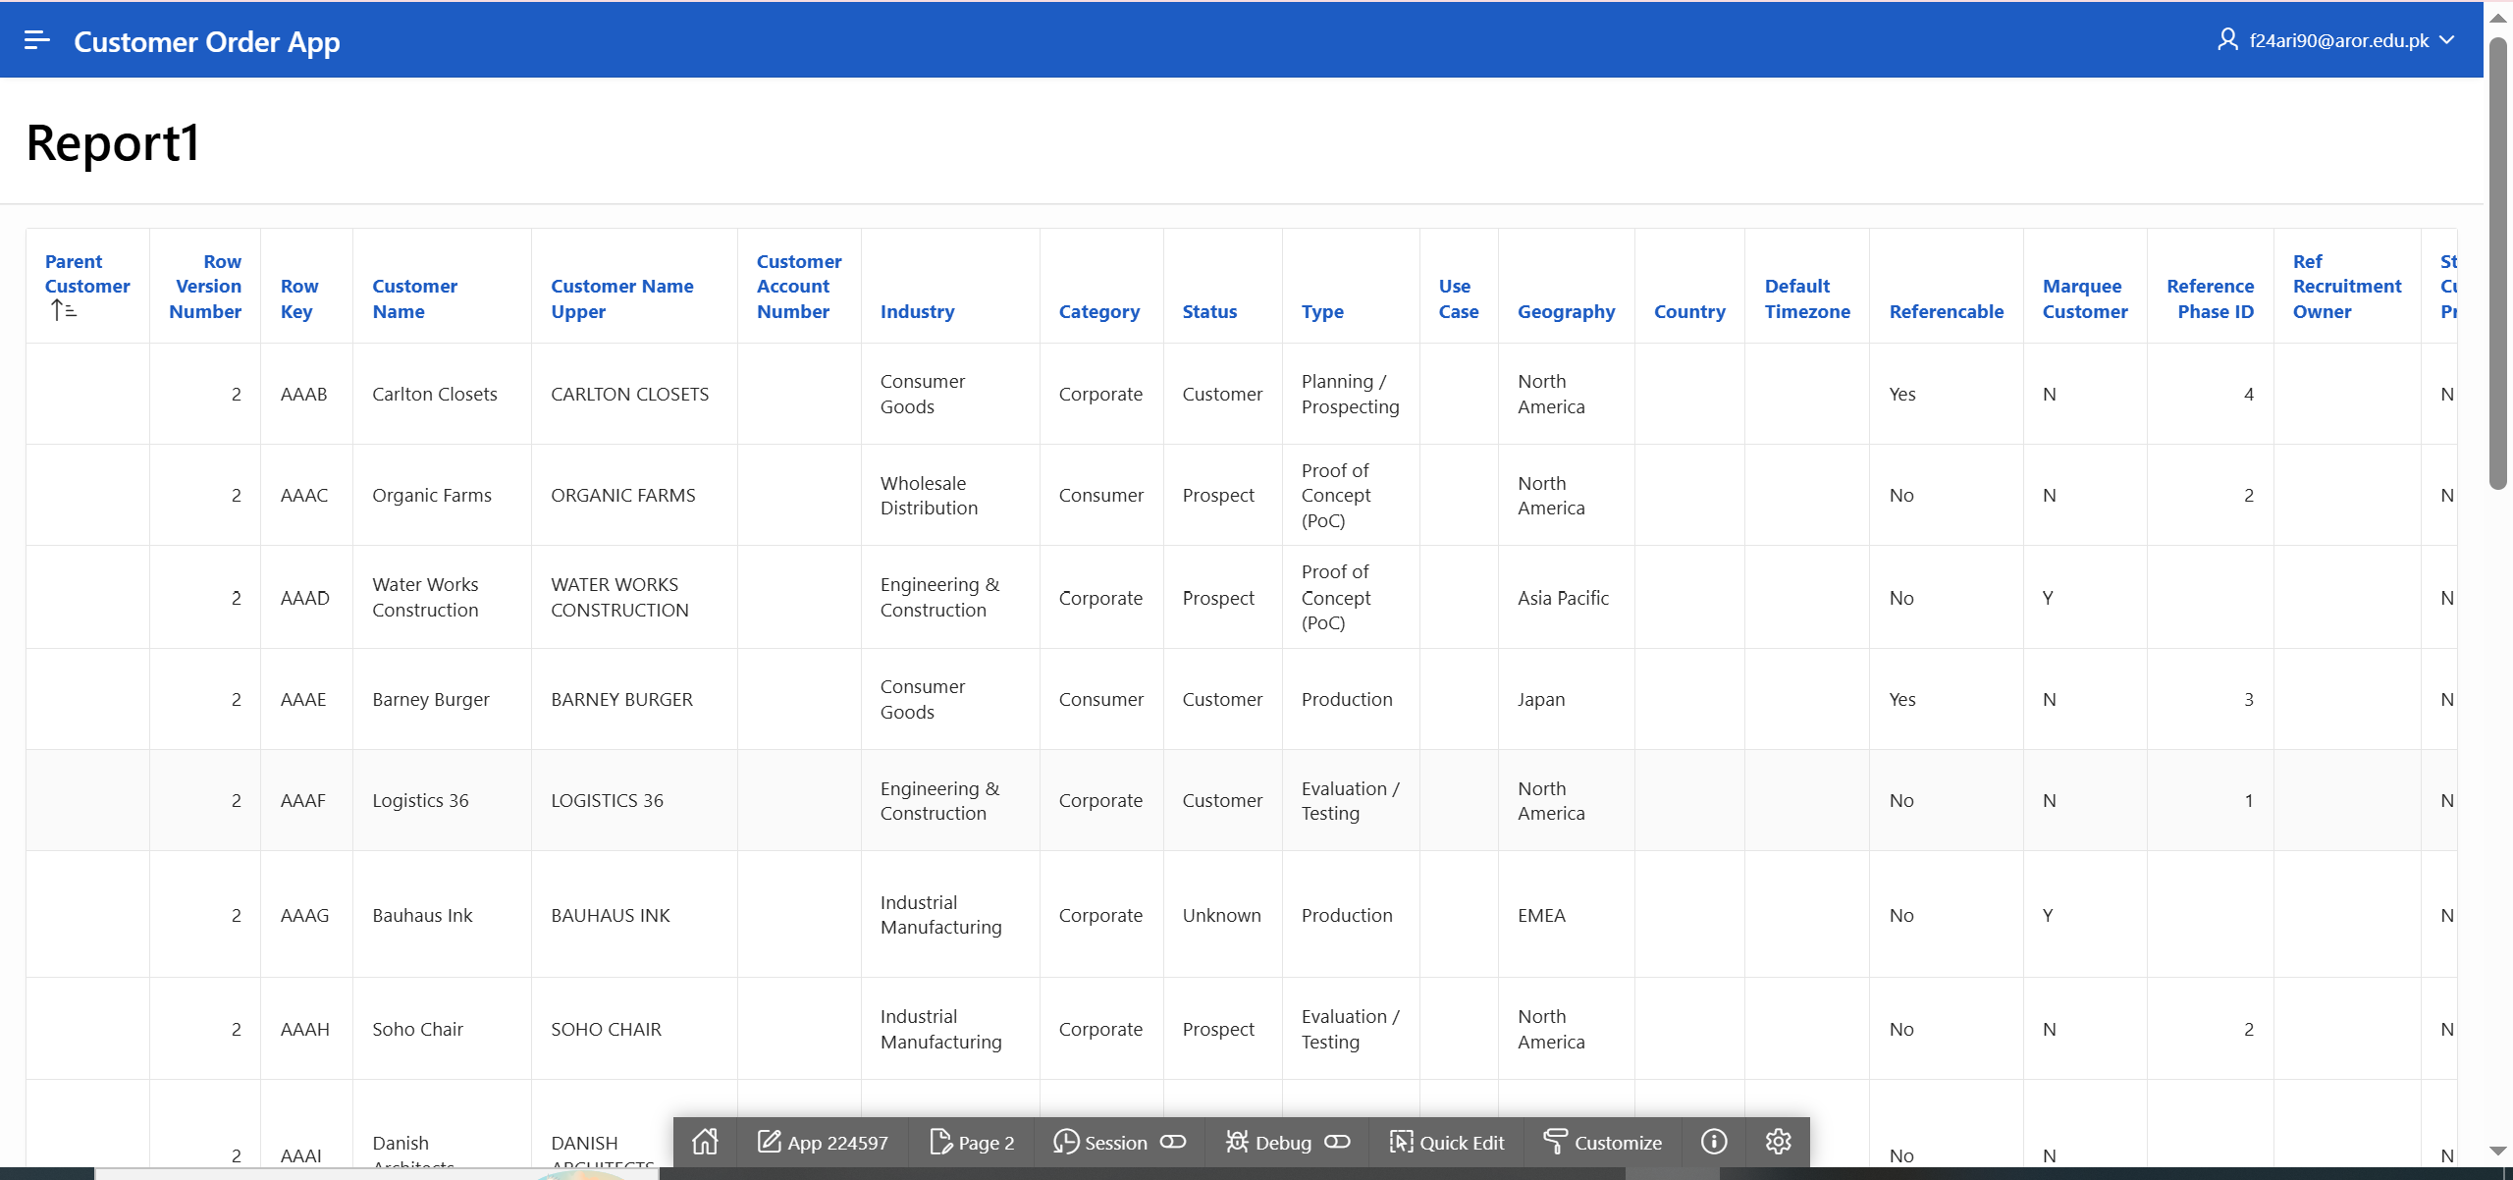
- Interactive Report:
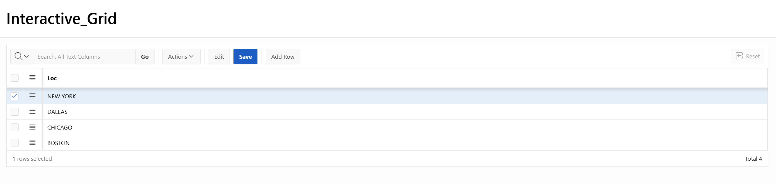
- Classic Report: Read-only, simple display of data.
- Interactive Grid: Editable, allows insert, update, delete, and advanced data handling.
Task 6: Interactive Dashboard with Charts.

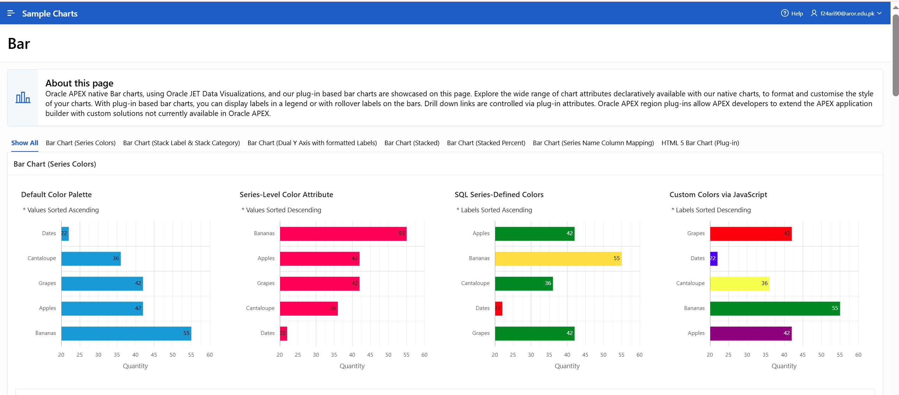
The dashboard visually summarizes sales by region using charts.

