Atika Mughal

SAP ID: 5000000280

Database Systems Lab-3

Task 1: Create a Table for Students.
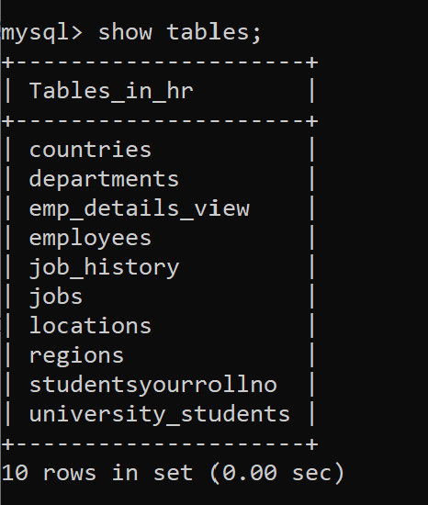
Task 2: Alter Table Structure (Add Email Column).
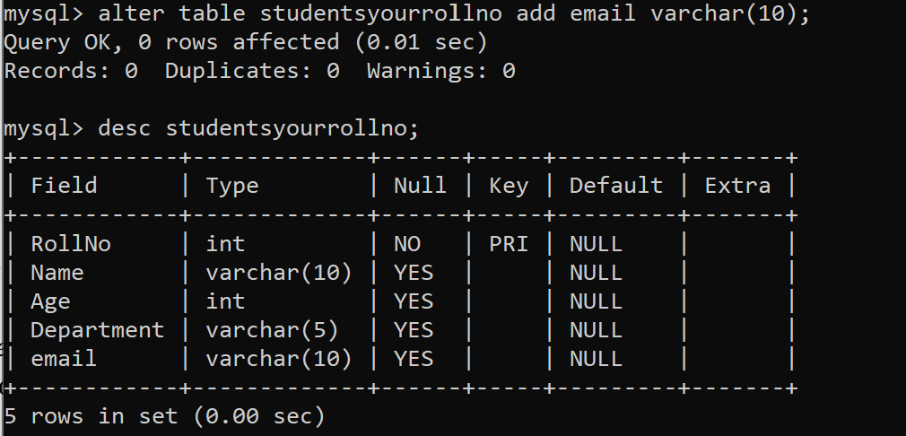

Task 3: Modify Column Data Type.
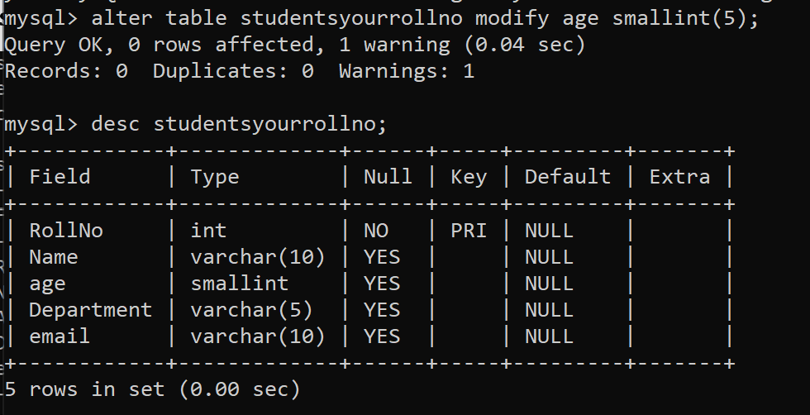
Task 4: Drop Email Column.
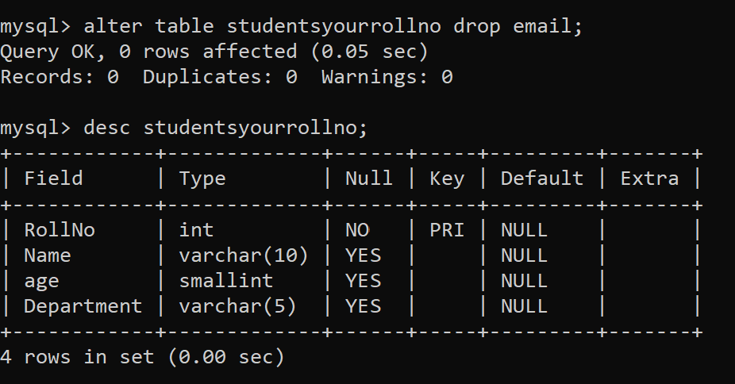
Task 5: Rename a Table.
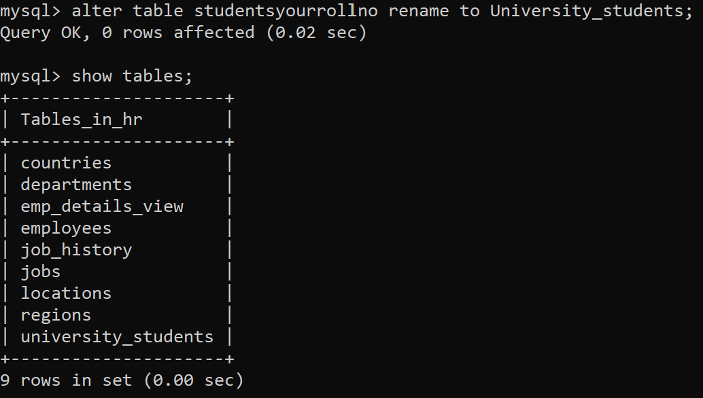

Task 6: Truncate a Table.
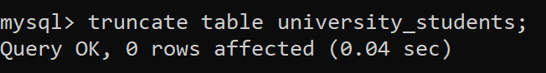
Task 7: Describe Table Structure.
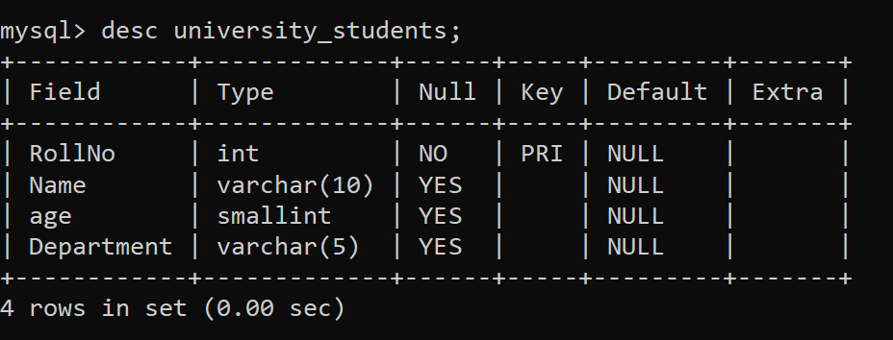
Task 8: Grant Privileges.
Task 9: Revoke Privileges.
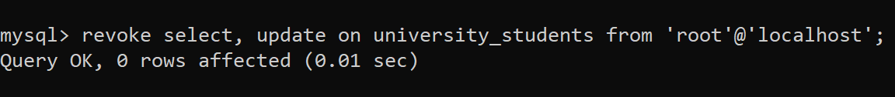
Task 10: Create Another Table for Courses.
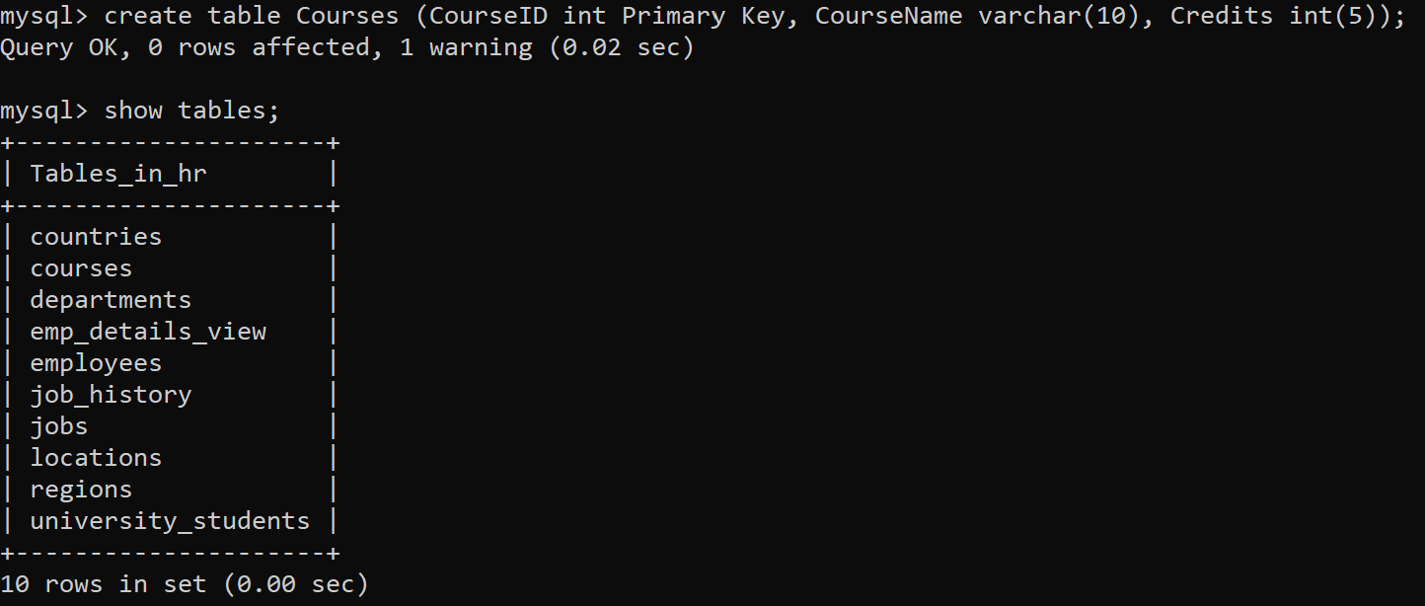
Task 11: Grant All Privileges.

Task 12: Drop a Table.
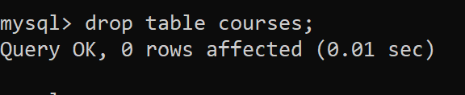
Task 13: Check Available Databases.
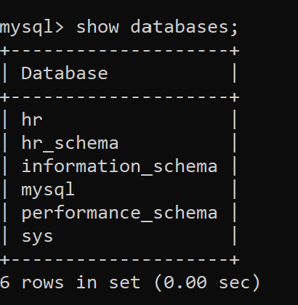
Task 14: Import HR Schema.
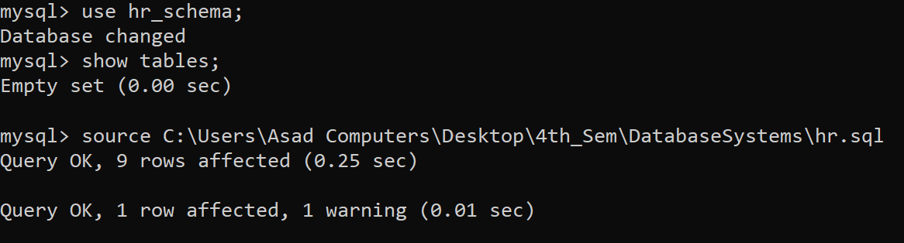
Task 15: View All Tables.
