Atika Mughal

SAP ID: 5000000280

Database Systems Lab-4

Task 1: Write a query to display the names (first_name, last_name) using the alias name “First Name", "Last Name".
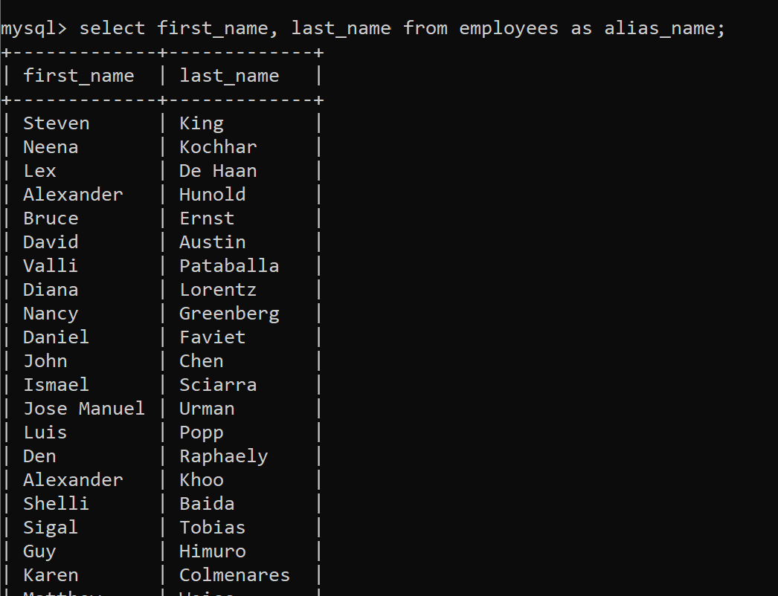
Task 2: Write a query to get a unique department ID from the employee table.
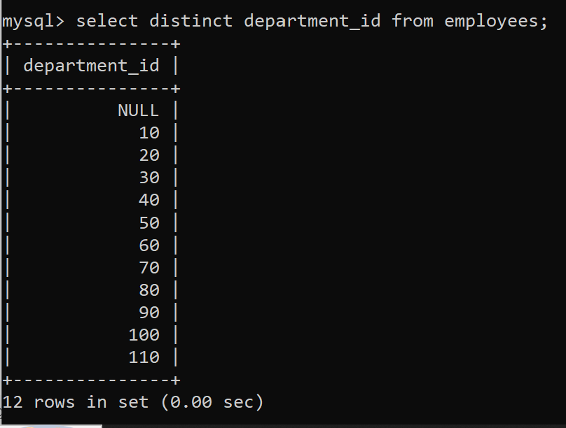

Task 3: Write a query to get all employee details from the employee table order by the first name, descending.
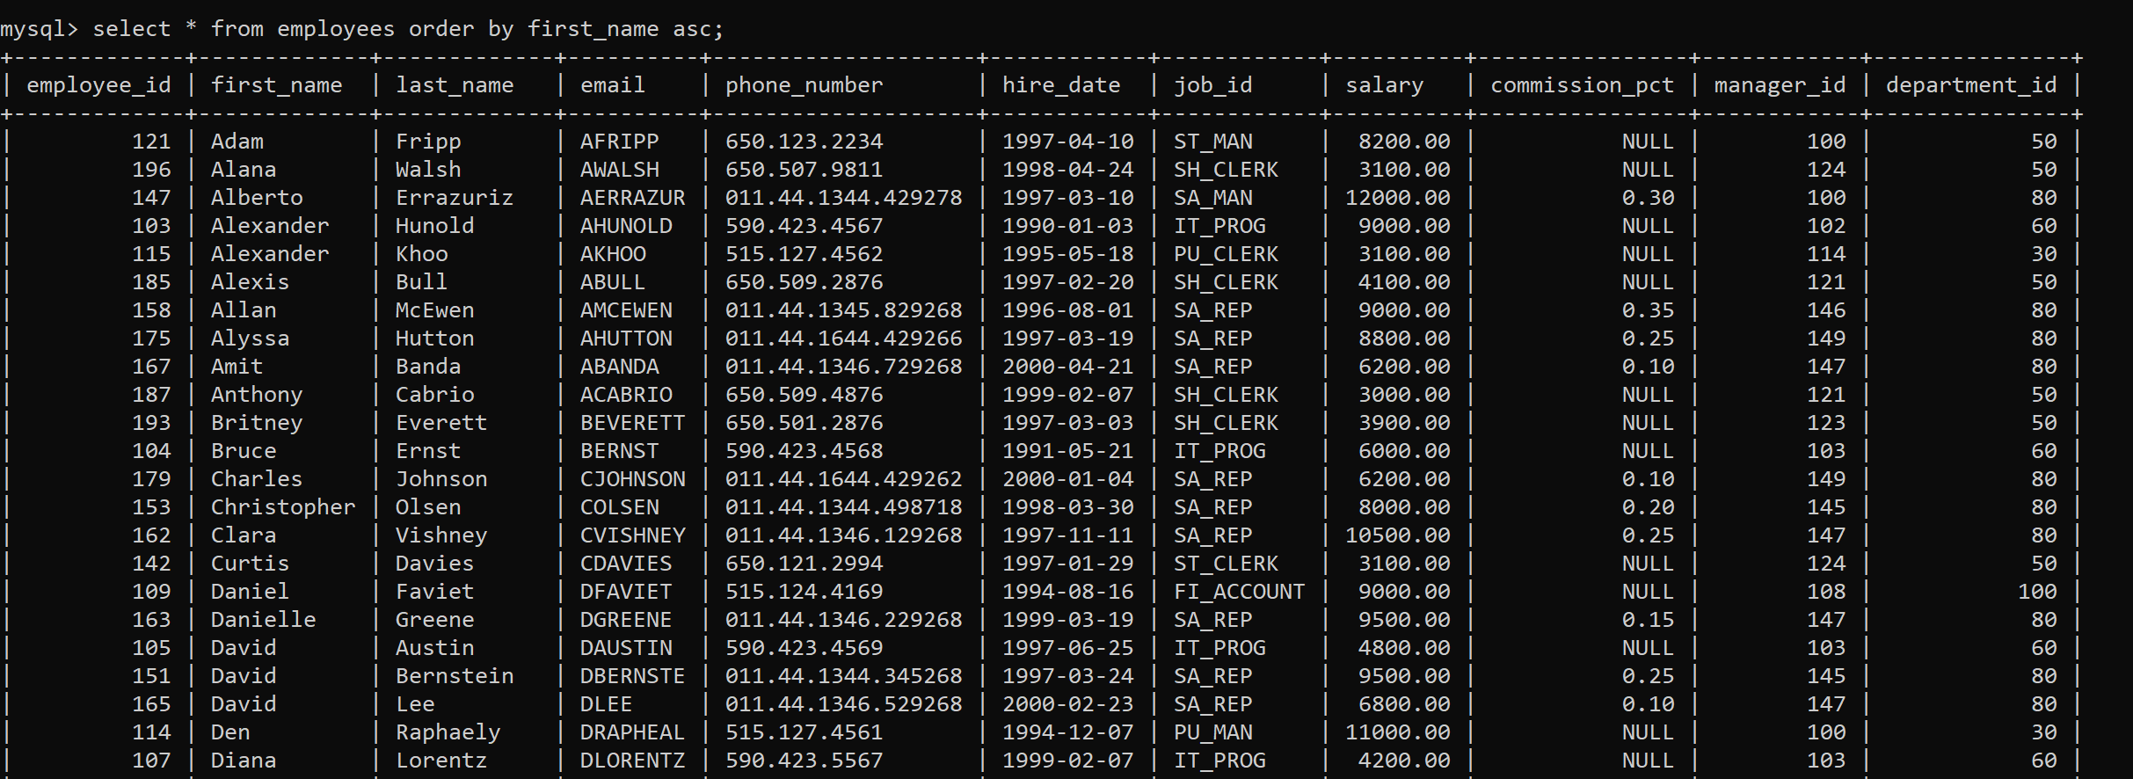
Task 4: Write a query to get the employee ID, names (first_name, last_name), salary in ascending order of salary.
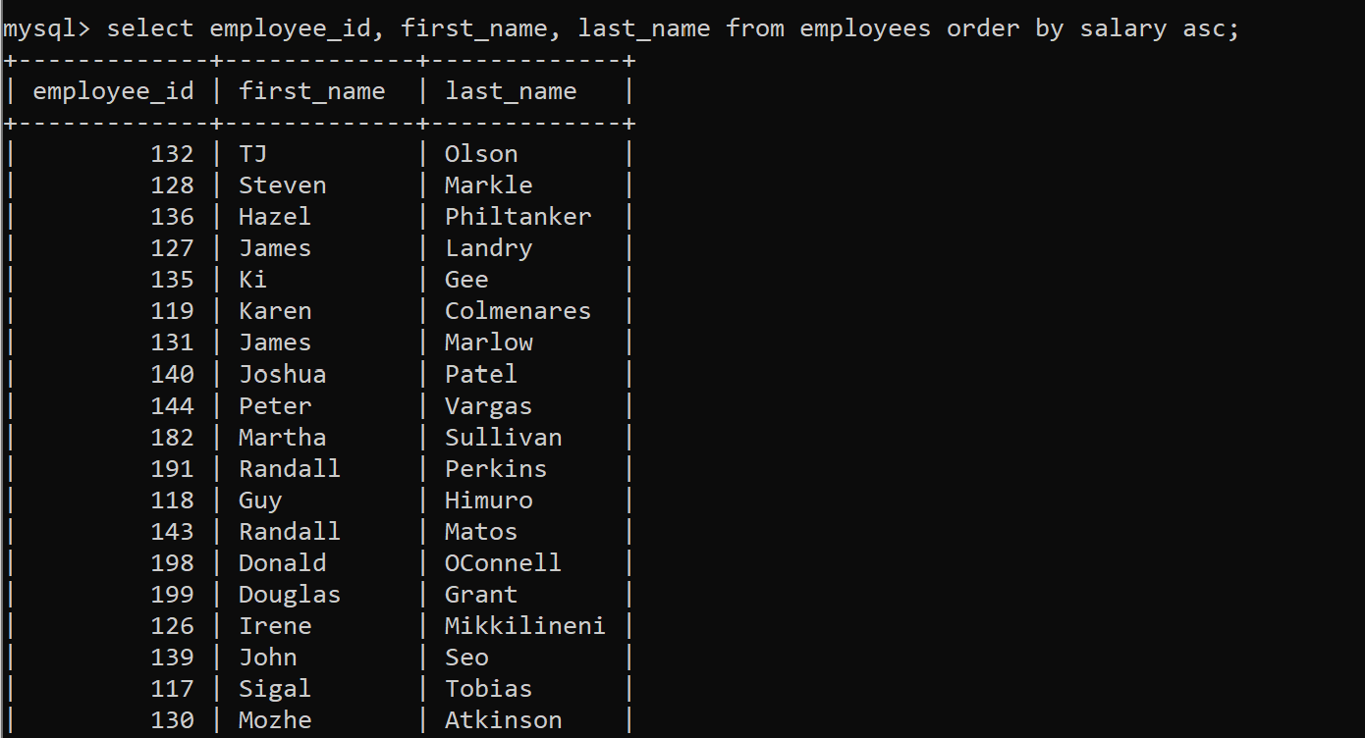
Task 5: Write a query to get the total salaries payable to employees.
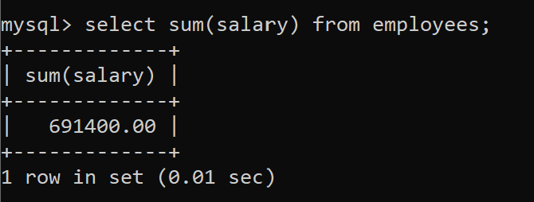

Task 6: Write a query to get the maximum and minimum salary from the employee's table.
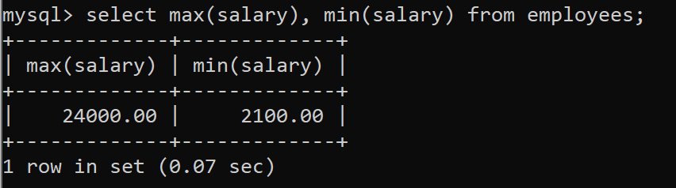
Task 7: Write a query to get the average salary and number of employees in the employees' table.
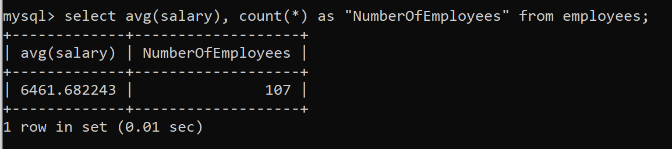
Task 8: Write a query to get the number of jobs available in the employee's table.
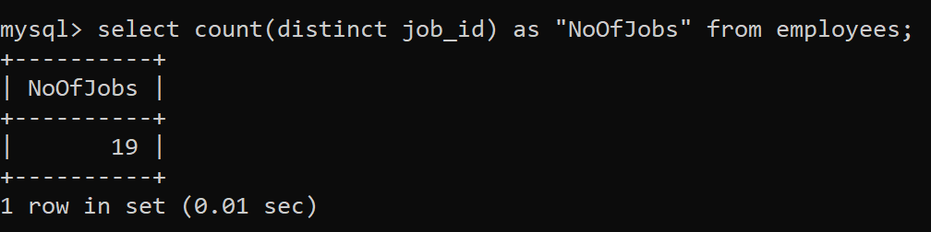
Task 9: Write a query to get all first names from the employee's table in the upper case.
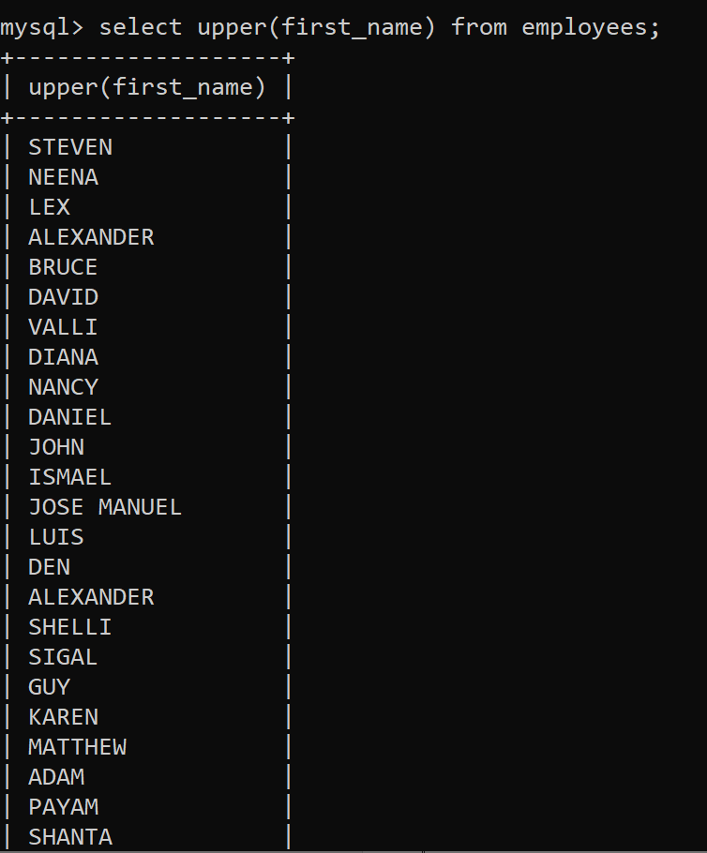
Task 10: Write a query to select the first 10 records from a table.
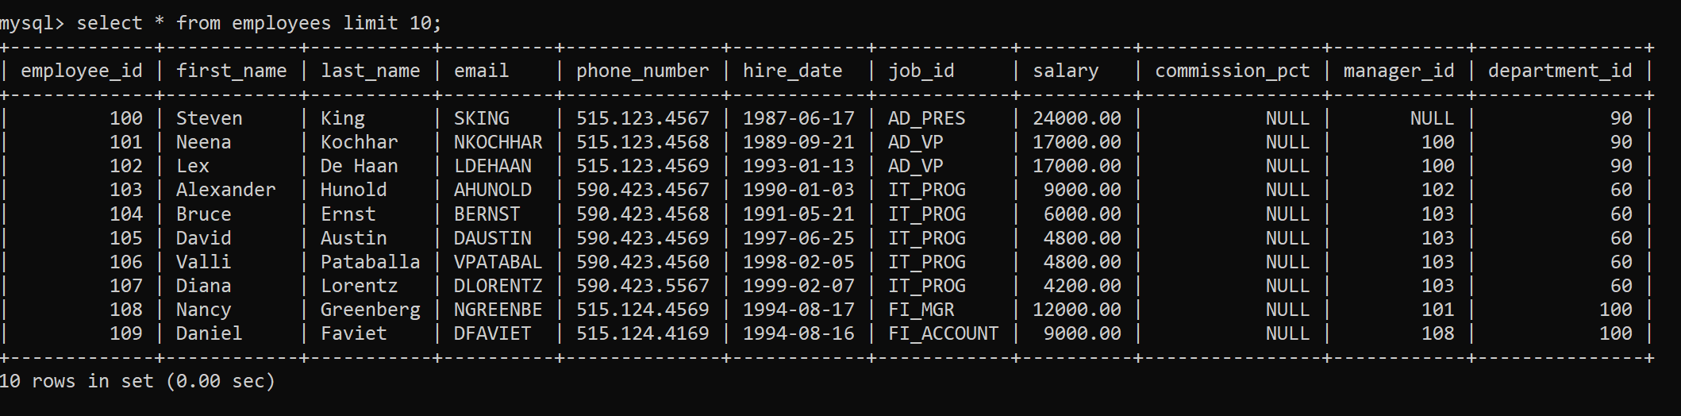
Task 11: Write a query to select the 3rd & 4th records of the employee's table.
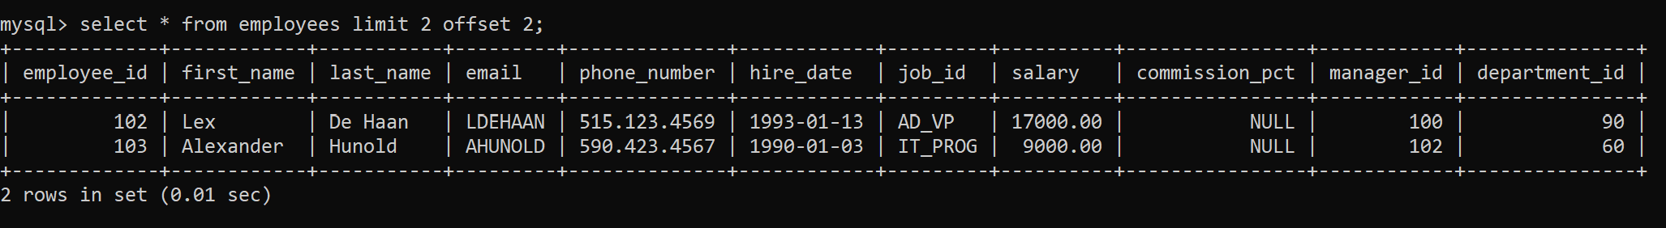
Task 12: Write a query to select 2nd last record of the employee's table.
