Atika Mughal

SAP ID: 5000000280

Database Systems Lab-5

Task 1: Write a query to display EMPLOYEE_ID, FIRST_NAME, and SALARY of employees whose SALARY is less than $3000.
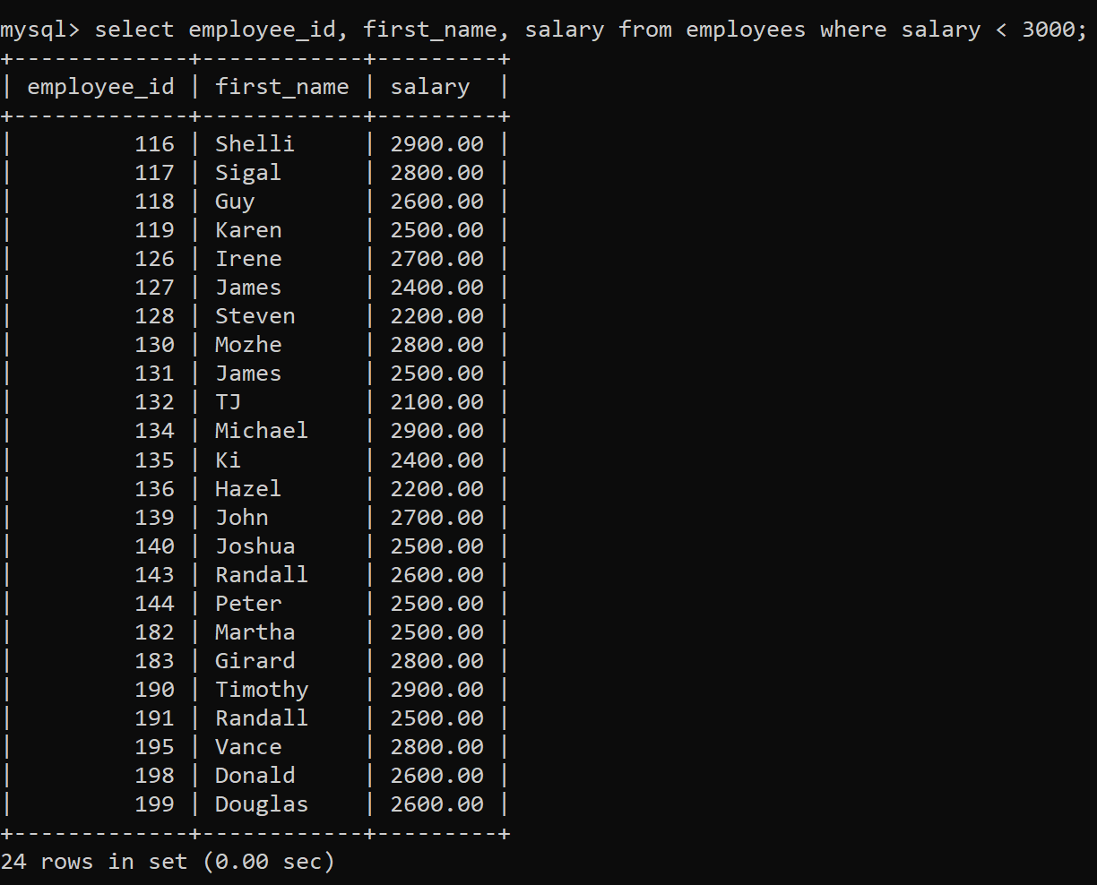
Task 2: Write a query to display FIRST_NAME, LASTNAME of all employees whose first name starts with letter ‘A’.
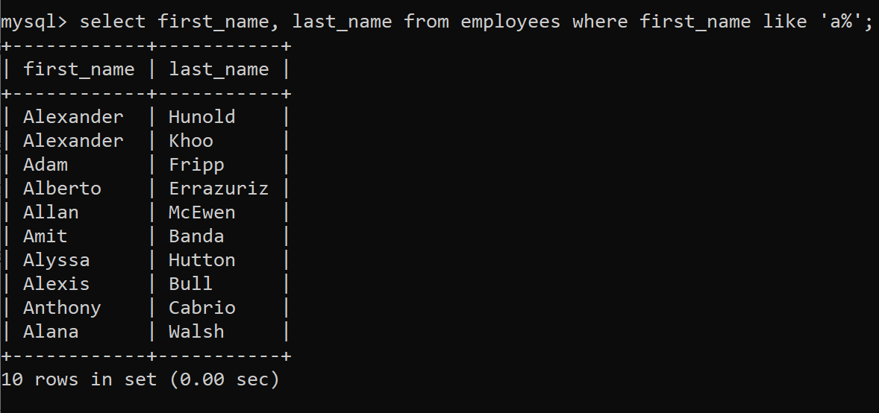

Task 3: Write a query to display FIRST_NAME, JOB_ID, DEPARTMENT_ID of employees who are either PU_CLERK or belongs to MANAGER_ID = 114.
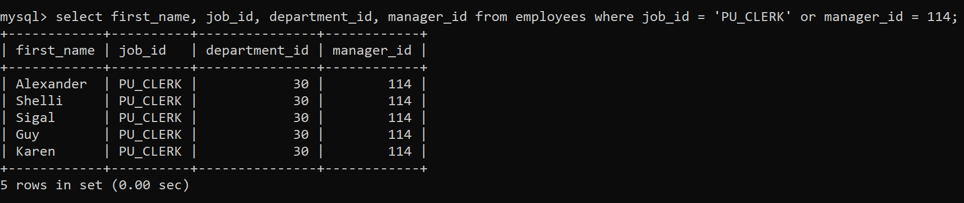
Task 4: Write a query to display EMPLOYEE_ID, FIRST_NAME, and SALARY of employees whose salaries lies in the range of $1500 to $3000;
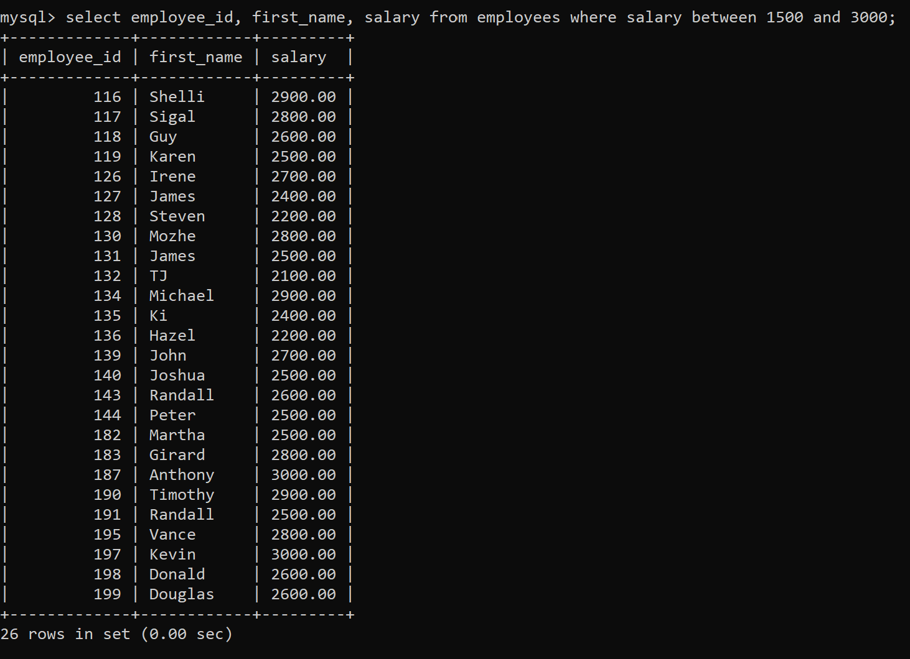

Task 5: Write a query to display EMPLOYEE_ID, FIRST_NAME, and SALARY of employees whose commission is empty.

Task 6: Write a query to display first names of all employees that end with alphabet ‘N’.
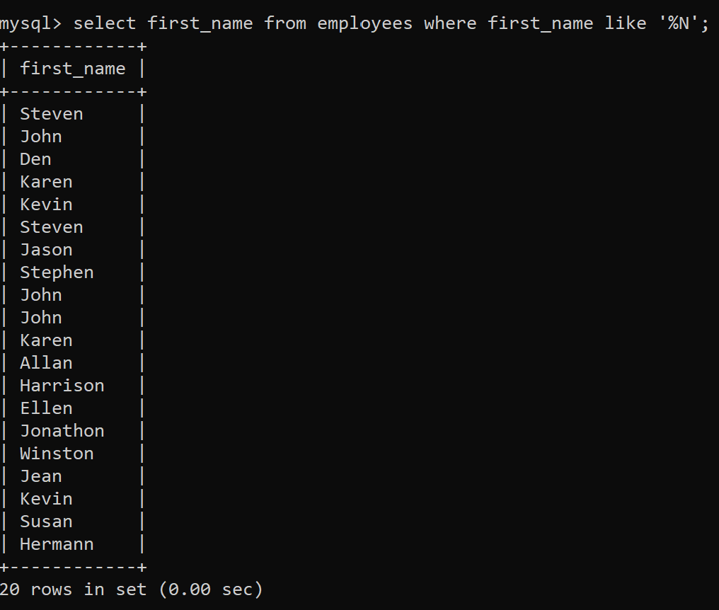
Task 7: Write a query to display FIRST_NAME, JOB_ID, DEPARTMENT_ID of employees who are not PU_CLERK.
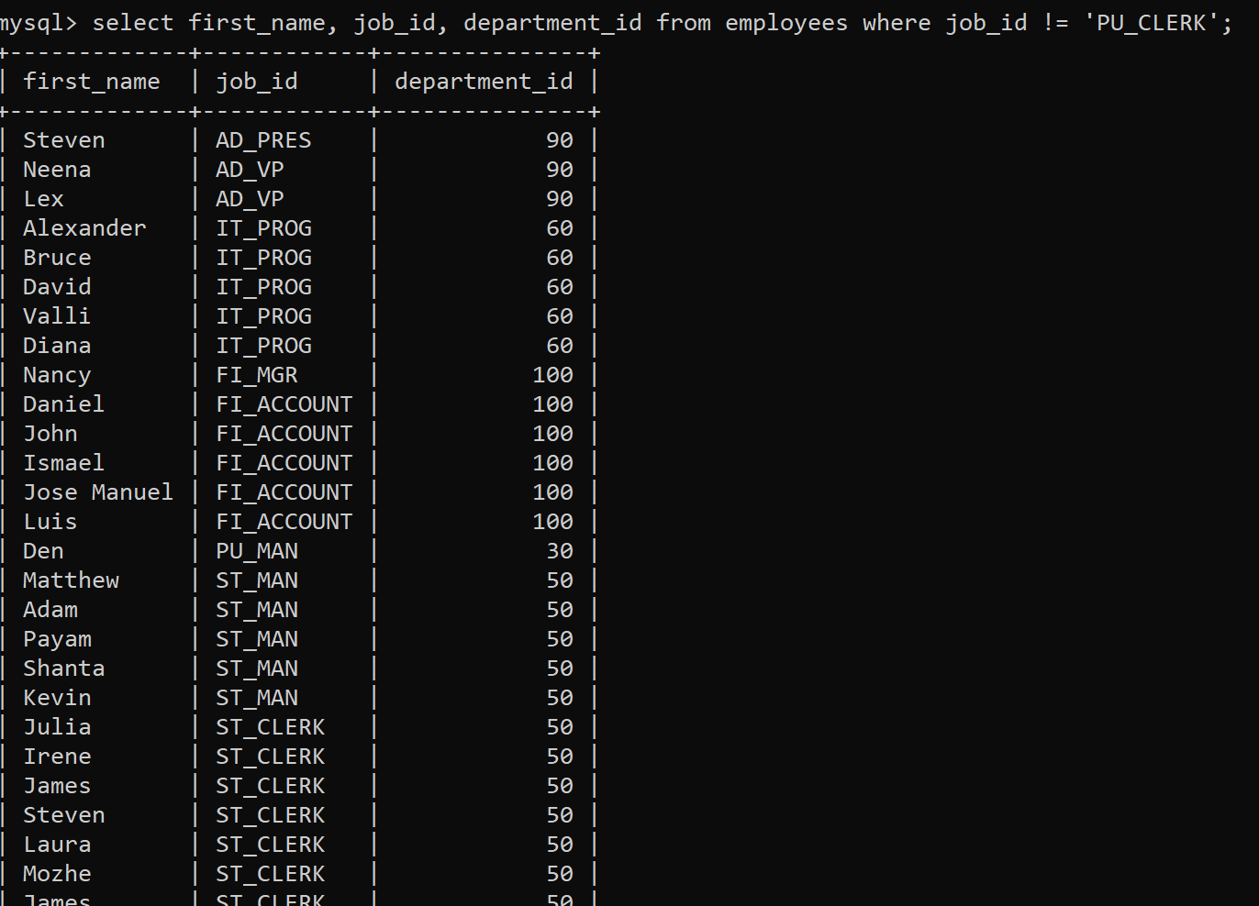

Task 8: Write a query to display EMPLOYEE_ID, FIRST_NAME, and SALARY of those employees who do not have salaries of $3300, $3200, $2200.
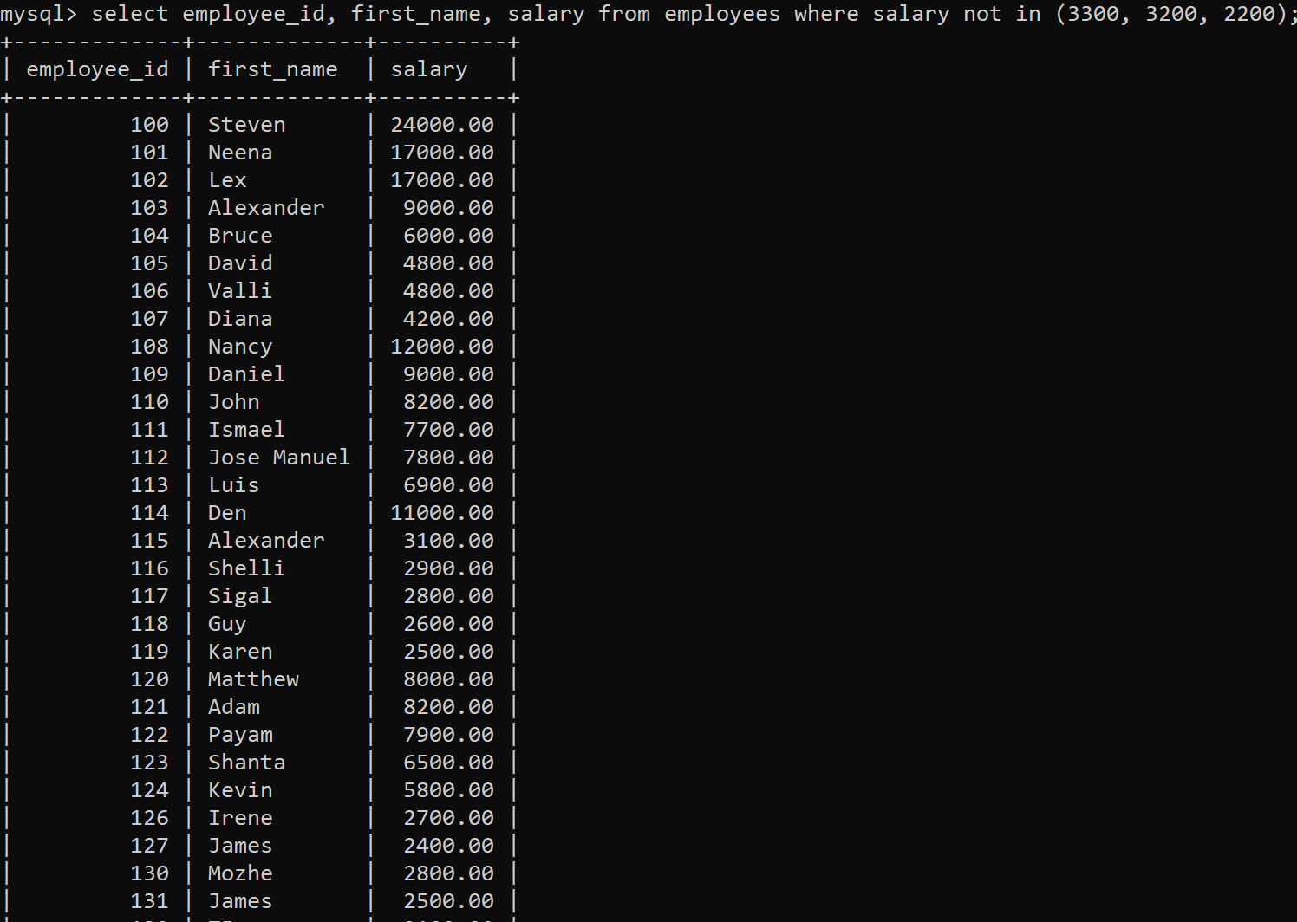
Task 9: Write a query to display names of those employees whose first name starts with ‘A’ and ends with ‘N’.
Task 10: Write a query to display the list of employee names that have letters ‘LA’ in their names.
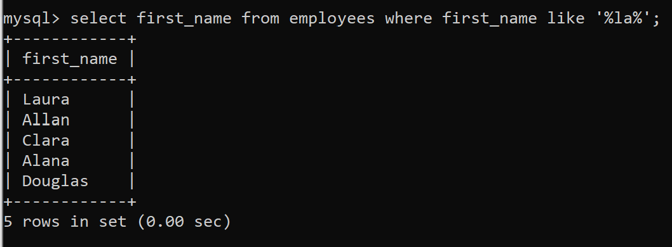

Task 11: Write a query to display the EMPLOYEE_ID, FIRST_NAME, and SALARY of employees. In that, the highest paid employee should display first and lowest paid should display last.
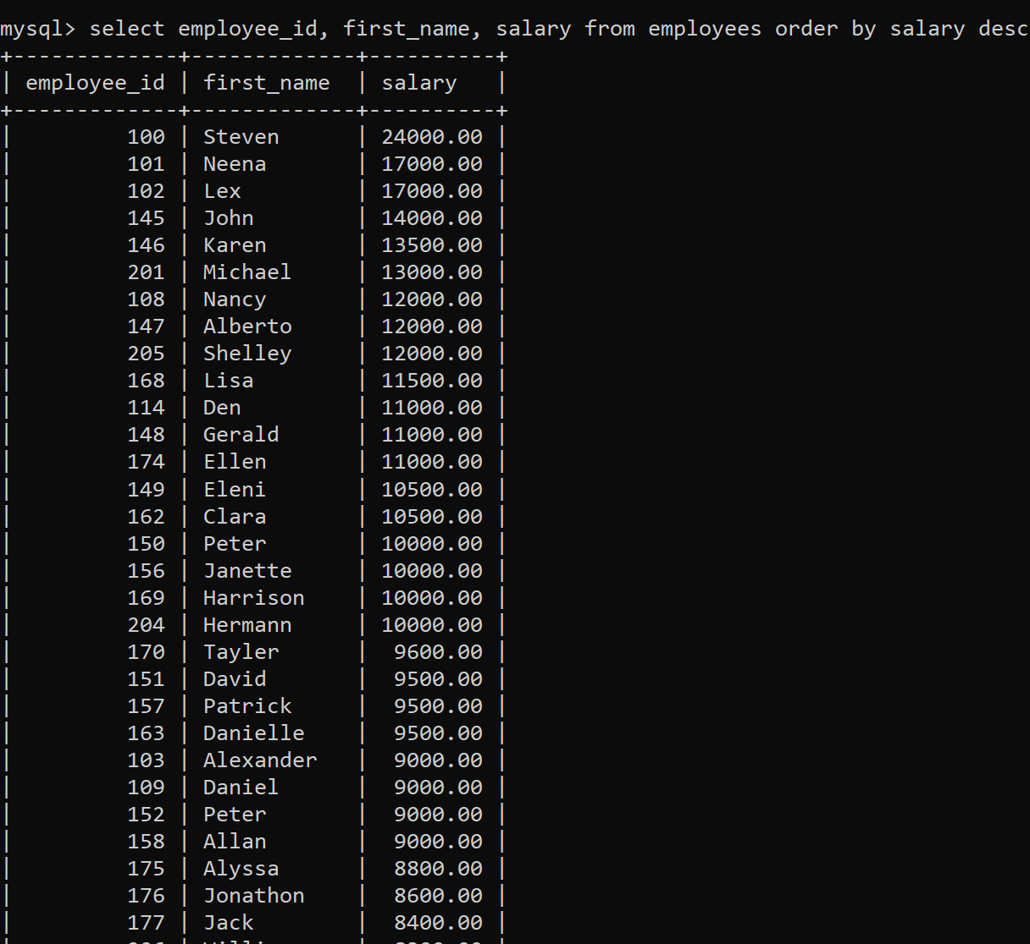
Task 12: Write a query to display FIRST_NAME of employees that have "a" in the second position.
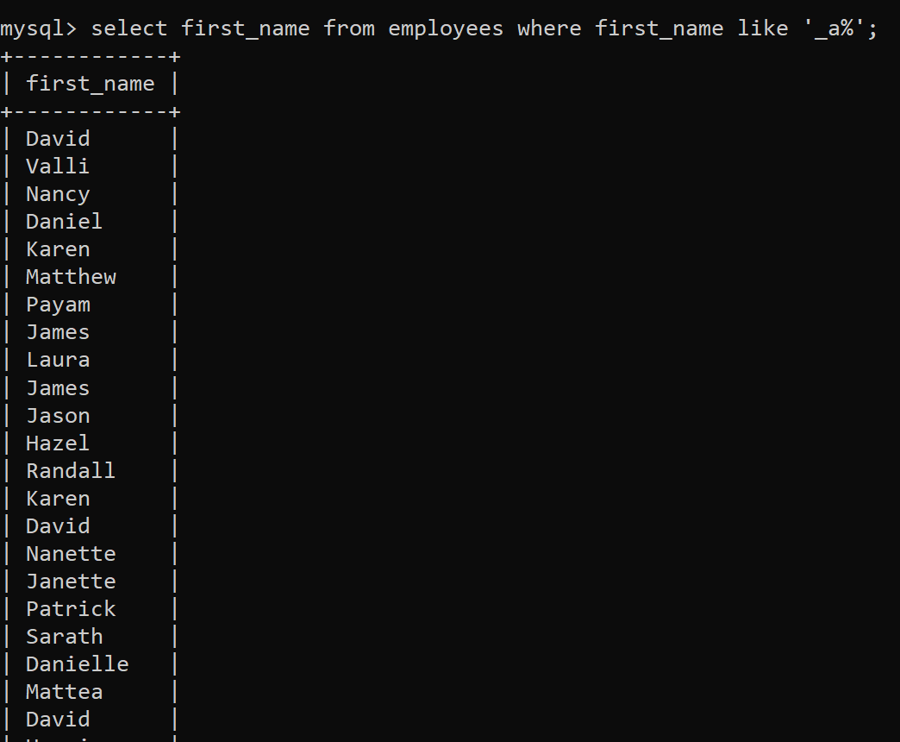

Task 13: Write a query to display EMPLOYEE_ID, FIRST_NAME, and SALARY of employees whose salaries do not lies in the range of $1500 to $3000;
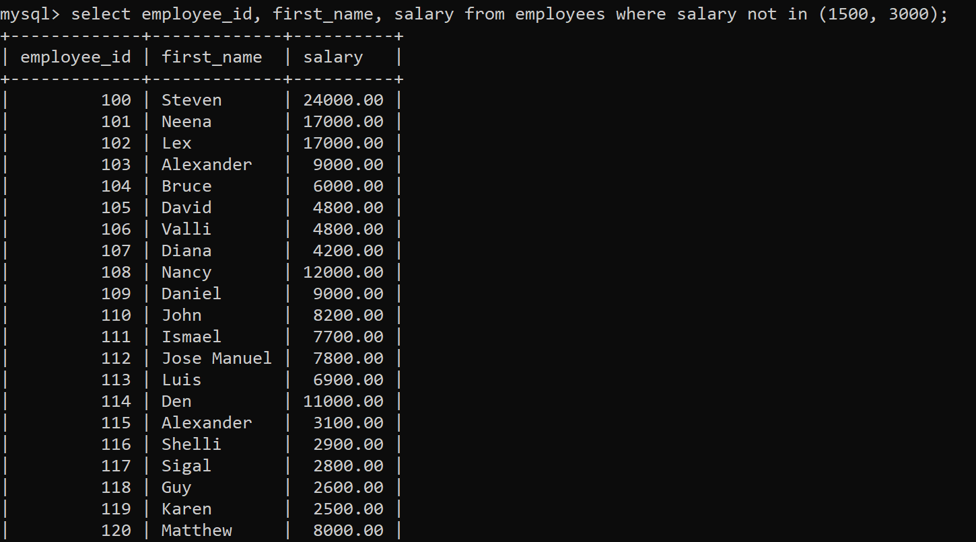
Task 14: Write a query to display FIRST_NAME, LAST_NAME and DEPARTMENT_ID of all employees in departments 30 or 100 in ascending order.
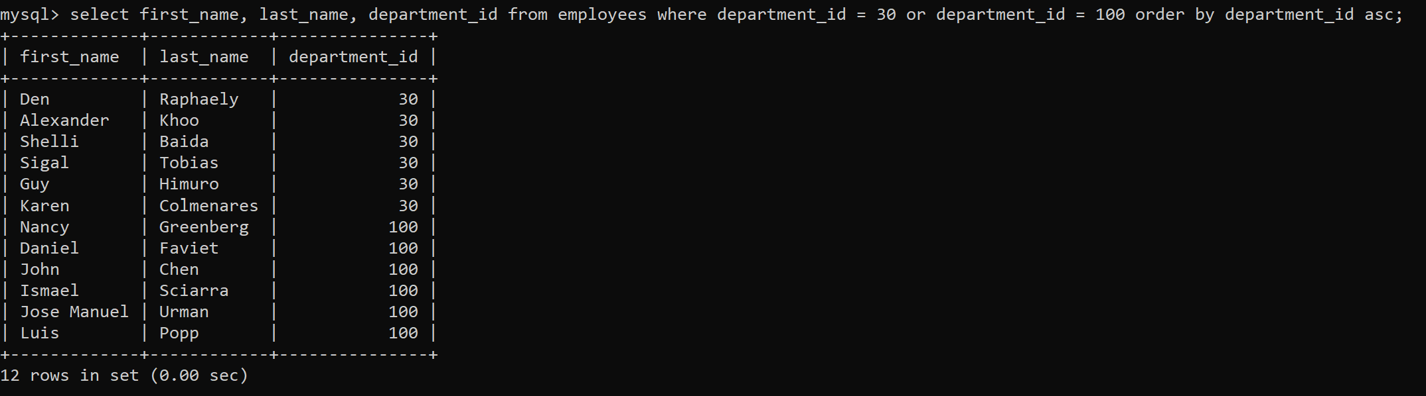
Task 15: Write a query to display FIRST_NAME, LAST_NAME and SALARY for all employees whose salary is not in the range $10,000 through $15,000 and are in department 30 or 100.
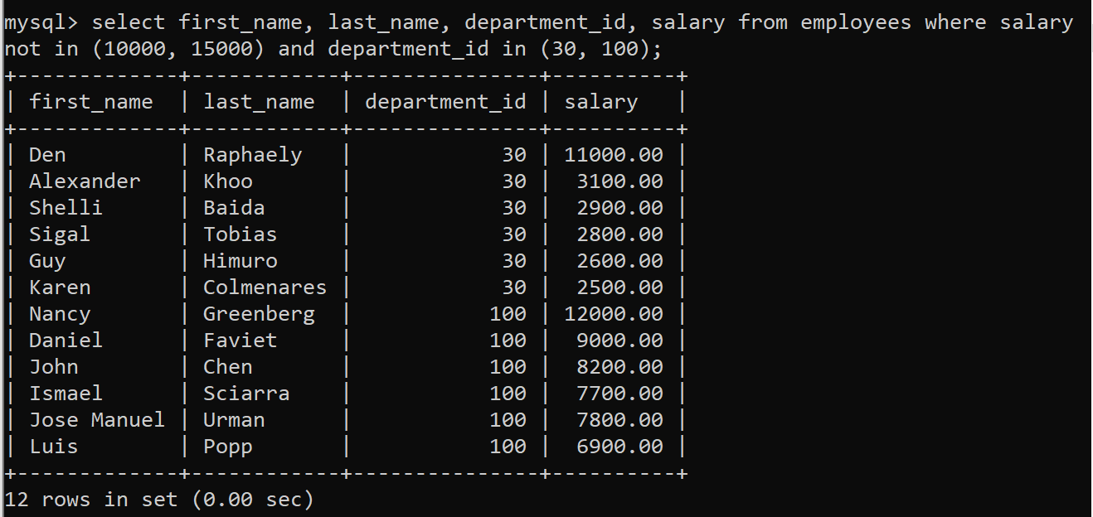

Task 16: Write a query to display FIRST_NAME, LAST_NAME and HIRE_DATE for all employees who were hired in 1987.
Task 17: Write a query to display the LAST_NAME of employees whose LAST_NAME have exactly 6 characters.
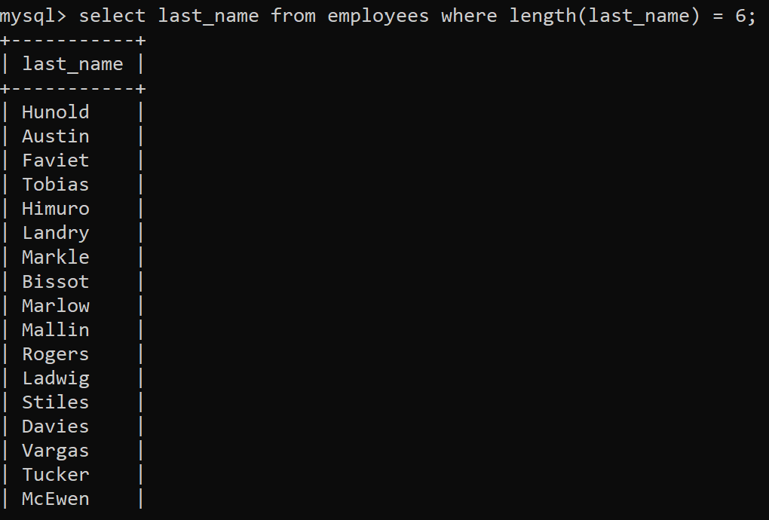
Task 18: Write a query to display FIRST_NAME, SALARY and PF (15% of salary) of all employees.
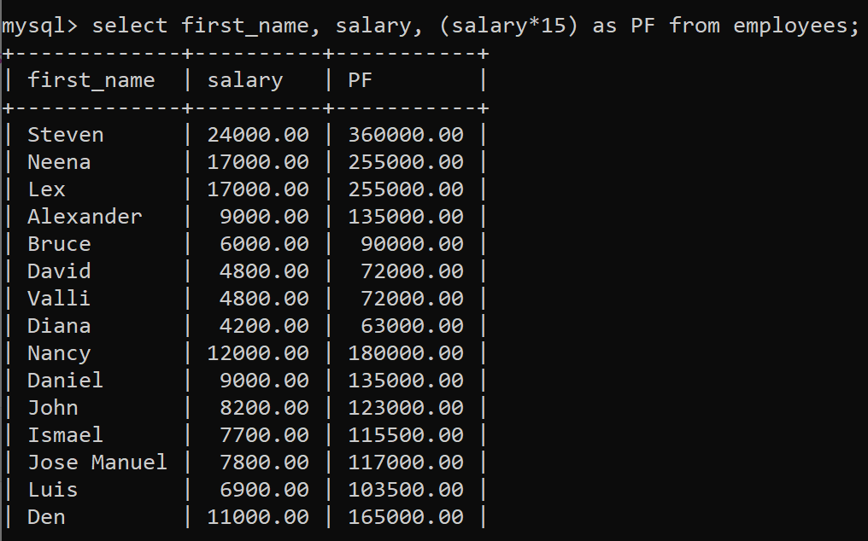

Task 19: Write a query to display FIRST_NAME, SALARY and commission amount (% of salary) of all employees.
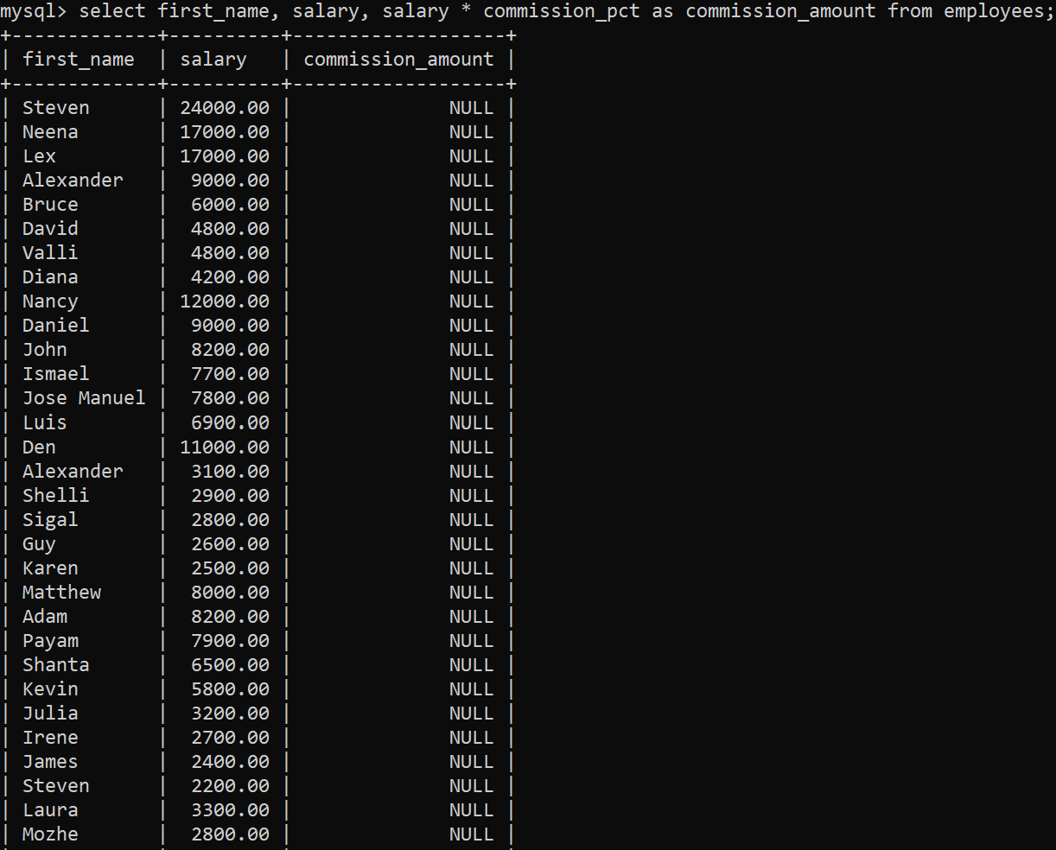
Task 20: Write a query to display FIRST_NAME, SALARY and NET_SALARY after 500 deduction from salary of all employees;
