Atika Mughal

SAP ID: 5000000280

Database Systems Lab-6

Task 1: Write a query in SQL to display the first name, last name, department number, and department name for each employee. (Sample tables: employees & departments).
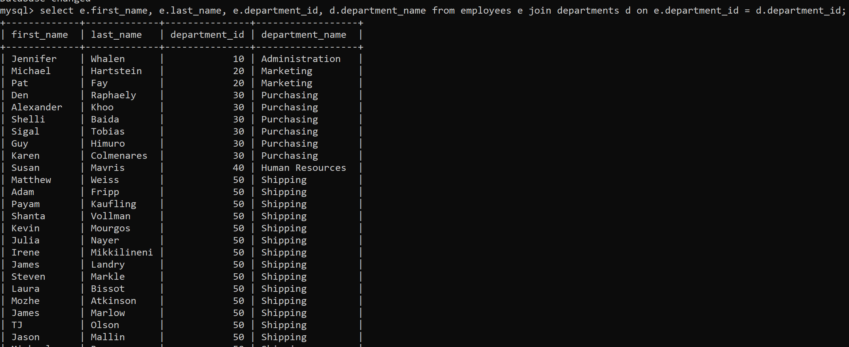
Task 2: Write a query to find the name (first_name, last_name), job, department ID and name of the department who works in London. (Sample tables: employees , locations & departments).
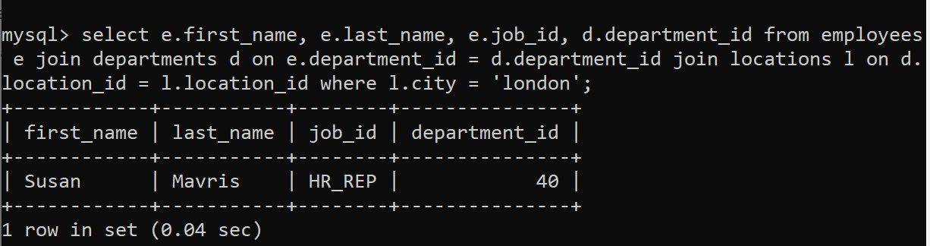
Task 3: Write a query in SQL to display the first and last name, department, city, and state province for each employee. (Sample tables: employees , locations & departments).
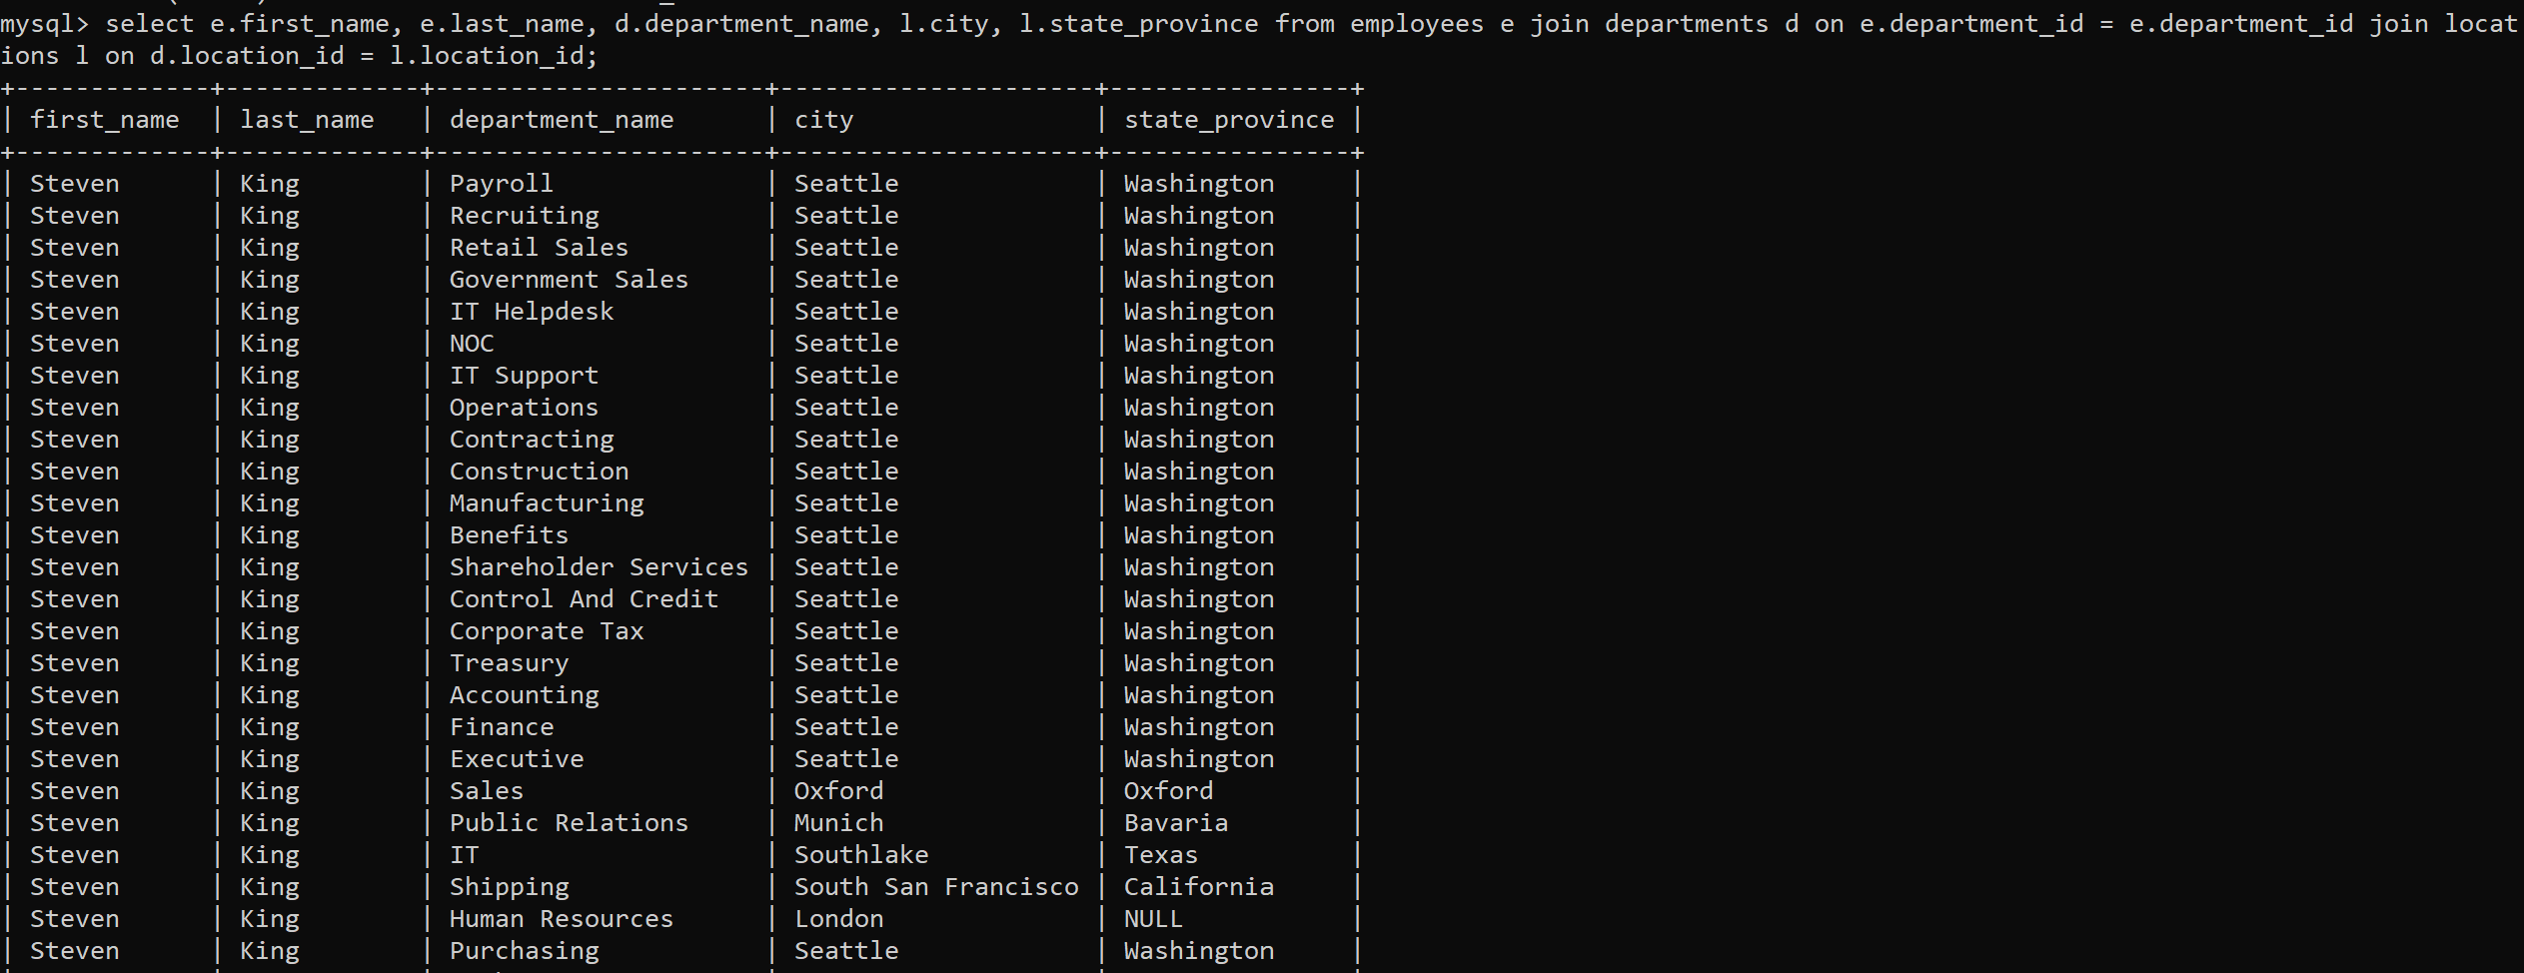
Task 4: Write a query to find the employee id, name (last_name) along with their manager_id and name (last_name). (Sample tables: employees).
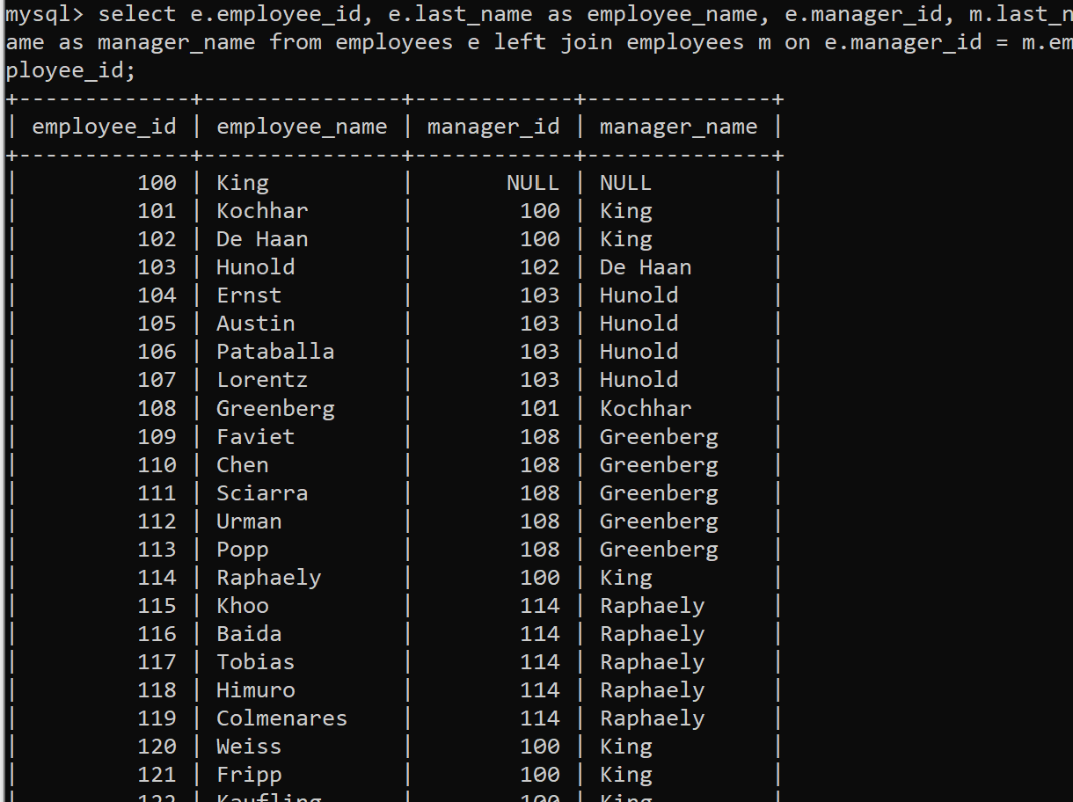
Task 5: Write a query to find the name (first_name, last_name) and hire date of the employees who was hired after 'Jones'. (Sample tables: employees).
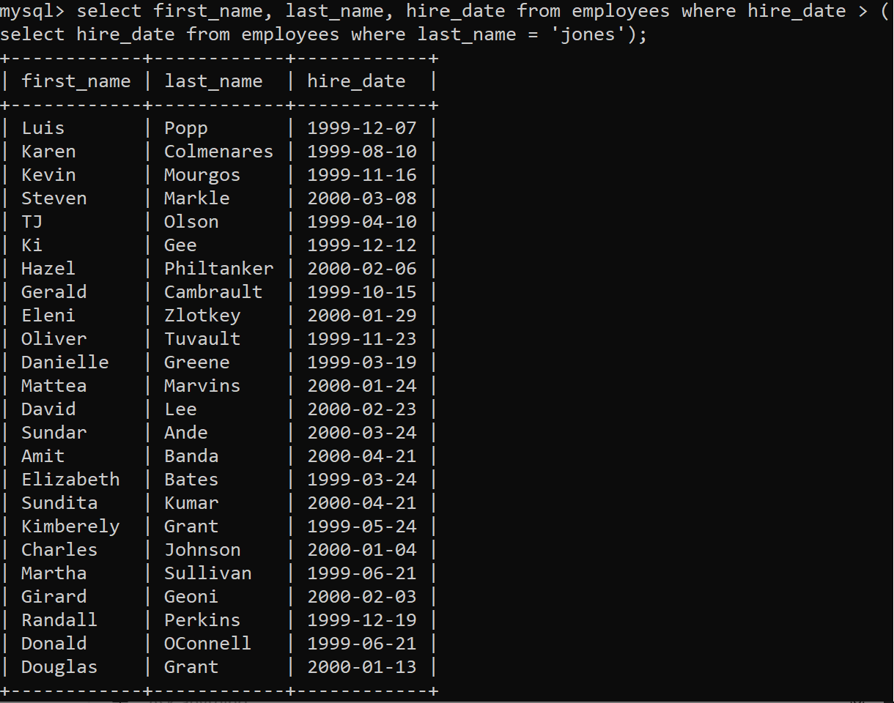

Task 6: Write a query to get the department name and number of employees in the department. (Sample tables: employees & departments).
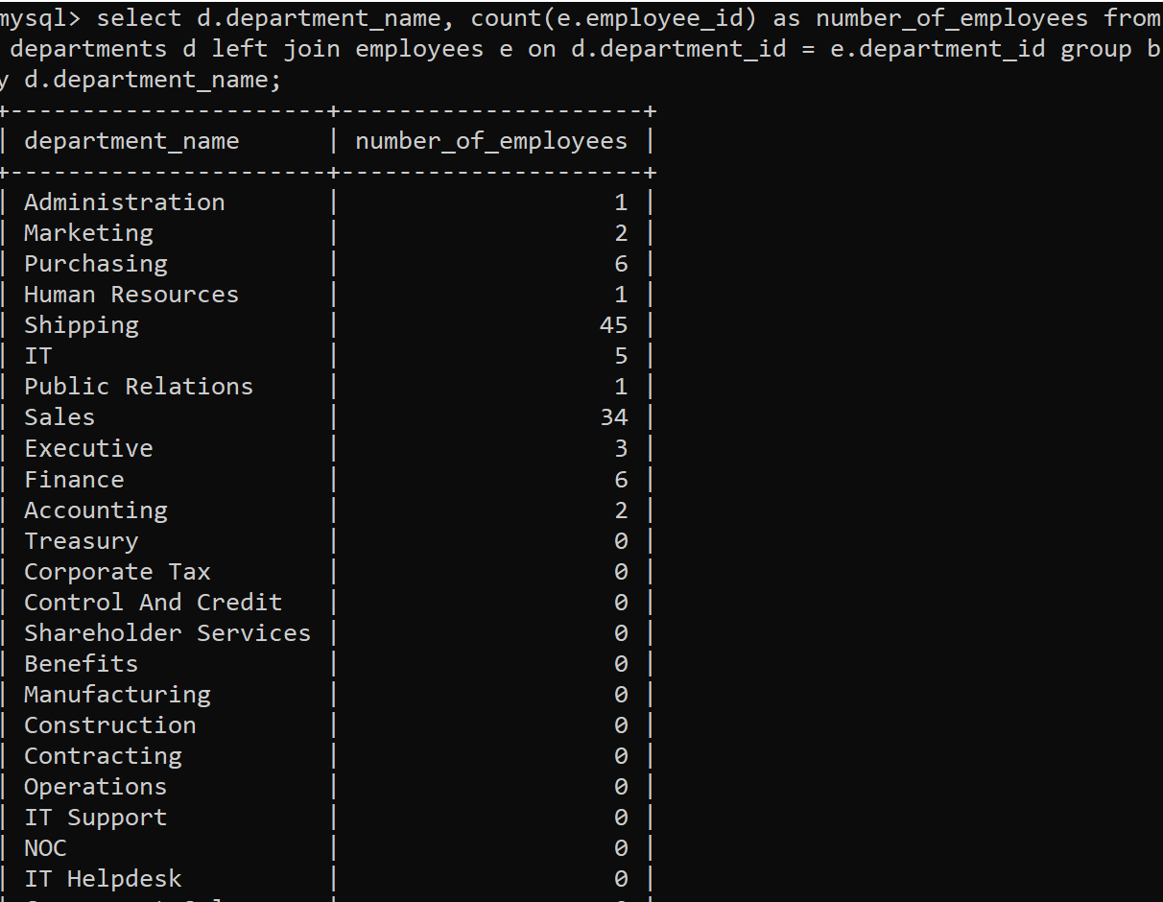
Task 7: Write a query to display the department ID and name and first name of manager. (Sample tables: employees & departments).
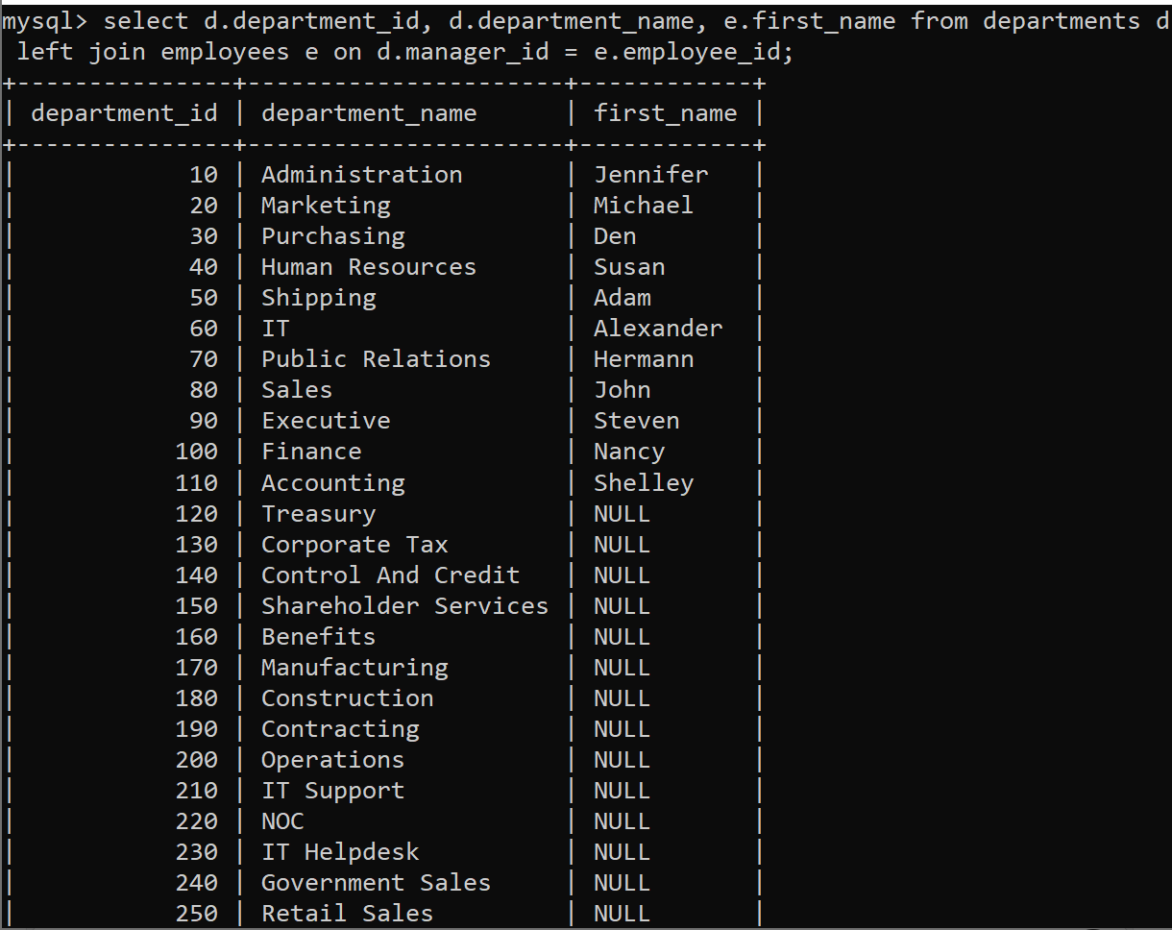

Task 8: Write a query to display the department name, manager name, and city. (Sample tables: employees , locations & departments).
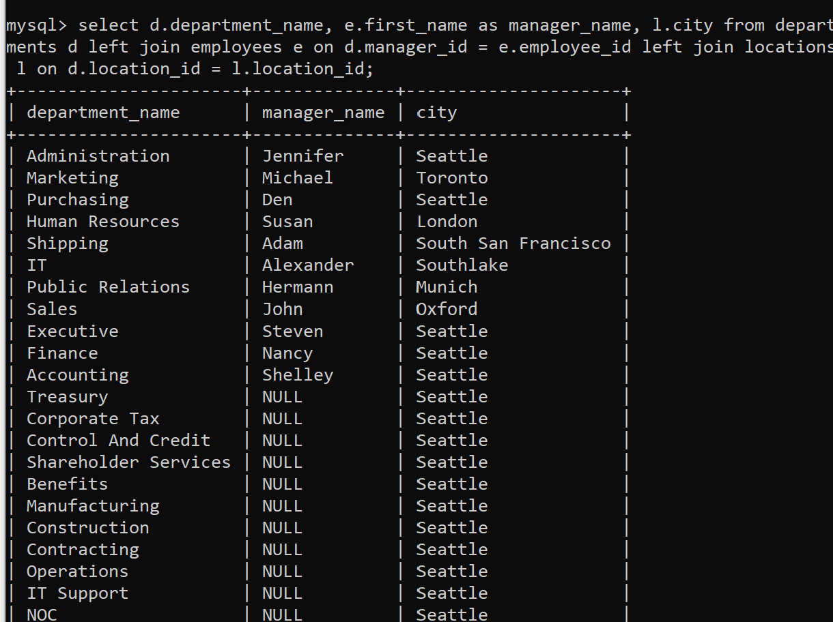
Task 9: Write a query to display the job history that were done by any employee who is currently drawing more than 10000 of salary. (Sample tables: employees & job_history).
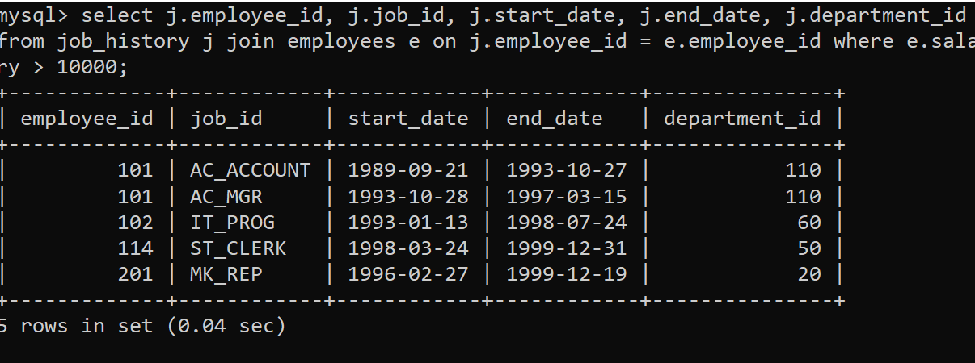
Task 10: Write a query to display the first name, last name, hire date, salary of the manager for all managers whose experience is more than 15 years. (Sample tables: employees & departments).
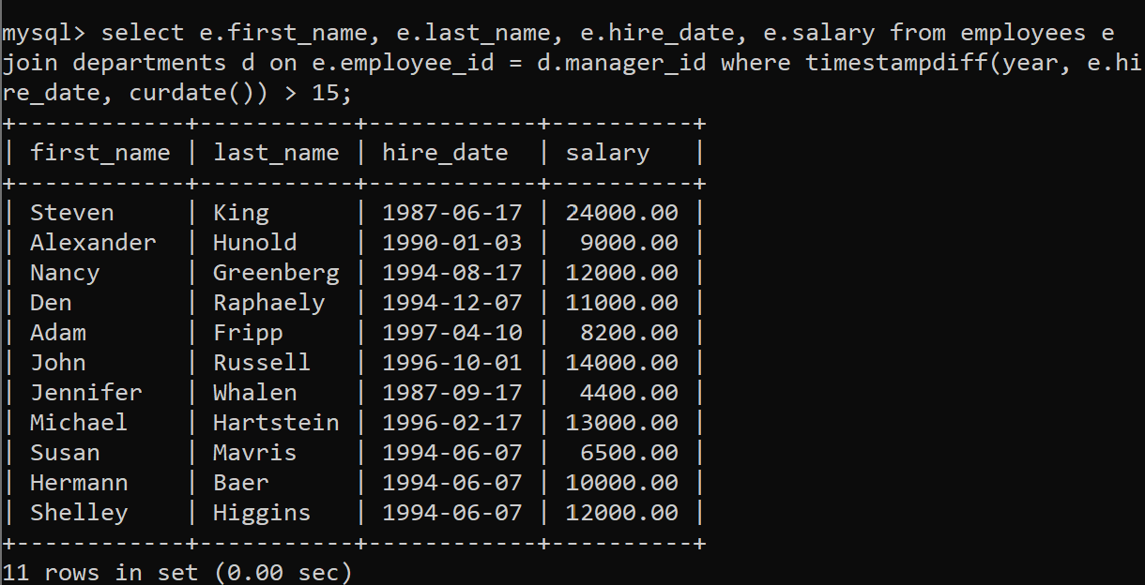
Task 11: Write a query in SQL to display the name of the department, average salary and number of employees working in that department who got commission. (Sample tables: employees & departments).
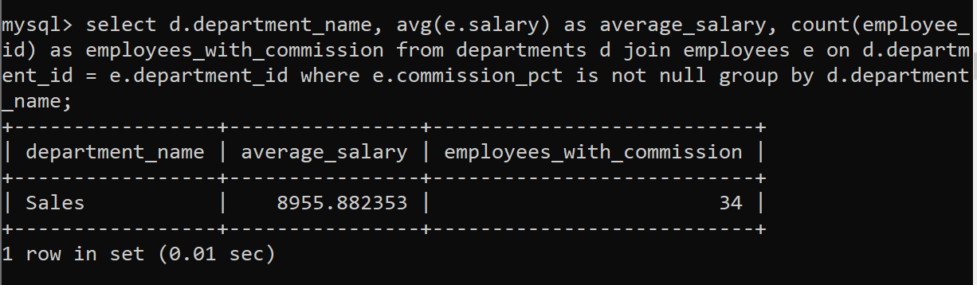
Task 12: Write a query in SQL to display the name of the country, city, and the departments which are running there. (Sample tables: countries , locations & departments).
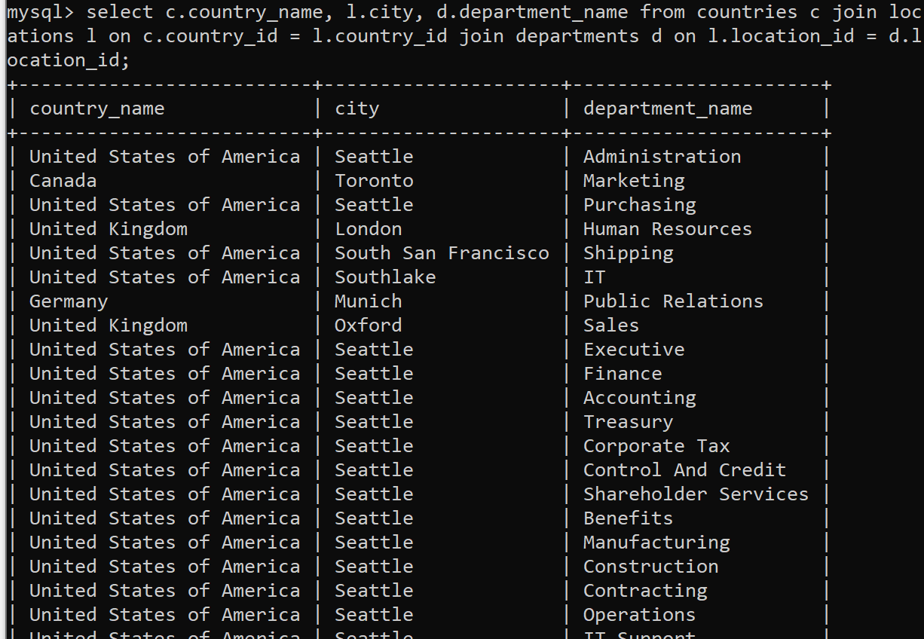
Task 13: Write a query in SQL to display department name and the full name (first and last name) of the manager. (Sample tables: employees & departments).
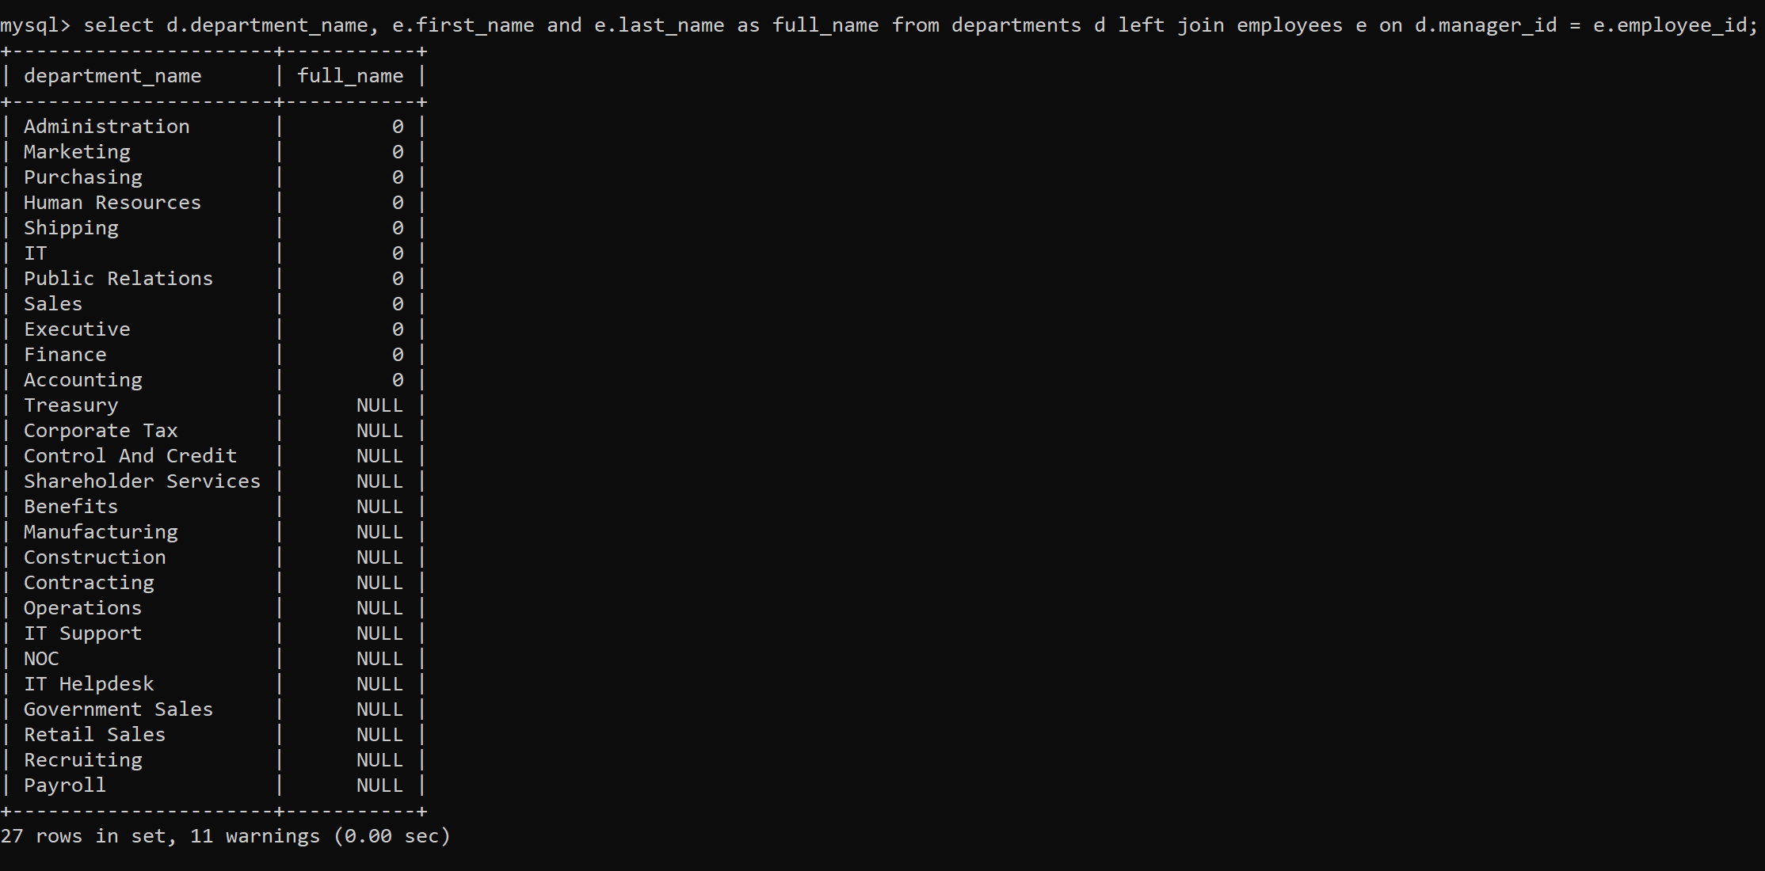
Task 14: Write a query in SQL to display the details of jobs which was done by any of the employees who is presently earning a salary on and above 12000. (Sample tables: employees & job_history).
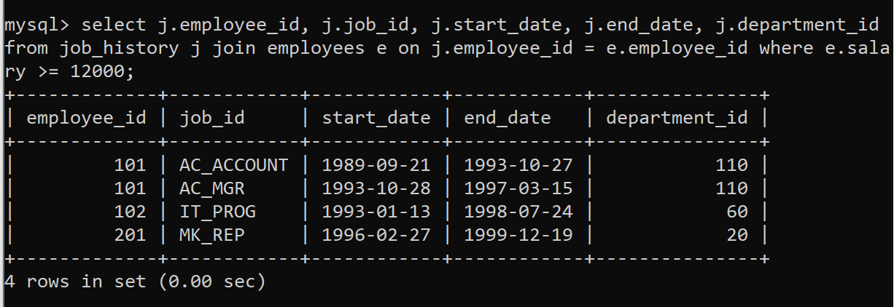
Task 15: Write a query in SQL to display the full name (first and last name), and salary of those employees who working in any department located in London. (Sample tables: employees , locations & departments).
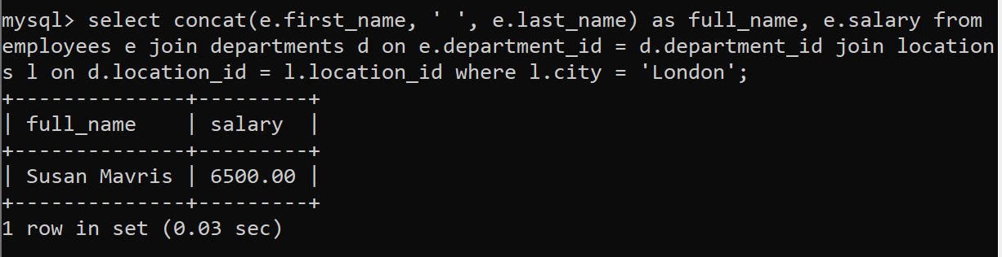
Task 16: Write a query to display job title, employee name, and the difference between salary of the employee and minimum salary for the job. (Sample tables: employees & jobs).
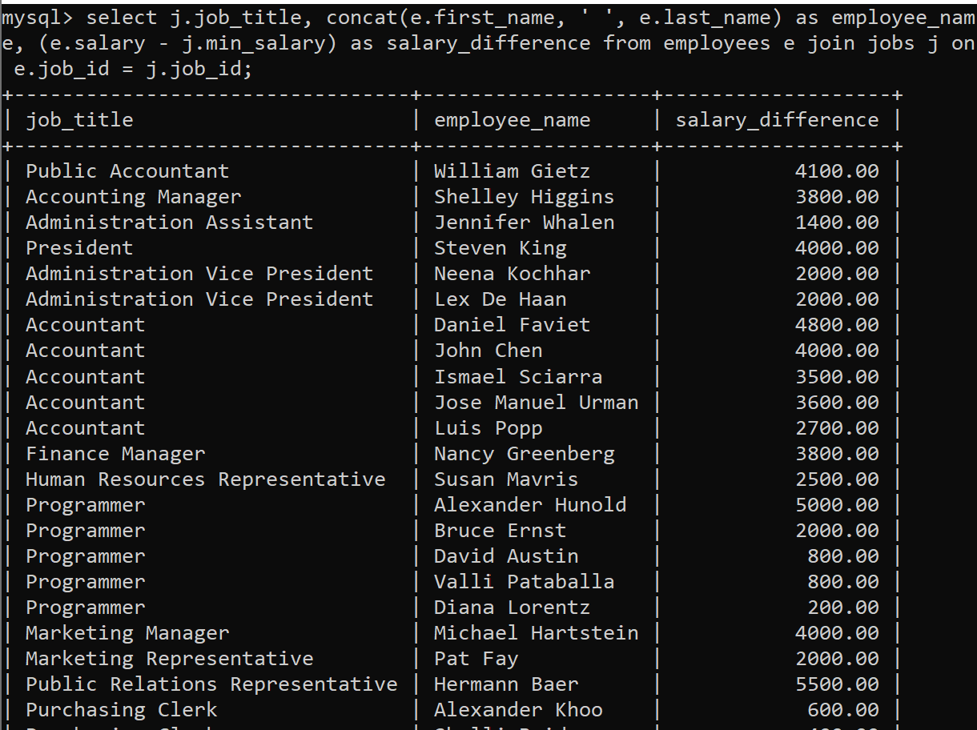
Task 17: Write a query to display the job title and average salary of employees. (Sample tables: employees & jobs).
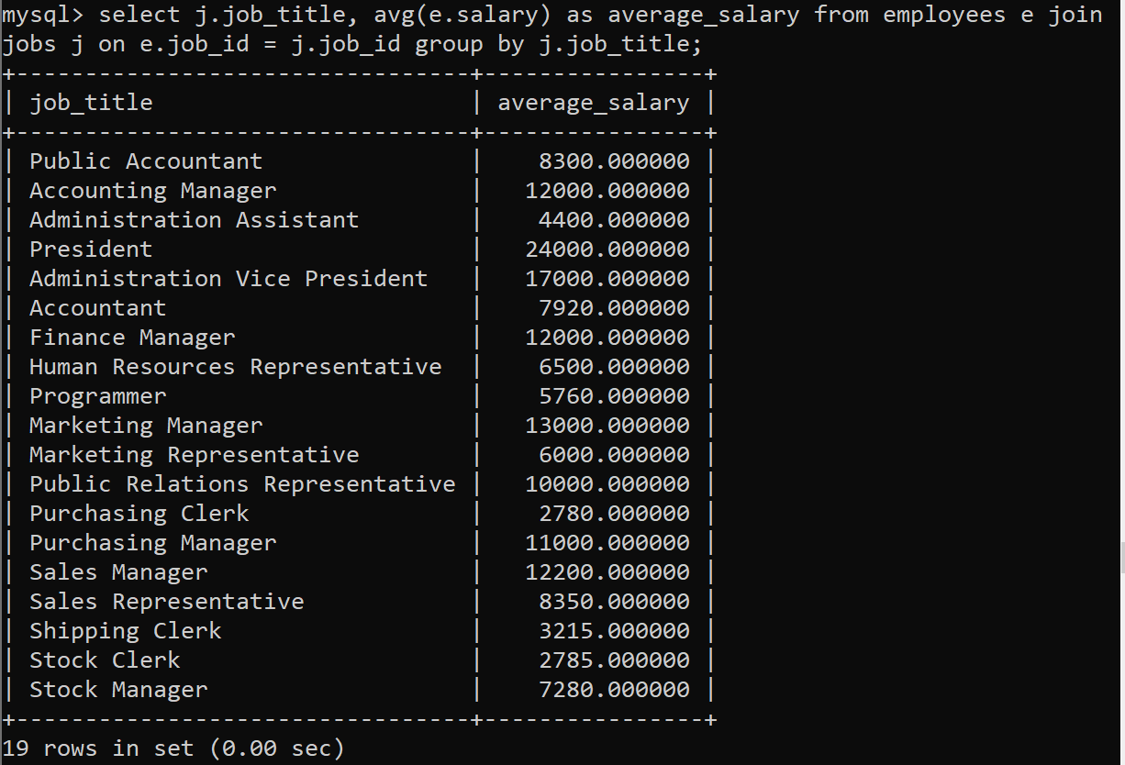
Task 18: Write a query to find the employee ID, job title, number of days between ending date and starting date for all jobs in department 90 from job history. (Sample tables: jobs & job_history).
