Atika Mughal

SAP ID: 5000000280

Database Systems Lab-7

Task 1: Write a query in SQL to display details of those employees who have changed jobs at least once. (Sample tables: employees & job_history).
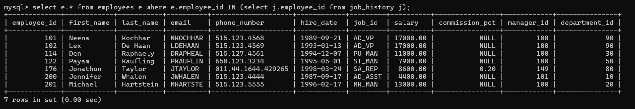
Task 2: Write a query to find the name (first_name, last_name) and the salary of the employees who have a higher salary than the employee whose last_name='Bull'. (Sample tables: employees).
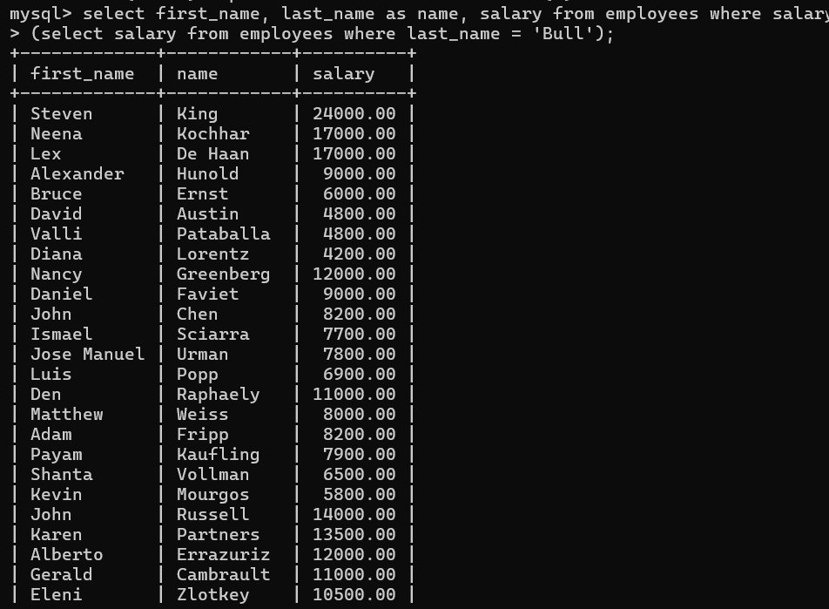

Task 3: Write a query to find the name (first_name, last_name) of all employees who works in the IT department. (Sample tables: employees).
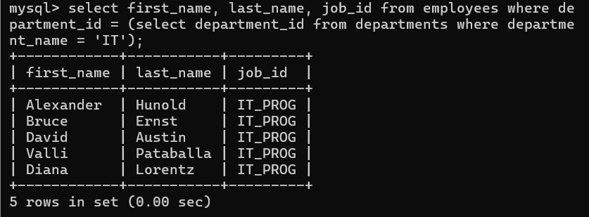
Task 4: Write a query to find the name (first_name, last_name) of the employees who have a manager and worked in a USA based department. (Sample tables: employees, departments & locations).
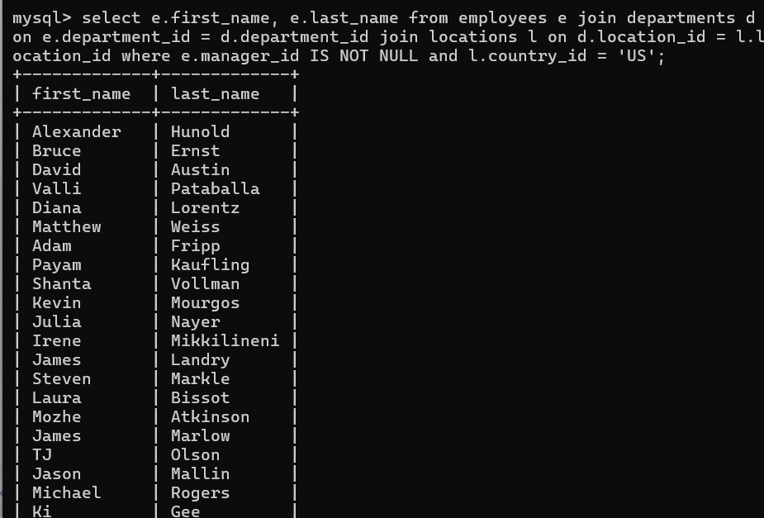
Task 5: Write a query to find the name (first_name, last_name) of the employees who are managers. (Sample tables: employees).
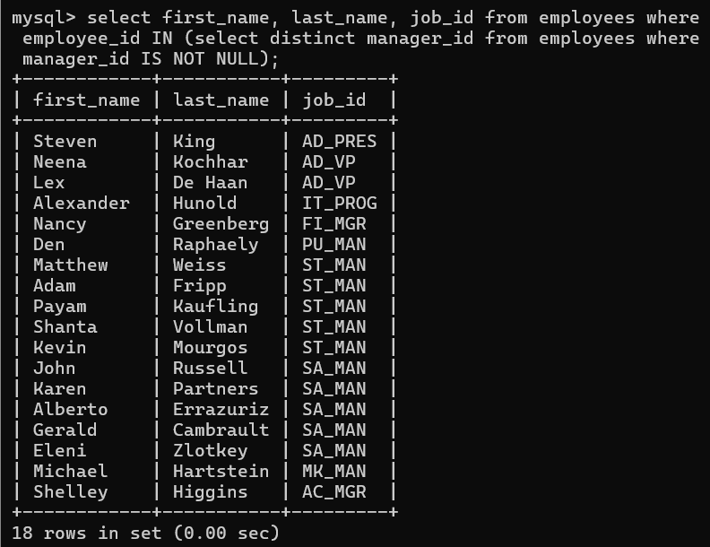
Task 6: Write a query to find the name (first_name, last_name), and salary of the employees whose salary is greater than the average salary. (Sample tables: employees).
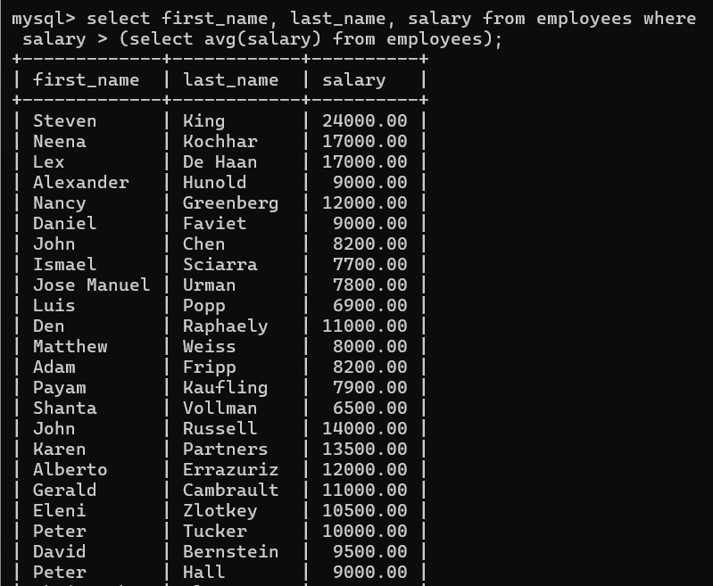
Task 7: Write a query to find the name (first_name, last_name), and salary of the employees whose salary is equal to the minimum salary for their job grade. (Sample tables: employees & jobs).
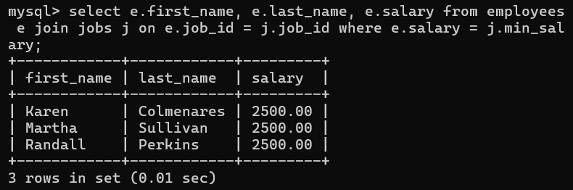
Task 8: Write a query to find the name (first_name, last_name), and salary of the employees who earns more than the average salary and works in any of the IT departments. (Sample tables: employees & departments).
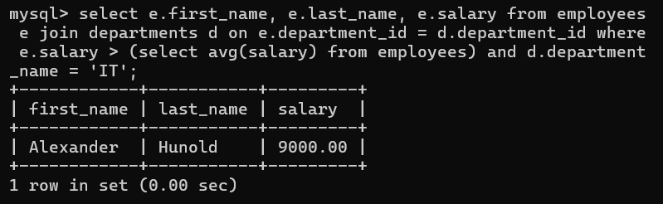
Task 9: Write a query to find the name (first_name, last_name), and salary of the employees who earns more than the earning of Mr. Bell. (Sample tables: employees & departments).
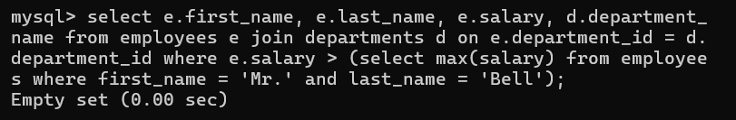
Task 10: Write a query to find the name (first_name, last_name), and salary of the employees who earn the same salary as the minimum salary for all departments. (Sample tables: employees & departments).
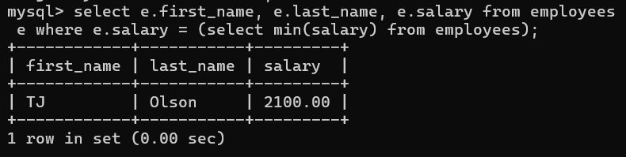
Task 11: Write a query to find the name (first_name, last_name), and salary of the employees whose salary is greater than the average salary of all departments. (Sample tables: employees).
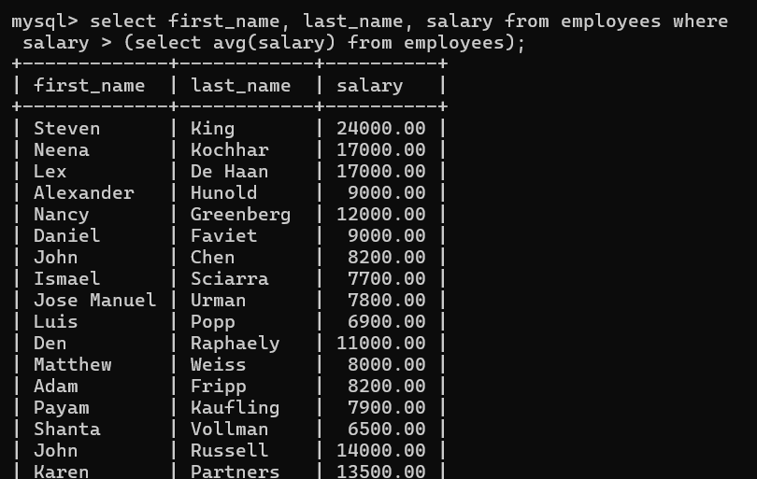

Task 12: Write a query to find the name (first_name, last_name) and salary of the employees who earn a salary that is higher than the salary of all the Shipping Clerk (JOB_ID = 'SH_CLERK'). Sort the results of the salary of the lowest to highest. . (Sample tables: employees).
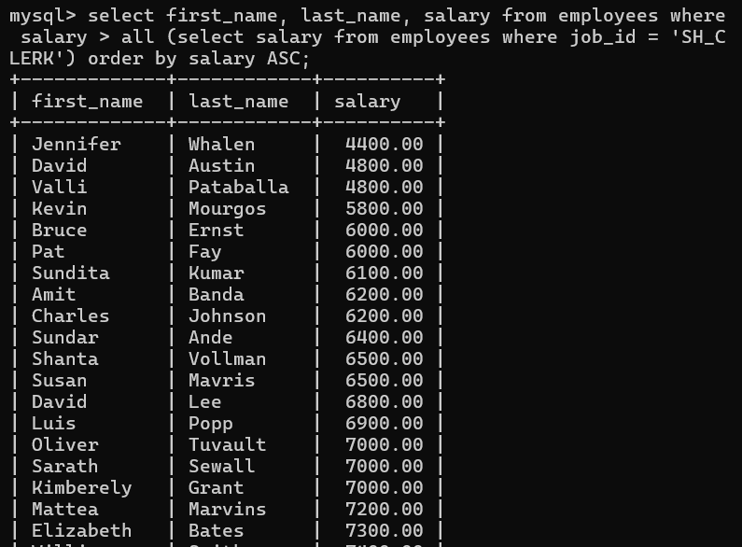
Task 13: Write a query to find the name (first_name, last_name) of the employees who are not supervisors. (Sample tables: employees).
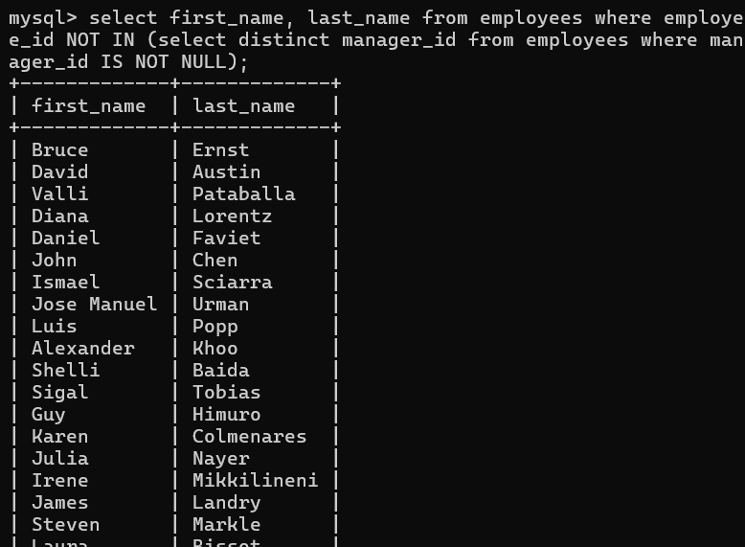

Task 14: Write a query to display the employee ID, first name, last name, and department names of all employees. (Sample tables: employees & departments).
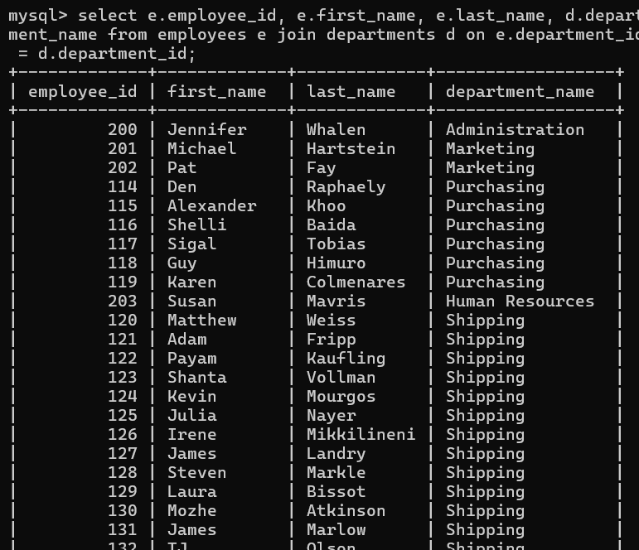
Task 15: Write a query to display the employee ID, first name, last name, salary of all employees whose salary is above average for their departments. (Sample tables: employees & departments).
