Atika Mughal

SAP ID: 5000000280

Database Systems Lab-08
Exercises (Weekly):
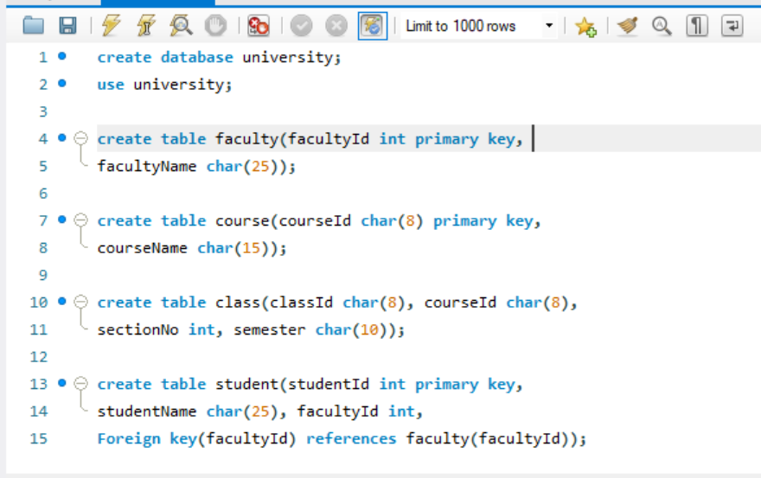
1.How would you add an attribute, CLASS, to the STUDENT table?
The ALTER TABLE statement is used to modify an existing table by adding new attributes (columns). It allows changes to the table structure without deleting existing data.
Example:
ALTER TABLE student ADD CLASS VARCHAR (20);

Using Employee table, solve the following queries
Task 1: Create a replica of Employee table with all the records in it.
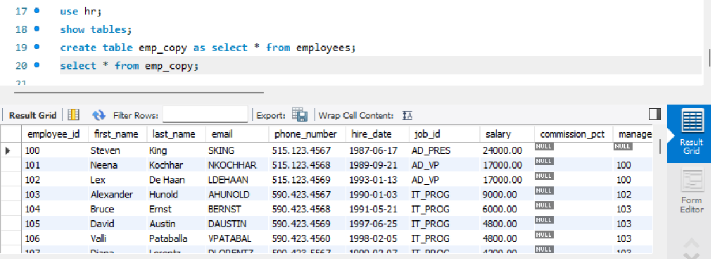
Task 2: Add a column ‘Address’ in it.
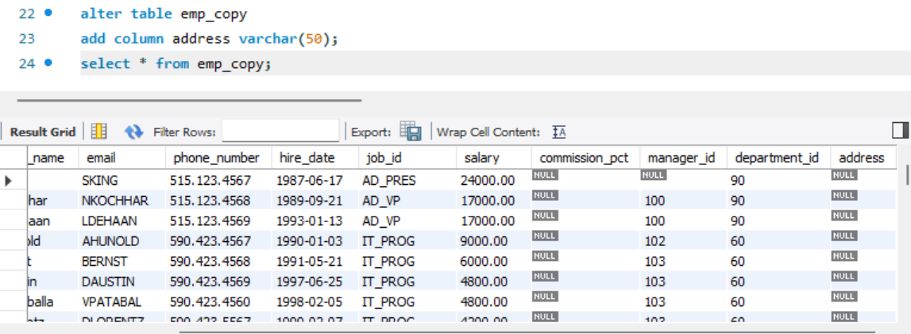
Task 3: Drop column ‘Address’ from it.
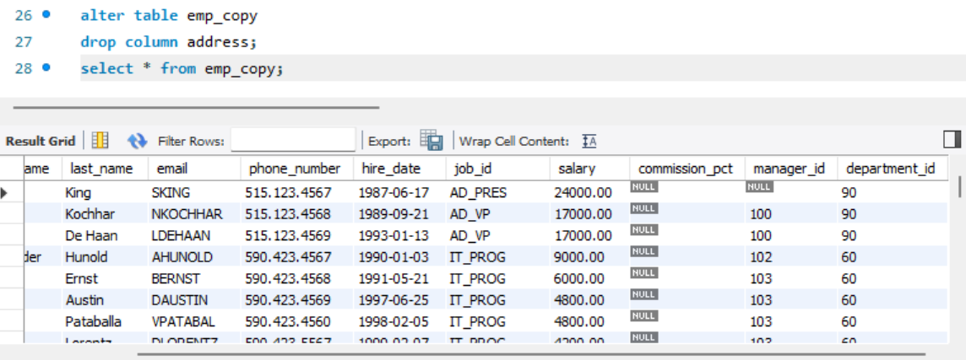
Task 4: Add columns ‘House No’ character, ’Street No’ numeric, ’Area’ character,’City’ character in it with the respective data types.
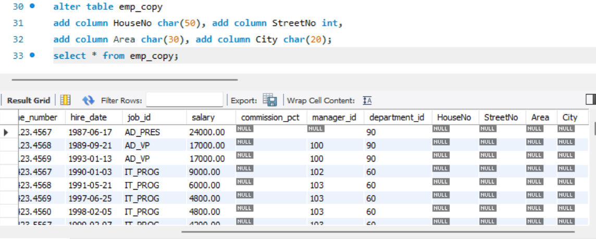

Task 5: Change the data type of ‘House No’ from character to numeric.
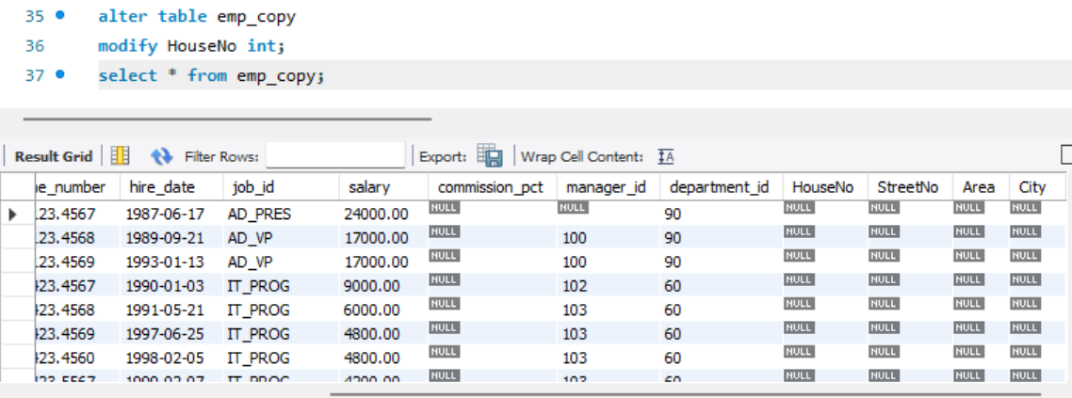
Task 6: Write a SQL statement to rename the table department to dept (with both methods).
Method 1:
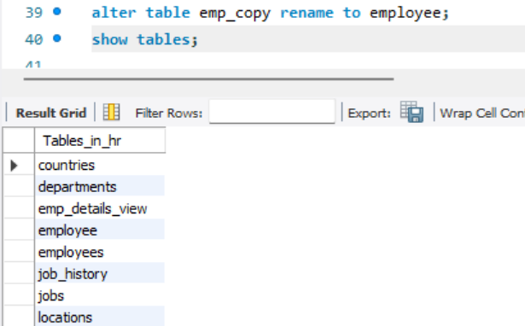
Method 2:
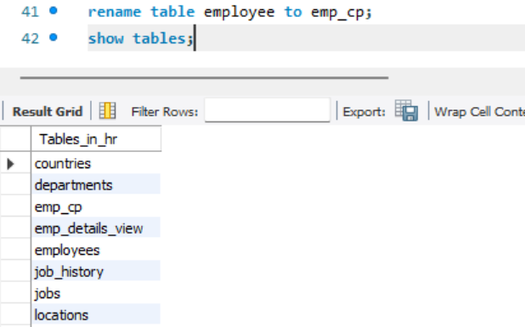

Task 7: Write a SQL statement to add a column regionId to the table locations.
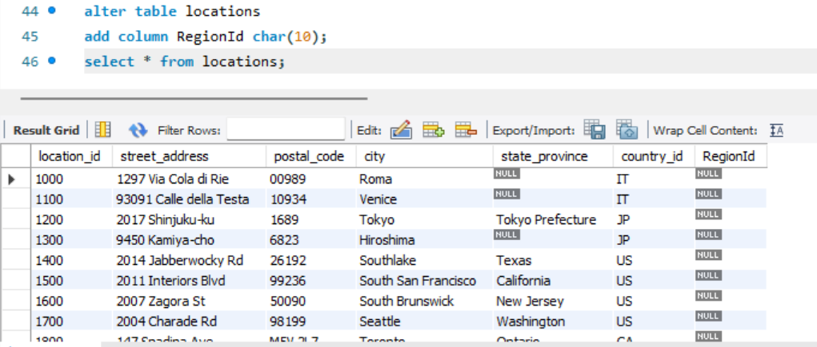
Task 8: Write a SQL statement to change the name of the column state_province to state in locations table, keeping the data type and size same.
