Atika Mughal

SAP ID: 5000000280

Database Systems Lab-09

Task 1: Create a table DEPARTMENT with the following attributes:
DEPTNO number, DNAME varchar(10), LOC varchar(10). PRIMARY KEY constraint on DEPTNO.
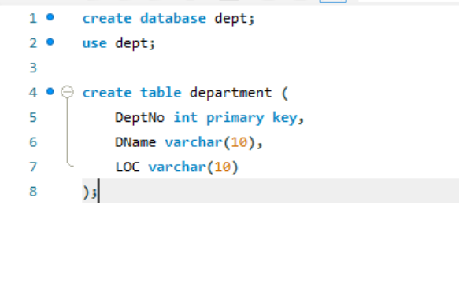
Task 2: Create a table EMPLOYEE with the following attributes:
EMPNO number, ENAME varchar(10),SAL number, DEPTNO number. Apply FOREIGN KEY constraint on DEPTNO referencing the DEPARTMENT table created in question 1 and PRIMARY KEY constraint on EMPNO and DEPTNO.
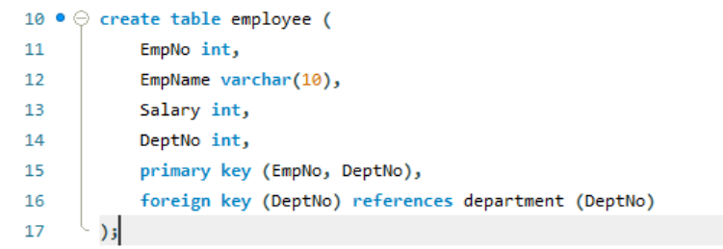
Task 3: ALTER table EMPLOYEE created in question 2 and apply the constraint CHECK on
ENAME attribute such that ENAME should always be inserted in capital letters.


Task 4: ALTER table DEPARTMENT created in question 1 and apply constraint on DNAME such that DNAME should not be entered empty.
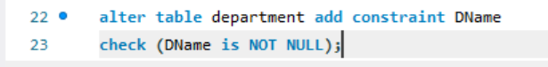
Task 5: ALTER table EMPLOYEE created in question 2 and apply the constraint on SAL attribute such that no two salaries of the employees should be similar.
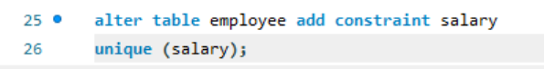
Task 6: ALTER table EMPLOYEE created in question 2 and apply the constraint on DEPTNO attribute such that on update, update a child value and on delete set null value to a child.
