Diabetes Detection System (DDS)

A PROJECT REPORT ON
Diabetes Detection System

SUBMITTED TO:
Geetanjali College of Computer Science and Commerce (BBA)
Saurashtra University Rajkot

FRONT END : | HTML5, CSS3, JavaScript, Bootstrap 5.3
BACK END : | Python 3, Flask, SQLite3
ML ENGINE : | Scikit-Learn (Random Forest)
AFFILIATED BY : | Saurashtra University
ACADEMIC YEAR : | 2025-2026

PROJECT GUIDE:
Prof. Harsh Joshi / Prof. Kishorsinh Vala
PREPARED BY:
Atik Bhas & Jay Sitapara

Acknowledgement

- First and foremost, we are sincerely thankful to Saurashtra University for giving us the opportunity to work on this project as part of our curriculum.
- We extend our gratitude to Geetanjali Group Of Colleges for providing us with the resources and environment needed to develop our project.
- We are particularly grateful to our Head of Department, Prof. Brijesh Shah, for their constant support and guidance throughout the project.
- We would like to express our deepest appreciation to our project guide, Prof. Kishorsinh Vala, who guided us through the analysis and development phases of our project, providing invaluable advice and support.
- We are also thankful to all well-wishers and friends who supported us during the project development.

Yours Faithfully,
Atik Bhas & Jay Sitapara

Index

SR.NO | TOPIC NAME | PAGE NO.
1 | Project Profile | 1
2 | Project Requirement | 2
3 | Technology Requirement | 3
4 | Data Flow Diagram | 4
5 | E-R Diagram | 6
6 | Software Development Life Cycle (SDLC) | 7
7 | Data Dictionary | 8
8 | Test Cases | 10
9 | Screenshots & Feature Walkthrough | 11
10 | Future Enhancement of project | 32
11 | Webliography | 33

Project Profile

➢ Project Title: Diabetes Detection System (DDS)
➢ Development Software: Visual Studio Code
➢ Front End: HTML5, CSS3, JavaScript, Bootstrap 5.3
➢ Back End: Python 3, Flask, SQLite3
➢ Machine Learning Engine: Scikit-Learn (Random Forest Classifier)
➢ Academic Year: 2025-2026
➢ Developed By: Atik Bhas & Jay Sitapara
➢ Submitted To: Geetanjali College of Computer Science and Commerce (BBA) Saurashtra University Rajkot
➢ Documentation Tool: Microsoft Word
➢ Operating System: Windows 11 / macOS / Linux

Project Requirement

❖ Processor: Intel Core i3 or higher
❖ RAM: 4 GB or more
❖ Hard Disk: 500 GB or more
❖ Display: 1366 x 768 resolution or higher

Technology Requirement

➢ Platform: 8 Bit, 2 core, 1.6 GHz or higher
➢ Operating System: Windows 11 / macOS / Linux
➢ Front End Tools: HTML5, CSS3, JavaScript, Bootstrap 5.3, Bootstrap Icons
➢ Back End Tools: Python 3.10+, Flask 3.0+, Werkzeug, Flask-Login
➢ Additional Libraries: Scikit-Learn, Pandas, NumPy, Matplotlib, ReportLab
➢ Database Engine: SQLite3
➢ Editing Tool: Visual Studio Code
➢ Browser: Google Chrome, Mozilla Firefox, or any modern browser

Data Flow Diagram

USER SIDE DFD
- 1. User / Guest fills 8 clinical metrics on Assessment Form.
- 2. System calculates BMI automatically via inline calculator.
- 3. If unauthenticated, data is stored in session and user redirected to Login/Signup.
- 4. ML Model (RandomForest) predicts risk score & probability.
- 5. Prediction record saved in SQLite database.
- 6. Renders visual gauge chart, comparison chart, diet plan, and downloadable PDF report.

ADMIN SIDE DFD
- 1. Admin accesses /admin portal.
- 2. Authenticates using secure password hash.
- 3. System checks is_admin database permission.
- 4. Grants access to protected Admin Dashboard.
- 5. Displays system stats, user list, prediction log filters, and user feedback records.

E-R Diagram

An Entity Relationship Diagram (ERD) is a data modeling technique that graphically illustrates an information system's entities and the relationship between those entities.
• User Table: _id (PK), username, email, password_hash, is_admin, created_at
• Predictions Table: _id (PK), user_id (FK), pregnancies, glucose, blood_pressure, skin_thickness, insulin, bmi, diabetes_pedigree, age, result, probability, created_at
• Feedback Table: _id (PK), name, email, rating, message, created_at
• Contact Submissions Table: _id (PK), name, email, subject, message, created_at

Software Development Life Cycle
o Planning and Requirement Analysis: Defining project goals, gathering medical parameter specs, and documenting requirements.
o Design: Creating overall architecture, user interface layout, chart rendering pipeline, and database schema.
o Development: Coding Flask backend, Scikit-learn ML predictor, and ReportLab PDF engine.
o Testing: Conducting rigorous testing to verify predictions, guest session redirects, and admin security.
o Deployment: Deploying software on local web server environment.
o Maintenance: Ongoing support, UI refinements, and feature updates.

Data Dictionary

User Table
Field Name | Data Type | Constraints
id | INTEGER | Primary Key, AUTOINCREMENT
username | TEXT | UNIQUE, NOT NULL
email | TEXT | UNIQUE, NOT NULL
password_hash | TEXT | NOT NULL
is_admin | BOOLEAN | DEFAULT 0

Predictions Table
Field Name | Data Type | Constraints
id | INTEGER | Primary Key, AUTOINCREMENT
user_id | INTEGER | Foreign Key (users.id)
glucose | REAL | NOT NULL
blood_pressure | REAL | NOT NULL
bmi | REAL | NOT NULL
result | TEXT | NOT NULL

Test Cases

Case Name | Case Description | Actual Output | Test Result
User Registration | Verify user registration with valid details. | User account created and logged in. | Pass
User Login | Verify login with valid credentials. | Redirects to user dashboard successfully. | Pass
Invalid Login | Verify login with incorrect password. | Error message displayed: 'Invalid credentials'. | Pass
Guest Form Submit | Verify unauthenticated guest form submission. | Stores form data in session, redirects to login. | Pass
BMI Calculator | Verify instant calculation from height & weight. | BMI computed and auto-filled into form. | Pass
ML Risk Predict | Verify ML risk prediction on 8 clinical metrics. | Calculates risk score and outputs prediction result. | Pass
PDF Generation | Verify downloadable PDF report export. | Generates formatted PDF with embedded charts. | Pass
Admin Dashboard | Verify admin dashboard access for admin users. | Displays user management, logs, and statistics. | Pass

Screen Shots

Login Page:

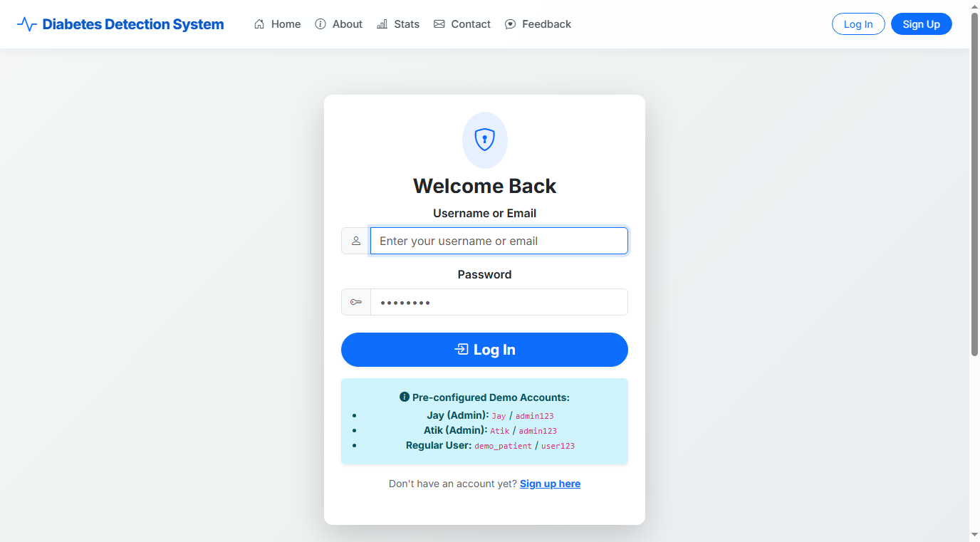

➢ This is the login page of the website.
➢ Users can enter their username/email and password to securely access their account.
➢ After successful login, the user is redirected to the dashboard or assessment report.

Registration (Sign Up) Page:

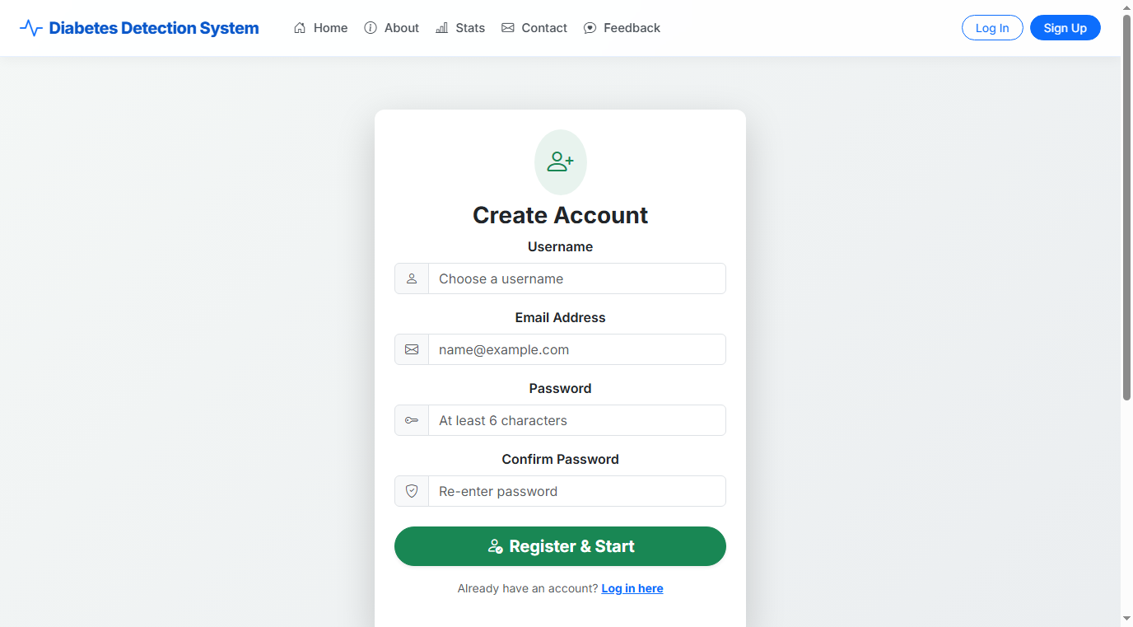

➢ This is the registration page of the website.
➢ New users can create an account by entering details like username, email address, and password.
➢ The system validates credentials and creates the user account securely.

Home Page & Interactive Assessment Form:

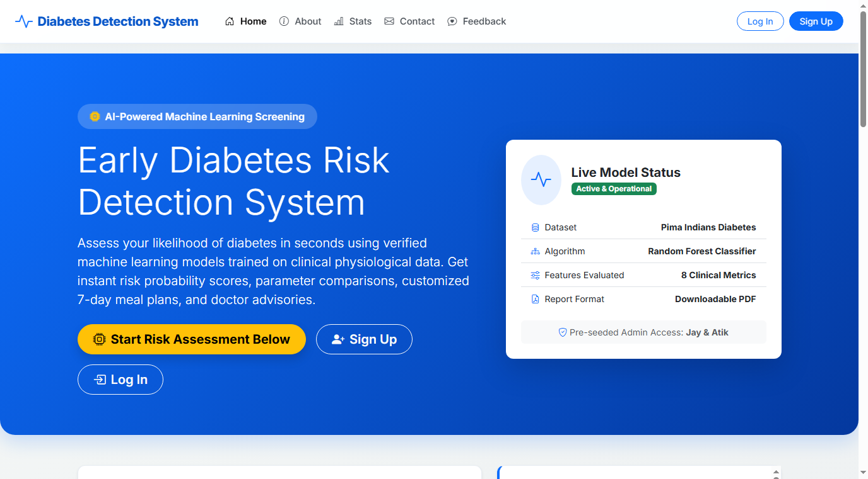

➢ This is the home page of the website featuring the embedded Diabetes Risk Assessment Form.
➢ All visitors (guests or logged-in users) can view the form, use the instant BMI calculator, and view metric guidance.
➢ Provides a direct CTA button to scroll straight to the screening form.

Predict Risk Assessment Page:

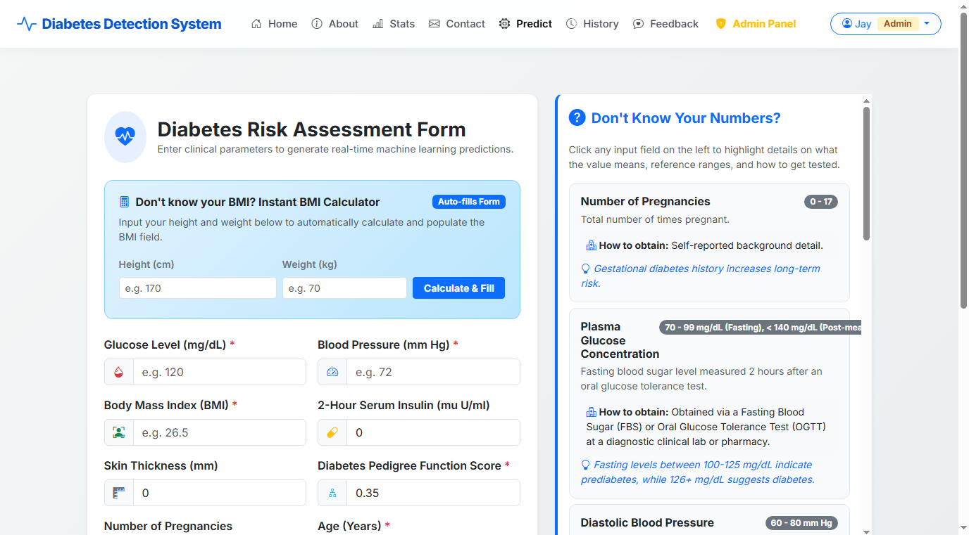

➢ This is the dedicated risk assessment form page.
➢ Users can enter clinical metrics such as Glucose, Blood Pressure, BMI, Insulin, Skin Thickness, Pedigree, Pregnancies, and Age.
➢ Includes the inline guidance accordion to assist users who do not know their baseline medical numbers.

Risk Assessment Result Page:

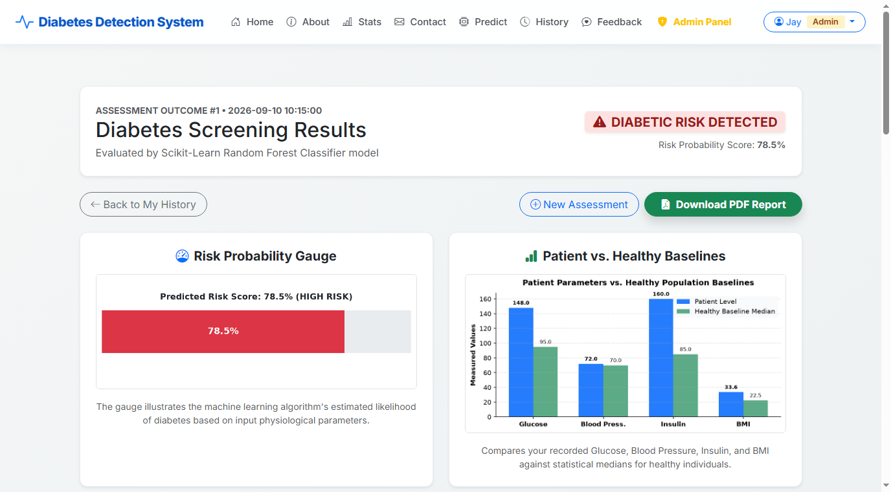

➢ This is the prediction result page generated by the machine learning model.
➢ Displays the risk outcome ('Diabetic' or 'Not Diabetic'), probability percentage score, server-side Matplotlib gauge chart, and baseline comparison bar chart.
➢ Provides a customized 7-day diabetic meal plan, doctor advisories, and instant PDF report export.

Prediction History Page:

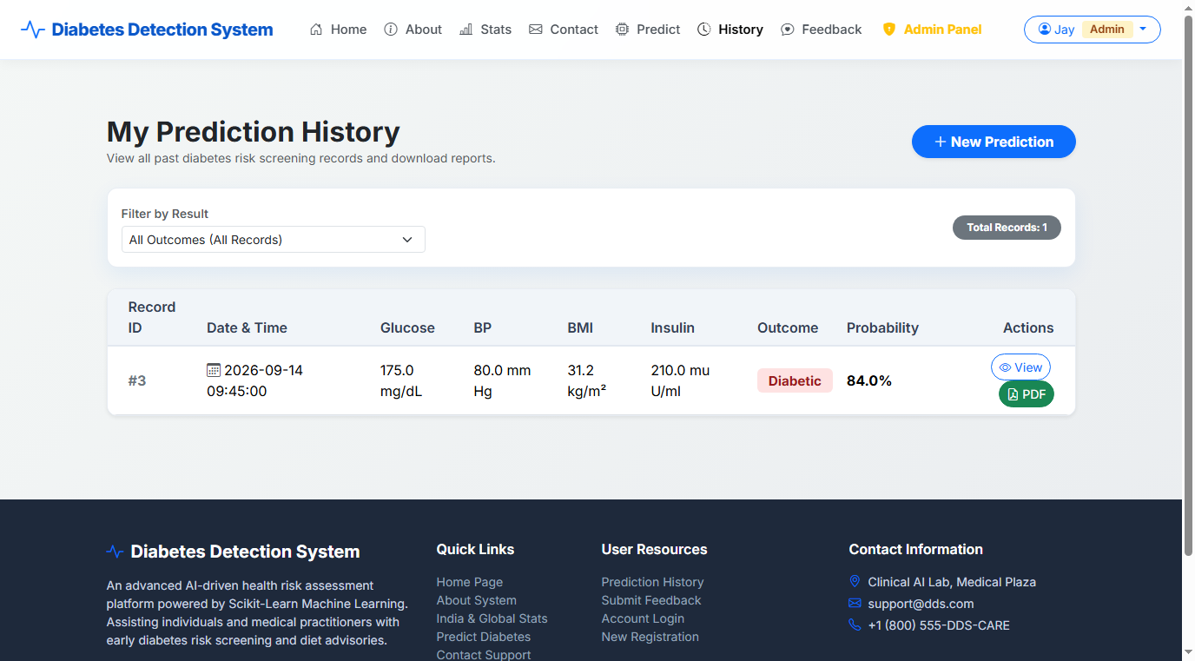

➢ This is the prediction history page for the logged-in user.
➢ Users can view a chronological log of all past screening results, probabilities, and recorded parameters.
➢ Allows users to review their health trajectory over time.

Global & India Diabetes Statistics Page:

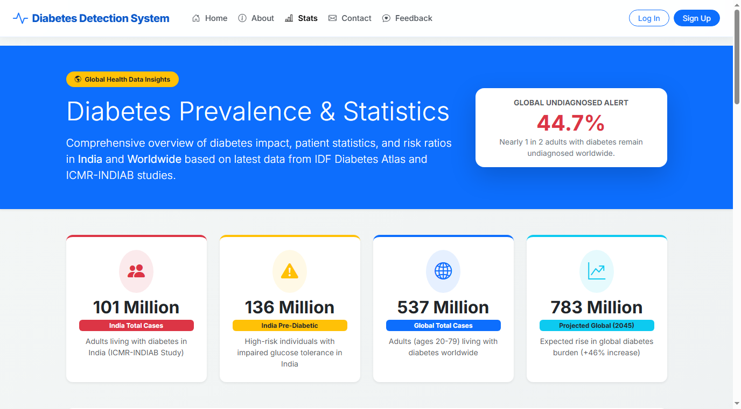

➢ This is the global and India diabetes statistics page.
➢ Displays clinical data highlighting 101 Million cases in India, 136 Million pre-diabetic cases, state rankings, and 537 Million global cases.
➢ Includes visual ratio comparison progress bars and regional breakdown tables.

User Feedback Page:

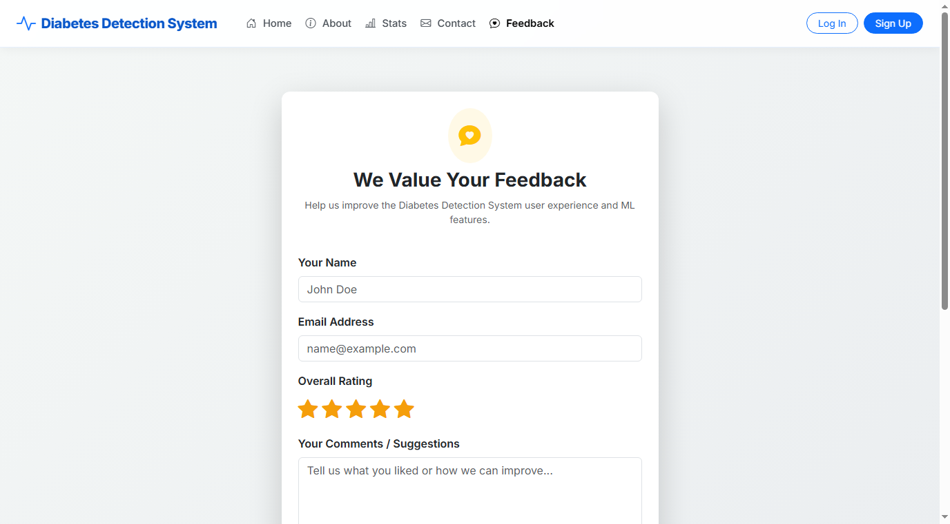

➢ This is the user feedback page of the website.
➢ Users can submit star ratings and feedback comments regarding application performance and accuracy.

Contact Us Page:

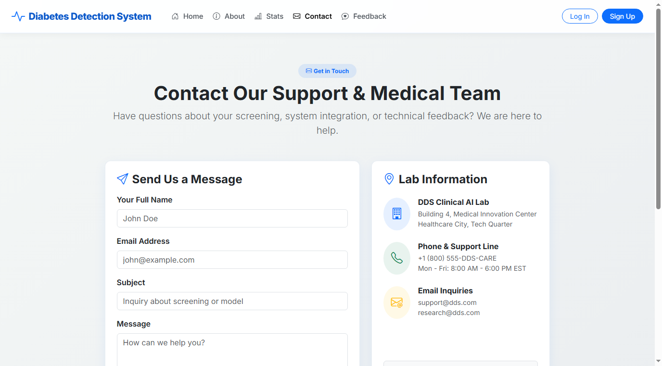

➢ This is the contact us page of the website.
➢ Users can send inquiries, support requests, and messages to the medical administration team.

Admin Dashboard Page:

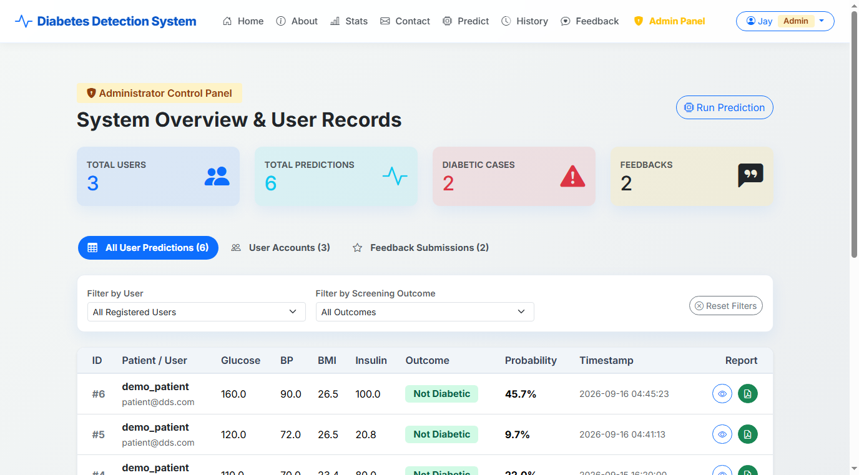

➢ This is the protected admin dashboard page of the website.
➢ Admins can view system-wide stats (total users, total predictions, diabetic count), filter prediction logs, manage user accounts, and review feedback submissions.

Future Enhancement

❖ Add real-time integration with hospital EHR and lab diagnostic APIs for direct patient metric sync.
❖ Implement advanced Deep Neural Network (DNN) and XGBoost machine learning models for higher prediction accuracy.
❖ Provide native mobile application support (iOS & Android) for enhanced user accessibility.
❖ Integrate smartwatch health sensor tracking (Apple Health, Fitbit, Google Fit) for continuous glucose and activity monitoring.
❖ Enable automated SMS and WhatsApp reminders for routine HbA1c screening and doctor consultations.

Webliography

➢ https://flask.palletsprojects.com/
➢ https://scikit-learn.org/
➢ https://getbootstrap.com/
➢ https://www.sqlite.org/
➢ https://matplotlib.org/
➢ https://www.reportlab.com/
➢ https://diabetesatlas.org/
➢ https://github.com/Atikbhas/Diabetes-Detection-System

