EUROPEAN HUMANITIES UNIVERSITY
Digital Competence School

DIPLOMA PROJECT
WEB-BASED SYSTEM FOR ADAPTIVE MEAL AND PHYSICAL ACTIVITY PLANNING
WITH DYNAMIC PLAN RECOVERY (VEYA)
BUSINESS ANALYSIS

Students: Hanna Ivanova, Mikita Malafei
Programme: Informatics, 4th year
Project type: Group (team) project
Supervisor: Andrii Kostromytskyi, PhD in Technical Sciences, Associate Professor (EPAM, Global Education)
Document: Joint Business Analysis (BA stage)

Vilnius, 2026

CONTENTS
INTRODUCTION 3
1. ANALYTICAL PART 5
1.1. Current State of the Process (AS-IS) 5
1.2. Review of Scientific Sources and Standards 7
1.3. Analysis of Software Analogs 8
1.4. Chapter Conclusions 10
2. SYSTEM REQUIREMENTS 12
2.1. Vision and Goals 12
2.2. Stakeholders and Users 13
2.3. Project Scope 14
2.4. Solution Concept 14
2.5. Functional Requirements 16
2.6. Use Case Scenarios 17
2.7. Non-Functional Requirements 18
2.8. Legal and Ethical Requirements 19
2.9. Risks 20
2.10. Chapter Conclusions 21
LIST OF REFERENCES 22
APPENDIX A. BACKLOG 24
APPENDIX B. DIAGRAMS AND MOCKUPS 28
APPENDIX C. SUPPORTING TABLES 35
STATEMENTS 38

INTRODUCTION
Planning meals and physical activity requires regular monitoring of food intake, nutrient values, available time and training. Maintaining a useful plan becomes difficult when an expected meal is unavailable, a workout is missed, or the day changes unexpectedly. People must often recalculate what remains and decide which actions are still feasible.
Existing tools support food logging, calorie tracking, exercise monitoring or meal planning, but the degree of integration and same-day adaptation varies. The practical problem for VEYA is not simply the absence of tracking: it is the effort required to turn recorded deviations into a clear, realistic and confirmed plan for the rest of the day. The product is intended for individuals who manage nutrition and activity without requiring a professional coach. Berry et al. reviewed 12 randomized trials of digital diet-and-activity self-monitoring among adults with overweight or obesity [1]; Laranjo et al. included 28 studies covering 7,454 adults in their physical-activity meta-analysis [2]. These figures describe the scale of the available evidence, not the prevalence or frequency of disrupted plans. For the target user, each unexpected meal or missed workout can require recalculating remaining goals and checking time, food and equipment constraints; the frequency of such events will be assessed in future user research.
VEYA is a proposed responsive web-based system for adaptive meal and physical activity planning with Dynamic Plan Recovery. It combines user goals, food and workout records, current constraints and plan versions to produce feasible alternatives. The system proposes changes and explains them, while the user remains responsible for accepting, editing or rejecting the revised plan.
This Business Analysis (BA) document establishes a common view of the problem, evidence, project boundaries, functional and non-functional requirements, success criteria and solution concept. It provides a shared basis for the two-person team, the supervisor, the BA expert and the assessment committee. Both the web interface and server-side services are addressed as components of one VEYA product.
Project goal: Reduce same-day replanning effort after deviations by providing a valid recovery proposal in ≥90% of feasible test scenarios, visible within 3 seconds and accepted in ≤3 user actions, with explicit confirmation for all plan changes.
The objectives of the project are:
• Analyze the existing planning process, scientific evidence and comparable digital products.
• Identify user needs and specify measurable functional, quality, security and legal requirements.
• Design a coherent web interface, REST API, data model and deterministic recovery algorithm.
• Implement nutrition and workout planning with reviewable input, feasible replacements and user-controlled plan recovery.
• Verify the developed solution against defined scenarios, usability and quality metrics.
Object of study: The process of personal nutrition and physical activity planning and adjustment.
Subject of study: Software methods and mechanisms for automating adaptive day planning while preserving user control.
Methods used in the analysis include literature and regulatory-document review, benchmarking of software analogs, scenario-based requirements elicitation, AS-IS/TO-BE process modelling and MoSCoW prioritization. The analysis focuses on a feasible educational MVP; claims about efficacy, provider availability and input accuracy require later evaluation rather than being assumed proven.

1. ANALYTICAL PART

1.1. Current State of the Process (AS-IS)
Personal meal and physical activity planning ordinarily involves defining a goal, selecting an approximate menu and exercise schedule, recording actual behavior, identifying deviations and manually correcting the remaining plan. A person may use a food diary, workout app, spreadsheet or notes; the same information can be separated across tools. Even when tracking is integrated, the responsibility for creating an executable remaining schedule often stays with the person.
A typical AS-IS workflow consists of goal definition; initial planning of meals, products, preparation time, exercise and equipment; logging consumed food and activity; discovering a mismatch (unavailable ingredients, missed workout, unexpectedly limited time or different food intake); manually recalculating the remainder; and continuing the adjusted plan. The user is the primary process participant; trainers or nutritionists are optional.
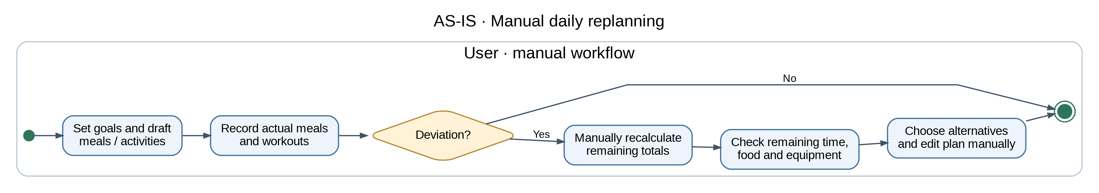
Figure 1.1 – AS-IS process of personal meal and physical activity planning.
The key cost is repeated decision-making after a deviation. The user must consider already consumed calories and macronutrients, completed activities, the time left, ingredient exclusions and accessible equipment. Fragmented data also increases duplicate entry and the risk of mistakes, although the extent of this problem depends on an application’s integrations.
The AS-IS decision can be decomposed into three information tasks. First, the user reconciles actual events with the original schedule: a recorded meal changes the remaining calorie and nutrient budget, while a missed or shortened workout changes the available activity plan. Second, the user checks the feasibility of the remaining tasks against constraints such as food availability, preparation time, exercise equipment and personal restrictions. Third, the user selects alternatives and manually updates the chosen tools. These stages create repeated cognitive effort because the conditions are linked: changing a planned dinner may change the nutritional feasibility of a later snack, and moving exercise can affect the time available for cooking.
A concrete reference scenario starts with several planned meals and a workout. An unexpectedly long meeting may leave less time for preparing dinner and remove the original workout slot. A diary can record an altered meal or skipped activity, but the person still has to reconcile the remaining calorie and nutrient budget, review available ingredients, and decide whether a shorter workout is feasible. When nutrition and exercise information are kept in separate tools, the same time and resource constraints may need to be checked repeatedly. This is a scenario used to derive requirements, not a measured frequency claim about existing products. It can be evaluated by counting decisions, repeated entries and elapsed time until a usable remainder is selected.
The process has several important exceptions. A small deviation may not require a new plan; a substantial one may invalidate several future slots. Some alternatives may satisfy every mandatory constraint but be less convenient for the user, while other combinations may be impossible within current resources. A robust target process must therefore distinguish minor changes, feasible recovery options and explicit no-solution outcomes. It must also avoid rewriting completed records: the fact that a workout was missed or a meal was eaten cannot be erased merely because a different future plan is selected.
The user is the decision owner in this process, whereas food and exercise catalogues are supporting data sources. External estimates may help identify candidate meals or activities, but they cannot confirm what the user actually consumed or completed. A common failure point is the distinction between planned and actual events: changing a future meal should not retroactively overwrite a confirmed diary entry. Another is dependency between choices: replacing a meal may change the remaining budget and affect later slots. These observations identify three records that must remain distinct in the target workflow: immutable confirmed actions, the active future plan, and provisional alternatives that have not yet been accepted.
The AS-IS and TO-BE diagrams model the same actor and boundary. In AS-IS, the user performs reconciliation, alternative selection and adjustment. In TO-BE, VEYA assists with candidate calculation and presents a proposal; the user remains in control of acceptance. This makes the transition measurable through fewer repeated actions, correct preservation of confirmed records and faster presentation of feasible next steps. The goal is to improve the existing decision process, not to claim that automated planning removes the need for user judgment.

Target process (TO-BE)
VEYA retains an active daily plan and confirmed actual records. When a significant deviation is recorded, the system identifies affected future items, calculates remaining targets and constraints, searches for feasible replacements and presents a revised plan with reasons. Completed items are preserved. The original active plan changes only after an explicit user decision; an impossible case is reported with its blocking constraints.
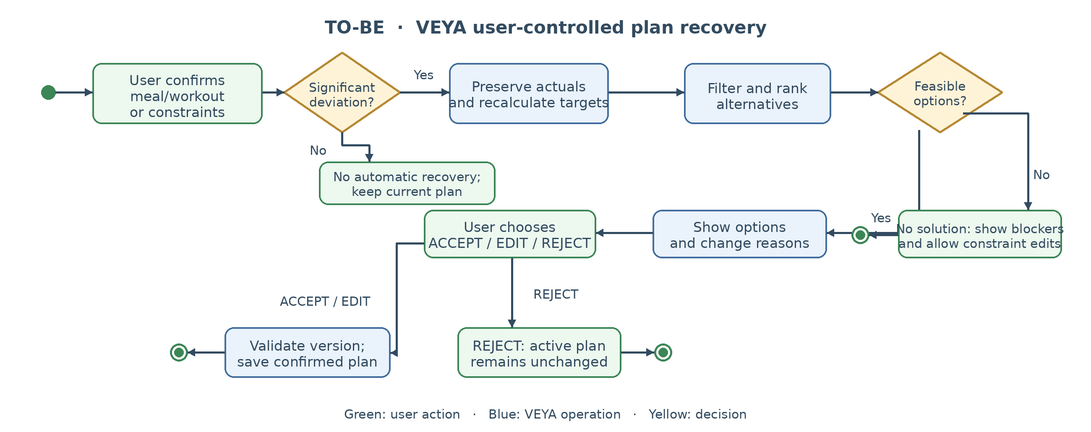
Figure 1.2 – TO-BE adaptive plan-recovery process in VEYA.
The target workflow connects the visible user decision with server-side validation and transactional plan versioning. This is the distinctive capability examined in the following requirements.

1.2. Review of Scientific Sources and Standards
Scientific literature supports the value of self-monitoring but does not itself establish the effectiveness of VEYA’s new recovery algorithm. Berry, Kassavou and Sutton reviewed 12 randomized controlled trials and observed positive effects from digital monitoring of diet and physical activity among adults with overweight or obesity [1]. Laranjo et al. analyzed 28 studies with 7,454 adults and reported a small-to-moderate positive effect of app and tracker interventions on physical activity; personalization was relevant for some subgroups [2]. These findings support accessible logging and meaningful feedback, while the resulting behavior change remains to be assessed for VEYA.
Meal planning must satisfy multiple conditions rather than search by dish name alone. Amiri et al. presented flexible personalized meal planning that uses knowledge-based selection, filtering and multi-criteria evaluation [3]. This informs VEYA’s hard-constraint filtering followed by scoring of feasible meal and activity alternatives. VEYA is a planning assistant; it does not provide medical diagnosis or treatment.
Image-based dietary estimation is uncertain. Shonkoff et al. reviewed 52 studies and found substantial variation in reported accuracy [8]. For this reason, VEYA treats photo recognition as preliminary data entry: users can review and correct recognized foods, portions and nutrition values before any record affects totals or recovery. The 2024 Adult Compendium of Physical Activities provides standardized reference MET values [9]; these are useful for approximate estimates and test data but are not individualized clinical measurements.
Krukowski et al. emphasized the role of feedback presentation in dietary and physical-activity self-monitoring [4]. Therefore, the recovery interface must show understandable change reasons, allow editing and make success or failure visible. Separate usability testing is needed to verify whether these interactions reduce the user’s effort.
VEYA processes profile parameters, goals, food/activity records and plan history. Data minimization, purpose limitation, secure processing and deletion must be considered under the GDPR [5], [6], [29]. The W3C WCAG 2.1 accessibility principles inform perceivable content, keyboard support, semantic labels, contrast and adaptive layouts [7]. These source-derived principles are reflected in the measurable requirements of Chapter 2 and Appendix C.
Taken together, the research and standards do not justify a single all-purpose optimization metric. They lead instead to requirements that can be checked independently: the accuracy of storing confirmed events; respect for user restrictions; transparent presentation of uncertain automatically obtained values; clear and accessible recovery feedback; and lawful handling of personal records. The resulting test plan must use fixed scenarios with expected outputs, plus a small usability exercise with real participants. The numerical targets in Chapter 2 are project acceptance targets, not results claimed by any of the cited scientific studies.
Table 1.1 – Evidence-to-requirement connections
Evidence | Design implication | Verification approach
Digital self-monitoring [1], [2] | Actual nutrition/activity events must be easy to record and review. | Diary totals, input step-count and task-completion scenarios.
Personalized meal planning [3] | Replacement candidates must satisfy simultaneous hard constraints. | Parameterized nutrition/exclusion tests.
Image dietary assessment [8] | Photo-derived nutrition must remain preliminary and editable. | Cancellation/confirmation and stored-value validation.
Activity energy-cost data [9] | MET estimates need clear source and approximate status. | Source/estimate display checks and scenario data.
Feedback formats [4] | Recovery proposals should explain each planned change. | User understanding and explanation checks.
GDPR and WCAG [5]–[7], [29] | Personal data protection and accessible controls are core quality requirements. | Authorization, consent, keyboard and contrast tests.

1.3. Analysis of Software Analogs
Five products were considered to represent different approaches: MyFitnessPal, Eat This Much, YAZIO, MacroFactor and the open-source OpenNutriTracker. The review compares food and activity logging, meal planning, photo input, replacement, adaptation and recovery after deviations. The complete comparison against eight criteria is presented in Appendix C, Table C.1, with primary documentation references [10]–[20].
Table 1.2 – Documented analog capabilities across seven criteria
Criterion | MyFitnessPal | Eat This Much | YAZIO | MacroFactor | OpenNutriTracker | VEYA
Food diary | Y | Y | Y | Y | Y | Planned
Meal planning | Y | Y | P | P | P | Planned
Activity records | Y | NC | Y | Y | Y | Planned
Photo meal entry | Y | NC | Y | NC | NC | Planned
Meal substitution | P | P | P | P | P | Planned
Joint same-day recovery | NC | NC | NC | NC | NC | Planned
Time/food/equipment in one recovery | NC | NC | NC | NC | NC | Planned
Y = documented capability; P = partial/related capability; NC = not confirmed in the reviewed documentation; VEYA = planned feature. This is a documentation-based comparison, not hands-on testing. Full evidence and limitations are detailed in Appendix C, Table C.1 [10]–[20].

The comparison is based on cited product documentation and the recovery scenarios defined for this analysis. “Not confirmed” means the reviewed sources do not establish the complete end-to-end feature; it is not proof that a product can never perform a similar task. Screenshots documenting practical checks are not included, so hands-on validation is not claimed.
VEYA does not claim novelty for logging, meal generation or periodic goal adaptation individually. Its proposed differentiation is the combined, same-day recovery of future meals and activity from confirmed actions and current constraints, with explicit user confirmation and explainable changes.
The analogs represent at least three distinct solution patterns. Food diaries, such as MyFitnessPal and OpenNutriTracker, are useful for capturing actual consumption and viewing a running summary. An automatic menu planner, such as Eat This Much, can reduce the work of preparing meals in advance. A coaching-oriented tool such as MacroFactor adapts targets over longer intervals, while YAZIO highlights rapid entry and review of estimated nutrition. These functions are valuable independently, so VEYA should reuse familiar interaction concepts rather than portraying every existing tool as ineffective.
The gap becomes more specific when a full user scenario is tested. Consider a planned workout that is no longer possible, followed by an unexpected meal with different nutrition values. A tracking application may record both facts; a menu planner may replace a dish; and a coaching application may revise target values. For VEYA, success means showing feasible meals and activities for the remaining slots together, based on already confirmed actions and the currently available time, food and equipment. This scenario explains why individual feature checkmarks are insufficient to prove end-to-end equivalence.
The feature table should be interpreted cautiously. A provider’s absence from documentation is not evidence that an interaction is technically impossible, and current commercial products may change. Accordingly, Chapter 2 describes the desired VEYA functionality as a proposed and testable requirement. It does not assert that the reviewed analogs have been exhaustively reverse-engineered or that VEYA will necessarily outperform them. The intended comparative measure is concrete scenario completion: whether the user receives a feasible, understandable and confirmable remaining-day plan under a defined set of constraints.

1.4. Chapter Conclusions
The analyzed needs are expressed as five traceable problems. Each is linked to a capability, candidate requirements and later verification metrics.
Table 1.3 – Identified problems and system responses
ID | Problem | Capability | Verification
P1 | Manual reconsideration of the remainder after a significant deviation. | Dynamic Plan Recovery (EPIC 4; KPI-1/KPI-4) | Feasible proposal or explicit no-solution result.
P2 | Repeated meal entry is slow; photo estimates can be uncertain. | Assisted logging and confirmation (EPIC 2; KPI-2) | Step count, validation and confirmed totals.
P3 | Meal alternatives must respect multiple restrictions. | Meal planning/replacement (EPIC 2; KPI-3) | Mandatory nutrition/exclusion constraints.
P4 | Changes to time/equipment invalidate planned activity. | Activity replacement (EPIC 3; KPI-3) | Valid time/equipment alternatives.
P5 | Goal adaptation alone does not reorganize the current day. | Versioned decisions and accessible control (EPICs 1, 4–7; KPI-4) | Latency, explanation and confirmation safety.

These problems define the scope of Chapter 2. The specification links product goals, epics, user stories, acceptance criteria, KPIs and measurable non-functional requirements rather than presenting features as independent lists.
P1 and P5 define the central expected outcome: after a meaningful deviation, the user should receive a feasible remainder without an unapproved change to the current plan. KPI-1 measures whether recovery produces valid proposals in the predefined feasible scenarios; KPI-4 addresses the time to display them and the safety of confirmation. P3 and P4 express the hard limits for food exclusions, time and equipment, which map to the replacement stories and KPI-3. P2 concerns logging effort and trust in source values. Confirmed manual and saved-meal entry are essential to the MVP; photo-assisted entry with user review remains a separately prioritized Should enhancement, not a dependency of Dynamic Plan Recovery.
The strongest evidence gap is not the absence of individual tracker functions but the incomplete proof that a user can replan both meals and exercises after an unexpected event without recomputing all remaining targets manually. The proposed validation therefore separates the correctness of constraint handling from its usability: a proposal can be mathematically valid and still be difficult to understand or act upon. Conversely, a visually clear proposal is not acceptable if it violates food exclusions, timing requirements or already completed actions.
The resulting evaluation must test more than the successful path. Representative cases include a minor difference that must not trigger automatic recovery, an unavailable ingredient, a missed exercise, a proposal made stale by another change, and a day for which no feasible replacement exists. For each case, verification should inspect the displayed message and the stored plan version. Already confirmed events must remain intact, rejected proposals must not become active, and unsatisfiable constraints must produce an explicit explanation instead of a misleading recommendation. These tests connect the chapter findings to the acceptance criteria in Chapter 2 without assuming that baseline timings or the frequency of real-life disruptions have already been measured.
Data provenance is another cross-cutting consideration. A calculation derived from a food database, an image-recognition estimate or a user-entered amount has a different confidence profile. VEYA must expose editable values, keep confirmed actual records distinct from planned ones and avoid replacing history when a new plan version is accepted. These principles inform both the architecture and acceptance criteria in the following chapter.

2. SYSTEM REQUIREMENTS
This chapter specifies VEYA as a complete web system. The browser client presents workflows and feedback; a documented REST API validates and stores records, integrates data providers and generates controlled recovery proposals. The functional decomposition is based on user-facing capabilities, with technical requirements incorporated where needed for correct end-to-end behavior.

2.1. Vision and Goals
VEYA helps a person plan, record and adjust meals and physical activity through a responsive web interface. Confirmed events and current constraints drive recommendations for the unfinished part of the day; changes are explained and remain subject to the user’s approval.
G1 – Reduce replanning effort: ≥90% valid recovery proposals, visible within 3 s (P1, P5).
G2 – Make saved-meal logging accurate, correctable and achievable in ≤3 actions (P2).
G3 – Provide feasible meal alternatives under nutrition and ingredient constraints (P3).
G4 – Provide feasible activity alternatives under available time and equipment constraints (P4).
G5 – Require explicit confirmation and valid versions for all plan changes (P5).
Table 2.1 – Product-level success criteria
KPI | AS-IS baseline | MVP target | Verification
KPI-1. Recovery quality | 0/20 scripted deviation scenarios (0%) receive an automatically generated combined meal-and-activity recovery plan in the manual AS-IS workflow. | ≥90% of predefined feasible scenarios produce valid proposals; infeasible ones report no solution. | Scenario tests, API integration and end-to-end tests.
KPI-2. Input integrity and effort | 6 user actions to re-enter a previously eaten meal in the scripted manual flow; 0/20 automated persistence-integrity checks before MVP. | Confirmed values preserved in 100% of tests; reusing a saved/recent meal takes ≤3 user actions. | Data-validation tests; task-step review.
KPI-3. Feasible replacements | 0/20 scripted meal/workout replacement scenarios (0%) receive automatically validated alternatives in the manual AS-IS process. | ≥90% of feasible meal and workout scenarios respect all mandatory constraints. | Parameterized replacement tests and UI review.
KPI-4. Recovery responsiveness and control | 120 s to revise the remaining day in a scripted manual scenario (provisional estimate); 0/10 automated stale-version checks before MVP. | API p95 ≤2 s on fixed data; visible ≤3 s; accept in ≤3 user actions; all plan changes require valid confirmation (100%). | API load, browser timing, click count, transaction and concurrency tests.

Baselines are unmeasured planning assumptions, not observed results: KPI-1/KPI-3 use 0/20 automatic results in scripted manual scenarios; KPI-2 assumes six meal-entry actions; KPI-4 uses 120 s as a provisional two-minute manual replanning reference, not a published norm. Validate these with consenting users on identical tasks before claiming improvements. At MVP acceptance, record scenario success, user actions, API/browser latency and version safety on fixed datasets. Additional quality targets appear in Appendix C, Table C.2.

2.2. Stakeholders and Users
Table 2.2 – Stakeholder interests and influence
Stakeholder | Interest / responsibilities | Influence
Primary user | Reliable logging; understandable plans; feasible substitutions; control over decisions. | M
Development team (two students) | Integrated UX, client/API contract, service logic, data and automated verification. | H
Diploma supervisor | Feasible scope, coherent analysis and demonstrable technical decisions. | H
BA expert and committee | Traceability, explicit acceptance criteria and transparent assessment. | H
External data providers | Correct use of provider APIs, availability, licensing and limits. | M
Hosting and test environment | Reliable deployment, migrations, logs, secrets and CI. | M

The primary actor plans personal meals and workouts. Food, exercise and photo providers are supporting systems, not end users; their availability and licences are dependencies. An optional trainer or nutritionist may advise on goals but has no separate MVP user role or data access. The development team and test environment support delivery. Two personas anchor the main scenarios:
Anna, 27, office employee: An unexpectedly long meeting changes lunch and shortens a workout. She needs to record actual intake, see a revised remainder and approve changes without losing completed items.
Max, 22, student: He prepares inexpensive meals and trains with limited equipment. He needs alternatives that respect available products, dietary constraints and time, rather than generic suggestions.

2.3. Project Scope
Table 2.3 – Scope of the VEYA MVP
In scope | Out of scope
Responsive web UI: registration, profiles, goals, diary, day dashboard, plan, replacement and recovery flows. | Native mobile applications and a full offline mode.
Food search, manual entry, saved-meal reuse, confirmed nutrition totals and meal planning. | Photo input/review (US-27/28, Should); own recognition model training; clinical diagnosis or treatment.
Basic exercise selection, workout planning, status logging and constraint-based alternatives. | Advanced exercise filters (US-11, Should); wearables or clinical-system integrations.
Deviation detection, scored feasible proposals, reasons, accept/edit/reject and stored plan/decision versions. | Fully autonomous plan changes without confirmation; unrestricted LLM-generated decisions; optional history browsing (US-21, Should) and recurring analytics (US-22, Could).
Spring Boot REST API, PostgreSQL, integration adapters, React/TypeScript client, documented contract, security, tests and CI. | Payments, social network, subscription or trainer marketplace; multi-region HA deployment.

Table 2.4 – Assumptions and constraints
Type | Assumption / constraint
Delivery | Two-person team; BA DOCX submission by 30 October 2026, BA-stage defense on the university schedule. MVP implementation milestones are to be agreed with the supervisor; Must stories are prioritized before post-MVP enhancements.
API and data | External food, exercise and photo providers may be incomplete, rate-limited or unavailable; manual/local fallback is required.
Technology | Web client: React + TypeScript [27], [28]; server: Java/Spring Boot [21], Spring Security [22], PostgreSQL [23], OpenAPI [24], Docker Compose [26].
Devices | Reference widths 360, 768 and 1280 px; recent Chrome, Firefox, Safari and Edge versions.
Quality/ethics | Nutrition and MET values are estimates; personal data must be protected; testing uses synthetic/anonymized information where practical.

2.4. Solution Concept
VEYA is modeled as one web-based planning system. Figure 2.1 defines its boundary: the primary user exchanges plans and confirmed records with VEYA, while external food, activity and optional photo-recognition providers supply supporting data.
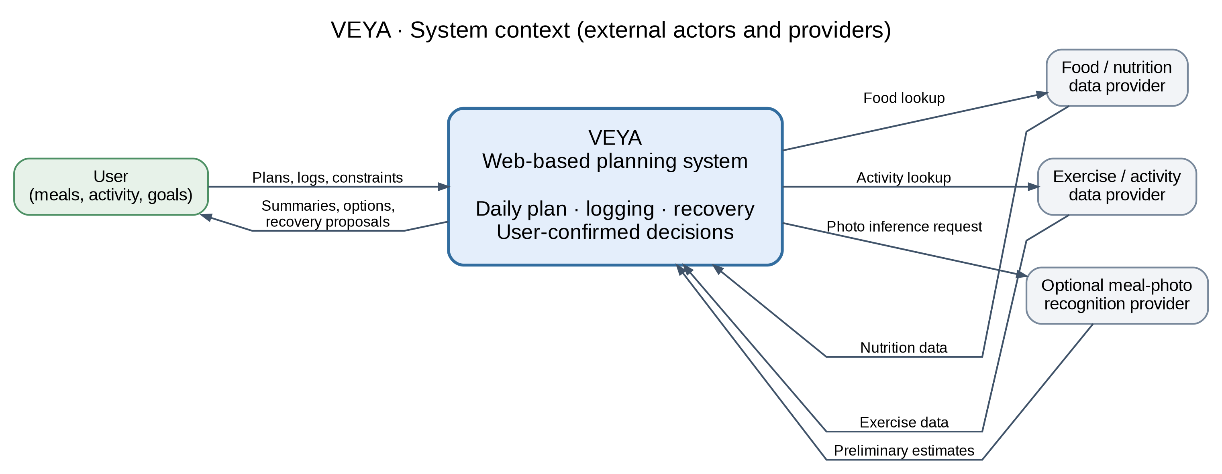
Figure 2.1 – VEYA system context and external providers.
Inside the system boundary, the selected implementation uses a React/TypeScript single-page client, a Spring Boot modular-monolith REST API over HTTPS/JSON and PostgreSQL. The client handles accessible validation, editable entries and explicit decisions; server modules handle identity, nutrition, activity, planning/recovery, history and provider adapters. OpenAPI provides a shared integration contract [21]–[26], [27], [28].
For MVP acceptance tests, a significant deviation means a confirmed meal differs by at least 200 kcal from its planned amount, a planned meal/workout is marked missed or skipped, or changed time/available ingredients/equipment invalidate a remaining item. Smaller differences without a hard-constraint breach do not set recoveryRequired; users can still request manual replacements. Recovery is deterministic and constraint-based: completed items remain immutable, remaining totals are derived from confirmed facts, candidates are filtered against mandatory exclusions, time and equipment, and feasible combinations are ranked. A proposal carries baseVersion and an explanation. On ACCEPT or EDIT, the server rechecks the current version and saves the decision and new plan version transactionally; on REJECT, the active plan stays unchanged. A stale proposal returns HTTP 409; an impossible combination returns a controlled no-solution response.
Optional post-MVP photo recognition (US-27/28, Should) would use an external provider through the API. Results remain tentative and editable: only user-confirmed values may create nutrition entries. If introduced, provider timeouts, empty lists and invalid records must have controlled error states and manual-entry fallback. Photo estimates must never silently update totals or recovery decisions.
Table 2.5 – Alternatives evaluated
Decision | Alternative not selected | Chosen approach and rationale
Product process | Extended diary with reminders and manual plan edits. | Constraint-based Dynamic Plan Recovery; directly addresses P1/P5 while retaining explicit decisions.
Server design | Independent microservices with separate databases and distributed updates. | Modular monolith with PostgreSQL transactions; fewer deployment risks and predictable plan versioning for a two-person MVP.
Meal-photo entry | Automatic recognition treated as final. | Assisted recognition with editable preliminary values; limits error propagation into recovery.

Appendix B contains a detailed data model, client screen map, backend and client interaction sequences, a use-case diagram and the three existing screen mockups. The mockups are illustrative layouts, not evidence that the implementation is complete; optional stories do not form part of the Must acceptance baseline.

2.5. Functional Requirements
The product backlog is organized into seven capability epics spanning identity and goals, nutrition, activity, recovery, history, accessible interaction and platform integration. Each of the 38 uniquely numbered stories has an explicit statement, MoSCoW priority and Given/When/Then acceptance criteria in Appendix A. The 27 Must stories define the planned MVP; seven Should and four Could stories are post-MVP enhancements. These include advanced exercise filters (US-11), history browsing (US-21), enhanced form guidance (US-25) and optional photo input with review (US-27/28). An epic marked Must may still include separately prioritized enhancements. Key testable stories are summarized below.
Table 2.6 – Product epics and priority
Epic | Capability | Stories | Epic priority
EPIC 1 – Identity and goals | Account, profile, preferences, goals and deletion | US-01–US-04 | Must
EPIC 2 – Nutrition and meals | Food diary, totals, meal planning/replacements; optional reviewed photo input | US-05–US-10; US-27–US-28; US-34 | Must
EPIC 3 – Physical activity | Basic exercise selection, planning, status and alternatives; optional filters | US-11–US-14; US-35 | Must
EPIC 4 – Dynamic Plan Recovery | Deviation, proposal, explanation, decision and no-solution response | US-15–US-19 | Must
EPIC 5 – Progress and history | Dashboard and stored versions; optional history browsing/analytics | US-20–US-22; US-36–US-37 | Must
EPIC 6 – Accessible interaction | Responsive flows, loading/errors, keyboard access; optional form guidance | US-23–US-26; US-38 | Must
EPIC 7 – Platform and integration | OpenAPI, security, provider fallbacks, deployment, CI/testing | US-29–US-33 | Must

Table 2.7 – Key end-to-end user stories
ID | Story | Acceptance summary
US-10 | Replace a planned meal | Given the active plan and restrictions, when replacement is requested, then only feasible options and reasons are shown; confirmation updates the version.
US-16 | Generate a recovery proposal | Given a significant deviation, when recovery is requested, then completed items remain untouched and only feasible future alternatives or a reasoned no-solution result are returned.
US-18 | Approve or reject a proposal | Given a proposal, when the user accepts, edits or rejects it, then only authorized, version-matching confirmation changes the active plan; stale versions return 409.
US-27/28 | Review photo input (post-MVP) | Given recognition results, when the user corrects/accepts values, then only confirmed foods, portions and nutrients are saved; cancellation leaves diary unchanged.

The existing dashboard, meal replacement and recovery proposal layouts are presented as Figures B.8–B.10 in Appendix B and correspond to US-20, US-10 and US-16–US-18. The screen map is Figure B.7. These visual scenarios complement, rather than replace, server-side contract and integrity requirements.
Table 2.8 – Shared API contract for key flows
Story | Method/path | Expected result
US-10 | POST /api/v1/meal-options | 200 candidates/reasons; 422 if no feasible alternative.
US-16 | POST /api/v1/plans/{planId}/recovery-proposals | 201 proposalId, baseVersion, changed items, totals and reasons; 422 if impossible.
US-18 | POST /api/v1/recovery-proposals/{id}/decision | 200 active plan/version; 409 stale version; 400 invalid edit.
US-20 | GET /api/v1/days/{date}/summary | 200 plan, nutrition/activity totals, history summary.
US-27 | POST /api/v1/nutrition/photo-recognition | Post-MVP: 200 tentative foods; 422 invalid image, 502 provider unavailable.

Complete API payloads, authorization, field validation and errors will be formalized in OpenAPI before integration. The service contract does not imply silent approval of recognized foods or recovery changes; the client explicitly requests confirmation.
Table 2.9 – Traceability from analyzed problem to deliverables
Problem | Goal / KPI | Epic / stories | Evidence
P1 | G1; KPI-1, KPI-4 | EPIC 4; US-15–US-19 | Recovery scenario, integration and e2e tests.
P2 | G2; KPI-2 | EPIC 2; US-05–US-08, US-27–US-28 | Input review, stored-value and step-count tests.
P3 | G3; KPI-3 | EPIC 2; US-09–US-10 | Meal hard-constraint tests.
P4 | G4; KPI-3 | EPIC 3; US-11–US-14 | Activity time/equipment tests.
P5 | G5; KPI-4 | EPIC 1: US-01–US-04; EPIC 4: US-17–US-18; EPIC 5: US-20–US-21; EPIC 6: US-23–US-26; EPIC 7: US-29–US-33 | Transaction/version, accessibility and UI feedback checks.

2.6. Use Case Scenarios

UC-01. Dynamic Plan Recovery after a deviation
Table 2.10 – Use case UC-01
Element | Description
Actor / trigger | Authenticated user; a confirmed meal differs from plan by ≥200 kcal, a planned meal/workout is marked missed/skipped, or a new time/ingredient/equipment constraint makes a future item infeasible (US-15 default).
Precondition | Active daily plan, personal goal and at least one future planned item.
Main flow | 1. User logs the event / changes constraints in the client. 2. Client validates and sends it via authenticated API. 3. Server stores actuals, detects deviation and marks recoveryRequired. 4. User requests recovery; engine loads current plan version and calculates remaining targets. 5. Engine filters and ranks feasible meal/activity alternatives and saves a proposal with reasons and baseVersion. 6. Client shows the proposal and differences. 7. User accepts, edits or rejects. 8. Server checks plan version and atomically saves decision/new plan; client updates dashboard and history.
Alternative A: no solution | When all candidates violate hard constraints, server returns 422/blockingConstraints; client explains the reason and offers a constraint edit; active plan is unchanged.
Alternative B: stale version | If another decision changed the plan before confirmation, server returns 409; client refreshes before a new request.
Alternative C: provider failure | Local candidates may be used. If unavailable, client shows a controlled error and retry/manual option; saved entries are preserved.
Postcondition | On ACCEPT/EDIT, new active plan version plus decision history; on REJECT, previous remainder stays active.

UC-02. Meal or exercise replacement under constraints
Table 2.11 – Use case UC-02
Element | Description
Actor / trigger | Authenticated user; a planned meal or workout becomes infeasible due to products, time or equipment.
Precondition | A relevant planned item exists and restrictions/goals are configured.
Main flow | 1. User selects item and Replace. 2. Client shows current conditions and requests candidates. 3. Server loads remaining targets, obtains and normalizes candidates. 4. Hard constraints are applied; feasible choices are ranked and returned with reasons. 5. Client presents options. 6. User selects and confirms a replacement. 7. Server validates authorization/version and updates plan and totals; client shows the result.
Alternative A: no candidates | A 422 response shows the blocking condition and a route to modify constraints; the old plan stays active.
Alternative B: provider unavailable | Use cached/local options or show a controlled failure; manual entry remains available.
Postcondition | The confirmed replacement appears in the active plan; history preserves the earlier version.

The overall use-case diagram (Figure B.6) and synchronized client/server interaction sequences (Figures B.4–B.5) are included in Appendix B. The scenarios specify behavior across the complete user-to-API interaction.

2.7. Non-Functional Requirements
Appendix C, Table C.2 contains 18 measurable non-functional requirements covering API/recovery performance, interface responsiveness, availability, security, data integrity, accessibility, compatibility, usability, testability, integration resilience and deployment. Representative thresholds include server CRUD p95 ≤500 ms, recovery p95 ≤2 s, visual response ≤100 ms, a ≤3-second dashboard and keyboard-operable core flows with WCAG 2.1 AA contrast and labels [7]. The metrics are linked to stories and verification methods; the target context is a controlled educational test environment.
For performance, separate server response time from the duration perceived by a browser user. The backend recovery target excludes rendering and network delay, whereas KPI-4 measures the full client-visible result under predefined conditions. This distinction prevents a slow user interface from being mistaken for a slow recovery algorithm and provides clear evidence for both integration and end-to-end testing. Likewise, local availability is assessed with a simulated provider failure rather than promised as continuous production uptime.
Table 2.12 – Representative measurable non-functional requirements
Category | Example measurable requirement | Linked story / verification
Performance | NFR-02: recovery generation p95 ≤2 s (≤100 meal + 100 activity candidates). | US-16; fixed-dataset benchmark
Security | NFR-08: 100% of negative ownership/auth tests yield 401/403; no secrets in logs. | US-01, US-30; security tests
Availability | NFR-11: ≥99% successful probes during a 30-min test with mocked provider failure. | US-20, US-31; synthetic probe
Usability | NFR-07: recent meal entry ≤3 actions; replacement task completed by ≥80% of ≥5 testers. | KPI-2; US-08/10; user tasks
Accessibility | NFR-06: WCAG 2.1 AA keyboard/labels, ≥4.5:1 contrast; audit score ≥90. | US-26; keyboard audit
Usability and accessibility are assessed through observable scenarios: entry and correction of a meal, selection of a feasible replacement, review of the recovery explanation and final decision. Validation includes keyboard navigation, clear field labels, contrast, informative loading states and preservation of unsent form content when a request fails. Combined quality indicators apply to the system experience rather than assigning separate success definitions to its implementation components.

2.8. Legal and Ethical Requirements
The system handles profile, goal, meal, activity and plan-history data, some of which may qualify as health data under the GDPR. For a future service offered under user terms, processing strictly necessary to provide the requested account and planning functions is provisionally assessed under Article 6(1)(b) (contract). Optional processing may instead require Article 6(1)(a) consent. Where particular records constitute special-category health data, an additional Article 9 condition is necessary: explicit consent under Article 9(2)(a) is the proposed route, together with an applicable Article 6 basis. For consent-based online services offered directly to children, Article 8 requires checking national consent ages (13–16) and parental authorization. These are design assumptions, not achieved compliance [5], [6], [29].
LEG-1. Collect only data necessary for declared functions; distinguish required from optional profile fields.
LEG-2. Display a clear privacy notice; where health-data consent is relied upon, obtain explicit, separately recorded and versioned consent.
LEG-3. Require authentication and resource ownership checks for personal plans, records, proposals and history.
LEG-4. Retain data while an account is active; support access, correction, export and deletion. Target erasure within 30 days and backup expiry within 90 days after verified deletion, subject to legal exceptions.
LEG-5. Use HTTPS, adaptive password hashing, protected tokens and secrets; keep sensitive payloads out of application logs.
LEG-6. Show nutrition/MET/photo-recognition calculations as estimates, not medical advice; require user review of automatic food entries.
LEG-7. Honor external-data licences and appropriate attribution; use licensed UI images, icons and fonts.
LEG-8. For usability interviews/tests, explain their purpose and obtain participation consent; use synthetic/anonymized records where practicable.
LEG-9. Design accessible controls and sufficient contrast based on WCAG 2.1 AA; test the main scenarios.

2.9. Risks
Project risk management covers data quality, recovery logic, integration, delivery, security and the user experience. Table 2.13 summarizes the priority project risks with probability, impact, mitigation and dependency; Appendix C, Table C.3 contains the full register of 11 risks. All plans preserve user control, fallbacks and testability. R10 keeps Should/Could enhancements outside the initial acceptance commitment, particularly Could-level analytics (US-22), if the two-person schedule is threatened.
Table 2.13 – Priority project risks (full register in Appendix C, Table C.3)
Risk | P | I | Mitigation | Dependency
R1: External APIs fail / change | M | H | Fallback to cached/manual input | Providers
R2: Recovery logic too complex | H | H | Bound candidates and Must-first scope | Team/time
R3: UI/API contract mismatch | M | H | Shared OpenAPI; integration tests | Team
R5: Stale decisions | M | H | Version check, transactions, 409 tests | Database
R10: Schedule or workload slip | H | H | Defer Could analytics; integrate iteratively | Two students

2.10. Chapter Conclusions
The BA specification defines one VEYA MVP with 7 epics and 38 prioritized stories (27 Must for MVP; 7 Should and 4 Could as eleven post-MVP enhancements), two integrated use cases, a shared REST interaction contract, 18 measurable NFRs, 9 legal/ethical requirements, 4 project KPIs and a combined risk register. The design includes the responsive web client, transactional service and database, and provider adapters, while keeping medical or autonomous decisions out of scope.
Evaluation will check KPI-1 (valid recovery or no-solution), KPI-2 (confirmed data correctness and input effort), KPI-3 (hard-constraint compliance in meal/activity alternatives), and KPI-4 (server/client responsiveness and explicitly authorized plan changes). Usability, accessibility, availability, security, compatibility and reproducibility are independently covered by the NFR verification plans. The source analysis, diagrams, acceptance criteria and mockups provide testable evidence for subsequent development; post-MVP enhancements are evaluated only if implemented.

LIST OF REFERENCES
[1] R. Berry, A. Kassavou, and S. Sutton, “Does self-monitoring diet and physical activity behaviors using digital technology support adults with obesity or overweight to lose weight? A systematic literature review with meta-analysis,” Obesity Reviews, 2021, doi: 10.1111/obr.13306.
[2] L. Laranjo et al., “Do smartphone applications and activity trackers increase physical activity in adults? Systematic review, meta-analysis and metaregression,” British Journal of Sports Medicine, 2021, doi: 10.1136/bjsports-2020-102892.
[3] M. Amiri, J. Li, and W. Hasan, “Personalized flexible meal planning for individuals with diet-related health concerns: System design and feasibility validation study,” JMIR Formative Research, vol. 7, e46434, 2023, doi: 10.2196/46434.
[4] R. A. Krukowski, A. H. Denton, and L. M. König, “Impact of feedback generation and presentation on self-monitoring behaviors, dietary intake, physical activity, and weight: a systematic review and meta-analysis,” International Journal of Behavioral Nutrition and Physical Activity, vol. 21, art. no. 3, 2024, doi: 10.1186/s12966-023-01555-6.
[5] European Commission, “Principles of the GDPR.” [Online]. Available: https://commission.europa.eu/law/law-topic/data-protection/information-business-and-organisations/principles-gdpr_en
[6] European Commission, “Legal grounds for processing data.” [Online]. Available: https://commission.europa.eu/law/law-topic/data-protection/information-business-and-organisations/legal-grounds-processing-data_en
[7] World Wide Web Consortium (W3C), “Web Content Accessibility Guidelines (WCAG) 2.1.” [Online]. Available: https://www.w3.org/TR/WCAG21/
[8] E. Shonkoff, K. Copeland Cara, X. A. Pei et al., “AI-based digital image dietary assessment methods compared to humans and ground truth: a systematic review,” Annals of Medicine, vol. 55, no. 2, 2023, doi: 10.1080/07853890.2023.2273497.
[9] S. D. Herrmann et al., “2024 Adult Compendium of Physical Activities: A third update of the energy costs of human activities,” Journal of Sport and Health Science, vol. 13, no. 1, pp. 6–12, 2024, doi: 10.1016/j.jshs.2023.10.010.
[10] MyFitnessPal, “Your Today tab.” [Online]. Available: https://support.myfitnesspal.com/hc/en-us/articles/39985611667341-Your-Today-tab
[11] MyFitnessPal, “How to use the Meal Planner.” [Online]. Available: https://support.myfitnesspal.com/hc/en-us/articles/34603055097869-How-to-use-the-Meal-Planner
[12] MyFitnessPal, “How to use the Meal Scanner.” [Online]. Available: https://support.myfitnesspal.com/hc/en-us/articles/360045761612-How-to-use-the-Meal-Scanner
[13] Eat This Much, “The Automatic Meal Planner.” [Online]. Available: https://www.eatthismuch.com/meal-planner/
[14] YAZIO, “Tutorial of the YAZIO app.” [Online]. Available: https://help.yazio.com/hc/en-us/articles/11804776635281-Tutorial-of-the-YAZIO-app
[15] YAZIO, “What is the AI Calorie Tracking Feature, and how does it work?” [Online]. Available: https://help.yazio.com/hc/en-us/articles/39137901903889-What-is-the-AI-Calorie-Tracking-Feature-and-how-does-it-work
[16] MacroFactor, “Introduction to Check-Ins and Coaching Modules.” [Online]. Available: https://help.macrofactorapp.com/en/articles/247-introduction-to-check-ins-and-coaching-modules
[17] MacroFactor, “Weekly Budget.” [Online]. Available: https://help.macrofactorapp.com/macro_program/weekly_budget
[18] MacroFactor, “Workout Logging.” [Online]. Available: https://help.macrofactorapp.com/en/collections/24-workout-logging
[19] MacroFactor, “Food Logging Style.” [Online]. Available: https://help.macrofactorapp.com/en/articles/45-food-logging-style
[20] OpenNutriTracker, “OpenNutriTracker — Free and open-source calorie, macro, and micronutrient logging for Android and iOS,” GitHub repository. [Online]. Available: https://github.com/simonoppowa/OpenNutriTracker
[21] Spring, “Spring Boot Documentation.” [Online]. Available: https://docs.spring.io/spring-boot/documentation.html
[22] Spring, “Spring Security — Password Storage.” [Online]. Available: https://docs.spring.io/spring-security/reference/features/authentication/password-storage.html
[23] PostgreSQL Global Development Group, “PostgreSQL 18 Documentation.” [Online]. Available: https://www.postgresql.org/docs/current/
[24] OpenAPI Initiative, “OpenAPI Specification, Version 3.2.1,” Sep. 2026. [Online]. Available: https://spec.openapis.org/oas/v3.2.1.html
[25] M. Jones, J. Bradley, and N. Sakimura, “JSON Web Token (JWT),” RFC 7519, May 2015. [Online]. Available: https://www.rfc-editor.org/rfc/rfc7519.html
[26] Docker, “Docker Compose Quickstart.” [Online]. Available: https://docs.docker.com/compose/gettingstarted/
[27] Meta Platforms, Inc., “React documentation.” [Online]. Available: https://react.dev/
[28] Microsoft, “TypeScript documentation.” [Online]. Available: https://www.typescriptlang.org/docs/
[29] European Parliament and Council of the European Union, “Regulation (EU) 2016/679 (GDPR),” Official Journal, 2016. [Online]. Available: https://eur-lex.europa.eu/eli/reg/2016/679/oj

APPENDIX A. BACKLOG
The backlog groups user and enabling technical stories under the same product epics. IDs and priorities are unique and are referenced throughout Chapter 2. A Must story has a verifiable Given/When/Then acceptance condition; Should/Could stories are separately prioritized for future iterations and are not required for initial MVP acceptance. The Must label on an epic identifies its essential capability, not every story grouped under it.

EPIC 1. Identity and goals
Table A.1 – User stories for EPIC 1
ID | User story | Given/When/Then acceptance criteria | MoSCoW
US-01 | As a visitor, I want to register and sign in so that my personal data stays private. | Given valid registration data, when submitted, then the account is created with a securely hashed password; invalid credentials return 401 without disclosing the account state. | Must
US-02 | As a user, I want to maintain my profile and goal so that plans reflect my current parameters. | Given authenticated, valid values, when saved, then the profile appears on subsequent requests; invalid ranges return a field error and do not change stored data. | Must
US-03 | As a user, I want to define food exclusions, equipment and available time so that suggestions fit my situation. | Given valid daily constraints, when saved, then they are stored and treated as mandatory conditions by meal, activity and recovery planning. | Must
US-04 | As a user, I want to delete my account and personal records so that I control my data. | Given explicit confirmation, when deletion completes, then associated personal records are deleted under the retention policy and the previous session cannot access them. | Must

EPIC 2. Nutrition and meals
Table A.2 – User stories for EPIC 2
ID | User story | Given/When/Then acceptance criteria | MoSCoW
US-05 | As a user, I want to search a food catalog so that I can find nutrition values without typing them. | Given a reachable provider, when the user searches, then normalized foods show calories, macros and source; timeout produces a documented error and manual-input option. | Must
US-06 | As a user, I want to log and correct food, portion and meals so that totals reflect what I ate. | Given valid confirmed food values, when added or edited, then the entry is persisted unchanged; invalid values are rejected without affecting totals. | Must
US-07 | As a user, I want to see consumed, target and remaining nutrition so that I can compare actuals to my goal. | Given saved records and a daily goal, when the summary is opened, then calories and macros match persisted confirmed entries and remaining targets. | Must
US-08 | As a user, I want to reuse saved or recent meals so that logging is quicker. | Given an existing saved/recent item, when selected, then a new entry is created within at most three user actions without altering its original template. | Must
US-09 | As a user, I want a daily meal plan based on my goal and constraints so that I do not plan every dish manually. | Given available candidate meals and goal/constraints, when requested, then the proposed menu excludes prohibited items and meets configured acceptable target ranges. | Must
US-10 | As a user, I want to replace a planned meal with a feasible alternative when ingredients are unavailable so that my remaining plan still meets my constraints. | Given an active planned meal, when replacement is requested, then only hard-constraint-compliant candidates and reasons are displayed; confirmation creates the next plan version and updates totals. | Must
US-27 | As a user, I want a preliminary nutrition estimate from a meal photo so that I can log more quickly. | Given a supported photo, when sent, then preliminary foods, portions and nutrients are shown from the provider; no FoodEntry is saved before confirmation; invalid image/provider outage is explained. | Should
US-28 | As a user, I want to correct recognition results before saving so that errors do not affect my plan. | Given preliminary photo data, when the user edits foods, portions or values and confirms, then only corrected confirmed entries are saved; cancellation leaves diary/plan unchanged. | Should
US-34 | As a user, I want to mark saved meals as favorites so that I can find common meals without searching again. | Given existing saved meals, when a meal is marked or unmarked as a favorite, then the favorites filter updates without changing or deleting the original meal. | Should

EPIC 3. Physical activity
Table A.3 – User stories for EPIC 3
ID | User story | Given/When/Then acceptance criteria | MoSCoW
US-11 | As a user, I want to browse exercises by muscle, difficulty and equipment so that I can choose suitable activity. | Given filters, when requested, then the catalog shows only matching exercises with the required normalized fields. | Should
US-12 | As a user, I want to schedule a workout with a duration so that it fits my day. | Given valid exercises and time, when the plan is saved, then scheduled items appear in the active day and summary/recovery calculations. | Must
US-13 | As a user, I want to mark workouts completed, skipped or changed so that the plan uses what happened. | Given a planned activity, when its status is recorded, then the actual event persists and deviation detection evaluates the changed plan state. | Must
US-14 | As a user, I want to replace an exercise when time or equipment changes so that I can still train. | Given changed time/equipment, when requested, then compliant alternatives or a reason for none are shown; confirmed choice updates the plan and history. | Must
US-35 | As a user, I want to filter my activity history by date and status so that I can review past workouts more easily. | Given recorded workouts, when a time range and completion status are selected, then only matching records appear; clearing the filter restores all records. | Should

EPIC 4. Dynamic Plan Recovery
Table A.4 – User stories for EPIC 4
ID | User story | Given/When/Then acceptance criteria | MoSCoW
US-15 | As a user, I want significant deviations to be identified so that I know when recovery is needed. | Given an active planned day, when a confirmed meal differs by at least 200 kcal from its planned value, a planned meal or workout is marked missed/skipped, or changed time/ingredients/equipment make a future slot infeasible, then recoveryRequired is set; smaller differences without a hard-constraint breach do not trigger automatic recovery. The 200-kcal default is used for MVP acceptance tests. | Must
US-16 | As a user, I want a revised remaining-day plan so that I do not recalculate it manually. | Given a recoveryRequired plan, when requested, then completed items are frozen and feasible future combinations are returned with totals or an explicit no-solution response. | Must
US-17 | As a user, I want reasons for each proposed change so that I can judge the alternative. | Given a proposal, when displayed, then each changed item has a human-readable reason tied to a nutrition, time, ingredient, equipment or other constraint. | Must
US-18 | As a user, I want to accept, edit or reject a proposal so that my plan changes only with consent. | Given a proposal with baseVersion, when a decision is confirmed, then the server checks ownership and version and transactionally applies ACCEPT/EDIT; REJECT leaves active plan unchanged; stale version returns 409. | Must
US-19 | As a user, I want an explanation if recovery is impossible so that I can adjust constraints. | Given no feasible combination, when recovery runs, then blockingConstraints and 422 are returned, no new plan version is created, and the UI offers existing manual/change flows. | Must

EPIC 5. Progress and history
Table A.5 – User stories for EPIC 5
ID | User story | Given/When/Then acceptance criteria | MoSCoW
US-20 | As a user, I want a daily dashboard so that I understand the day at a glance. | Given the selected date, when opened, then planned and actual nutrition, remaining totals, activity and active plan version are visible. | Must
US-21 | As a user, I want to review historical plans and decisions so that I understand what changed. | Given past changes, when history is opened, then valid versions, triggers and decisions are returned to the rightful account without exposing others’ data. | Should
US-22 | As a user, I want a summary of recurring deviations so that I can plan more realistically. | Given sufficient historic records, when pattern summaries are requested, then nonmedical aggregate information is shown only after a configured event count. | Could
US-36 | As a user, I want to export my nutrition and activity history as CSV so that I can analyze it outside VEYA. | Given authenticated access, when CSV export is requested, then the downloaded file contains only that user’s dated records and standard column headings. | Could
US-37 | As a user, I want a calendar view of planned days so that I can navigate older and upcoming plans quickly. | Given existing day plans, when the calendar is opened and a day is chosen, then its current plan summary is shown without altering any records. | Could

EPIC 6. Accessible interaction
Table A.6 – User stories for EPIC 6
ID | User story | Given/When/Then acceptance criteria | MoSCoW
US-23 | As a user, I want VEYA to work on mobile, tablet and desktop so that I can use it wherever needed. | Given widths 360, 768 and 1280 px, when opening key screens, then controls remain usable without horizontal page scrolling. | Must
US-24 | As a user, I want clear loading, empty and error states so that I understand every request. | Given a pending or failed API request, when its state changes, then progress, safe retry and non-loss of entered data are displayed as specified in NFRs. | Must
US-25 | As a user, I want help correcting forms so that invalid input does not waste time. | Given missing or invalid fields, when submitted, then corresponding labels and messages explain what to correct without sending invalid values to the API. | Should
US-26 | As a user, I want keyboard-operable and readable controls so that I can use core functions accessibly. | Given the key flows, when navigated by keyboard, then focus order, labels, contrast and form/error feedback satisfy the WCAG 2.1 AA checklist. | Must
US-38 | As a user, I want to switch between light and dark appearance so that I can use the interface comfortably. | Given a saved preference, when light or dark appearance is selected, then key screens use the chosen theme and the choice persists on the next sign-in. | Could

EPIC 7. Platform and integration
Table A.7 – User stories for EPIC 7
ID | User story | Given/When/Then acceptance criteria | MoSCoW
US-29 | As a developer, I want a documented stable API contract so that the web client integrates predictably. | Given a published build, when contract docs are generated, then every client-used method specifies path, auth, schemas, success and main error responses in OpenAPI. | Must
US-30 | As a user, I want server-side authorization so that another account cannot access my records. | Given missing/invalid token or another user’s resource, when requested, then 401/403 is returned without disclosing personal data or secrets. | Must
US-31 | As a user, I want controlled provider failures so that I do not lose locally confirmed actions. | Given an external timeout/5xx, when integration fails, then a stable error code and safe retry/manual route are returned and already saved data stays intact. | Must
US-32 | As a developer, I want reproducible startup so that VEYA runs consistently in test environments. | Given a clean machine with Docker, when Compose starts, then PostgreSQL becomes healthy, migrations run and the API is ready without manual schema work. | Must
US-33 | As a developer, I want automated checks so that critical changes are verified before integration. | Given code changes, when CI runs, then builds, unit and integration tests, coverage checks and an e2e recovery flow run; failed checks fail the build. | Must

APPENDIX B. DIAGRAMS AND MOCKUPS
Full-size figures supporting the AS-IS/TO-BE analysis, overall design, use cases and UI acceptance scenarios. Figure numbering is independent from the main text.
Figure B.1 – AS-IS personal planning process.
Figure B.2 – TO-BE VEYA plan recovery activity.
Figure B.3 – VEYA system context and external providers.
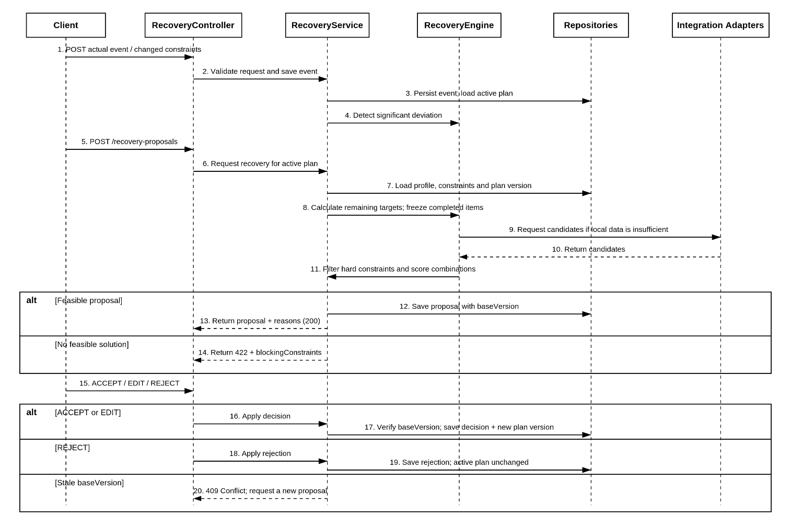
Figure B.4 – Service-side recovery sequence and version checks.
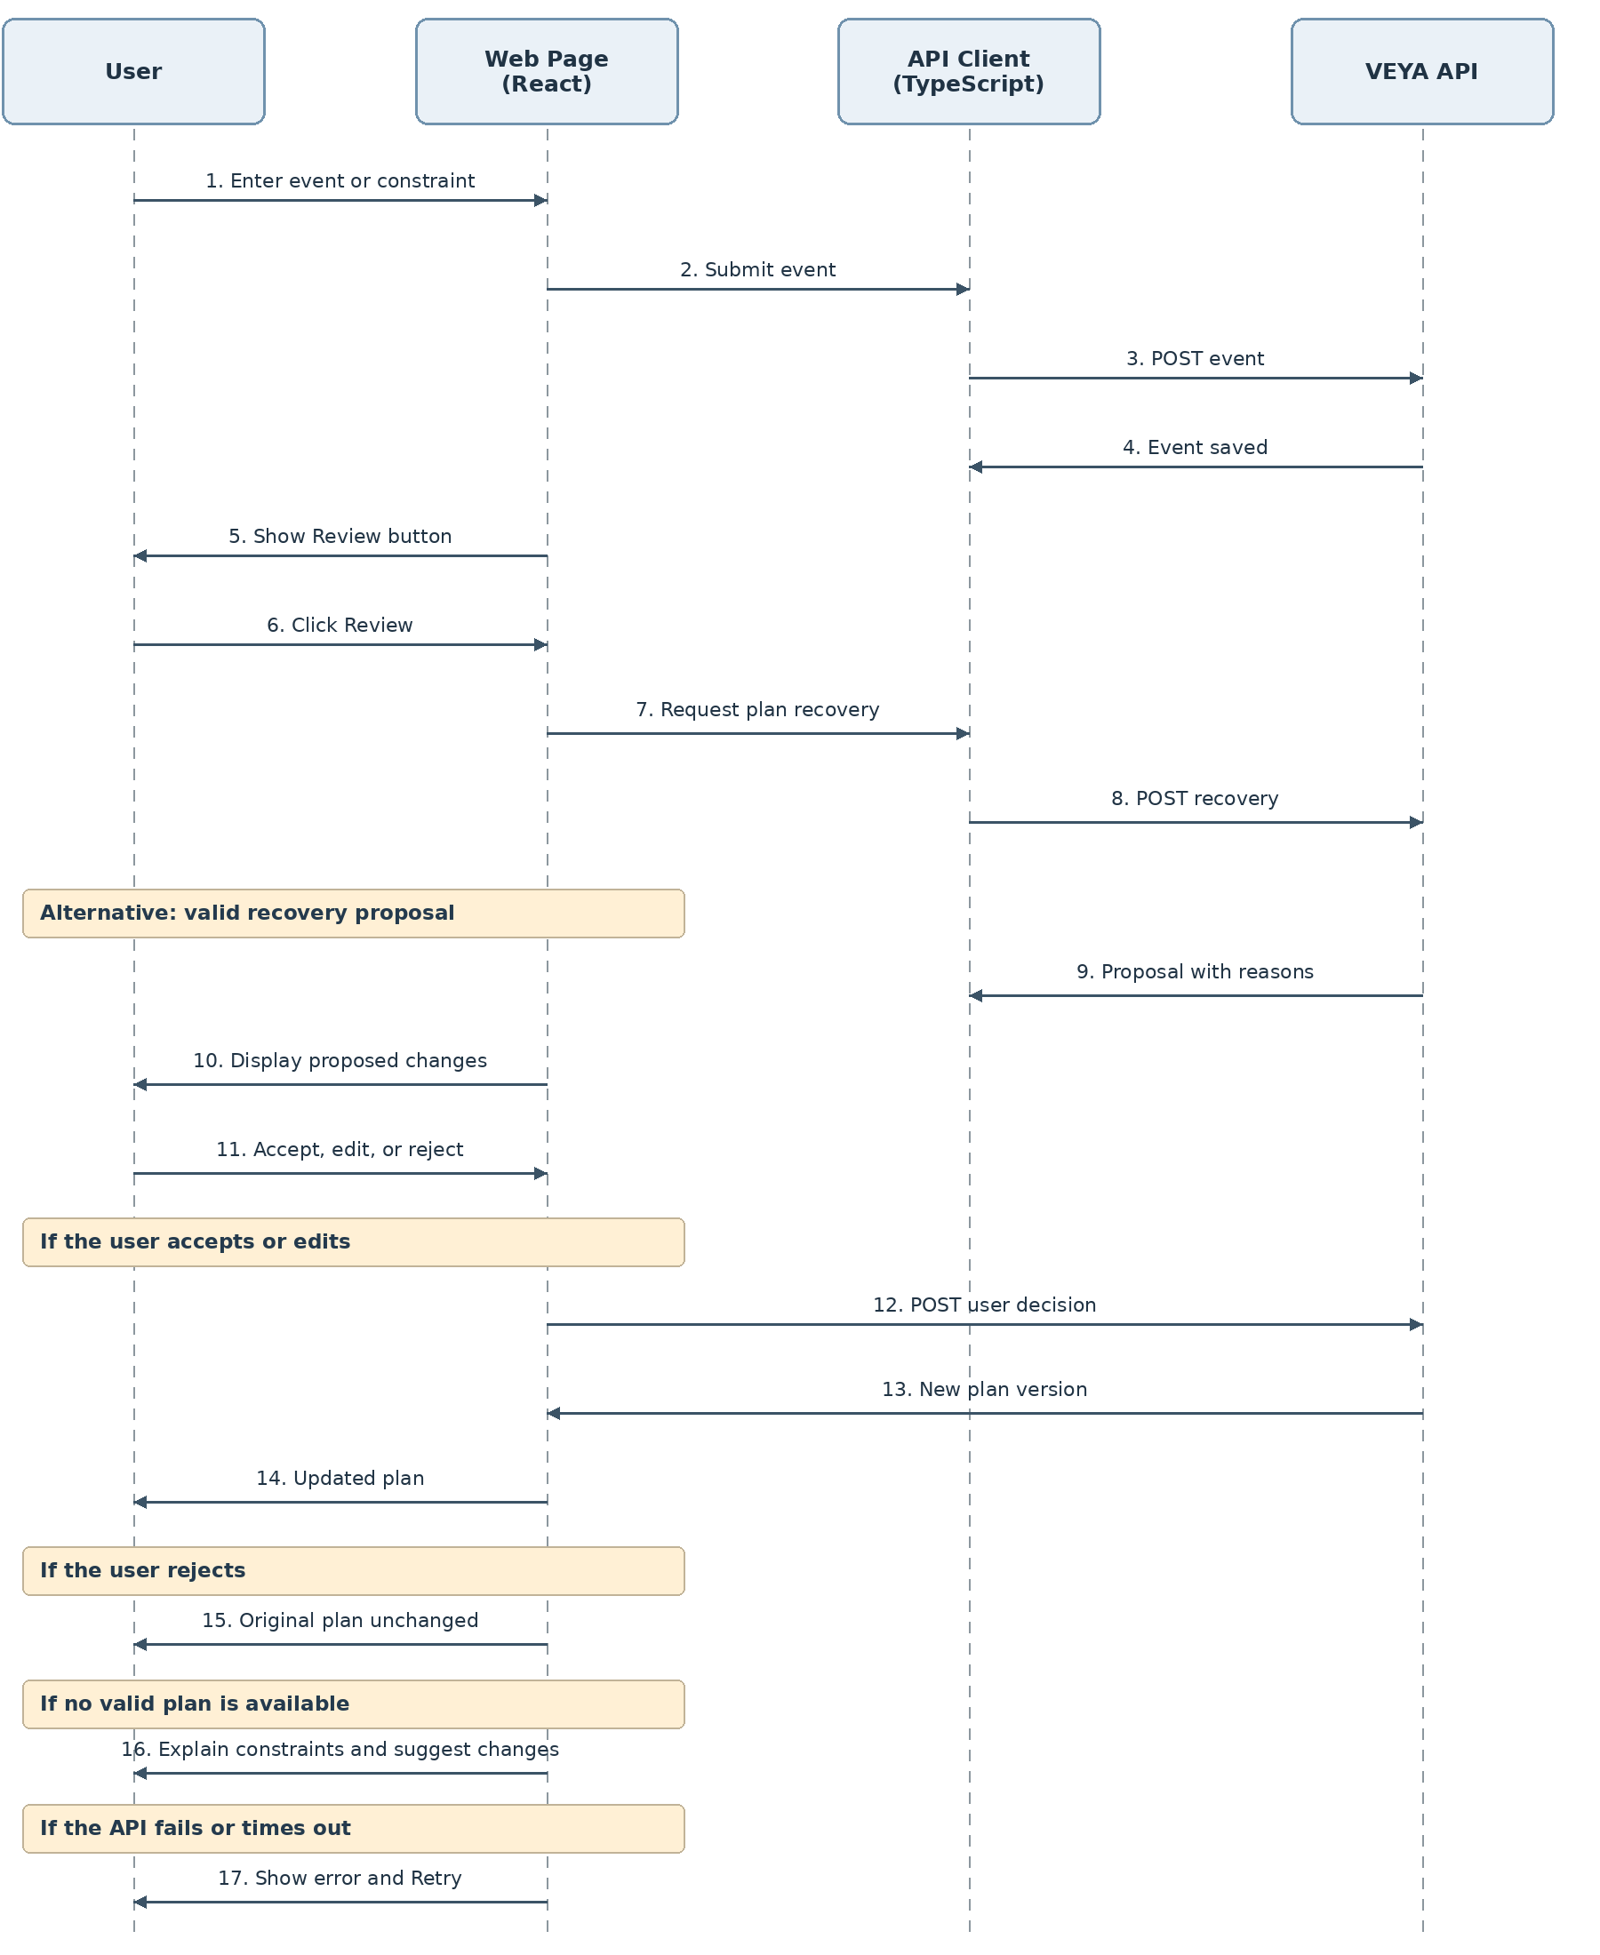
Figure B.5 – Web client recovery interaction sequence.
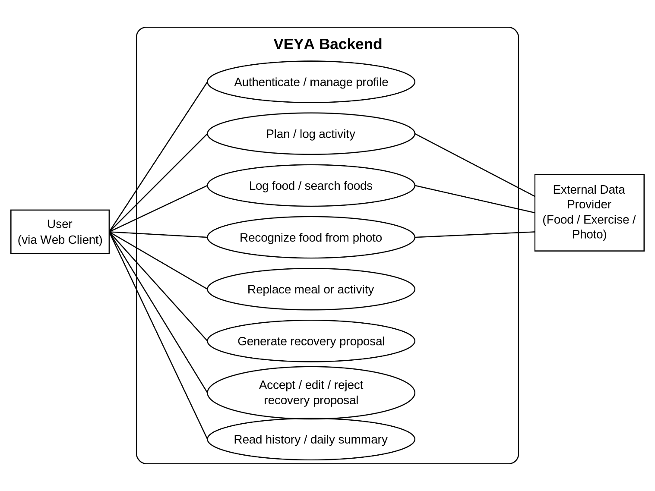
Figure B.6 – Main authenticated user use cases and external providers.
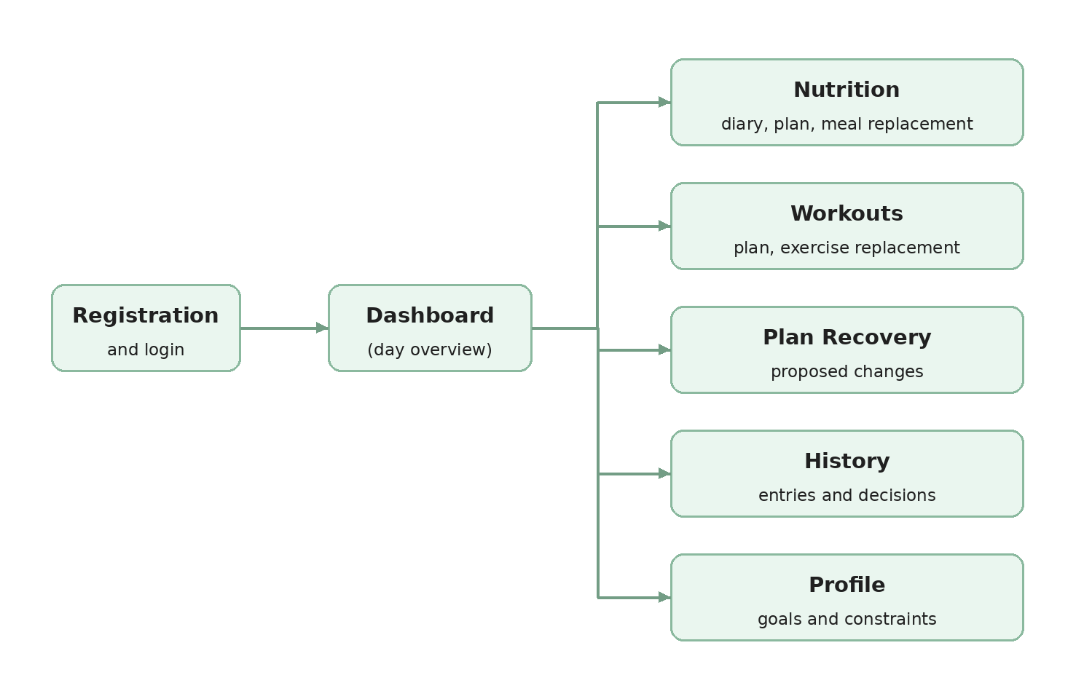
Figure B.7 – VEYA client screen map.
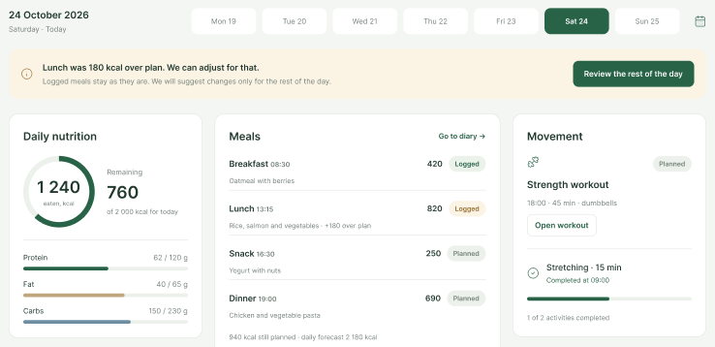
Figure B.8 – Dashboard layout for the selected day (US-20).
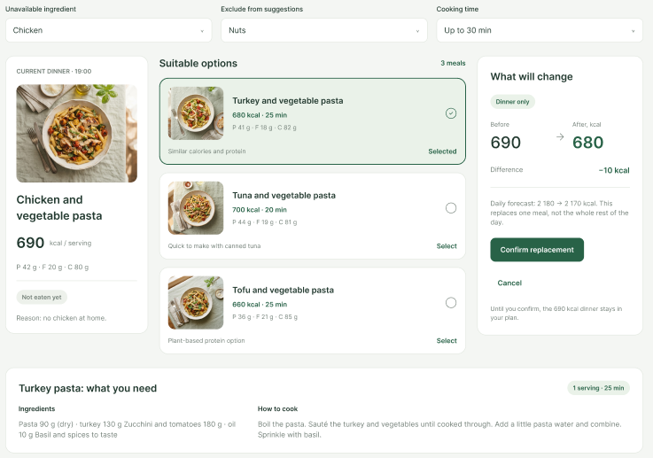
Figure B.9 – Meal replacement layout (US-10).
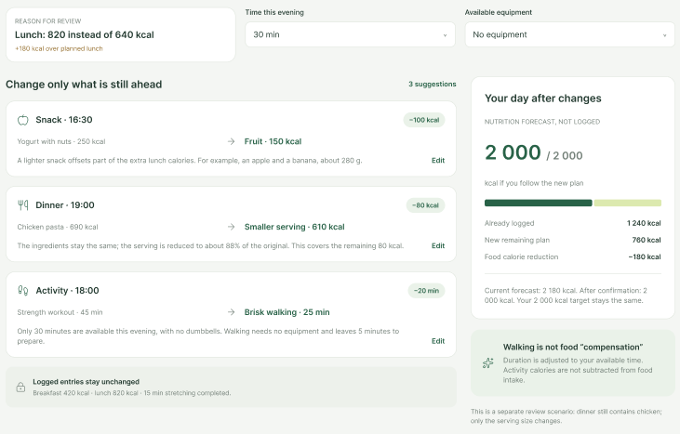
Figure B.10 – Plan recovery proposal layout (US-16–US-18).
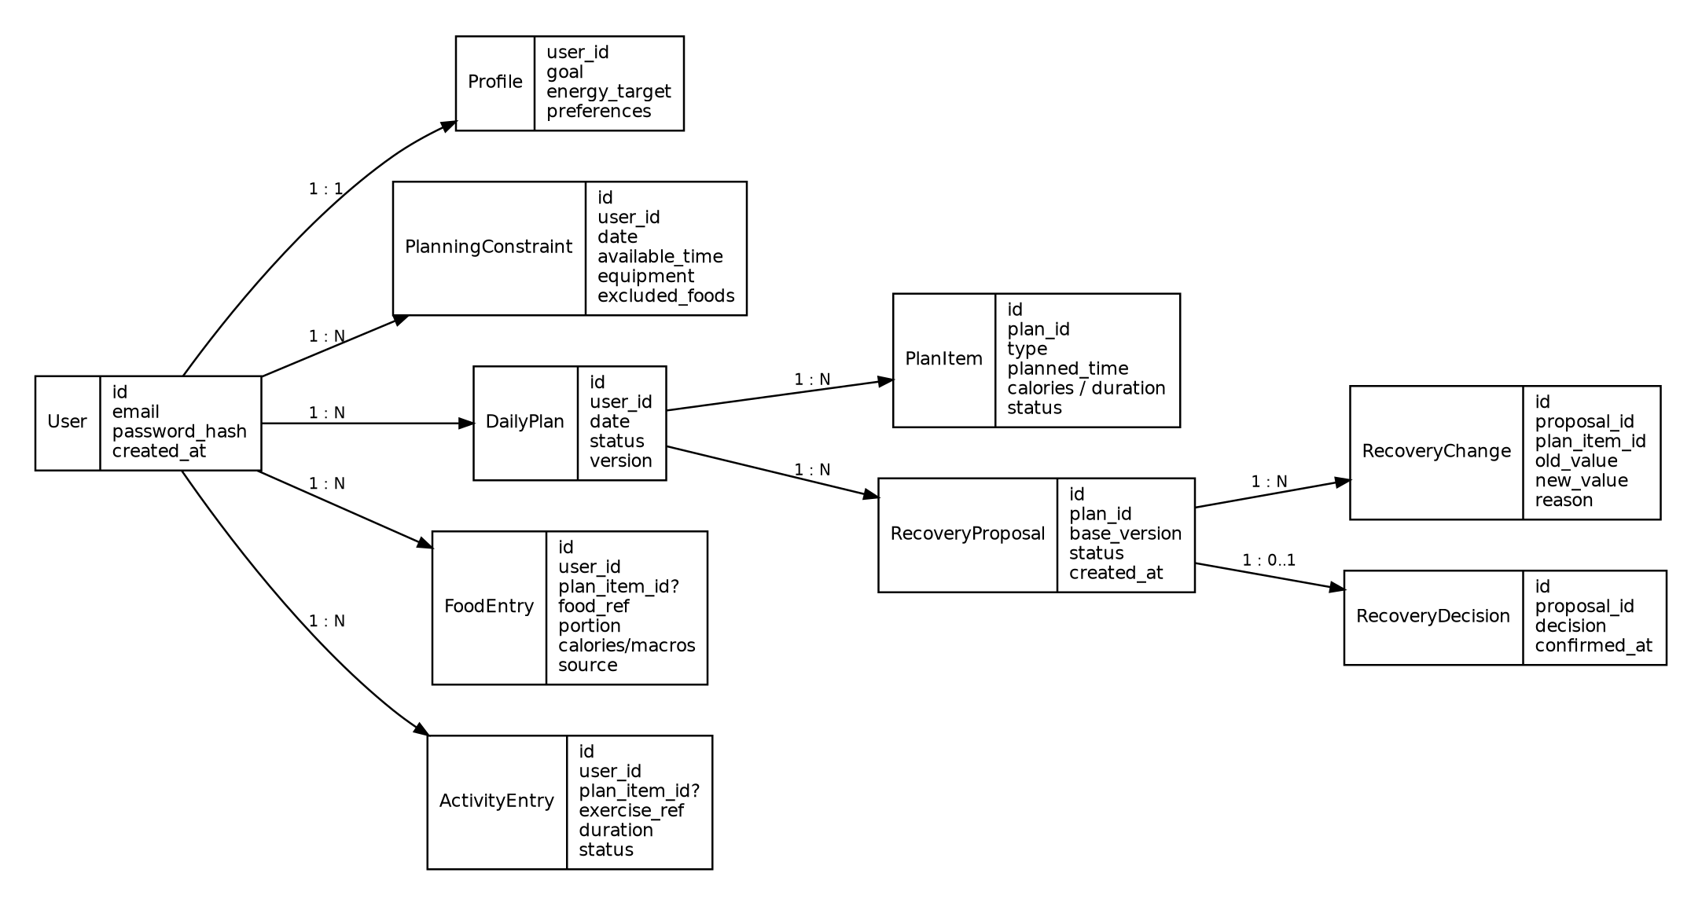
Figure B.11 – High-level VEYA persistent data model.
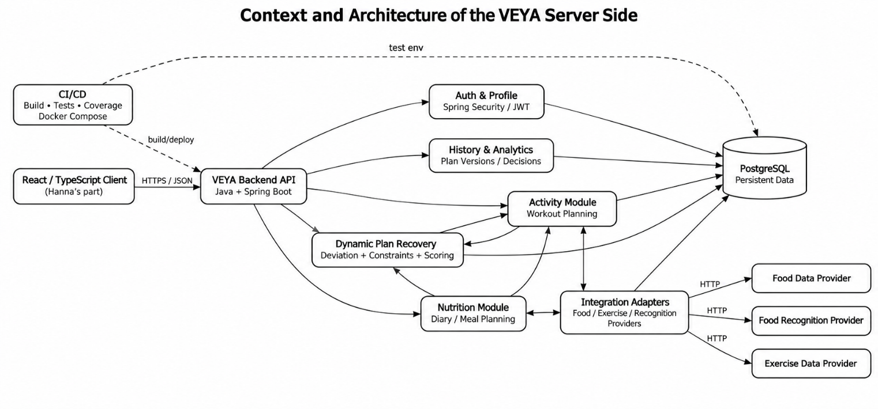
Figure B.12 – Detailed REST service modules and provider adapters.

APPENDIX C. SUPPORTING TABLES

C.1. Full comparison of software analogs
The comparison summarizes capabilities documented in sources [10]–[20]; unconfirmed features are described as unverified, not asserted absent.
Table C.1 – Five comparable solutions versus VEYA
Criterion | MyFitnessPal | Eat This Much | YAZIO | MacroFactor | OpenNutriTracker | VEYA (planned)
Food diary and calorie tracking | Yes; diary, calories, and macronutrients [10] | Yes; it is possible to record what is actually eaten [13] | Yes; nutrition, calories, and macronutrients [14] | Yes; nutrition management is used in program calculations [16], [19] | Yes; food diary, calories and macronutrients; search, barcode scanning, and quick entry [20] | Yes
Meal planning | Meal Planner generates plans and allows you to change recipes [11] | Automatic personalized menu planning [13] | Recipes and stored dishes; automatic formation of a full daily menu has not been confirmed [14] | Plans calories and macro goals; an automatic menu of specific dishes is not the main function [16], [17] | There are reusable dishes and recipes; the automatic formation of a full daily menu is not declared [20] | Yes; specific meals and daily plan
Physical activity tracking | Exercises and steps can be recorded in the diary [10] | Not confirmed as a core function[13] | Activity can be recorded or synced [14] | There is a separate training module and exercise log [18] | Yes; activity catalog, custom activities, and reusable templates [20] | Yes
Entering a dish from a photo | Meal Scan offers recognized products and allows manual adjustment [12] | Not confirmed in the reviewed documentation [13] | AI evaluates ingredients, portion, and nutritional value; the result can be edited [15] | Not confirmed as the main function in the reviewed documentation | Recognition of the dish by photo is not declared; search, barcode scanning and quick entry are available [20] | It is planned as an auxiliary input with mandatory verification
Meal Substitution / Plan Change | Recipe replacements available in Meal Planner [11] | The plan is based on preferences, budget, and schedule; the actual meal can be entered separately [13] | Entries, dishes, and recipes can be edited; automatic replacement of the remaining plan is not confirmed [14], [15] | Changes calorie and macro goals within the program and weekly check-in [16], [17] | Entries, dishes, and recipes can be edited; no automatic rearrangement of the rest of the day is announced [20] | It is planned to replace dishes and activities, taking into account the restrictions
Adapting goals over time | Changes in the goals and parameters of the plan are possible [11] | The plan is formed according to the user's parameters [13] | Goals and parameters are personalized by the user [14] | The Weekly Check-In suggests changes in calories and macronutrients based on progress [16] | Goals are calculated according to the profile; the calorie goal can be adjusted as weight changes, but the restoration of the plan during the day is not announced [20] | It is possible to update the current plan after actual events
Recovery of the rest of the day after deviation | The full agreed scenario is not found in the reviewed documentation | It is possible to bring in what has actually been eaten, but the automatic rearrangement of the remaining dishes and activity has not been confirmed [13] | Not found in reviewed documentation | Adaptation is described primarily at the level of goals and periodic check-ins, and not at the level of a specific rest of the day [16], [17] | Not found in the project documentation; the application is focused on accounting, goals and analysis of dynamics [20] | Dynamic Plan Recovery's key feature
Track time, products, and equipment in a single recovery scenario | Meal Planner takes into account cooking time and food preferences; a single recovery scenario has not been confirmed [11] | Food preferences, budget and schedule are taken into account [13] | Individual targets and activities are supported, but a single recovery scenario has not been confirmed [14] | Nutrition and training are supported, but joint recovery in time, products and equipment has not been described [16], [18] | Nutrition and activities are taken into account, but a single recovery scenario in terms of time, products and equipment is not described [20] | It is planned to take into account time, food, food and equipment

C.2. Combined non-functional requirements
Table C.2 – Measurable quality requirements
ID | Category | Requirement / target | Traceability | Verification
NFR-01 | API performance | CRUD/summary request p95 ≤500 ms on fixed test database, excluding client latency. | MVP US-01–US-10, US-12–US-14, US-20; US-11 (Should) | Integration benchmark.
NFR-02 | Recovery performance | Proposal generation p95 ≤2 s with up to 100 meal and 100 exercise candidates. | KPI-4; US-16 | Fixed-dataset benchmark.
NFR-03 | Web page performance | Dashboard interactive ≤3 s; LCP ≤2.5 s in emulated Fast 4G conditions. | KPI-4; US-20 | Lighthouse and browser timing.
NFR-04 | UI feedback | Action feedback appears ≤100 ms; show a loading indicator when API wait exceeds 1 s. | US-24 | DevTools timings and scenario test.
NFR-05 | Responsive support | All major screens have no horizontal scrolling at 360/768/1280 px; verify latest two Chrome, Firefox, Safari, Edge versions. | US-23 | Responsive and browser matrix.
NFR-06 | Accessibility | Key tasks meet WCAG 2.1 AA for labels, keyboard and contrast ≥4.5:1; Lighthouse accessibility score ≥90. | US-26 | Audit + keyboard checklist.
NFR-07 | Task usability | Recent meal entry ≤3 actions; meal replacement ≤4 actions; ≥80% of at least five test participants finish the replacement task. | KPI-2; US-08, US-10 | Usability sessions and action count.
NFR-08 | Security | 100% of negative authorization/ownership tests return 401/403; secrets/tokens/passwords absent from logs and client console. | US-01, US-30 | Security tests and code review.
NFR-09 | Atomicity | Plan decision, new version and history are atomic; injected failure creates no partial plan. | US-18 | PostgreSQL transaction tests.
NFR-10 | Concurrency | 100% of stale baseVersion decision requests return 409 without changing active data. | US-18 | Parallel request/stale tests.
NFR-11 | Availability | ≥99% of scheduled health-check and daily-summary probes return 2xx during a 30-min test with DB active and mock provider outage. | US-20, US-31 | Timed synthetic probe.
NFR-12 | Provider resilience | 100% of simulated timeout/5xx failures create controlled responses and preserve already saved local records. | US-05, US-14, US-31 (MVP); US-27 (Should) | Fault-injection/mocked provider.
NFR-13 | Client error handling | 100% of simulated failures or >5-s timeouts show a clear error/retry without clearing entered forms. | US-24, US-31 | Browser fault simulation.
NFR-14 | API usability | 100% of negative-input, no-solution and stale requests return documented status + stable code understood by client. | US-06, US-10, US-18, US-29 | OpenAPI contract tests.
NFR-15 | Contract completeness | 100% of used endpoints have OpenAPI path/auth/schema/errors and typed TypeScript client models. | US-29 | API contract checklist.
NFR-16 | Testability | Backend selected logic coverage ≥70% plus PostgreSQL integration; selected client logic ≥70%; UC-01/02 end-to-end. | US-33 | CI and coverage report.
NFR-17 | Reproducibility | One Docker Compose startup launches API and PostgreSQL with health checks and migrations before readiness. | US-32 | Clean environment test.
NFR-18 | Scalability and observability | Under 50 read-heavy virtual users, 5xx rate <1%; health endpoint/request IDs present; sensitive content never logged. | US-20, US-31, US-32 | Load and health/log audit.

C.3. Project risks and dependencies
Table C.3 – Joint project risk register
ID | Risk | P | I | Mitigation | Dependency
R1 | External provider API downtime, limits or response changes | M | H | Adapter/timeouts, normalization, local/manual alternatives. | Provider services
R2 | Recovery logic exceeds feasible MVP complexity | H | H | Deterministic constraints, bounded candidate set, phased Must scope. | Developers/time
R3 | Client/API payload contracts diverge | M | H | One OpenAPI specification and typed client, agreed changes, mock responses. | Team integration
R4 | Poor input or recognition accuracy affects recommendations | M | H | Reviewable estimates, validation, sources, manual correction. | Provider/user data
R5 | Concurrent actions apply stale proposals | M | H | baseVersion, HTTP 409, database transactions, concurrency tests. | Server/database
R6 | Personal-data security or consent defect | L | H | Ownership checks, hashed passwords, privacy notices, safe logs, tests. | Deployment/config
R7 | The recovery screen is hard to understand | M | H | Explanations per change, prototypes and usability scenarios. | Test participants
R8 | Responsive/accessibility defects appear late | M | M | Early WCAG audits, widths/browser matrix, shared components. | Client devices
R9 | Insufficient realistic test examples or participants | M | M | Synthetic meal/activity catalog; early recruiting, declare sample limits. | Test data/users
R10 | Workload and delivery schedule slip | H | H | Must-first shared backlog, defer Could analytics, iterative integration. | Two-person team
R11 | Build/CI environments differ from local setup | M | M | Pinned tool versions, Compose and CI tests on changes. | CI/hosting

STATEMENTS

Use of AI
Claude.ai and ChatGPT (OpenAI) were used to assist with language editing, proofreading, and improving the clarity and consistency of selected passages in the Introduction and Chapters 1–2, including the wording of requirements and diagram descriptions. The authors independently developed the content, requirements, diagrams, and design decisions, and reviewed the final document. AI-generated output was not used as scientific evidence.

Individual contributions (group project)
Table S.1 – Contribution of each student
Participant | Contributions
Hanna Ivanova | Joint problem analysis and Chapter 1 preparation; AS-IS/TO-BE process modelling, user needs analysis, user flows and use case scenarios, user-facing functional requirements and acceptance criteria, UI/UX and responsive interface concepts, accessibility and usability requirements, screen map and three UI mockups.
Mikita Malafei | Joint problem analysis and refinement of scientific literature and software analog analysis; system architecture and backend-related requirements, project scope and requirement traceability, API and data model concepts, Dynamic Plan Recovery specification, backend-related user stories and acceptance criteria, non-functional and security requirements, risks and verification criteria.

Organization consent
The VEYA project is not commissioned by an external organization and does not use proprietary organizational data. Synthetic or anonymized datasets are intended for system testing.

