Curriculum Vitae

PERSONAL INFORMATION Md Atikur Rahman

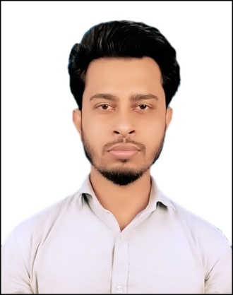 Address: Charbalaki, Gazaria, Munshiganj  +8801829018244

 [mdatikurr355@gmail.com](mailto:mdatikurr355@gmail.com)

# Career Objective

To pursue a career with a renowned institution that will employ my educational qualifications, practical skills and experiences with immense responsibilities to utilize fullest potential acquired in academic life to bring a positive change in the industry and offers me a consistently positive atmosphere to enhance my professional skills with cutting edge of technologies.

# Career Summary

Training on Web Design & Application Development with 4 months of duration. Topic HTML, CSS, PHP, MYSQL at 2018 from Bangladesh Korea Information Access Center (Dept. of CSE BUBT) Dhaka-1205 Bangladesh. Completed B.Sc. in Computer Science and Engineering with CGPA 2.88 out of 4. Publish one publications on HBRP Publication.

# Academic Qualifications

|  |  |  |  |  |
| --- | --- | --- | --- | --- |
| **Degree** | **Concentration/ Department** | **Institute** | **Passing Year** | **CGPA** |
| B.Sc. | Computer Science & Engineering | Hamdard University Bangladesh | 2019 | 2.88 |
| H.S.C. | Science | Sonargaon University College | 2014 | 3.40 |
| S.S.C. | Science | Taherpur Hazi Lalmiah High School | 2012 | 4.25 |

***Publications***

1. Payel Rani, Md Atikur Rahman, & Hasan Mahmud. (2021). Farming Information Management System of Bangladesh. Research and Applications of Web Development and Design, 4(1), 1–10.<http://doi.org/10.5281/zenodo.4548426>

# Project Work

“Design and Development of an Online Integrated Farming and Information Management System” in this project user can get information about how to farming, about farming equipment, about vaccine of animal in online.https://github.com/Atikurr355/design_and_development_of_an_online_integrated_farming_and_information_management_system

# Extra-Curricular Activities & Achievements

* Ex-Member of “Hamdard University Programming & Skill Development Club”
* Took part and Champion in Football Tournament organized by Hamdard University Bangladesh

# Skills & Qualifications

Training Web Development

Basic Knowledge C Programming, PHP, HTML5, CSS3, Java, Java Script, Laravel, Bootstrap 4, My SQL, Python, Django

Office Software’s Microsoft Office (Word, Power Point, Excel)

Language & Communication Proficiency in reading, writing & speaking in both Bangla & English

# References

Eng. Md. Monowar Hossain

Head

Dept. of Computer Science and Engineering Hamdard University Bangladesh

Phone: +8801521-431843

Email: [hasanmahmud4277@gmail.com](mailto:hasanmahmud4277@gmail.com)

Hasan Mahmud

Lecturer

Dept. of Computer Science and Engineering Hamdard University Bangladesh

Phone: +8801521-431843

Email: [hasanmahmud4277@gmail.com](mailto:hasanmahmud4277@gmail.com)

# Declaration:

I solemnly declare that all the information above that I provided is correct according to my best of knowledge & belief.



Md Atikur Rahman