**Strings in Java**

In Java, string is basically an object that represents sequence of char values. An array of characters works same as Java string. For example:

1. char[] ch={'j','a','v','a','t','p','o','i','n','t'};
2. String s=new String(ch);

### What is String in Java?

Generally, String is a sequence of characters. But in Java, string is an object that represents a sequence of characters. The java.lang.String class is used to create a string object.

### How to create a string object?

There are two ways to create String object:

1. By string literal
2. By new keyword

### 1) String Literal

Java String literal is created by using double quotes. For Example:

1. String s="welcome";

Each time you create a string literal, the JVM checks the "string constant pool" first. If the string already exists in the pool, a reference to the pooled instance is returned. If the string doesn't exist in the pool, a new string instance is created and placed in the pool. For example:

1. String s1="Welcome";
2. String s2="Welcome";//It doesn't create a new instance

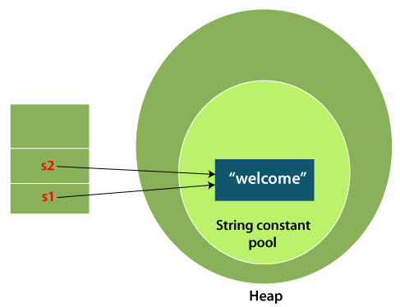

In the above example, only one object will be created. Firstly, JVM will not find any string object with the value "Welcome" in string constant pool that is why it will create a new object. After that it will find the string with the value "Welcome" in the pool, it will not create a new object but will return the reference to the same instance.

#### Note: String objects are stored in a special memory area known as the "string constant pool".

### Why Java uses the concept of String literal?

To make Java more memory efficient (because no new objects are created if it exists already in the string constant pool).

### 2) By new keyword

1. String s=new String("Welcome");//creates two objects and one reference variable

In such case, JVM will create a new string object in normal (non-pool) heap memory, and the literal "Welcome" will be placed in the string constant pool. The variable s will refer to the object in a heap (non-pool).