**Java Inheritance Example**

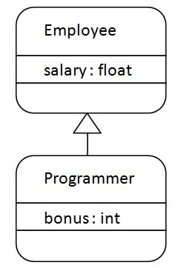

As displayed in the above figure, Programmer is the subclass and Employee is the superclass. The relationship between the two classes is **Programmer IS-A Employee**. It means that Programmer is a type of Employee.

class Employee{

 float salary=40000;

}

class Programmer extends Employee{

 int bonus=10000;

 public static void main(String args[]){

   Programmer p=new Programmer();

   System.out.println("Programmer salary is:"+p.salary);

   System.out.println("Bonus of Programmer is:"+p.bonus);

}

}

Programmer salary is:40000.0

Bonus of programmer is:10000

In the above example, Programmer object can access the field of own class as well as of Employee class i.e. code reusability.

## Types of inheritance in java

On the basis of class, there can be three types of inheritance in java: single, multilevel and hierarchical.

In java programming, multiple and hybrid inheritance is supported through interface only. We will learn about interfaces later.

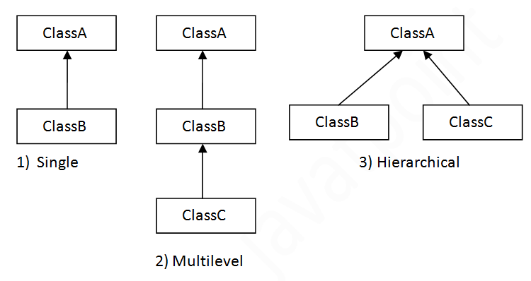

When one class inherits multiple classes, it is known as multiple inheritance. For Example:

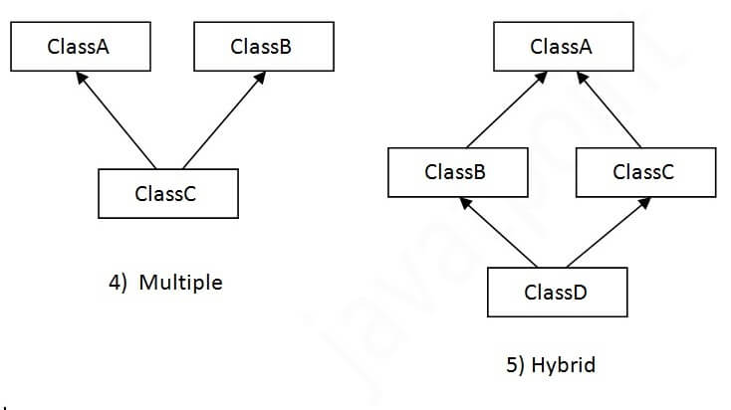

## Q) Why multiple inheritance is not supported in java?

To reduce the complexity and simplify the language, multiple inheritance is not supported in java.

Consider a scenario where A, B, and C are three classes. The C class inherits A and B classes. If A and B classes have the same method and you call it from child class object, there will be ambiguity to call the method of A or B class.

Since compile-time errors are better than runtime errors, Java renders compile-time error if you inherit 2 classes. So whether you have same method or different, there will be compile time error.