**Anagram**

The dictionary meaning of the word **anagram** is a word or phrase formed by rearranging the letters.

Two strings are said to be **anagrams** if they make a meaningful word by rearranging or shuffling the letters of the string. In other words, we can say that two strings are **anagrams** if they contain the same characters but in a different order. Note that a letter has to be used only once.

# What is an anagram in Java?

In this section, we will discuss **what is anagram in Java** and **how to check if the given string is an anagram or not.**

### Example of Anagram

There are several anagram words some of them are:

LISTEN - > SILENT

HEART - > EARTH

LIVES - > ELVIS

KEEP -> PEEK

TABLE - >BLEAT

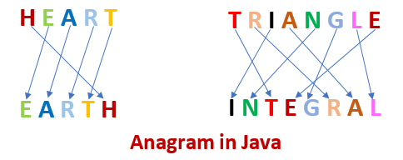

## How to check two strings are anagram or not?

* Read or initialize two strings **str1** and **str2**.
* Find the length of both the strings.
* Compare the length of the strings.
  1. If length is not equal, print strings are not an anagram.
  2. Else, do the following:
     1. Convert the string into a character array.
     2. Sort both the arrays by using the **sort()** method.
     3. After sorting, compare the strings by using the **equals()** method. Store the value in a Boolean variable (**status**) returned by the equals() method.
  3. Pass the variable in the if statement. If it returns true, the given strings are **anagram**. Else, not an **anagram**.

Let's implement the above steps in a Java program.

## Java Anagram Program

There is various way to find anagram string but, in this section, we will focus on the following three ways.

* Using Arrays Class
* Using for Loop
* Using StringBuilder Class

### Using Arrays Class

In the following program, we have used to methods **String.sort()** and **equals()** method to check if the two strings are anagram or not.