**What is a Subarray?**

A **subarray** is a contiguous part of array, i.e., Subarray is an array that is inside another array.

In general, for an array of size n, there are **n*(n+1)/2** non-empty subarrays.

For example, Consider the array [1, 2, 3, 4], There are 10 non-empty sub-arrays. The subarrays are:

(1), (2), (3), (4),

(1,2), (2,3), (3,4),

(1,2,3), (2,3,4), and

(1,2,3,4)

[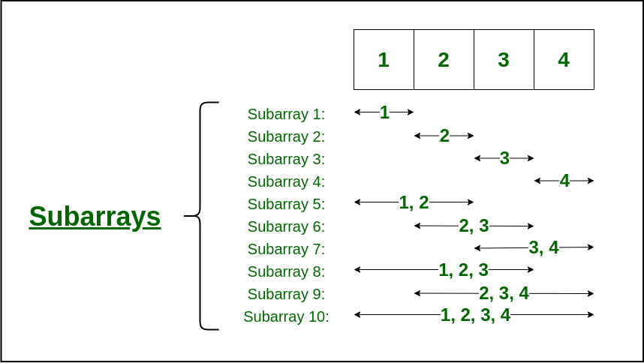](https://media.geeksforgeeks.org/wp-content/cdn-uploads/20220620163127/subarray.png)

## Java Arrays

Arrays are used to store multiple values in a single variable, instead of declaring separate variables for each value.

To declare an array, define the variable type with **square brackets**:

String[] cars;

We have now declared a variable that holds an array of strings. To insert values to it, you can place the values in a comma-separated list, inside curly braces:

String[] cars = {"Volvo", "BMW", "Ford", "Mazda"};

To create an array of integers, you could write:

int[] myNum = {10, 20, 30, 40};

## Access the Elements of an Array

You can access an array element by referring to the index number.

This statement accesses the value of the first element in cars:

### Example

String[] cars = {"Volvo", "BMW", "Ford", "Mazda"};

System.out.println(cars[0]);

// Outputs Volvo

**Note:** Array indexes start with 0: [0] is the first element. [1] is the second element, etc.

## Change an Array Element

To change the value of a specific element, refer to the index number:

### Example

cars[0] = "Opel";

### Example

String[] cars = {"Volvo", "BMW", "Ford", "Mazda"};

cars[0] = "Opel";

System.out.println(cars[0]);

// Now outputs Opel instead of Volvo

## Array Length

To find out how many elements an array has, use the length property:

### Example

String[] cars = {"Volvo", "BMW", "Ford", "Mazda"};

System.out.println(cars.length);

// Outputs 4