**Stack Data Structure**

Stack is a linear data structure which follows a particular order in which the operations are performed. The order may be LIFO(Last In First Out) or FILO(First In Last Out).

There are many real-life examples of a stack. Consider an example of plates stacked over one another in the canteen. The plate which is at the top is the first one to be removed, i.e. the plate which has been placed at the bottommost position remains in the stack for the longest period of time. So, it can be simply seen to follow LIFO(Last In First Out)/FILO(First In Last Out) order.

# What is a Stack?

A Stack is a linear data structure that follows the **LIFO (Last-In-First-Out)** principle. Stack has one end, whereas the Queue has two ends (**front and rear**). It contains only one pointer **top pointer** pointing to the topmost element of the stack. Whenever an element is added in the stack, it is added on the top of the stack, and the element can be deleted only from the stack. In other words, a **stack can be defined as a container in which insertion and deletion can be done from the one end known as the top of the stack.**

### Some key points related to stack

* It is called as stack because it behaves like a real-world stack, piles of books, etc.
* A Stack is an abstract data type with a pre-defined capacity, which means that it can store the elements of a limited size.
* It is a data structure that follows some order to insert and delete the elements, and that order can be LIFO or FILO.

### Working of Stack

Stack works on the LIFO pattern. As we can observe in the below figure there are five memory blocks in the stack; therefore, the size of the stack is 5.

Suppose we want to store the elements in a stack and let's assume that stack is empty. We have taken the stack of size 5 as shown below in which we are pushing the elements one by one until the stack becomes full.

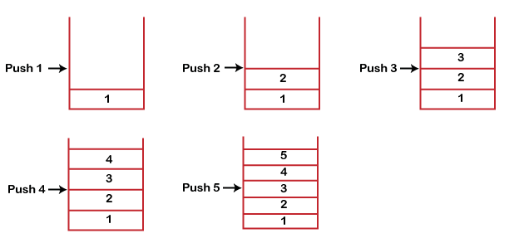

Since our stack is full as the size of the stack is 5. In the above cases, we can observe that it goes from the top to the bottom when we were entering the new element in the stack. The stack gets filled up from the bottom to the top.

When we perform the delete operation on the stack, there is only one way for entry and exit as the other end is closed. It follows the LIFO pattern, which means that the value entered first will be removed last. In the above case, the value 5 is entered first, so it will be removed only after the deletion of all the other elements.