E2/E3 Induction – Classroom Rules and Health and Safety Words – Preteaching
Name: ______________________________ Date: ______________
Use these activities before the Induction & Health and Safety RARPA form.

Activity 1 – Key words
Match each word to its meaning. Say each word with your teacher first.
Word |  | Meaning
1. ID card | ___ | a) work you do at home
2. attend | ___ | b) pay attention with your ears
3. time | ___ | c) no class – a break from college
4. folder | ___ | d) have food
5. holiday | ___ | e) keep your papers safe inside it
6. listen | ___ | f) come to class
7. respect | ___ | g) call or message the college
8. eat | ___ | h) be polite and kind to others
9. homework | ___ | i) be on time – not late
10. contact | ___ | j) a card with your photo and name

Activity 2 – must / mustn’t / should
must = a rule. It is necessary. → You must attend every day.
mustn’t = not allowed. → You mustn’t eat in class.
should = a good idea, but not a rule. → You should listen to the teacher.
shouldn’t = not a good idea, but not a rule. → You shouldn’t stay up late before an exam.
Complete each sentence with must, mustn’t or should.
- You ______________ bring your ID card every day.
- You ______________ eat in the classroom.
- You ______________ check your work before you give it to the teacher.
- You ______________ arrive on time.
- You ______________ use your phone in class.
- You ______________ practise English at home, too.

Activity 3 – Write your own rules
Use the words and must, mustn’t or should to write a full sentence.
Prompt | Your sentence
attend / every day
contact the college / if ill
homework / do it
respect / teachers and students
phone / switch off

Activity 4 – Getting ready to write
Use these sentence starters to write about the rules in your class and college.
In this class, you must ______________________________________________.
You mustn’t ______________________________________________.
You should ______________________________________________.
If you are ill, you must ______________________________________________.
You must bring your ______________________________________________.
Word bank: ID card · time · attend · folder · holiday · listen · respect · eat · homework · contact

Activity 5 – Spelling: Health and Safety signs
Read each word. Cover it. Write it from memory three times.
Sign | Word | Write it 3 times
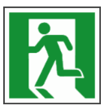 | exit
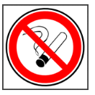 | no smoking
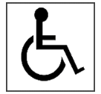 | wheelchair access
 | first aid
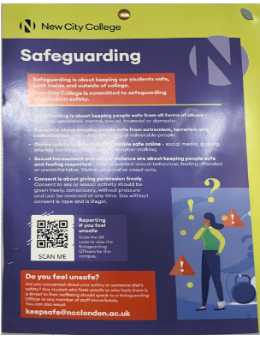 | safeguarding poster

