Entry 1 — Induction Preteaching Activities
To use before the Induction & Health and Safety RARPA evidence form
Learning aims
- Learn day and time words to talk about your timetable
- Learn classroom item words
- Use "want to" + verb to say why you are learning English
- Learn Health and Safety sign words

Activity 1 — My timetable: days and times
New words:
Monday Tuesday Wednesday Thursday Friday Saturday Sunday
o'clock morning afternoon evening
Look and say each day with your teacher. Then trace the days below.
Day | Trace and copy
Monday | ______________________________
Tuesday | ______________________________
Wednesday | ______________________________
Thursday | ______________________________
Friday | ______________________________

Grammar — talking about your timetable:
I study English on Monday at 10 o'clock.

Now write about your class:
I study English on ______________________ at ______________________.
__________________________________________________

Activity 2 — What do you bring to college?
New words — look, say, and match with your teacher:
Word | Word
pen | dictionary
folder | bag
ID card | bottle of water
paper | lunch
pencil

Now practise the sentence. Write 3 things you bring to college:
I bring my ______________________ to college.
I bring my ______________________ to college.
I bring my ______________________ to college.

Activity 3 — Why are you learning English?
Grammar — "want to" + verb:
want to + verb (no -s, no -ing)
I want to speak English.
I want to help my children.
I want to work in the UK.

Verb bank:
speak read write work help understand
Complete the sentence, then write your own 2 sentences for the form:
I want to ______________________ English because I want to ______________________.
__________________________________________________
__________________________________________________

Activity 4 — Health and Safety signs
Look at each sign. Say the word with your teacher. Trace and copy the word 3 times before you do the matching task.
Sign | Word — trace and copy it 3 times
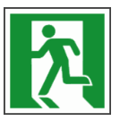 | exit  ___________________________________  ___________________________________
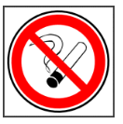 | no smoking  ___________________________________  ___________________________________
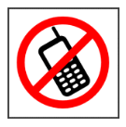 | switch off phones  ___________________________________  ___________________________________
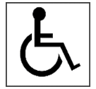 | wheelchair access  ___________________________________  ___________________________________
 | first aid  ___________________________________  ___________________________________

