E1 Describe the Picture 1: In the kitchen
Name: ______________________________ Date: ________________
Useful language: In this picture I can see … · There is a … / There are … · He is / She is / They are …ing · I like it because …
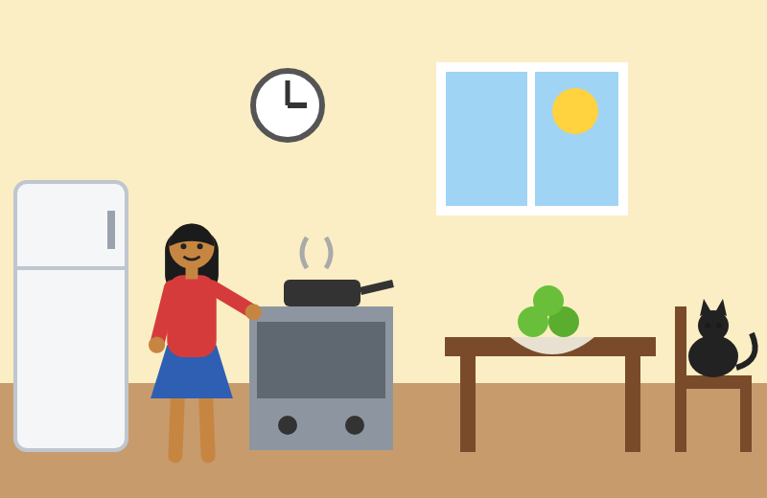  Picture A | 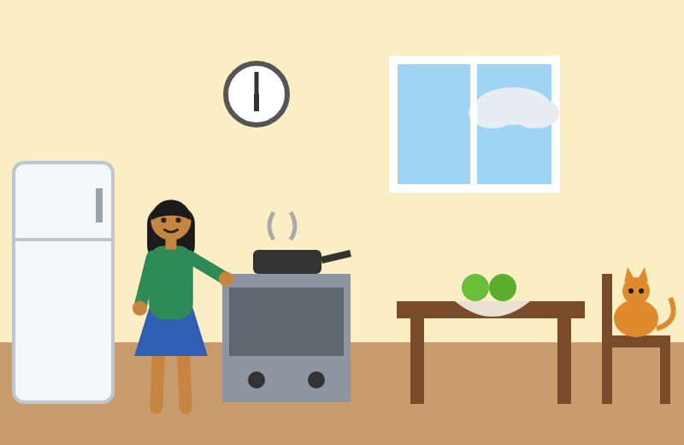  Picture B
Part 1: Look at Picture A. Write the words in the gaps.
Word box: kitchen cooking red three apples cat chair
In this picture I can see a (1) __________. A woman is (2) __________. She has a (3) __________ top. There are (4) __________ green (5) __________ on the table. A black (6) __________ is on the (7) __________.
Part 2: Answer the questions. Write full sentences.
1. What is the woman doing?
____________________________________________________________________
2. What is on the table?
____________________________________________________________________
3. Where is the cat?
____________________________________________________________________
4. Do you like cooking? Why? / Why not?
____________________________________________________________________
5. What food do you cook at home?
____________________________________________________________________
Part 3: Find 5 differences between Picture A and Picture B.
 | In Picture A … | In Picture B …
1
2
3
4
5

E1 Describe the Picture 2: In the park
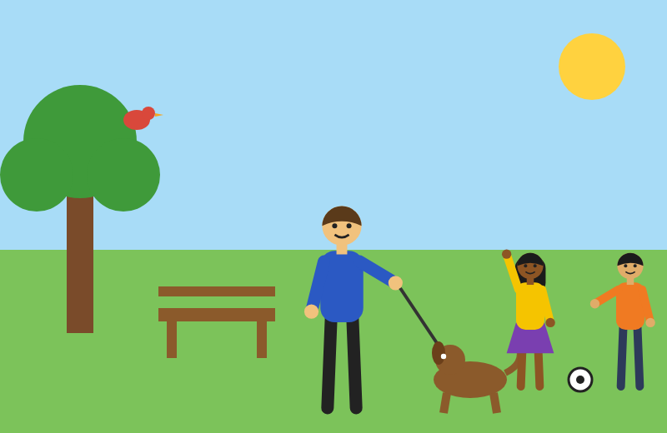  Picture A | 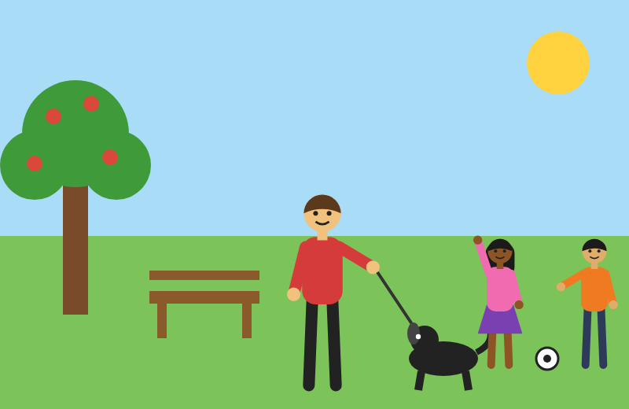  Picture B
Part 1: Look at Picture A. Write the words in the gaps.
Word box: park sunny walking dog children football bird
In this picture I can see a (1) __________. It is (2) __________. A man is (3) __________ his (4) __________. Two (5) __________ are playing (6) __________. There is a (7) __________ in the tree.
Part 2: Answer the questions. Write full sentences.
1. What is the man doing?
____________________________________________________________________
2. What are the children doing?
____________________________________________________________________
3. What is in the tree?
____________________________________________________________________
4. Do you like parks? Why? / Why not?
____________________________________________________________________
5. What do you do at the weekend?
____________________________________________________________________
Part 3: Find 5 differences between Picture A and Picture B.
 | In Picture A … | In Picture B …
1
2
3
4
5

E1 Describe the Picture 3: At the bus stop
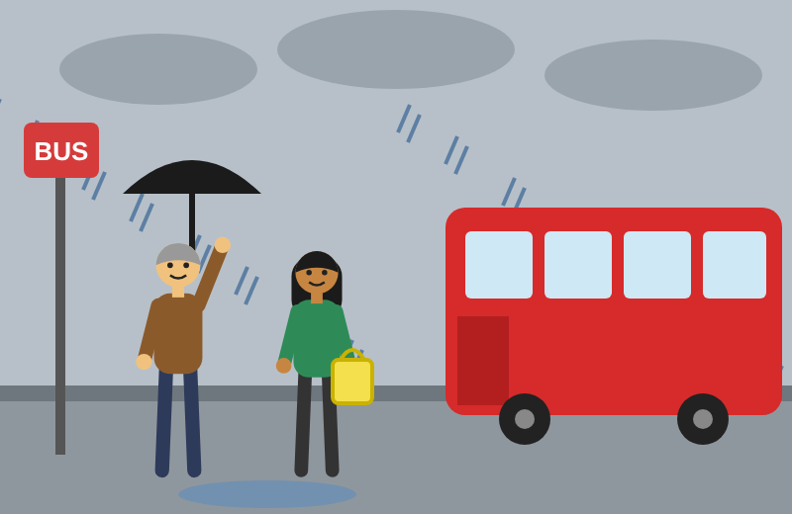  Picture A | 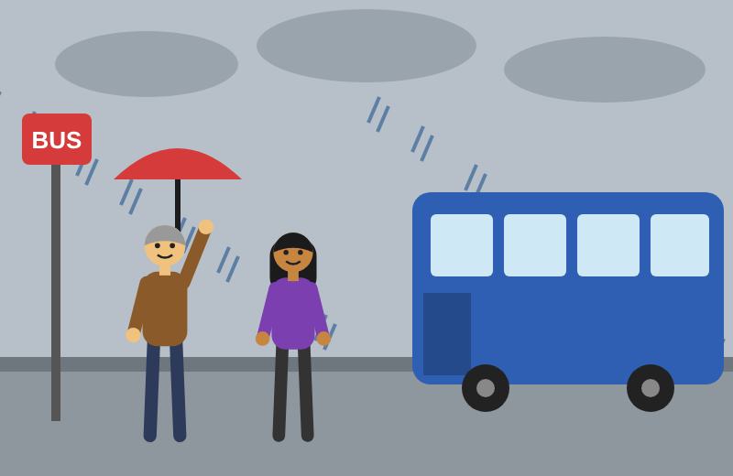  Picture B
Part 1: Look at Picture A. Write the words in the gaps.
Word box: bus stop raining umbrella bag green coat red
In this picture I can see a (1) __________. It is (2) __________. A man has a black (3) __________. A woman has a (4) __________. She is wearing a (5) __________ (6) __________. The (7) __________ bus is coming.
Part 2: Answer the questions. Write full sentences.
1. What is the weather like?
____________________________________________________________________
2. What is the man holding?
____________________________________________________________________
3. What is the woman wearing?
____________________________________________________________________
4. Do you like the rain? Why? / Why not?
____________________________________________________________________
5. How do you come to college?
____________________________________________________________________
Part 3: Find 5 differences between Picture A and Picture B.
 | In Picture A … | In Picture B …
1
2
3
4
5

E1 Describe the Picture 4: In the classroom
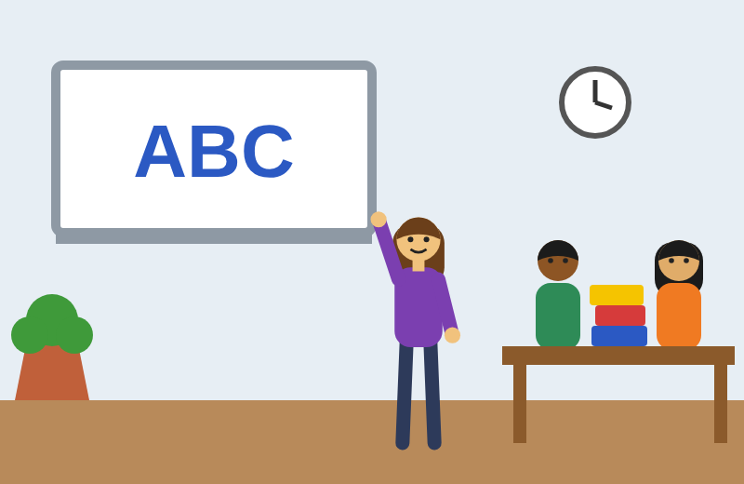  Picture A | 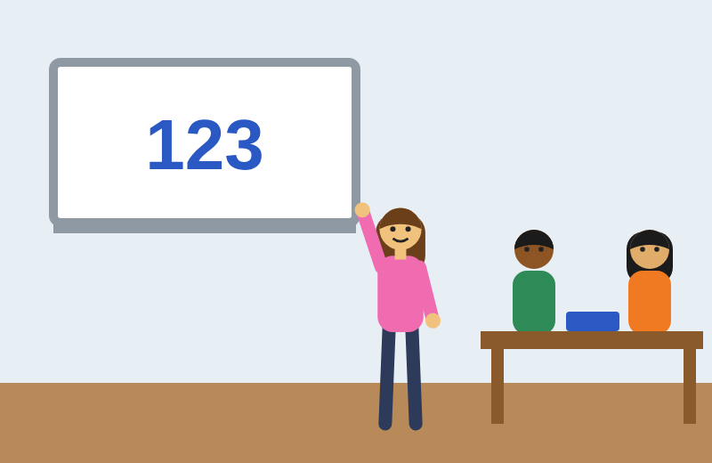  Picture B
Part 1: Look at Picture A. Write the words in the gaps.
Word box: classroom teacher board two sitting desks books
In this picture I can see a (1) __________. The (2) __________ is pointing at the (3) __________. There are (4) __________ students. They are (5) __________ at their (6) __________. There are (7) __________ on the desks.
Part 2: Answer the questions. Write full sentences.
1. What is the teacher doing?
____________________________________________________________________
2. How many students can you see?
____________________________________________________________________
3. What is on the desks?
____________________________________________________________________
4. Do you like learning English? Why?
____________________________________________________________________
5. What is your favourite lesson?
____________________________________________________________________
Part 3: Find 5 differences between Picture A and Picture B.
 | In Picture A … | In Picture B …
1
2
3
4
5

