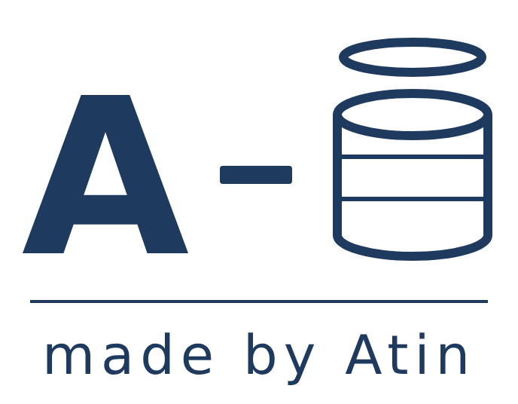

What Does It Test? Reading Exam Sort – Answers

Teacher answer key
Skill | Questions | Curriculum focus
1. Alphabetical order | 3, 8, 15 | Word (Rw)
2. Vocabulary | 6, 12, 20 | Word (Rw)
3. Scanning for information | 1, 9, 16 | Text (Rt)
4. Gist | 4, 13, 18 | Text (Rt)
5. Grammar and punctuation | 2, 10, 17 | Sentence (Rs)
6. Text type and layout | 5, 11, 19 | Text (Rt)
7. Inference | 7, 14, 21 | Text (Rt)
Answers to the questions
Q | Answer
1 | 3pm
2 | c) organised
3 | c) children
4 | b
5 | a
6 | c
7 | a
8 | advice, coat, nurse, soup
9 | c) midday–1pm
10 | The event is at Clapton Community Hall on Saturday.
11 | b) a leaflet
12 | boots
13 | c
14 | No – children must stay with an adult.
15 | Amina, Dariusz, Kofi, Yusuf
16 | 020 7946 0381
17 | must
18 | b
19 | the section headed “Lunch”
20 | a) Please come.
21 | a
Words repeated from the text on purpose: Q6 (advice), Q20 and Q21 (quoted phrases), Q17 (quoted rule) and Q8 (word list). These target the word or sentence itself, so paraphrase would defeat the item. Discussion point: Q14 and Q12 can be argued as scanning – worth letting learners debate.

