

In the Kitchen – Questions and Answers
Name: ______________________ Date: ______________
Look at the picture of the kitchen. Match the questions (1–13) with the answers (a–m). Write the letter.
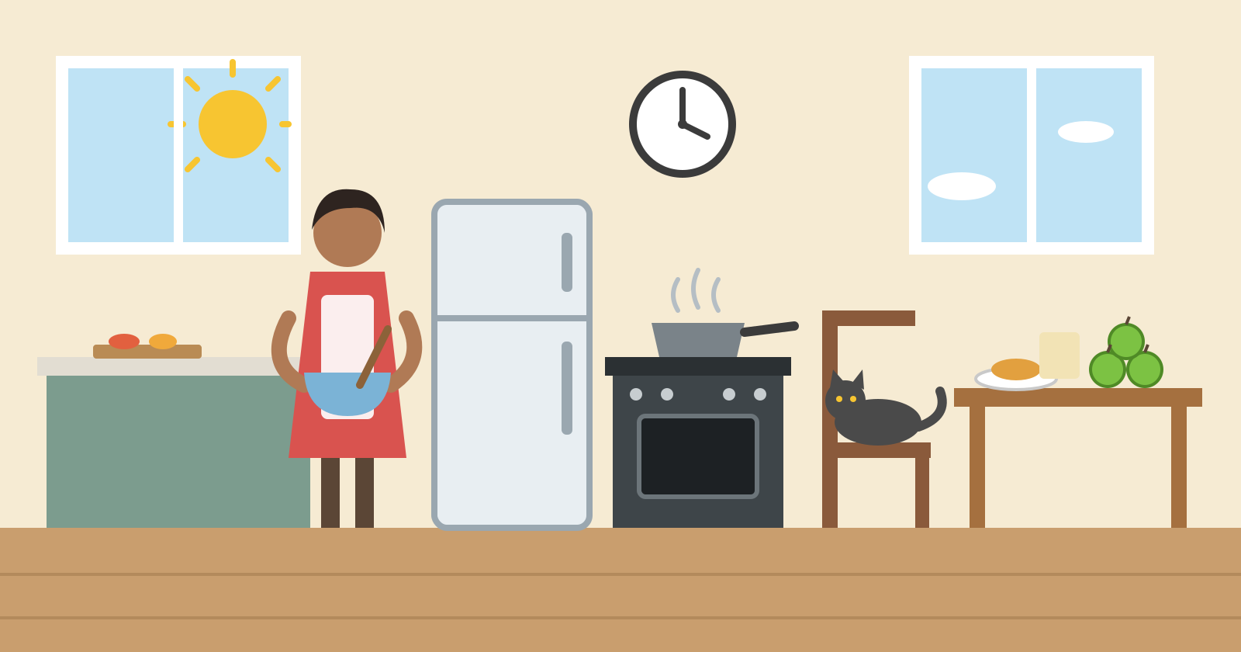

Questions
No. | Question | Letter
1 | What is on the wall?
2 | Who is cooking?
3 | Is there a table in the kitchen?
4 | Where is the food?
5 | How many apples are there on the table?
6 | Is there a refrigerator in the kitchen?
7 | What is between the woman and the cooker?
8 | Where is the sun?
9 | What is on the chair?
10 | Are there windows in the kitchen?
11 | What is on the stove?
12 | Who is next to the fridge?
13 | Is there a cooker in the kitchen?

Answers
Letter | Answer
a | There is a cooker in the kitchen.
b | The sun is in the sky.
c | There is a cat on the chair.
d | There is a woman next to the fridge.
e | There are three green apples on the table.
f | There is a pan on the stove.
g | There is a table in the kitchen.
h | The fridge is between the woman and the cooker.
i | There is a clock on the wall.
j | The food is on the table.
k | There are windows in the kitchen.
l | There is a woman cooking.
m | There is a refrigerator in the kitchen.

Answer key (teacher only)
1 i · 2 l · 3 g · 4 j · 5 e · 6 m · 7 h · 8 b · 9 c · 10 k · 11 f · 12 d · 13 a

