E3 Mixed Tenses – Error Hunt Name: ____________________  Find 11 grammar mistakes. Underline them. Write the corrections in the table. | 
The Hackney Bugle
Wednesday 21 October 2026 · Your local news
Home News Hackney Dalston Homerton What's on Sport
WELL STREET · LOCAL NEWS  Angry shop owner tells graffiti artist: "This is my last warning"  A poster on a Well Street shutter has got people talking. Is it a warning or a threat?  By Bugle reporter · 21 October 2026  A shop owner on Well Street have put an angry poster on his shutter after graffiti artists paint his shop five times this year.  The poster, which has appeared last week, says "This is my last and final warning". It also shows two photos from the shop's CCTV camera.  "I have clean the shutter many times," the owner told the Bugle. "Last month I have paid £200 to clean it. I am work every day and I doesn't want any trouble."  Local people has different opinions. "Some graffiti is art, but this is just tagging," said Maria, who live near the shop. Another neighbour, Tom, said: "The poster is a threat. He should to call the police."  A police spokesperson said: "We will looking at the CCTV. Shop owners should report graffiti to us."  The owner says he will keep the poster on his shutter until the graffiti stops. | 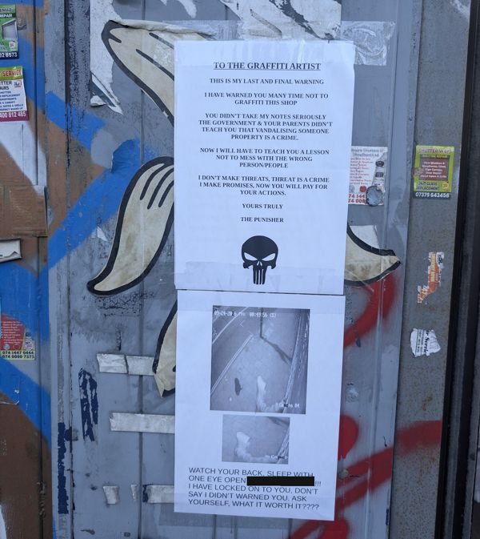  The poster on the shutter, with two photos from the shop's CCTV camera.  CLUES  • 2 mistakes with has / have  • 4 mistakes with past simple or present perfect  • 2 mistakes with I + present simple  • 1 mistake: he / she + -s  • 2 mistakes after will and should: use the base verb
Corrections
 | Mistake | Correction |  | Mistake | Correction
1 |  |  | 7
2 |  |  | 8
3 |  |  | 9
4 |  |  | 10
5 |  |  | 11
6
The Hackney Bugle is a made-up newspaper for an English lesson.

E3 Reading Exam Practice – The Hackney Bugle
Name: ______________________ Time: 30 minutes
Read the newspaper article on page 1 again. Then answer the questions.
Part A – Choose the correct answer: A, B, C or D.
1. Why did the newspaper write this story?
A to advertise a shop | B to report a local problem
C to explain how to remove paint | D to give a phone number

2. In 2026, how often has someone damaged the shop?
A two times | B four times
C five times | D eight times

3. What else is on the notice, next to the message?
A a phone number | B a map
C the artist's name | D pictures from a security camera

4. How much did the owner spend a month ago?
A £20 | B £100
C £200 | D £2,000

5. Who thinks the notice could frighten someone?
A Maria | B Tom
C the police | D the reporter

6. What does the owner plan to do?
A take the notice down soon | B leave the notice up until the painting ends
C paint the shutter himself | D move to a different street

Part B – True (T), False (F) or Not Given (NG)? Circle one.
7. The notice went up about seven days ago. | T | F | NG
8. Maria believes all painting on walls is bad. | T | F | NG
9. Maria's home is close to the business. | T | F | NG
10. The police have caught the person responsible. | T | F | NG
11. The owner is looking for problems. | T | F | NG
12. Tom has met the person who damaged the shop. | T | F | NG
Part C – Answer the questions. Write one word or a short phrase.
13. Which road is the business on? ________________________________
14. What word does a neighbour use for paint on walls that is NOT art? ______________________
15. Who does the police officer want to hear from about painted walls? ______________________

