1. PYTHON VIRTUAL ENVIRONMENT -venv is a folder inside your working directory -contains libraries and modules required for the project -to create a venv, on the cmd, type the following research task 1: *find other ways to create a venv

You

8:02 PM

okay

TechCamp Africa

8:02 PM

2. PYTHON VARIABLES *statically typed *dynamically *RULES FOLLOWED WHEN CREATING VARIABLES 1. no spaces NB: INSTEAD USE a) snake type way of naming variable - words contain _ eg first_name, date_of_birth b) camel case way of naming variable - the 1st letter of second word is title-case eg. firstName, dateOfBirth

3. PYTHON KEYWORDS examples: if,else, and, or, not, in, for...etc research task 2: more keywords 4. PYTHON DATA TYPES –

**Site for learning**

https://meet.google.com/linkredirect?authuser=0&dest=https%3A%2F%2Fedabit.com%2Fchallenges%2Fpython3

p

**steps in setting up the libraries**

python -m venv env

then env\Scripts\activate

pip freeze>requirements.txt

**functions**

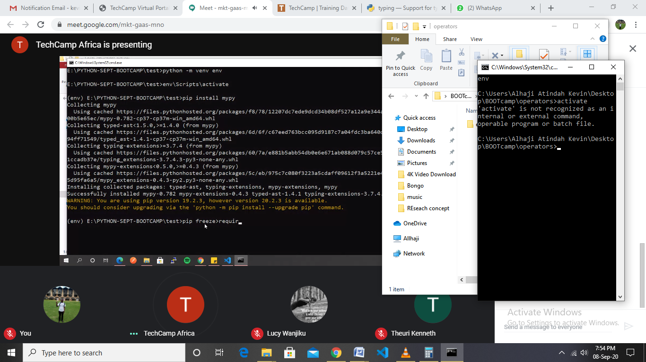

REQUIREMENTS pt A -CREATE A CONSOLE APP THAT ASKS FOR THE FOLLOWING -STUDENT NAME, -CLASS, -CLASS TEACHER -ASK FOR THE SCORES FOR THE FOLLOWING SUBJECTS 1.Math 2.Eng 3.Kisw 4.Sci 5.SST -COMPUTE THE FOLLOWING a) Total score b) Average score pt B USING THE FOLLOWING THE FOLLOWING SYSTEM GRADE THE STUDENT based on the average score 80-100 A

75-79 A-

70-74 B+

65-69 B

60-64 B-

55-59 C+

50-54 C

45-49 C-

40-44 D+

35-39 D

30-34 D-

0-29 E I – Invalid

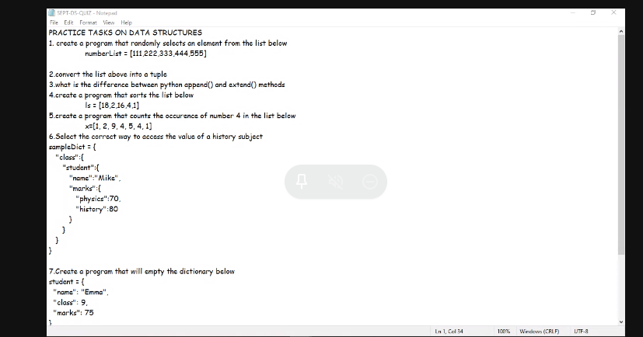

**Calculator design**

<https://meet.google.com/linkredirect?authuser=0&dest=https%3A%2F%2Fgithub.com%2Fleonbaraza%2Fformula-to-calculate-tax>

<https://meet.google.com/linkredirect?authuser=0&dest=https%3A%2F%2Fwww.geeksforgeeks.org%2Ffunctools-module-in-python%2F%23%3A~%3Atext%3DFunctools%2520module%2520is%2520for%2520higher%2Ctwo%2520classes%2520%25E2%2580%2593%2520partial%2520and%2520partialmethod>

**TASKS**

1. SELECT o.OrderId, o.OrderDate, c.CustomerName, c.City, c.Address, c.PostalCode, s.ShipperName, p.ProductName, d.Quantity from Orders o INNER JOIN Customers c ON o.CustomerID=c.CustomerID INNER JOIN Shippers s ON o.ShipperID=s.ShipperID INNER JOIN OrderDetails d ON o.OrderID=d.OrderID INNER JOIN products p ON d.ProductID=p.ProductID;

2. SELECT p.ProductName,s.ShipperName FROM Products as p JOIN OrderDetails as ord ON p.ProductID = ord.ProductID JOIN Orders as o ON o.OrderID = ord.OrderID JOIN Shippers as s ON s.ShipperID = o.ShipperID

3. SELECT COUNT(p.ProductID),s.ShipperName, s.ShipperID FROM Shippers as s JOIN Orders as o ON o.ShipperID = s.ShipperID JOIN OrderDetails as ord ON o.OrderID=ord.OrderID JOIN Products as p ON ord.ProductID=p.ProductID GROUP BY s.ShipperID

4.

5. SELECT * FROM Customers

WHERE CustomerName LIKE '%son%'

6. SELECT * FROM [Orders]

WHERE OrderDate BETWEEN '1996-10-01' AND "1996-10-30"

ORDER BY OrderDate ASC;

Or

SELECT o.orderid,o.orderdate FROM [Orders] as o where orderdate like '1996-10%' order by orderdate asc

7. SELECT * FROM [Products] as p join orderdetails as od on p.productid = od.productid join orders as ord on od.orderid = ord.orderid where ord.orderdate like '1997%'

pivot table

composite primary key

Update : alter

Child table - Id - serial primary key profile_id - int -Foreign key

Profile - id - primary key

Read about Self Join and come up with an example