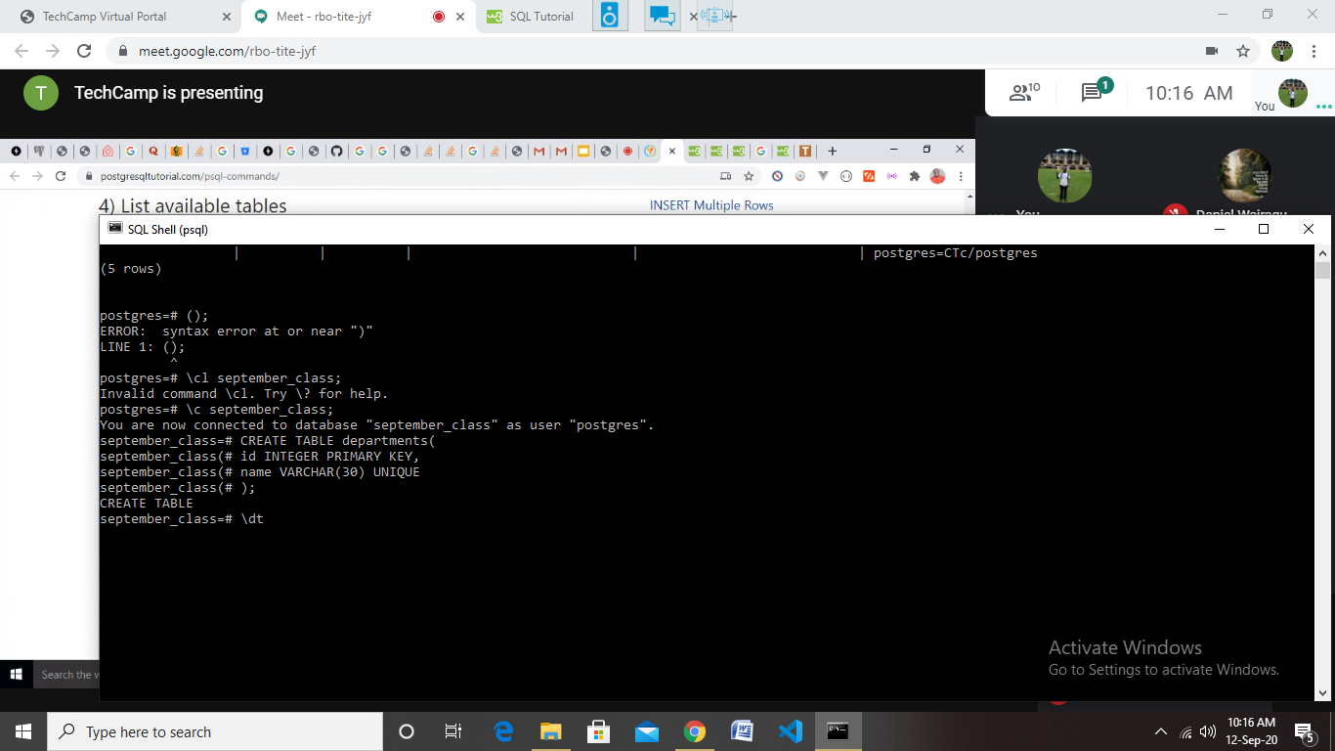

\dt;

\d departments;

uter - what one offers, what all of you offer (left, right, full outer join) self join - employees supervisors

TechCamp

11:21 AM

SELECT \* FROM Customers as c join Orders as o ON c.CustomerID = o.CustomerID;

TechCamp

11:28 AM

SELECT \* FROM Customers as c join Orders as o ON c.CustomerID = o.CustomerID join OrderDetails as ord on o.OrderID = ord.OrderID;

OrderId, OrderDate, CustomerName, City, Address, PostalCode, ShipperName, ProductName, Quantity.