**Linux Programming: Assignment-1:**

1. **What is Linux Operating System (OS)? List three pros and cons of it**.

Ans. Linux operating system is a open source software known for its security and stability. It is a Unix like operating system that manages system hardware and software.

Pros: Cons:

1.Open source 1.Takes time to learn (because it is CLI)

2.Security 2.Hardware driver issues

3.Performance 3.Gaming limitations

1. **Differentiate between Linux, Mac, Android, and Windows OS with at least six unique features.**

|  |  |  |  |
| --- | --- | --- | --- |
| **Linux** | **Mac** | **Android** | **Windows** |
| Command line interface | Graphical user interface | Graphical user interface | Graphical user interface |
| Strong security | High Security | Secure | Secure |
| For computers | For computers | Mobile Focused | For computers |
| Free OS | Economical | Free OS | Economical |
| Open Source | Not an open source | Open Source | Not an open source |
| Faster compared to other three | Fast | Fast | Fast |

Ans.

1. **Why is Linux preferred for Mainframe Servers for legacy application? Give three out-of-the-box technical reasons**

Ans. Reasons Linux is preferred for Mainframe servers:

* Size is less compared to other OS (approx. 5GB).
* Can handle large amount of data and traffic
* Provides backward compatibility.

1. **Explain the structure of the Linux File System with proper diagram. Note: you can use the tree command to find it out.**

Ans. Linux follows a Hierarchical structure with root directory present at the top. All the other directories and files branch out from this root. In Linux everything is treated as a file or a special file that can be interacted with using a standard file operation. In the below picture, Desktop is the root directory and the rest directories and file are branched out from the root directory, giving a total count of 9 directories and 2 files.

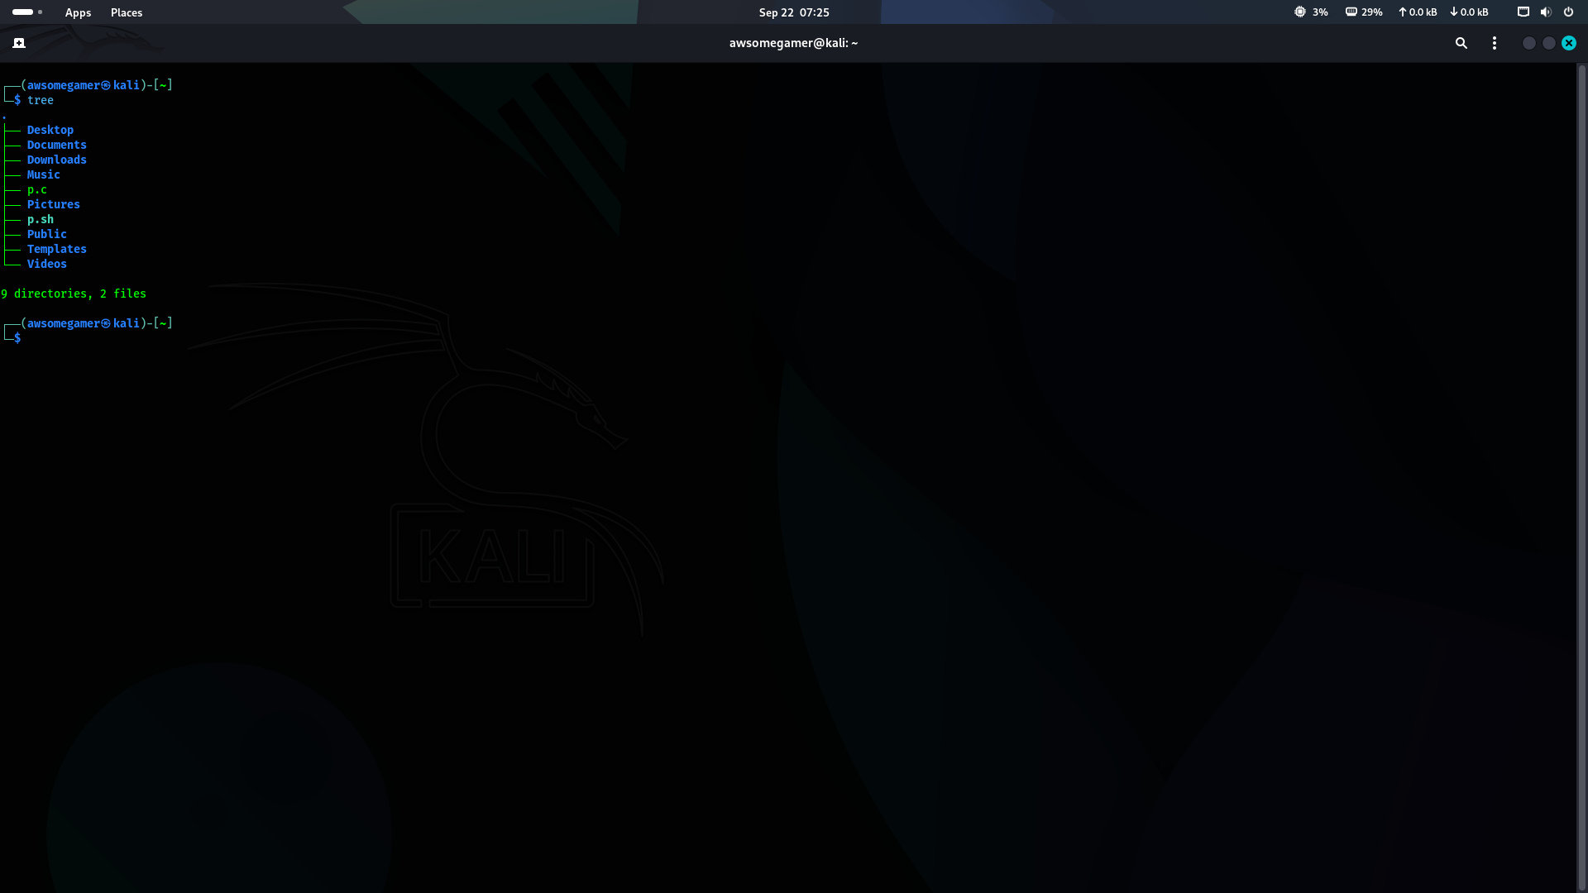

1. **If Linux OS is open-source, how do companies like Red Hat still making money from it? Do a market study and answer properly.**

Ans. Companies like REDHAT use the open source OS like Linux OS and make it customizable and sell it in the market and make money. They add value, support, service and enterprise grade reliability and make it more useful. Red Hat's model which is often referred to as the "open-source business model” is centered on a subscription service. Customers don't buy a license for Red Hat Enterprise Linux (RHEL) they purchase a subscription that gives them access to a comprehensive package of services. They also provide good technical support.

1. **Write the command to display today’s date and time (i.e., current System time).**

Ans. Command: date

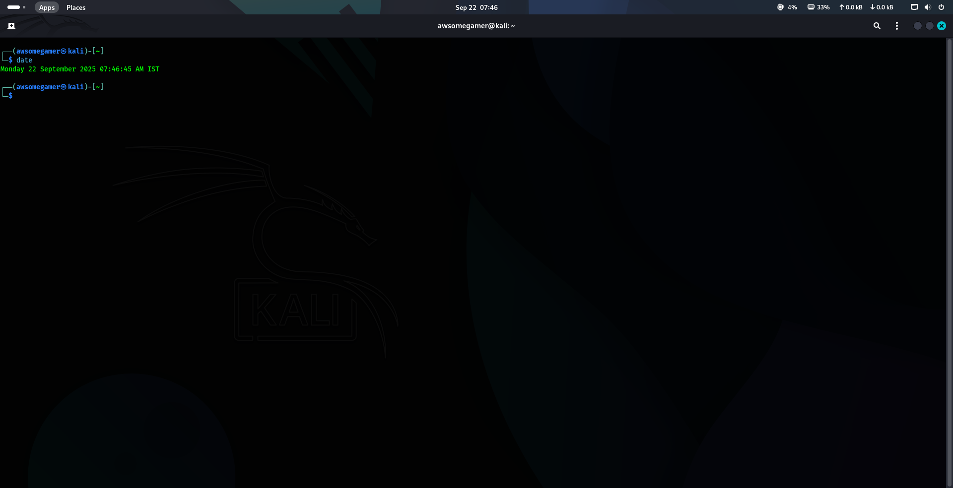

1. **Which command is used to check how long the system has been running?**

Ans. Command: uptime

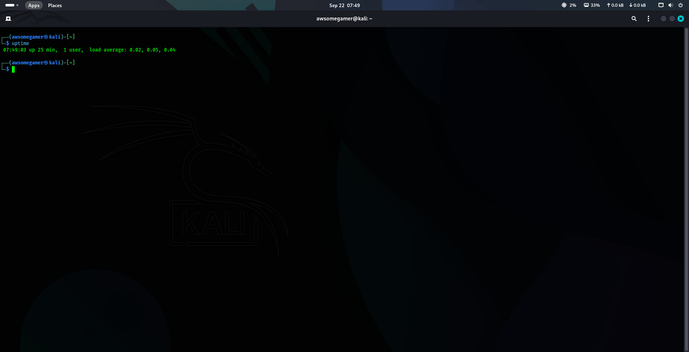

1. **What is the difference between shutdown -h now and halt?**

Ans. Shutdown -h - It Shutdowns the system or brings the system to its lowest state and will turn off the power. It instructs the system to power down.

Halt – It Shutdowns the system or brings the system to its lowest state but doesn’t turn off the power. It instructs the hardware to stop the CPU functions.

1. **Compare init 0 and shutdown -h. Which is safer? Why?**

Ans.

|  |  |
| --- | --- |
| **Init 0** | **shutdown -h** |
| Shutdowns the system without notification | Shutdowns the system with notification |
| Can be initiated by super user | Should be initiated by super user |
| Cannot set shutdown time | Can set shutdown time |

Compared to init 0 and shutdown -h, shutdown -h is safer because the -h(halt) option will stop the system after a clean shutdown.

1. **A system administrator accidentally powers off a Server machine without shutting it down properly. What problems can occur to the said Server?**

Ans. By powering off of the machine without proper shutdown can cause the following problems:

* Data corruption
* Data Loss
* Hardware damage
* Application Malfunction

**BRAINSTROMING:**

1. **As Linux Kernel is open-source, can we build our own operating system?**

Ans. Yes, we can build our own operating system.

1. **In order to do that, what are the stoppers, hurdles, and challenges?**

Ans. The challenges faced to build an operating system are:

* Bootloader
* Lack of utilities
* Hardware support
* Drivers
* Security
* Maintenance

1. **Is anyone in India working on this field? Find at-least three to four engineers**.

Ans. Yes, there are Indians working on this field. Some of them are:

* Sudeep Holla
* Viresh Kumar
* Tejun Heo
* Aakarsh Jain