**Linux Programming: Assignment-2:**

1. **What does the command pwd, whoami, and hostname display?**

Ans.

* Pwd- displays present working directory
* Whoami -displays username
* Hostname – displays name of the system

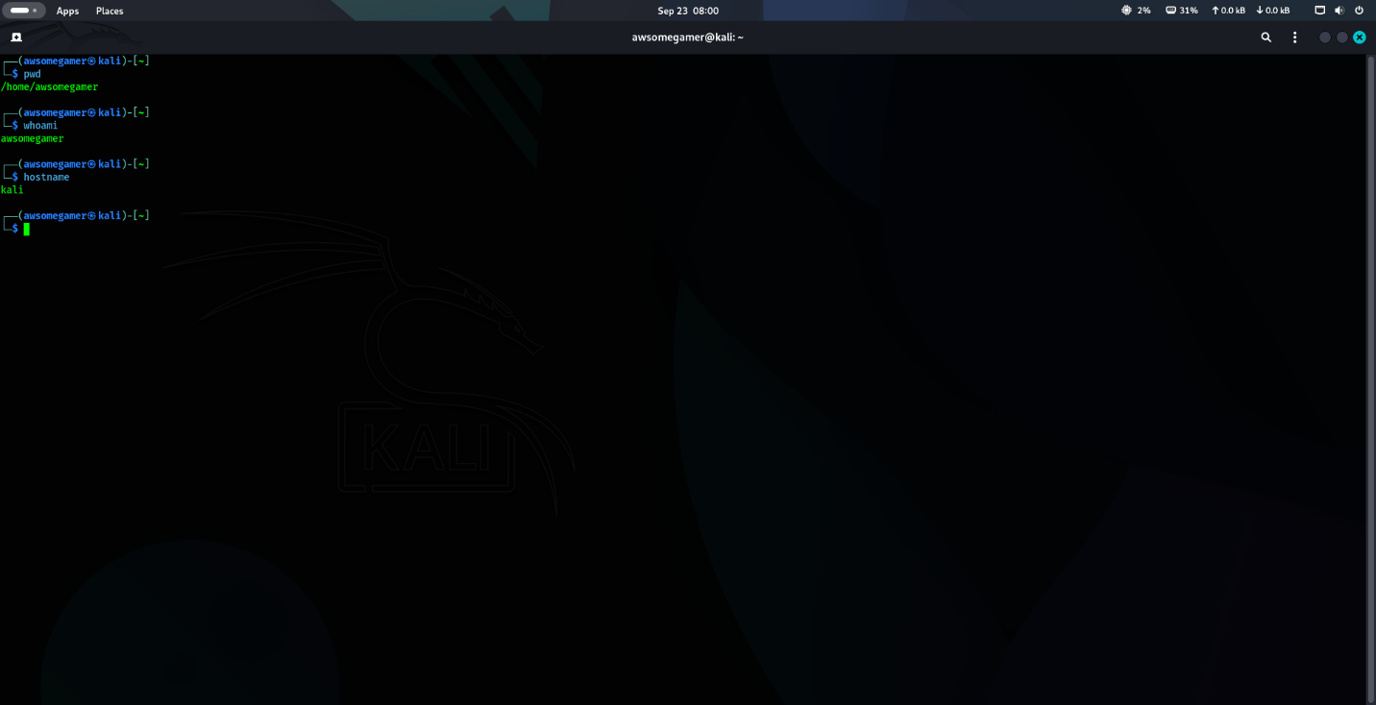

1. **Write the command to create a directory named “project” inside the /home/student folder and keep three .txt file into it. Give output snapshot.**

Ans.

* mkdir /home/student/project
* touch /home/student/project/file1.txt
* touch /home/student/project/file2.txt
* touch /home/student/project/file3.txt

1. **Explain the difference between absolute path and relative path with proper examples.**

Ans.

* Absolute path- This is the route to a file or directory which includes or starts from root directory. Since it starts from root node it displays same location regardless of your present working directory.

EX: /home/student/project/file1.txt

* Relative path- This is a route to a file or directory which starts from your present working directory

EX:/project/file1.txt

1. **What command will give you the already executed command traces in the terminal. Give output snapshot.**

Ans. Command- History

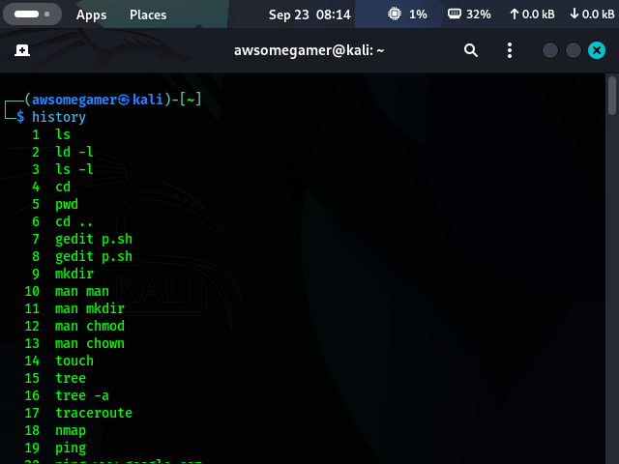

1. **Compare the working functionality of find and locate command. Which one is faster and why?**

Ans.

* Find – This command searches for files and directories by traversing the filesystem tree from a specified starting point. It will always show you the most up to date result.
* Locate – This command searches for files by querying a pre-built database. This contains a list of all files and their paths and it is typically updated once a day.

Comparing find and locate, locate is faster because it rely on a pre-built database.

1. **Which command is used to modify file permissions in Linux? Give an example.**

Ans. Command: chmod

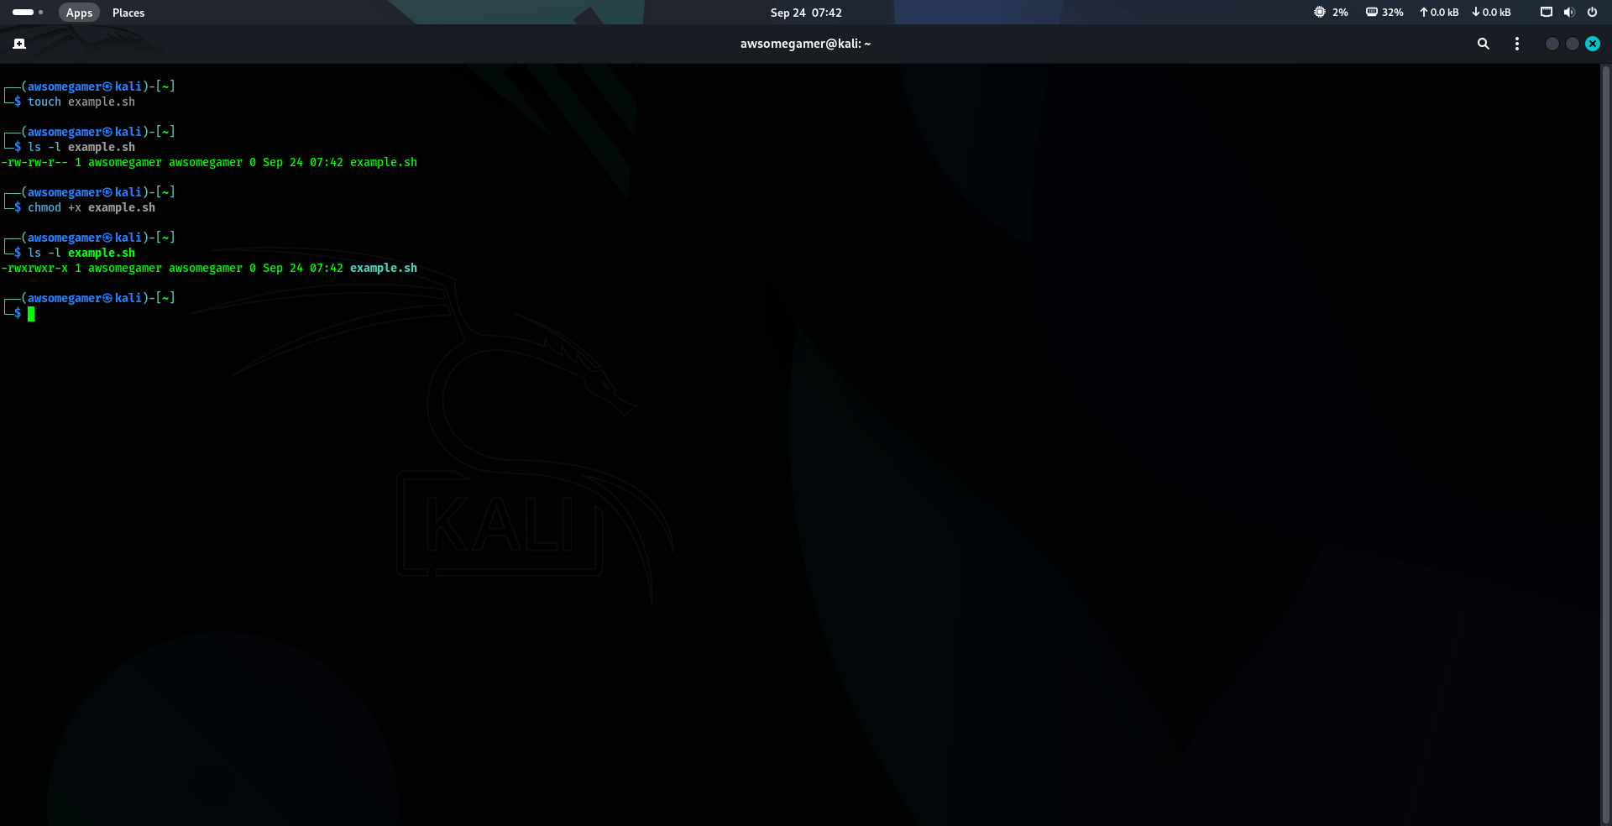

In the above example, I’ve created a bash file (example.sh). The file is initially not executable. By using the chmod command I’ve changed the permission of the file and made it as executable.

1. **A file has permissions -rw -r- -r- -. What does this mean?**

Ans. The first dash (- ) represents that it is a regular file. The next characters (rw-) which represents the owner’s permission i.e, r(read), w(write), (-) no execute permission. The next characters (r--) represents group permission. The next net of characters (r--) represents permission for other users in the system.

1. **Explain the difference between chown and chgrp with an example.**

Ans.

* chown- It is used to change the owner and optionally the group owner of a file or directory.
* chgrp-It is used to change the group owner of a file or directory.

1. **A file needs to be accessible by multiple users but only writable by the owner. How will you set permissions?**

Ans. This is done by using the chmod command with octal permission code 644. The chmod is a combination of three digits for a different category of users:

* 6 - represents owner’s permissions. 6(sum of 4 and 2), 4(read) and 2(write). This gives owner read and write access.
* 4 - represents group’s permission. This value is for read only access.
* 4 - represents the other user’s permission. This value is for read only access.

1. **How do you check the manual page for any Linux commands?**

Ans. Command: man (command name)

