**Linux Programming: Assignment-3:**

1. **Distinguish between man and whatis commands? Justify with proper example.**

Ans.

* whatis- It gives one-line description of any command.
* man – displays the manual of a command

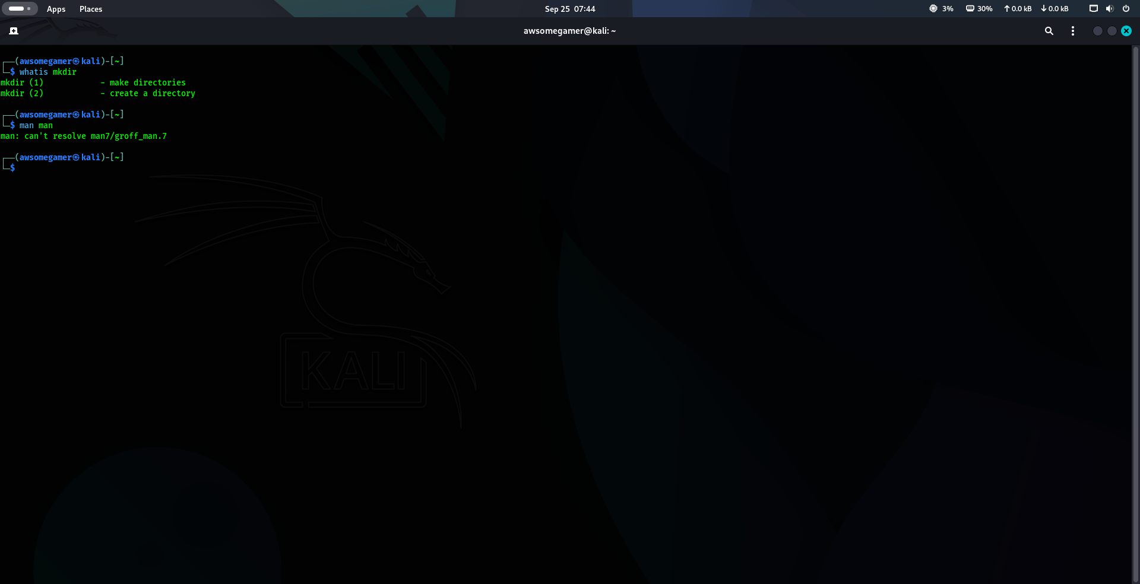

1. **Use the tee command to save the output of ls -l into a file while also displaying it.**

Ans.

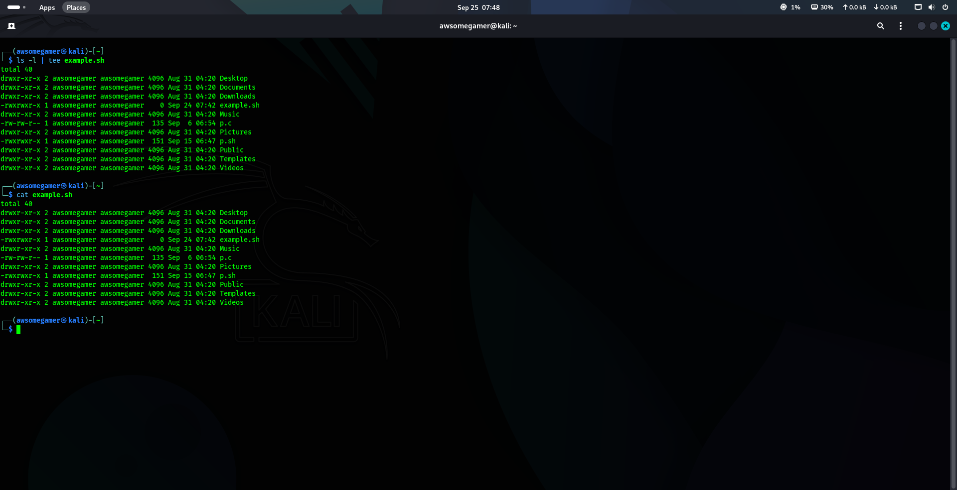

1. **Explain with an example how the tee command can be used in logging.**

Ans. Command – [file executing command] | tee [other file]

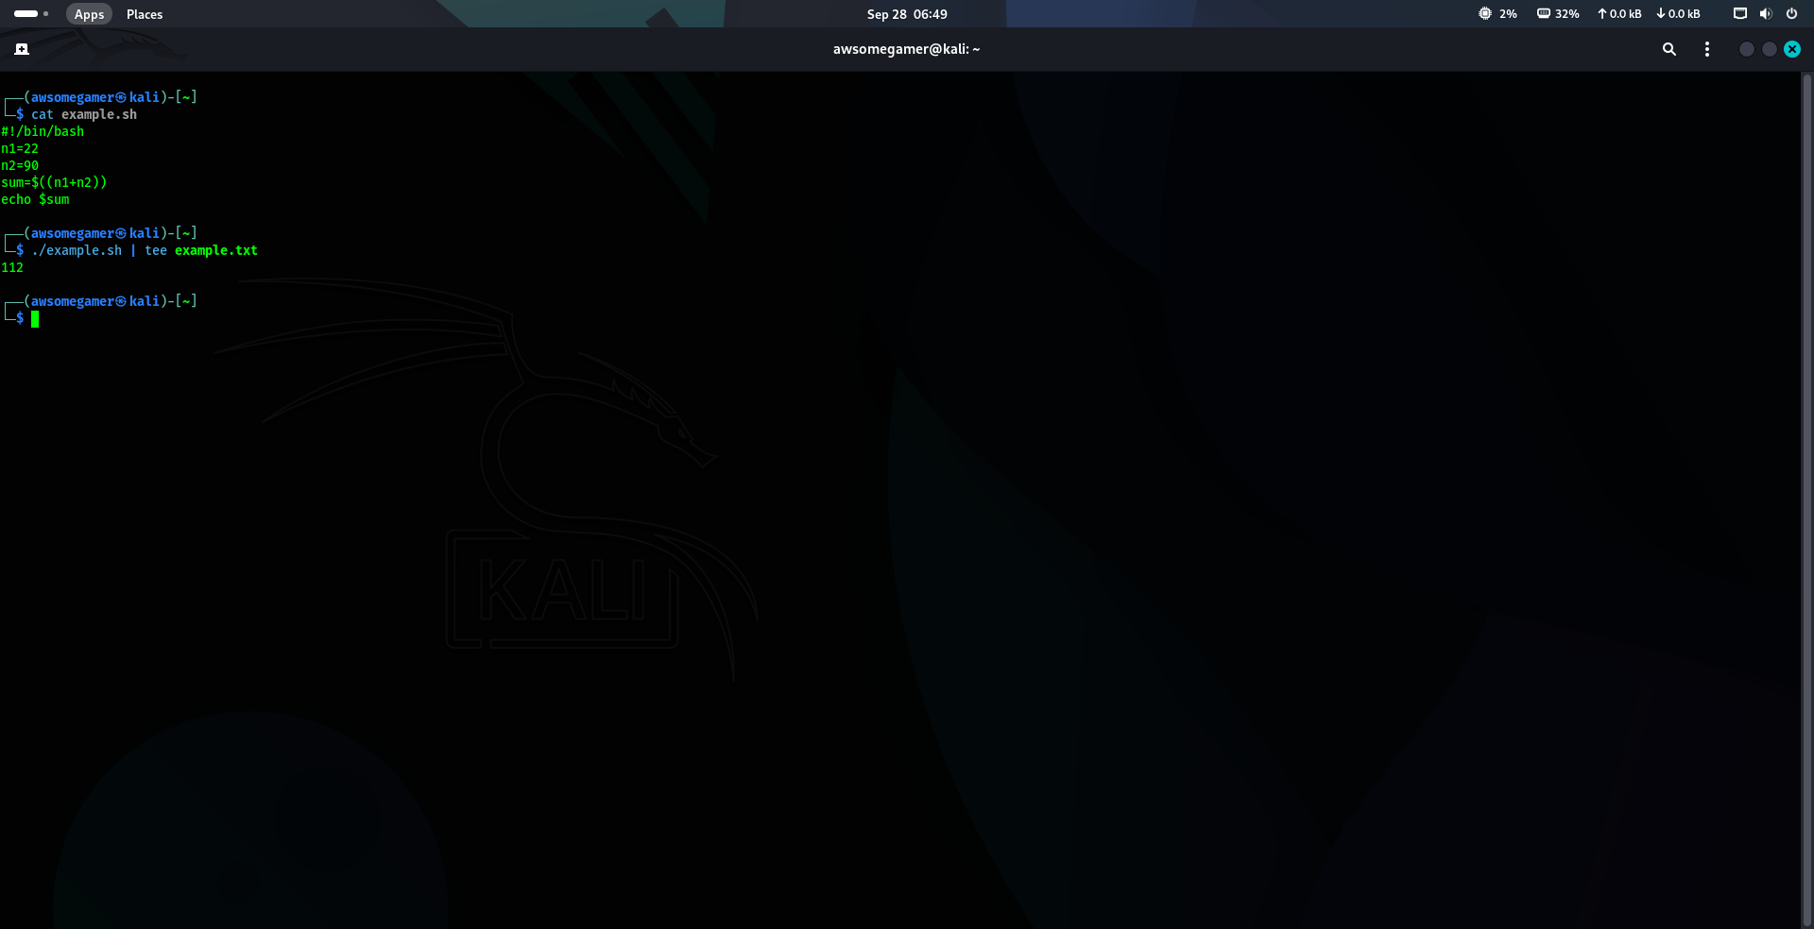

**4. List the steps involved in installing Ubuntu 25.04 LTS on Oracle VirtualBox.**

Ans.

* Install oracle virtual box on your machine
* Allocate hardware resources
* Install ubuntu from the official software
* In virtual box add the ubuntu file installed
* Allocate space, ram, and no. of cores of CPU
* After installing open the ubuntu software and start using it

**5. During Ubuntu OS installation, you face a Kernel Panic Error. How would you troubleshoot it?**

Ans.

* Adjust the hardware settings
* Check the installation media
* Inspect system hardware

**6. Write the command to display the system’s hostname? How to change hostname using sysctl command?**

Ans. Command – hostname

Command to change hostname(temporary) – sudo systcl kernel.[hostname] = [new-hostname]

Command to change hostname(permanent) – sudo [hostname]ctl set-[hostname] [your-new-hostname].

**7. Which command is used to show the calendar of the year 1984 with August month?**

Ans. Command – cal [month no.] [year]

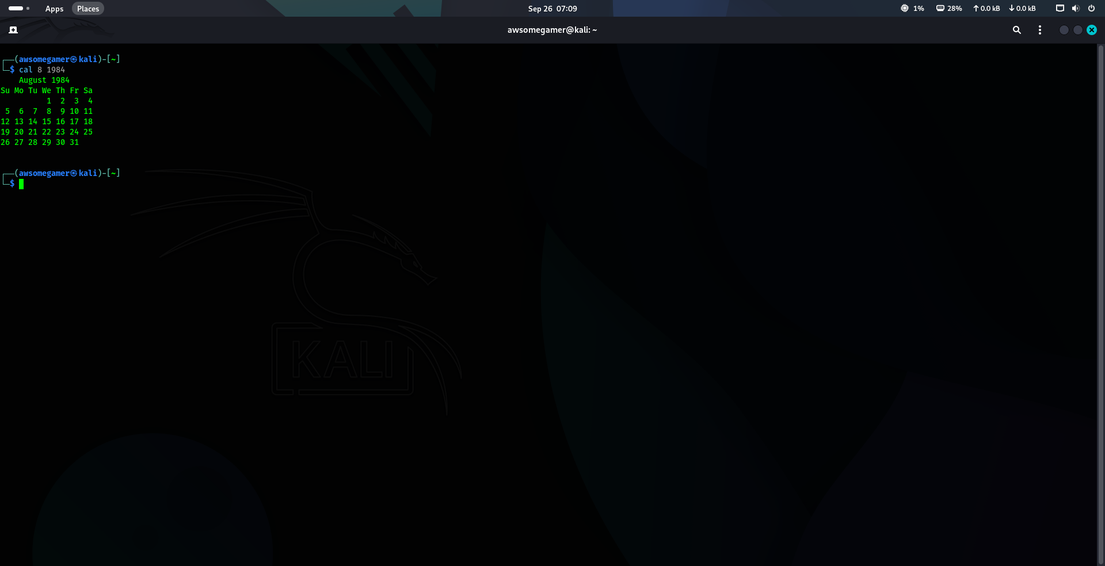

**8. Write a command to display system uptime and logged-in users together.**

Ans. Command for uptime – uptime

Command for logged in users – who

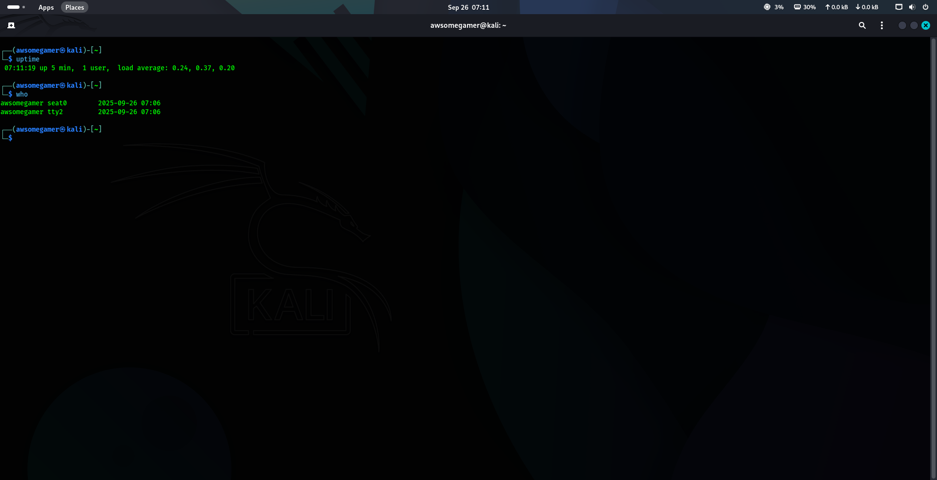

**9. Use the find command to list all “.c” files in /home/user.**

Ans. Command – find [path] [filename]

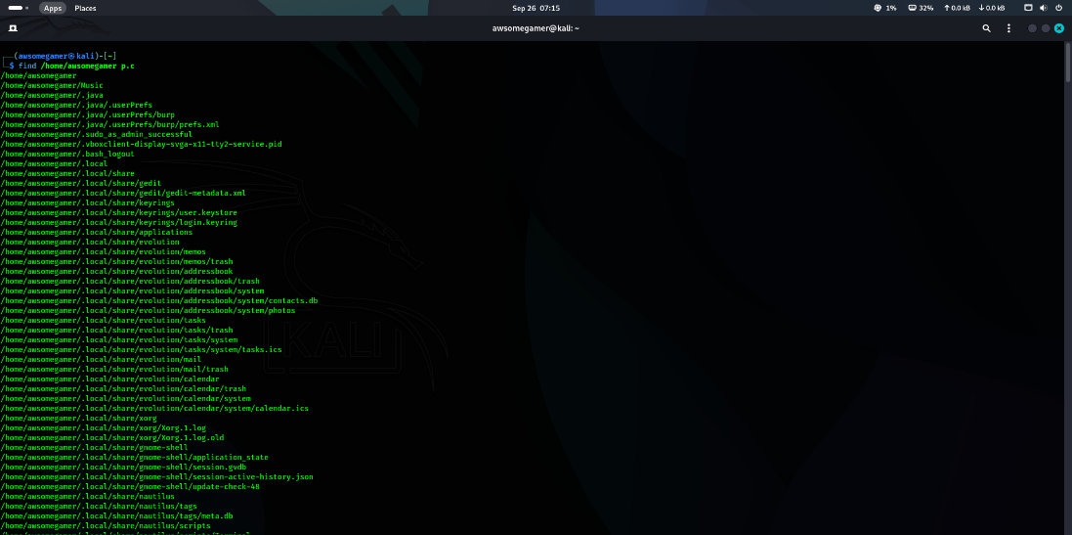

**10. How do you change file permissions to allow only the owner to read and write?**

Ans. Command – chmod 600 [filename]

6(4+2) – grants read (4) and write (2) permission to the owner

0 – represents group’s permissions

0 – represents permission of all others.