**Linux Programming: Assignment-4**

1. **A system has a file /etc/passwd. How would you use grep + tee to extract usernames and save them to a file while also displaying them on screen?**

Ans. Command: grep -oP ^[^:]+ [path] | tee [filename ](to copy)

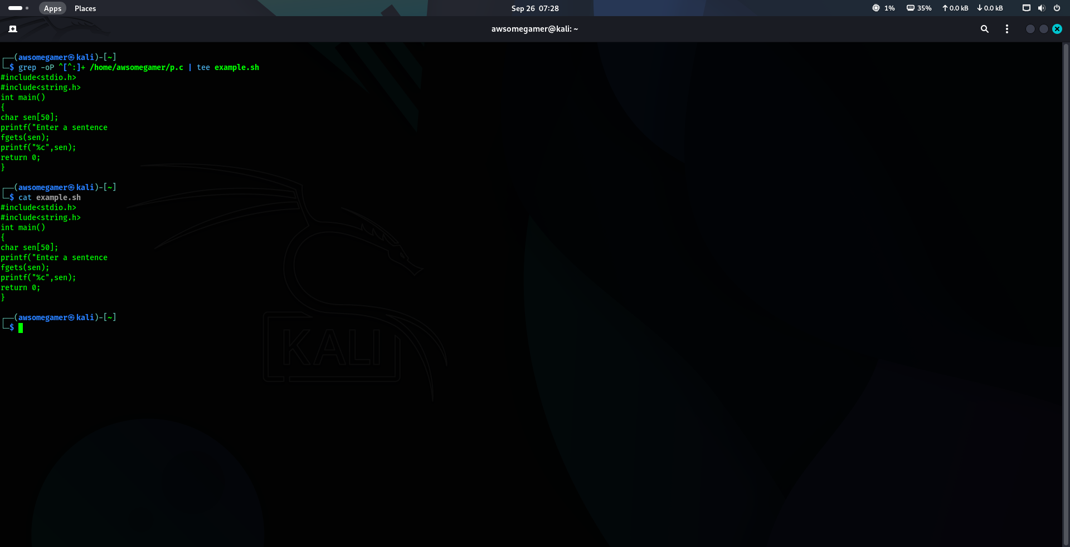

1. **A binary isn’t found in $PATH. How would you use commands (which, find, locate) to troubleshoot and fix the issue?**

Ans. Command – which [binary name]

This command is used to check *if* the binary is already in the path. If the command returns nothing, it confirms the binary is missing.

Command – locate [binary name]

This uses a pre-built database for a very fast search. It's fast but might not be up-to-date with a newly installed binary.

Command – find / -name [binary name]> 2>/dev/null

This is the most reliable way. It searches the entire filesystem for the binary file.

1. **Write a command pipeline that finds all .log files modified in the last 24 hours in /var/log and saves results into log_report.txt**

Ans. Command - find /var/log -type f -name “*.log” -mtime -1 -exec cat {} \; > log_report.txt

1. **What is the difference between shutdown -r now and reboot?**

Ans.

|  |  |
| --- | --- |
| **Shutdown -r** | **reboot** |
| Originally intended for graceful, scheduled reboots, sending a warning to all users. | A simple, direct command for an immediate system restart. |
| More formal | Less formal |
| Preferred for multi user | Preferred for single user |

1. **How can you use the tee command to debug a script that generates both standard output and error messages?**

Ans. Command – [Path] 2>&1 | tee debug_log.txt

In command 2>&1 , 2(stderr) redirects the file descriptor to file descriptor 1(stdout) . The path executes the scripts and both scripts output and error message are sent to debug.txt.

1. **Explain any three real-world applications of Linux in industries.**

Ans.

* Cloud Infrastructure
* Operating systems
* IOT devices
* Embedded systems

1. **Differentiate application, system and utility software in the context of Linux environment.**

Ans.

|  |  |  |
| --- | --- | --- |
| **Application Software** | **Utility Software** | **System Software** |
| Performs specific tasks for the end-user to fulfill a direct need | Helps maintain, manage, and optimize the operating system, hardware, or disk resources. It performs maintenance/support tasks. | Manages and controls the computer hardware and provides a platform for other software to run. It's the foundation. |
| Eg. Firefox, GIMP, VS Code | Eg. Text editors, Package Managers | Eg. Linux kernel, Bash |

1. **What are the key differences between open-source and proprietary operating systems?**

Ans.

|  |  |
| --- | --- |
| **open-source** | **proprietary operating systems** |
| Free of cost | Requires license fee |
| Publicly available | Private |
| Highly customizable | Low customazible |

1. **Write the command to display the system’s kernel version.**

Ans. Command – uname -r

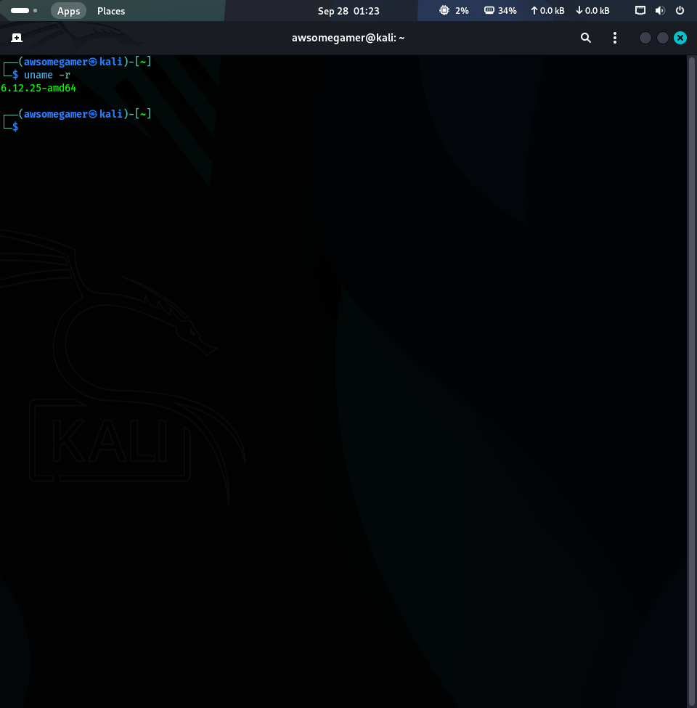

1. **What is the difference between head and tail commands in text processing?**

Ans.

|  |  |
| --- | --- |
| **head** | **tail** |
| Outputs the beginning portion of a file. | Outputs the ending portion of a file. |
| Displays the first 10 lines of the input file | Displays the last 10 lines of the input file |
| Used to review file structure | Used to check last entries of a data file |