**Linux Programming: Assignment-5:**

1. **What is a shell in Linux OS? How many categories of shell is currently exists in Linux? Why bash shell is very popular in Linux distribution?**

Ans. The shell in Linux allows the user to communicate with the OS. It is a CLI (Command Line Interpreter). It is a medium between user and kernel.

Categories:

* Bourne Shell
* C Shell

It is popular because:

* It has features like command-line editing, command history and better scripting capabilities
* It is highly suitable for automation
* Most shell scripts written for sh will run in bash

1. **What does the ls -Z command display?**

Ans. Command: ls -Z

It displays Security Context of files and directories

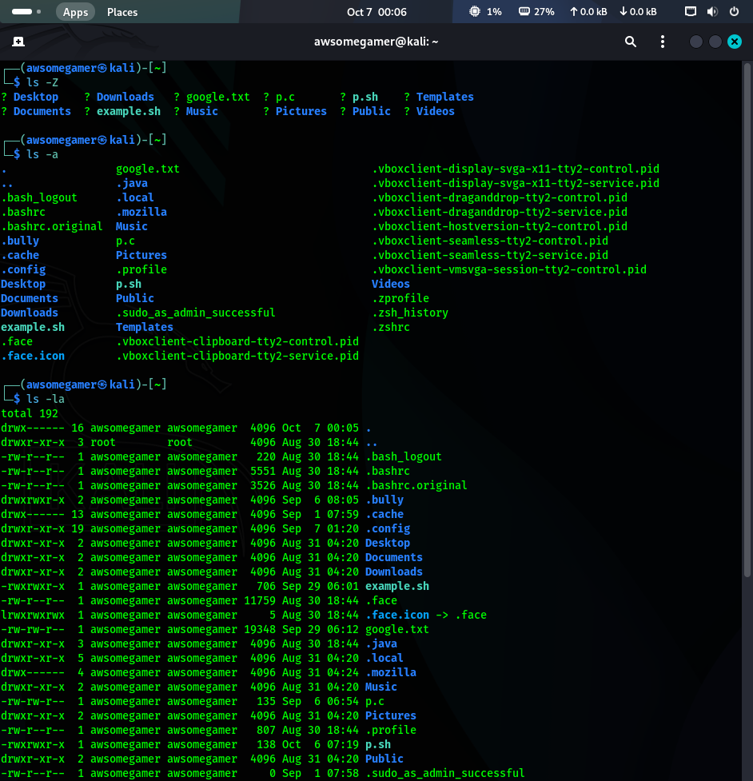

1. **Write a command to list all hidden files in the current directory.**

Ans. Command: ls -a

Command: ls -la (for detailed view)



1. **Explain the difference between hard links and soft links (symbolic links) in Linux.**

Ans.

|  |  |
| --- | --- |
| **Hard Links** | **Soft Links** |
| Appears as a regular file | Appears as a special file (indicated by ‘I’) |
| They reside on same file system as the original system | They can link to files and directories on different file systems |
| Deleting the file does not delete the hard link | Deleting the original file makes the soft link invalid |

1. **A file has permissions -rwxr-x--x. Explain who can read, write, and execute it.**

Ans.

* -: defines the type of file (regular).
* rwx: Denotes the owner’s permissions
* r-x: Denotes the group’s permission
* --x: Denotes the permission of other users in the system

Hence the owner can read, write and execute, whereas the group can read and execute (cannot write) and other users can only execute the file.

1. **Write the command to change the group ownership of a file data.txt to group staff.**

Ans.Command: chgrp staff data.txt

1. **Why is it dangerous to give 777 permissions to a file? Explain with an example.**

Ans. The 777 command gives permission to read, write, and execute to all (owner, group and all users in the system). Hence anyone can read and make changes which leads to security vulnerabilities and also system instability.

Command: chmod 777 [filename]

1. **What is the difference between apropos (i.e., man -k) and whatis (i.e., man -f)?**

Ans.

|  |  |
| --- | --- |
| **apropos** | **whatis** |
| It searches names | It gives description about a keyword briefly |
| It gives complete manual about a given keyword | Displays a one-line definition of a keyword |
| It can also perform keyword search (fuzzy match) | It performs exact match |

1. **Write a command to redirect the error output of a command to a file named error.log.**

Ans. Command: [error] 2> error.log

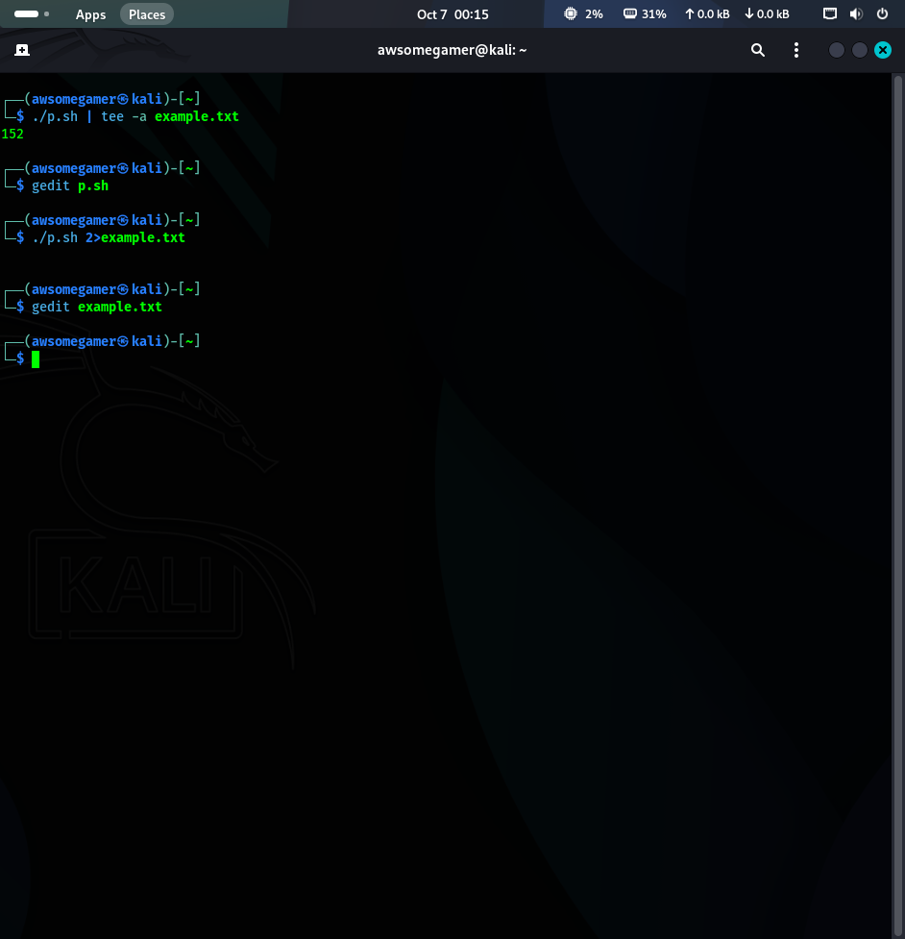

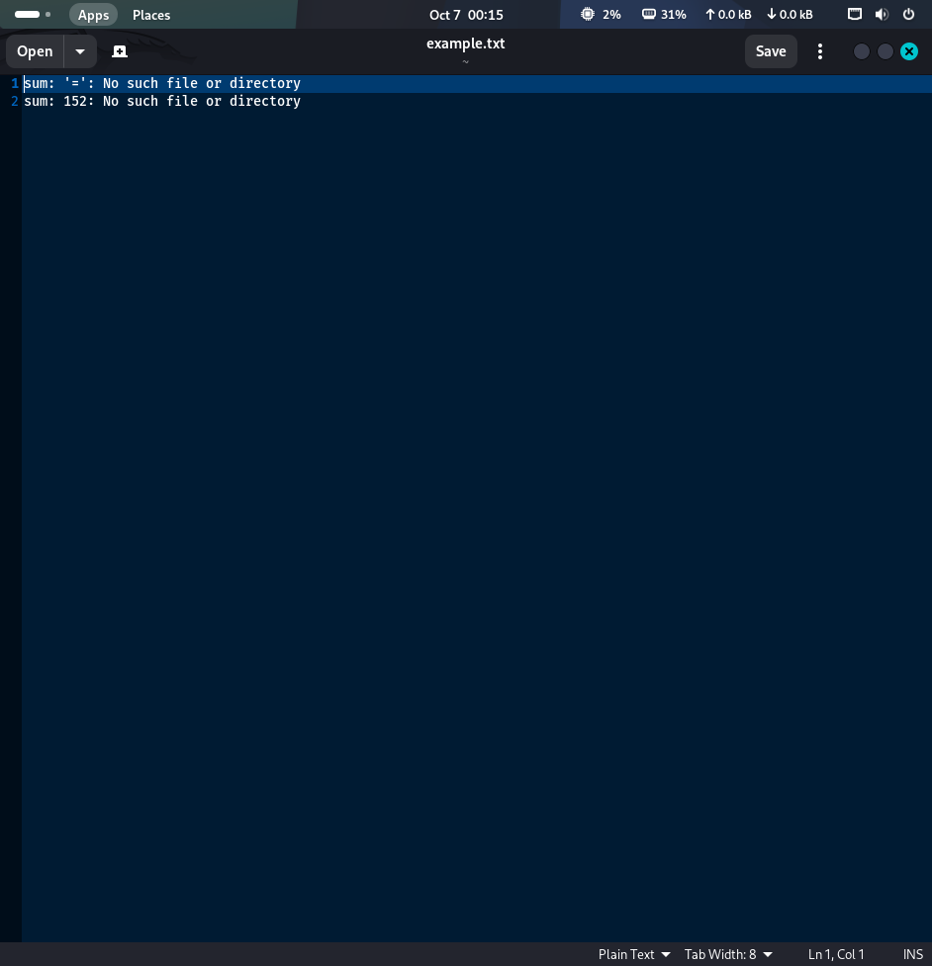

1. **How can you use the tee command to append output to a file instead of overwriting it?**

Ans.Command: [command/filename (a file with some content)] | tee -a [filename]

