**Linux Programming: Assignment-6:**

1. **Which command is used to list the contents of a directory? Justify with proper example.**

Ans. Command: ls

The command ls used for list is the basic command used to list the contents of a directory. To see a detailed list ls -a command is used.

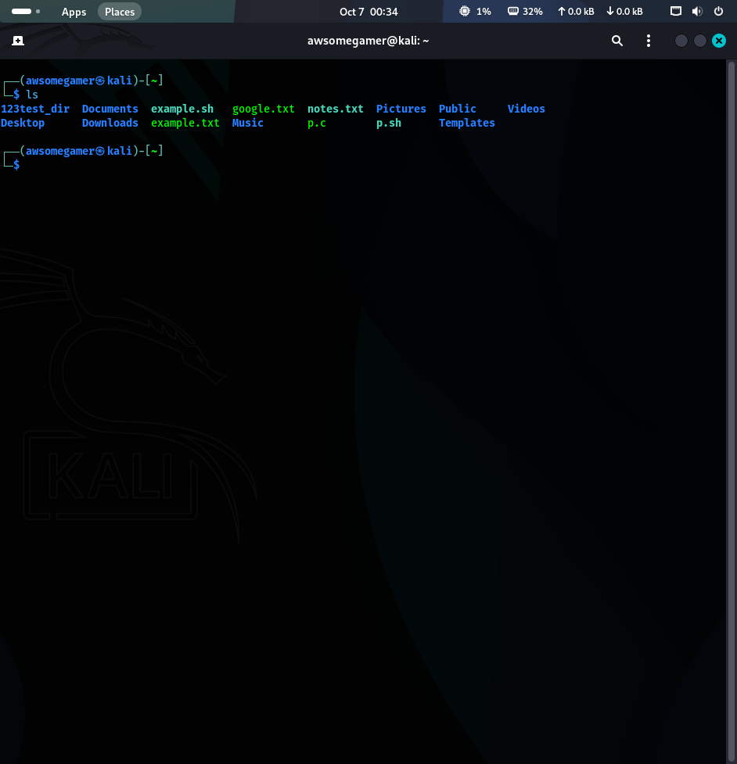

1. **Write the command to create a new directory named 123test_dir.**

Ans. Command: mkdir 123test_dir

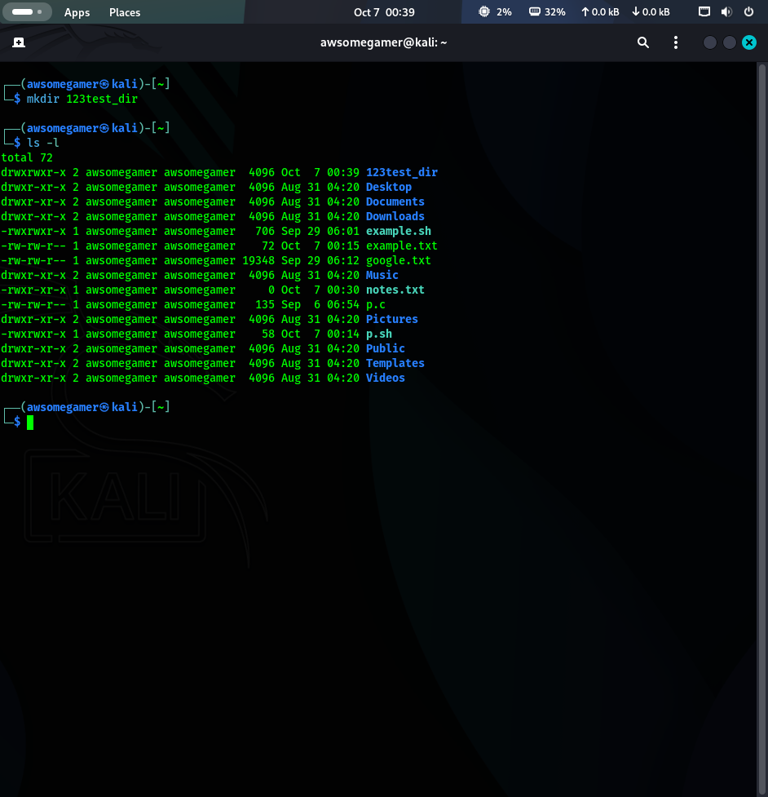

1. **What is the purpose of the sed command? Justify with proper example.**

Ans. Command: sed

It is a utility function used for transforming text. It is also used for test manipulation.

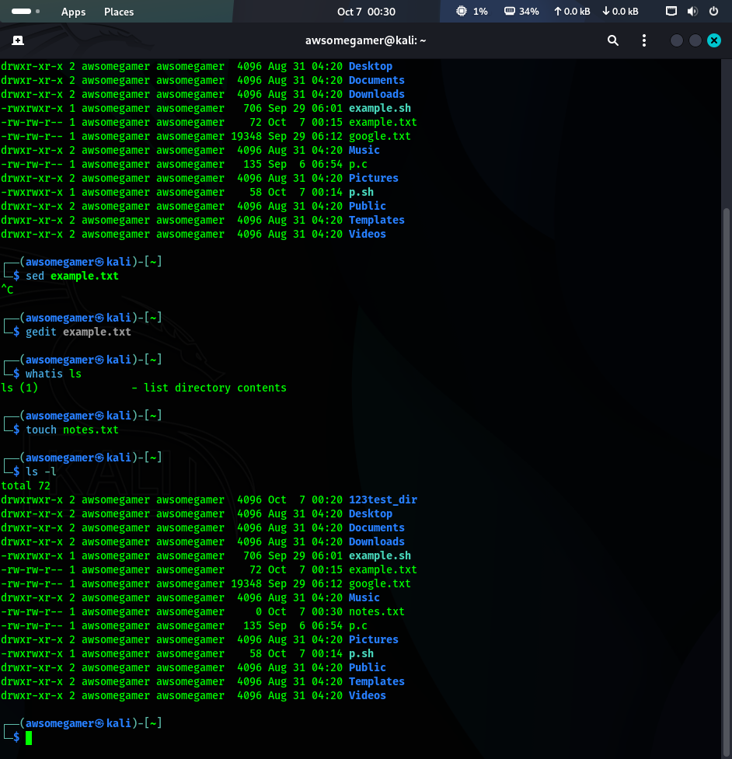

1. **Which distinct command is used to display one-line descriptions of any commands?**

Ans. Command: whatis



1. **Write the command to create an empty file named “notes.txt”.**

Ans. Command: touch notes.txt



1. **Differentiate between grep and awk commands with an example.**

Ans.

|  |  |
| --- | --- |
| **grep** | **awk** |
| Works on entire lines of text | Works on columns within a line |
| If a line matches, it’ll be printed | If a pattern is matched, it’ll be printed |
| It is mainly used for searching text | It is mainly used for processing or reporting based on text files |

1. **Write the command to give read, write, and execute permission to the owner of a file script.sh.**

Ans. Command: chmod u+rwx script.sh (or) chmod 755 script.sh

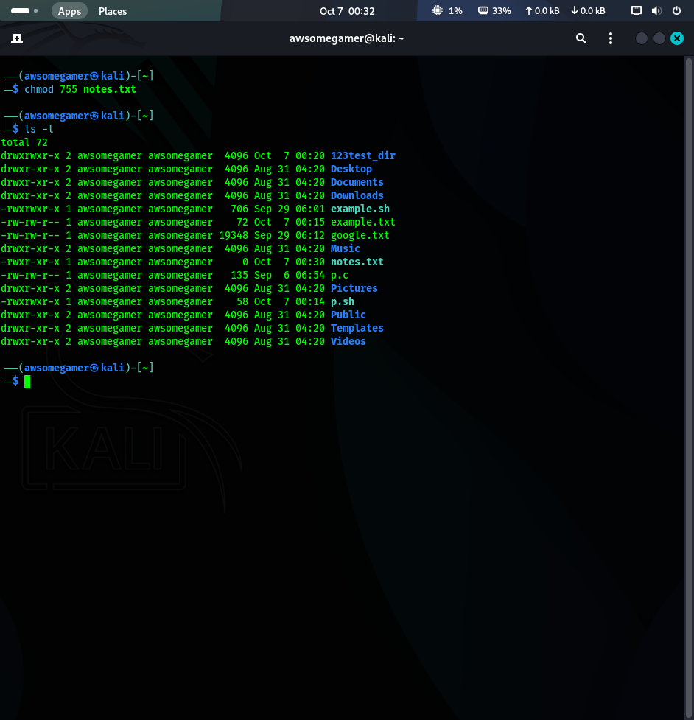

1. **How is chown different from chgrp? Give one example for each.**

Ans.

|  |  |
| --- | --- |
| **chown** | **chgrp** |
| It is used to change the owner of a file or directory | It is used to change the group owner of a file or directory |
| chown tom example.pdf | chgrp james newone.txt |

1. **A user complains that they cannot execute a file even though it exists in their directory. How would you troubleshoot this using ls -l, chmod, and whoami?**

Ans.

* First using ls -l, we need to check the permission of the file. If the permission doesn’t contain x then it is not executable.
* Second, we need to confirm if the user asking is the owner using whoami command
* Third if the user is owner, we need to change the file permission using chmod +x [filename] command.

By following these steps the user/owner has the permission to execute the file.

1. **Design a command pipeline to: find all .log files modified in the last 2 days in /var/log, display them on screen, and save the results into a file recent_logs.txt using tee command.**

Ans. find /home/user/log -type f -name “*.log” -mtime -2 | tee history_logs.txt