**Linux Programming: Assignment-8:**

**11. What is a user-defined function in shell scripting? Explain with an example.**

Ans. A user-defined function in shell scripting is a block of reusable code which is defined by the user and it performs a specific task, and is easier to maintain.

Ex: function example {

Echo “Hiiiii………How are you”

}

**12. Write a bash script with a function that multiply two integer numbers.**

Ans. #! /bin/bash

Function product () {

if [ "$#" -ne 2]; then

echo "Error: Please provide exactly two numbers."

return

else

product=$(($1 * $2))

fi

echo "The product of $1 and $2 is: $product"

}

product 15 5

product 20 3

**13. Explain how arrays (1D, 2D, and 3D) are declared in bash scripting.**

Ans. 1D array:

color [0] =” blue”

color [1] =” red”

2D array:

matrix [0,2] =” diamond”

matrix [1,0] =” king”

3D array:

cube [3,3,3] =” end”

**14. Write a shell script to display elements of an array.**

Ans. #! /bin/bash

FRUITS= ("Apple" "Banana" "Cherry" "Date" "Elderberry")

for i in "${! FRUITS [@]}"; do

ele="${FRUITS[$i]}"

echo "Index $i: $ele"

done

**15. What is the purpose of cron in Linux?**

Ans. It is a time-based job scheduler in Unix OS. Its fundamental purpose is automation. It automates repetitive task by scheduling commands

**16. Write a cron job to run a backup script every day at midnight.**

Ans. Command: 0 0 * * * /home/personal/example.sh

* 0- At the 0th minute
* 0- At the 0th hour i.e, midnight
* *- Every day of the month
* *- Every month
* *- Every day of the week

**17. How do you schedule a one-time job using at command?**

Ans. Command: at [time] tomorrow

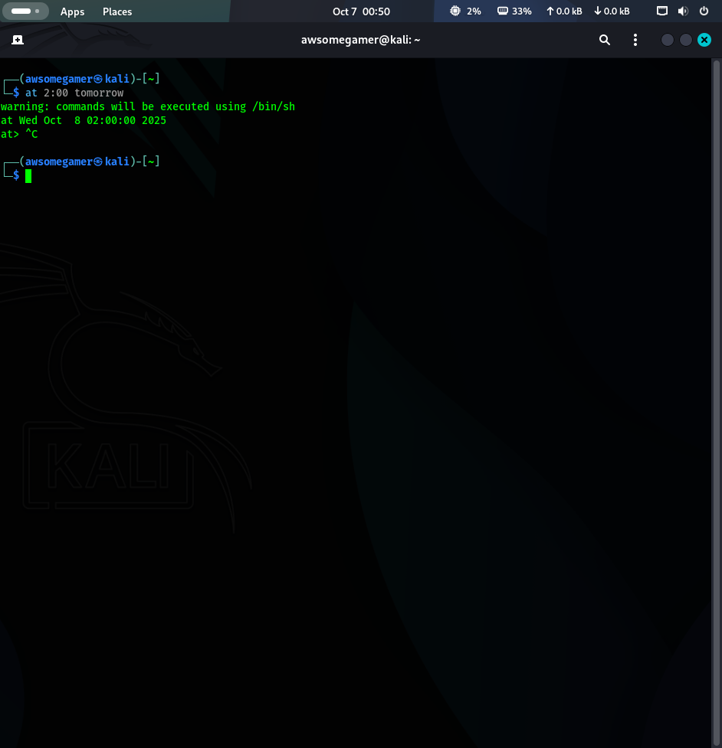

**18. Write a script to display disk usage using df and du.**

Ans. #!/bin/bash

tardir="/var/log"

echo "1. Filesystem Disk Usage "

df -h /

echo ""

echo "2. Directory Disk Usage for $tardir"

du -sh "$tardir"

echo ""

echo "3. Top 5 Largest Subdirectories in $tardir"

du -h "$tardir" | sort -hr | head -5

**19. How can you log the output of a script using the tee command?**

Ans. Command: [command] 2>&1 | tee -a [filename]

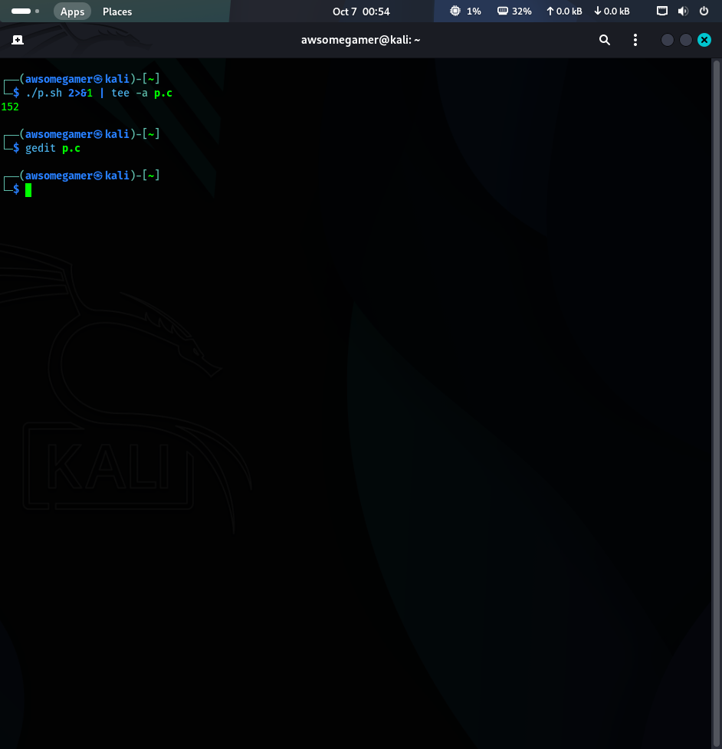

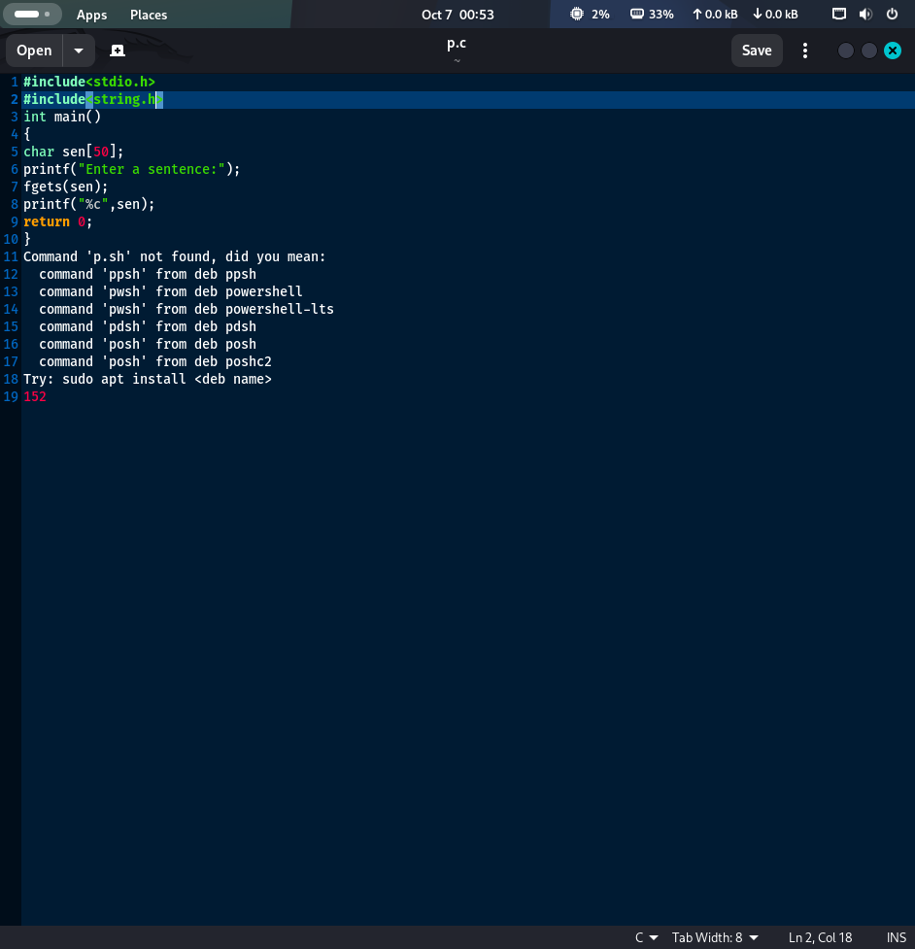

**20. Explain with an example how shell scripting can automate system administration tasks.**

Ans.

#! /bin/bash

log="/var/log/app"

archive="/var/log/app/archive"

days_old=7

logfile="log_rotation.log"

echo " Log Rotation Script Started on $(date) " > "$logfile" 2>&1

mkdir -p "$archive"

echo "Finding and moving logs older than $days_old days..." | tee -a "$logfile"

find "$log" -maxdepth 1 -type f -mtime +"$days_old" -name "*.log" -exec mv {} "$archive" \;

echo "Compressing moved logs..." | tee -a "$log"

tar -czf "$archive/archive_$(date +%Y%m%d). tar.gz" -C "$archive”.

find "$archive" -maxdepth 1 -type f -name "*.log" -delete

MAIL_SUBJECT="SUCCESS: Daily Log Rotation Complete"

ADMIN_EMAIL="admin@yourdomain.com"

echo "Log rotation finished. Check attached log file for details." | mail -s "$MAIL_SUBJECT" -a "$logfile" "$ADMIN_EMAIL"

echo " Log Rotation Script Finished on $(date) " | tee -a "$logfile"