LAPORAN

WORKSHOP SISTEM INFORMASI WEB SERVER
(TIF330805)

SEMESTER



ACARA13

NAMA:
GATOT DWI UMI EKA PUTRA ATIPYA

NIM:
E41250539

PROGRAM STUDI DI LUAR KAMPUS UTAMA (PSDKU)
TEKNIK INFORMATIKA KAB. NGANJUK
JURUSAN TEKNOLOGI INFORMASI
POLITEKNIK NEGERI JEMBER
TAHUN 2026

Pada prosedur kerja acara ini mahasiswa harus mengimplementasikan service layer dan flashmessage pada code mereka.
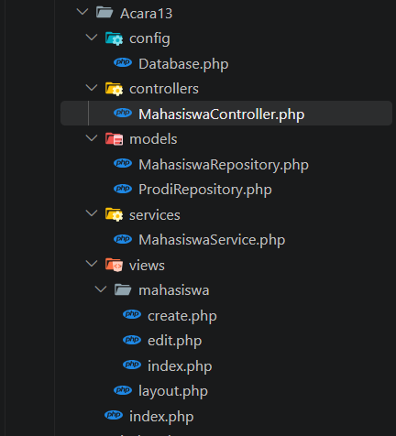
Ini adalah struktur codenya.
<?php

class Database
{
private static $host = 'localhost';
private static $db_name = 'siakademik';
private static $username = 'root';
private static $password = ''; // Isikan password MySQL jika ada (default XAMPP/Laragon biasanya kosong)
private static $pdo = null;

public static function getConnection()
{
if (self::$pdo === null) {
try {
$dsn = "mysql:host=" . self::$host . ";dbname=" . self::$db_name . ";charset=utf8mb4";
self::$pdo = new PDO($dsn, self::$username, self::$password);
self::$pdo->setAttribute(PDO::ATTR_ERRMODE, PDO::ERRMODE_EXCEPTION);
self::$pdo->setAttribute(PDO::ATTR_DEFAULT_FETCH_MODE, PDO::FETCH_ASSOC);
} catch (PDOException $e) {
die("Koneksi Database Gagal: " . $e->getMessage());
}
}
return self::$pdo;
}
}
Diatas adalah code bagian ConfigDatabase.
<?php

class MahasiswaController
{
private $mahasiswaService;

public function __construct($mahasiswaService)
{
$this->mahasiswaService = $mahasiswaService;
}

public function index()
{
$mahasiswa = $this->mahasiswaService->getAllMahasiswa();
$viewContent = __DIR__ . '/../views/mahasiswa/index.php';
require __DIR__ . '/../views/layout.php';
}

public function create()
{
$prodiList = $this->mahasiswaService->getAllProdi();
$viewContent = __DIR__ . '/../views/mahasiswa/create.php';
require __DIR__ . '/../views/layout.php';
}

public function store()
{
$data = [
'nim' => $_POST['nim'] ?? '',
'nama' => $_POST['nama'] ?? '',
'prodi_id' => $_POST['prodi_id'] ?? ''
];

$success = $this->mahasiswaService->create($data);

if ($success) {
header('Location: index.php?page=mahasiswa');
} else {
header('Location: index.php?page=mahasiswa_create');
}
exit;
}

public function edit()
{
$id = $_GET['id'] ?? null;
$mahasiswa = $this->mahasiswaService->getMahasiswaById($id);

if (!$mahasiswa) {
header('Location: index.php?page=mahasiswa');
exit;
}

$prodiList = $this->mahasiswaService->getAllProdi();
$viewContent = __DIR__ . '/../views/mahasiswa/edit.php';
require __DIR__ . '/../views/layout.php';
}

public function update()
{
$id = $_POST['id'] ?? null;
$data = [
'nim' => $_POST['nim'] ?? '',
'nama' => $_POST['nama'] ?? '',
'prodi_id' => $_POST['prodi_id'] ?? ''
];

$success = $this->mahasiswaService->update($id, $data);

if ($success) {
header('Location: index.php?page=mahasiswa');
} else {
header("Location: index.php?page=mahasiswa_edit&id={$id}");
}
exit;
}

public function delete()
{
$id = $_GET['id'] ?? null;
if ($id) {
$this->mahasiswaService->delete($id);
$this->mahasiswaService->setFlashMessage('success', 'Data berhasil dihapus.');
}
header('Location: index.php?page=mahasiswa');
exit;
}
}
Diatas adalah code bagian MahasiswaControllers.
<?php

class MahasiswaRepository
{
private $db;

public function __construct($db)
{
$this->db = $db;
}

public function getAll()
{
$query = "SELECT m.*, p.nama_prodi
FROM mahasiswa m
JOIN prodi p ON m.prodi_id = p.id
ORDER BY m.id DESC";
return $this->db->query($query)->fetchAll();
}

public function findById($id)
{
$stmt = $this->db->prepare("SELECT * FROM mahasiswa WHERE id = :id");
$stmt->execute(['id' => $id]);
return $stmt->fetch();
}

public function findByNim($nim)
{
$stmt = $this->db->prepare("SELECT * FROM mahasiswa WHERE nim = :nim");
$stmt->execute(['nim' => $nim]);
return $stmt->fetch();
}

public function insert($data)
{
$stmt = $this->db->prepare("INSERT INTO mahasiswa (nim, nama, prodi_id) VALUES (:nim, :nama, :prodi_id)");
return $stmt->execute([
'nim' => $data['nim'],
'nama' => $data['nama'],
'prodi_id' => $data['prodi_id']
]);
}

public function update($id, $data)
{
$stmt = $this->db->prepare("UPDATE mahasiswa SET nim = :nim, nama = :nama, prodi_id = :prodi_id WHERE id = :id");
return $stmt->execute([
'id' => $id,
'nim' => $data['nim'],
'nama' => $data['nama'],
'prodi_id' => $data['prodi_id']
]);
}

public function delete($id)
{
$stmt = $this->db->prepare("DELETE FROM mahasiswa WHERE id = :id");
return $stmt->execute(['id' => $id]);
}
}
Diatas adalah code bagian mahasiswa repository.
<?php

class ProdiRepository
{
private $db;

public function __construct($db)
{
$this->db = $db;
}

public function getAll()
{
$stmt = $this->db->query("SELECT * FROM prodi ORDER BY nama_prodi ASC");
return $stmt->fetchAll();
}
}
Diatas adalah code bagian ProdiRepository.
<?php

class MahasiswaService
{
private $mahasiswaRepository;
private $prodiRepository;

public function __construct($mahasiswaRepository, $prodiRepository)
{
$this->mahasiswaRepository = $mahasiswaRepository;
$this->prodiRepository = $prodiRepository;
}

public function getAllMahasiswa()
{
return $this->mahasiswaRepository->getAll();
}

public function getAllProdi()
{
return $this->prodiRepository->getAll();
}

public function getMahasiswaById($id)
{
return $this->mahasiswaRepository->findById($id);
}

public function setFlashMessage($type, $message)
{
if (session_status() === PHP_SESSION_NONE) {
session_start();
}
$_SESSION['flash_message'] = [
'type' => $type,
'message' => $message
];
}

public function validateData($data, $isUpdate = false, $currentId = null)
{
$errors = [];

if (empty(trim($data['nim']))) {
$errors[] = "NIM wajib diisi.";
} else {
$existing = $this->mahasiswaRepository->findByNim($data['nim']);
if ($existing && (!$isUpdate || $existing['id'] != $currentId)) {
$errors[] = "NIM sudah terdaftar.";
}
}

if (empty(trim($data['nama']))) {
$errors[] = "Nama wajib diisi.";
}

if (empty($data['prodi_id'])) {
$errors[] = "Program Studi wajib dipilih.";
}

return $errors;
}

public function create($data)
{
$errors = $this->validateData($data);

if (!empty($errors)) {
if (in_array("NIM sudah terdaftar.", $errors)) {
$this->setFlashMessage('danger', 'NIM sudah terdaftar.');
} else {
$this->setFlashMessage('danger', 'Data gagal disimpan.');
}
return false;
}

$result = $this->mahasiswaRepository->insert($data);

if ($result) {
$this->setFlashMessage('success', 'Data berhasil ditambahkan.');
return true;
} else {
$this->setFlashMessage('danger', 'Data gagal disimpan.');
return false;
}
}

public function update($id, $data)
{
$errors = $this->validateData($data, true, $id);

if (!empty($errors)) {
if (in_array("NIM sudah terdaftar.", $errors)) {
$this->setFlashMessage('danger', 'NIM sudah terdaftar.');
} else {
$this->setFlashMessage('danger', 'Data gagal disimpan.');
}
return false;
}

$result = $this->mahasiswaRepository->update($id, $data);

if ($result) {
$this->setFlashMessage('success', 'Data berhasil diubah.');
return true;
} else {
$this->setFlashMessage('danger', 'Data gagal disimpan.');
return false;
}
}

public function delete($id)
{
return $this->mahasiswaRepository->delete($id);
}
}
Diatas adalah code bagian MahasiswaService.
<div class="row justify-content-center">
<div class="col-md-6">
<div class="card shadow-sm">
<div class="card-header bg-white">
<h4 class="mb-0">Tambah Mahasiswa</h4>
</div>
<div class="card-body">
<form action="index.php?page=mahasiswa_store" method="POST">
<div class="mb-3">
<label for="nim" class="form-label">NIM</label>
<input type="text" class="form-control" id="nim" name="nim" required>
</div>
<div class="mb-3">
<label for="nama" class="form-label">Nama Mahasiswa</label>
<input type="text" class="form-control" id="nama" name="nama" required>
</div>
<div class="mb-3">
<label for="prodi_id" class="form-label">Program Studi</label>
<select class="form-select" id="prodi_id" name="prodi_id" required>
<option value="">-- Pilih Program Studi --</option>
<?php foreach ($prodiList as $p): ?>
<option value="<?= $p['id']; ?>"><?= htmlspecialchars($p['nama_prodi']); ?></option>
<?php endforeach; ?>
</select>
</div>
<div class="d-flex justify-content-between">
<a href="index.php?page=mahasiswa" class="btn btn-secondary">Batal</a>
<button type="submit" class="btn btn-success">Simpan</button>
</div>
</form>
</div>
</div>
</div>
</div>
Diatas adalah code bagian mahasiswa create.
<div class="row justify-content-center">
<div class="col-md-6">
<div class="card shadow-sm">
<div class="card-header bg-white">
<h4 class="mb-0">Ubah Data Mahasiswa</h4>
</div>
<div class="card-body">
<form action="index.php?page=mahasiswa_update" method="POST">
<input type="hidden" name="id" value="<?= $mahasiswa['id']; ?>">

<div class="mb-3">
<label for="nim" class="form-label">NIM</label>
<input type="text" class="form-control" id="nim" name="nim" value="<?= htmlspecialchars($mahasiswa['nim']); ?>" required>
</div>
<div class="mb-3">
<label for="nama" class="form-label">Nama Mahasiswa</label>
<input type="text" class="form-control" id="nama" name="nama" value="<?= htmlspecialchars($mahasiswa['nama']); ?>" required>
</div>
<div class="mb-3">
<label for="prodi_id" class="form-label">Program Studi</label>
<select class="form-select" id="prodi_id" name="prodi_id" required>
<option value="">-- Pilih Program Studi --</option>
<?php foreach ($prodiList as $p): ?>
<option value="<?= $p['id']; ?>" <?= $p['id'] == $mahasiswa['prodi_id'] ? 'selected' : ''; ?>>
<?= htmlspecialchars($p['nama_prodi']); ?>
</option>
<?php endforeach; ?>
</select>
</div>
<div class="d-flex justify-content-between">
<a href="index.php?page=mahasiswa" class="btn btn-secondary">Batal</a>
<button type="submit" class="btn btn-success">Simpan Perubahan</button>
</div>
</form>
</div>
</div>
</div>
</div>
Diatas adalah code bagian mahasiswa edit.
<div class="d-flex justify-content-between align-items-center mb-3">
<h3>Daftar Mahasiswa</h3>
<a href="index.php?page=mahasiswa_create" class="btn btn-primary">Tambah Mahasiswa</a>
</div>

<div class="card shadow-sm">
<div class="card-body p-0">
<table class="table table-striped mb-0">
<thead class="table-dark">
<tr>
<th>No</th>
<th>NIM</th>
<th>Nama</th>
<th>Program Studi</th>
<th width="150" class="text-center">Aksi</th>
</tr>
</thead>
<tbody>
<?php if (empty($mahasiswa)): ?>
<tr><td colspan="5" class="text-center py-3">Belum ada data mahasiswa.</td></tr>
<?php else: ?>
<?php foreach ($mahasiswa as $index => $m): ?>
<tr>
<td><?= $index + 1; ?></td>
<td><?= htmlspecialchars($m['nim']); ?></td>
<td><?= htmlspecialchars($m['nama']); ?></td>
<td><?= htmlspecialchars($m['nama_prodi']); ?></td>
<td class="text-center">
<a href="index.php?page=mahasiswa_edit&id=<?= $m['id']; ?>" class="btn btn-sm btn-warning">Edit</a>
<a href="index.php?page=mahasiswa_delete&id=<?= $m['id']; ?>" class="btn btn-sm btn-danger" onclick="return confirm('Yakin ingin menghapus?')">Hapus</a>
</td>
</tr>
<?php endforeach; ?>
<?php endif; ?>
</tbody>
</table>
</div>
</div>
Diatas adalah code bagian mahasiswa index.
<?php
if (session_status() === PHP_SESSION_NONE) {
session_start();
}
?>
<!DOCTYPE html>
<html lang="id">
<head>
<meta charset="UTF-8">
<meta name="viewport" content="width=device-width, initial-scale=1.0">
<title>Sistem Informasi Akademik</title>
<link href="https://cdn.jsdelivr.net/npm/bootstrap@5.3.0/dist/css/bootstrap.min.css" rel="stylesheet">
</head>
<body class="bg-light">
<nav class="navbar navbar-expand-lg navbar-dark bg-primary mb-4">
<div class="container">
<a class="navbar-brand fw-bold" href="index.php">Sistem Informasi Akademik</a>
</div>
</nav>

<div class="container">
<!-- Menampilkan & Menghapus Flash Message (Langkah 7, 8, 9) -->
<?php if (isset($_SESSION['flash_message'])): ?>
<div class="alert alert-<?= $_SESSION['flash_message']['type']; ?> alert-dismissible fade show" role="alert">
<?= htmlspecialchars($_SESSION['flash_message']['message']); ?>
<button type="button" class="btn-close" data-bs-dismiss="alert" aria-label="Close"></button>
</div>
<?php unset($_SESSION['flash_message']); ?>
<?php endif; ?>

<?php include $viewContent; ?>
</div>

<script href="https://cdn.jsdelivr.net/npm/bootstrap@5.3.0/dist/js/bootstrap.bundle.min.js"></script>
</body>
</html>
Diatas adalah code bagian layout.

<?php

session_start();

// Load Config & Classes
require_once __DIR__ . '/config/Database.php';
require_once __DIR__ . '/models/ProdiRepository.php';
require_once __DIR__ . '/models/MahasiswaRepository.php';
require_once __DIR__ . '/services/MahasiswaService.php';
require_once __DIR__ . '/controllers/MahasiswaController.php';

// Inisialisasi Database dan Repositories
$db = Database::getConnection();
$prodiRepo = new ProdiRepository($db);
$mahasiswaRepo = new MahasiswaRepository($db);

// Inject Repositories ke Service (Langkah 1 & 2)
$mahasiswaService = new MahasiswaService($mahasiswaRepo, $prodiRepo);

// Inject Service ke Controller
$controller = new MahasiswaController($mahasiswaService);

// Routing Sederhana
$page = $_GET['page'] ?? 'mahasiswa';

switch ($page) {
case 'mahasiswa':
$controller->index();
break;
case 'mahasiswa_create':
$controller->create();
break;
case 'mahasiswa_store':
$controller->store();
break;
case 'mahasiswa_edit':
$controller->edit();
break;
case 'mahasiswa_update':
$controller->update();
break;
case 'mahasiswa_delete':
$controller->delete();
break;
default:
$controller->index();
break;
}
Dan diatas adalah code bagian Index
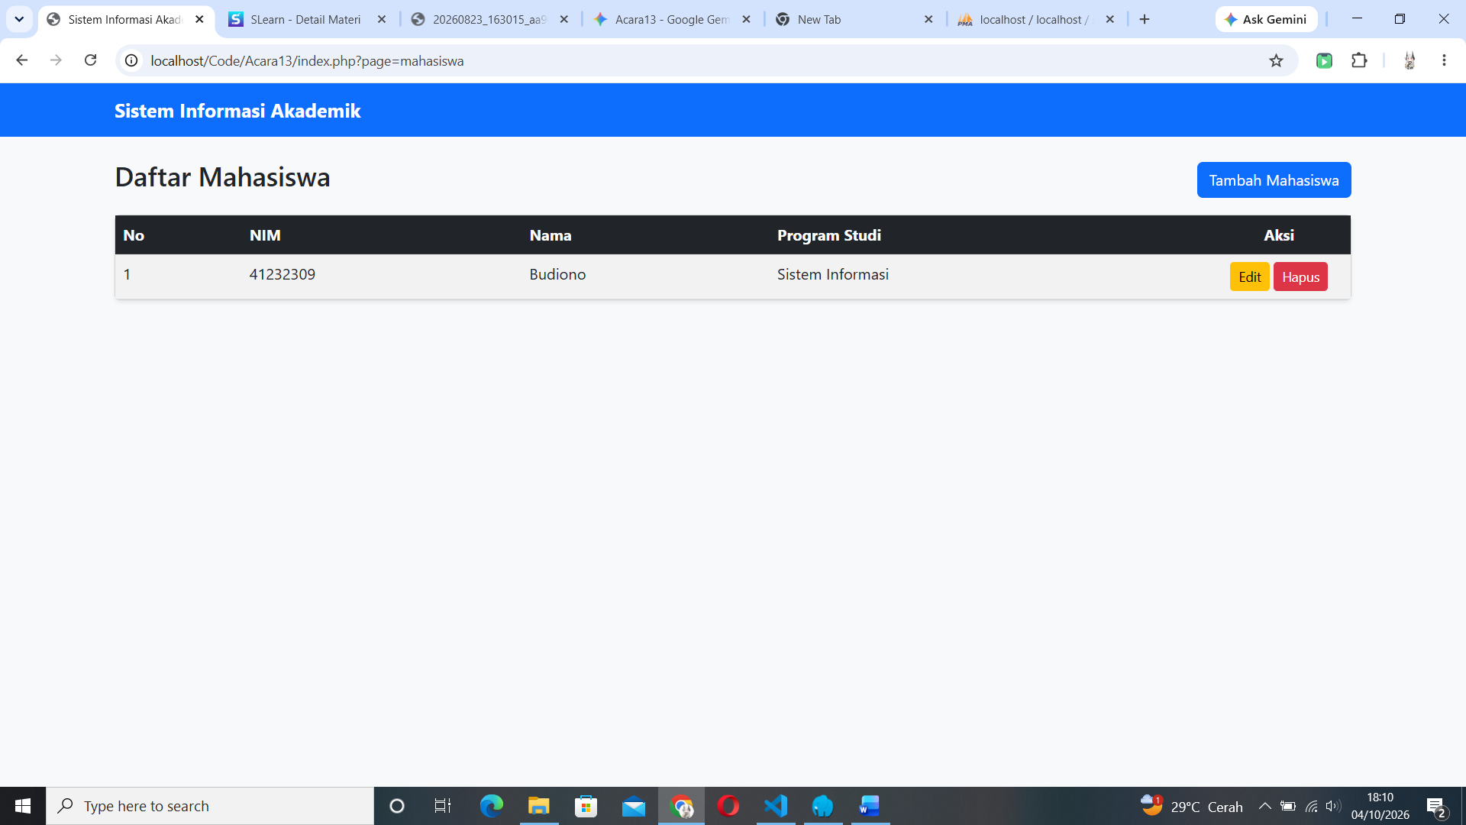
Dan ini adalah hasilnya.
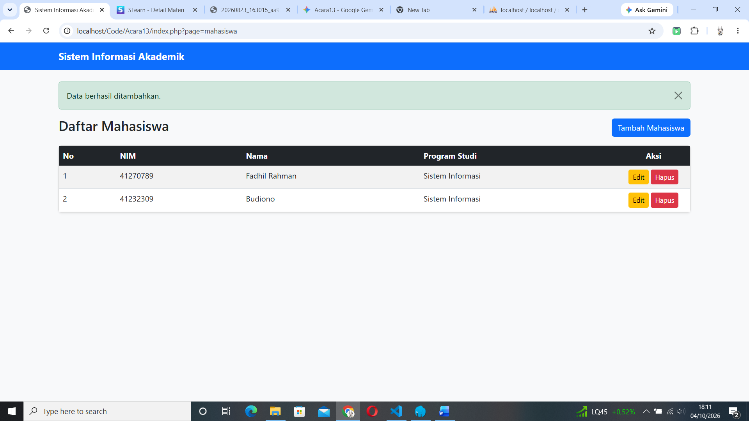
Untuk memunculkan flashmessagenya kita perlu untuk menambah data mahasiswa maka flashmessagenya akan muncul seperti diatas.
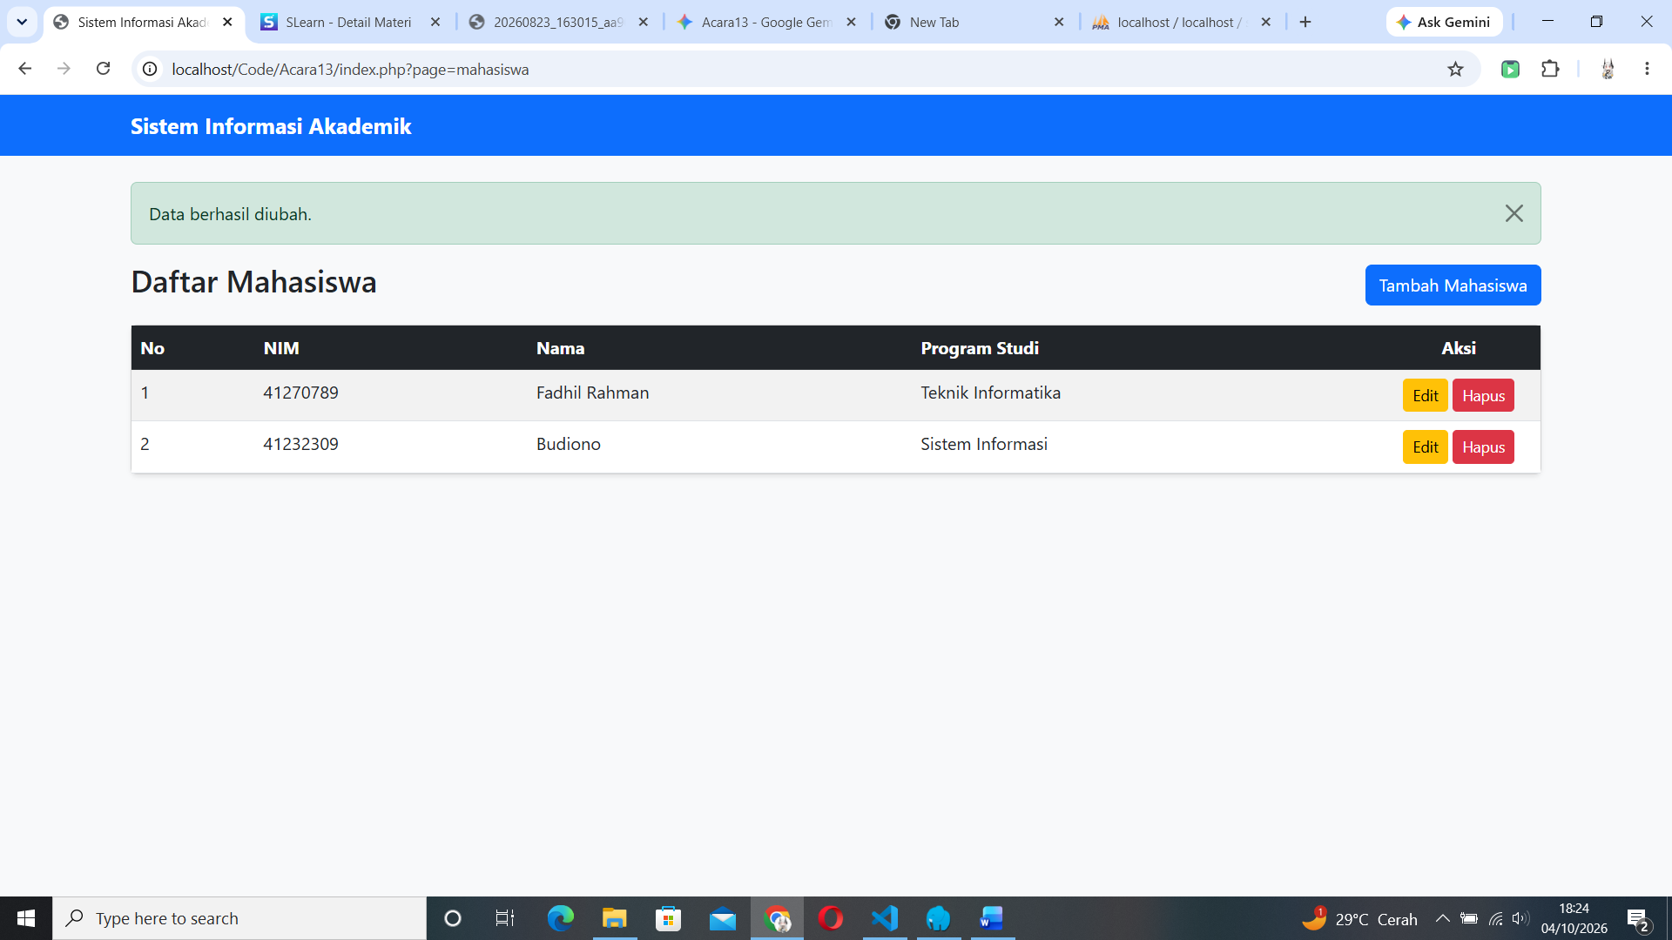
Saat kita mengubah data akan muncul flashmessage seperti ini.
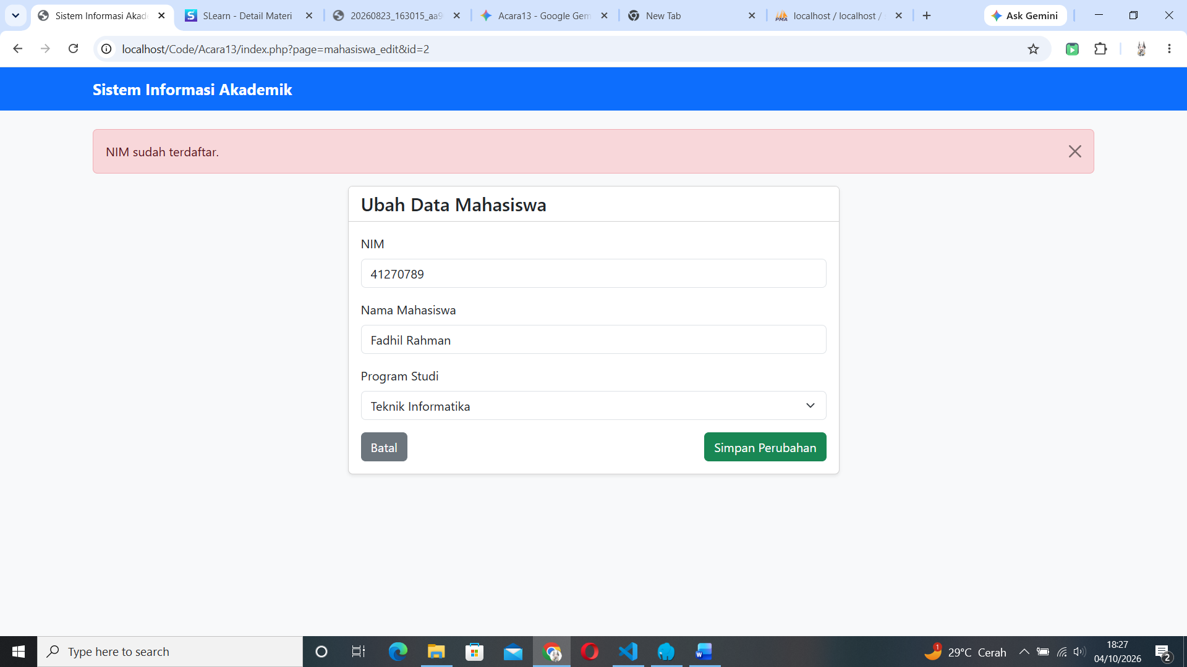
Dan jika kita mencoba menambah atau mengubah data menggunakan NIM yang sudah ada makan akan muncul flashmessage seperti ini.

