LAPORAN

WORKSHOP SISTEM INFORMASI WEB SERVER
(TIF330805)

SEMESTER 3



ACARA22

NAMA:
GATOT DWI UMI EKA PUTRA ATIPYA

NIM:
E41250539

PROGRAM STUDI DI LUAR KAMPUS UTAMA (PSDKU)
TEKNIK INFORMATIKA KAB. NGANJUK
JURUSAN TEKNOLOGI INFORMASI
POLITEKNIK NEGERI JEMBER
TAHUN 2026

Pada acara ini mahasiswa diberi tugas untuk mengkonversikan dokumentasi pada Acara 21 menjadi OpenAPI 3.0 yang pathnya mengikuti url pada user bukan .php
Pertama kita membuat file di folder docs dengan nama openapi.yaml
Lalu kita konversi dokumentasi sebelumnya menjadi OpenAPI 3.0 didalamnya
openapi: 3.0.0
info:
title: API Sistem Informasi Akademik (MVC)
description: >-
Dokumentasi OpenAPI untuk API Sistem Informasi Akademik.
Path mengikuti resource pada peta Router (bukan nama berkas .php).
Endpoint bertanda gembok membutuhkan header Authorization Bearer token (JWT, berlaku 5 menit).
version: 1.0.0
servers:
- url: http://localhost/Code/Acara22/public
description: Server lokal (sesuaikan dengan folder proyekmu)

tags:
- name: Auth
description: Registrasi dan autentikasi pengguna
- name: Mahasiswa
description: Pengelolaan data mahasiswa

paths:
/register:
post:
tags: [Auth]
summary: Pendaftaran pengguna baru (AuthController::register)
requestBody:
required: true
content:
application/json:
schema:
type: object
required: [username, email, password]
properties:
username: { type: string, example: admin }
email: { type: string, format: email, example: admin@example.com }
password: { type: string, format: password, example: rahasia123 }
responses:
'201':
description: Registrasi berhasil
content:
application/json:
schema:
allOf:
- $ref: '#/components/schemas/ApiResponse'
- type: object
properties:
data:
type: object
properties:
id: { type: integer, example: 1 }
example:
success: true
message: Registrasi berhasil
data: { id: 1 }
timestamp: '2026-10-24T10:51:00+07:00'
'400':
description: Field kosong (Username, email, dan password wajib diisi)
content:
application/json:
schema: { $ref: '#/components/schemas/ApiResponse' }
'405':
description: Metode bukan POST (Gunakan metode POST untuk register)
content:
application/json:
schema: { $ref: '#/components/schemas/ApiResponse' }
'409':
description: Username atau email sudah terdaftar
content:
application/json:
schema: { $ref: '#/components/schemas/ApiResponse' }

/login:
post:
tags: [Auth]
summary: Autentikasi pengguna, menghasilkan token (AuthController::login)
requestBody:
required: true
content:
application/json:
schema:
type: object
required: [username, password]
properties:
username: { type: string, example: admin }
password: { type: string, format: password, example: rahasia123 }
responses:
'200':
description: Login berhasil
content:
application/json:
schema:
allOf:
- $ref: '#/components/schemas/ApiResponse'
- type: object
properties:
data:
type: object
properties:
token: { type: string, example: eyJ... }
role: { type: string, example: admin }
example:
success: true
message: Login berhasil
data: { token: eyJ..., role: admin }
timestamp: '2026-10-24T10:51:00+07:00'
'400':
description: Username dan password wajib diisi
content:
application/json:
schema: { $ref: '#/components/schemas/ApiResponse' }
'401':
description: Username atau password salah
content:
application/json:
schema: { $ref: '#/components/schemas/ApiResponse' }
example:
success: false
message: Username atau password salah
data: null
timestamp: '2026-10-24T10:51:00+07:00'
'405':
description: Metode bukan POST (Gunakan metode POST untuk login)
content:
application/json:
schema: { $ref: '#/components/schemas/ApiResponse' }

/mahasiswa:
get:
tags: [Mahasiswa]
summary: Mengambil data mahasiswa (MahasiswaController::index)
description: Tanpa parameter menampilkan semua data. Dengan `?id=` menampilkan satu data.
parameters:
- $ref: '#/components/parameters/IdOptional'
responses:
'200':
description: Data berhasil diambil
content:
application/json:
schema:
allOf:
- $ref: '#/components/schemas/ApiResponse'
- type: object
properties:
data:
type: array
items: { $ref: '#/components/schemas/Mahasiswa' }
'400':
description: ID tidak valid
content:
application/json:
schema: { $ref: '#/components/schemas/ApiResponse' }
'404':
description: Data tidak ditemukan
content:
application/json:
schema: { $ref: '#/components/schemas/ApiResponse' }
'500':
description: Terjadi kesalahan server
content:
application/json:
schema: { $ref: '#/components/schemas/ApiResponse' }

post:
tags: [Mahasiswa]
summary: Menambahkan data mahasiswa (MahasiswaController::store)
security:
- bearerAuth: []
requestBody:
required: true
content:
application/json:
schema: { $ref: '#/components/schemas/MahasiswaInput' }
responses:
'201':
description: Data berhasil ditambahkan
content:
application/json:
schema:
allOf:
- $ref: '#/components/schemas/ApiResponse'
- type: object
properties:
data:
type: object
properties:
id: { type: integer, example: 1 }
'400':
description: Data tidak lengkap (field wajib kosong)
content:
application/json:
schema: { $ref: '#/components/schemas/ValidationError' }
example:
success: false
message: Data tidak lengkap
data: null
errors: { nim: Field nim wajib diisi dengan teks }
timestamp: '2026-10-24T10:51:00+07:00'
'401': { $ref: '#/components/responses/Unauthorized' }
'409':
description: NIM sudah terdaftar
content:
application/json:
schema: { $ref: '#/components/schemas/ApiResponse' }
'422':
description: Validasi gagal (format salah)
content:
application/json:
schema: { $ref: '#/components/schemas/ValidationError' }
example:
success: false
message: Validasi gagal
data: null
errors: { nim: 'Format NIM tidak valid, harus 9 digit' }
timestamp: '2026-10-24T10:51:00+07:00'

put:
tags: [Mahasiswa]
summary: Mengubah data mahasiswa (MahasiswaController::update)
description: Semua field wajib dikirim. Parameter `id` wajib.
security:
- bearerAuth: []
parameters:
- $ref: '#/components/parameters/IdRequired'
requestBody:
required: true
content:
application/json:
schema: { $ref: '#/components/schemas/MahasiswaInput' }
responses:
'200':
description: Data berhasil diperbarui
content:
application/json:
schema: { $ref: '#/components/schemas/ApiResponse' }
example:
success: true
message: Data berhasil diperbarui
data: null
timestamp: '2026-10-24T10:51:00+07:00'
'400':
description: ID wajib untuk PUT / Data tidak lengkap
content:
application/json:
schema: { $ref: '#/components/schemas/ValidationError' }
'401': { $ref: '#/components/responses/Unauthorized' }
'404':
description: Data tidak ditemukan
content:
application/json:
schema: { $ref: '#/components/schemas/ApiResponse' }
'409':
description: NIM sudah digunakan mahasiswa lain
content:
application/json:
schema: { $ref: '#/components/schemas/ApiResponse' }
'422':
description: Validasi gagal
content:
application/json:
schema: { $ref: '#/components/schemas/ValidationError' }

delete:
tags: [Mahasiswa]
summary: Menghapus data mahasiswa (MahasiswaController::destroy)
security:
- bearerAuth: []
parameters:
- $ref: '#/components/parameters/IdRequired'
responses:
'200':
description: Data berhasil dihapus
content:
application/json:
schema: { $ref: '#/components/schemas/ApiResponse' }
example:
success: true
message: Data berhasil dihapus
data: null
timestamp: '2026-10-24T10:51:00+07:00'
'400':
description: ID wajib untuk DELETE
content:
application/json:
schema: { $ref: '#/components/schemas/ApiResponse' }
'401': { $ref: '#/components/responses/Unauthorized' }
'404':
description: Data tidak ditemukan
content:
application/json:
schema: { $ref: '#/components/schemas/ApiResponse' }
'500':
description: Gagal menghapus data
content:
application/json:
schema: { $ref: '#/components/schemas/ApiResponse' }

components:
securitySchemes:
bearerAuth:
type: http
scheme: bearer
bearerFormat: JWT
description: Token JWT (HS256) dari POST /login, berlaku 5 menit.

parameters:
IdOptional:
name: id
in: query
required: false
description: ID mahasiswa, bilangan bulat >= 1
schema: { type: integer, minimum: 1 }
IdRequired:
name: id
in: query
required: true
description: ID mahasiswa, bilangan bulat >= 1
schema: { type: integer, minimum: 1 }

responses:
Unauthorized:
description: Token tidak ditemukan, tidak valid, atau kedaluwarsa
content:
application/json:
schema: { $ref: '#/components/schemas/ApiResponse' }
examples:
tokenHilang:
summary: Header Authorization tidak ada / salah format
value:
success: false
message: Token tidak ditemukan
data: null
timestamp: '2026-10-24T10:51:00+07:00'
tokenInvalid:
summary: Signature salah atau lewat 5 menit
value:
success: false
message: Token tidak valid atau kedaluwarsa
data: null
timestamp: '2026-10-24T10:51:00+07:00'

schemas:
ApiResponse:
type: object
properties:
success: { type: boolean, example: true }
message: { type: string }
data:
nullable: true
description: Selalu ada; bernilai null jika tidak ada data.
timestamp:
type: string
format: date-time
example: '2026-10-24T10:51:00+07:00'

ValidationError:
allOf:
- $ref: '#/components/schemas/ApiResponse'
- type: object
properties:
errors:
type: object
additionalProperties: { type: string }
description: Pesan kesalahan per field

Mahasiswa:
type: object
properties:
id: { type: integer, example: 1 }
nim: { type: string, example: '123456789' }
nama: { type: string, example: Budi Santoso }
prodi: { type: string, example: Teknik Informatika }

MahasiswaInput:
type: object
required: [nim, nama, prodi]
properties:
nim:
type: string
pattern: '^[0-9]{9}$'
description: Wajib 9 digit angka
example: '123456789'
nama:
type: string
maxLength: 100
example: Budi Santoso
prodi:
type: string
maxLength: 50
example: Teknik Informatika
Lalu kita tinggal menyalin semua itu di https://editor.swagger.io/ bagian panel kiri.
Nanti akan muncul visualisasinya seperti ini.
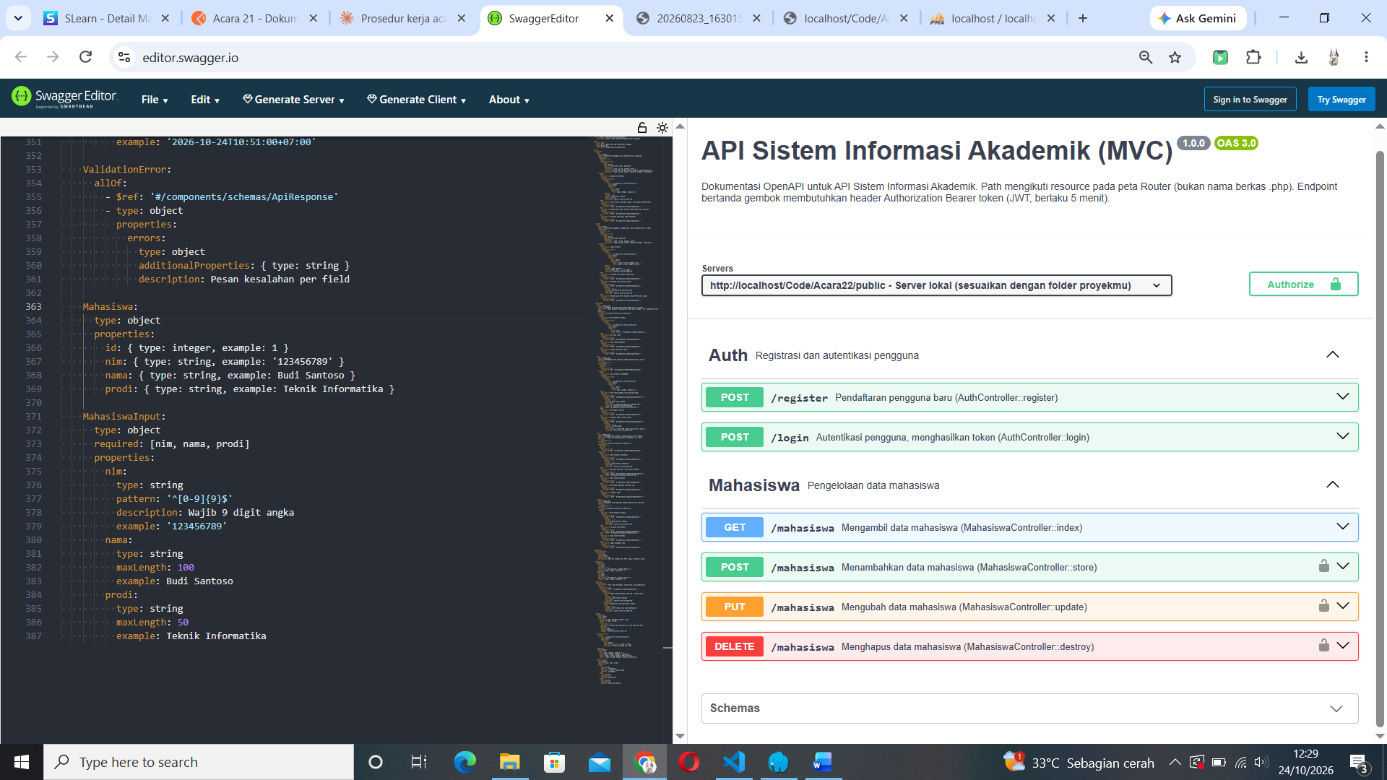
Jika kita menekan tanda panah di bagian panel kanan nanti akan muncul penjelasan yang lebih mendetail.

