Quantum Hybrid Image Transfer via Superdense Coding

Shaik Atiq Rehaman
Lakireddy Bali Reddy College of Engineering
Mylavaram, India atiqrehamanshaik@gmail.com

Munagala Surendra Reddy
Lakireddy Bali Reddy College of Engineering
Mylavaram, India msurendrareddym143@gmail.com

Jarapala Roja
Lakireddy Bali Reddy College of Engineering
Mylavaram, India roja.rnpm.krsn@gmail.com

Godavarthi Shrestha Charitha
Lakireddy Bali Reddy College of Engineering
Mylavaram, India sresthacharitha2@gmail.com

Kosuru Mounika
Lakireddy Bali Reddy College of Engineering
Mylavaram, India kosurumounika350@gmail.com
Saragada Tirupathi Venkata Mohan Reddy
Lakireddy Bali Reddy College of Engineering
Mylavaram, India saragadamohanreddy123@gmail.com

Abstract—In this paper, we proposed a hybrid image transmission method that effectively combines classical and quantum channels. We start by dividing images into blocks and calculating the entropy of each block to find areas with high information content. We transmit high-entropy blocks, using SuperDense Coding. The remaining blocks and important metadata are sent through classical channels. The receiver uses the metadata to rebuild the original image and applies error recovery methods to cope with channel noise and quantum transmission errors. The experimental results show a Structural Similarity Index Measure(SSIM) of 0.996 and Image Fidelity of 99.96%. In our prototype, we focus on the quantum SDC-based transmission, since classical transmission is already well-established and operational. Some limitations and future research areas include managing quantum entanglement, reducing errors, and scaling SDC for larger uses.

I. INTRODUCTION
Image transmission plays a crucial role in modern communication systems. Its applications range from sharing on social media to satellite imaging, surveillance, and tele-medicine. As high-resolution imaging grows, so does the need for realtime communication. The secure and efficient transmission of images has become a significant challenge. Currently, traditional communication systems dominate this area. They convert images into sequences of bits (0s and 1s), which are then compressed using techniques such as JPEG, Huffman coding, or run-length encoding. To ensure reliable data transfer, methods such as Forward Error Correction (FEC) or retransmission protocols are used. Data travels through common channels such as wired internet, Wi-Fi, or wireless cellular networks. Although traditional transmission is robust and scalable, it is limited by bandwidth availability and can be vulnerable to data interception or modification.
In contrast, quantum communication offers new ways to transfer data. A notable example is Superdense Coding(SDC). This protocol allows the transmission of two classical bits of information using just one qubit, assuming that Alice and Bob share an entanglement beforehand [1]. while traditional communication needs two separate bits sent over a channel, SDC encodes them into a single qubit transmission. This effectively doubles the channel capacity and offers inherent quantum security.
Although SDC is theoretically powerful, transmitting an entire image through SDC alone is not practical today. Current quantum systems have issues like limited qubit counts, noisy quantum gates, decoherence, and challenges in maintaining entanglement over long distances. These limitations block the large-scale use of SDC for multimedia files. [2], [3]
To fill this gap, we suggest a hybrid image transmission approach where backgrounds or repetitive areas are sent via the classical channel, while edges and details are transmitted through the quantum channel using SDC. This ensures that quantum resources are utilized only where they are most beneficial.
This hybrid strategy merges the scalability and reliability of traditional transmission with the bandwidth efficiency and security of quantum SDC. It represents a practical advance given the current limitations of quantum hardware. This approach lays the groundwork for future communication systems that can integrate classical and quantum technologies.

II. LITERATURE REVIEW
Classical communication achieves efficiency through compression and channel coding techniques. Despite these advances, classical communication remains fundamentally constrained by Shannon’s channel capacity, which limits the maximum achievable information rate based on channel bandwidth and noise characteristics. [4], [5]
This is where superdense coding (SDC) shows its benefits over purely classical methods by effectively increasing the classical payload per channel use without requiring additional bandwidth [6], [7]. This makes SDC a complementary enhancement to classical methods, boosting throughput while remaining compatible with quantum-secure transmission.
Mastriani (2023), in ”Teleporting Digital Images”, proposed a quantum image transmission architecture that encodes classical image bits into quantum states and transmits them via quantum teleportation. Although the work demonstrates the conceptual feasibility of quantum image transmission, the process remains highly resource-intensive and time-consuming for practical image resolutions. Although qubit reuse strategies [8] have been explored to mitigate limited hardware resources, such approaches do not eliminate the fundamental overhead associated with preparing, transmitting, and measuring quantum states for full-resolution images. Consequently, fully quantum image teleportation remains impractical under current quantum hardware constraints.
This perspective forms the basis for the hybrid image transmission framework proposed in this work. By combining SDC with established classical techniques, hybrid approaches aim to leverage the strengths of both paradigms.

III. METHODOLOGY AND APPROACH
When multiple communication paths operate in parallel, the overall effective throughput is the sum of the individual channel throughputs [5]. In 5G networks, devices often use multi-connectivity, simultaneously combining WiFi, LTE, and 5G carriers, demonstrating that the effective data rate in such systems can be calculated as the sum of the individual link rates, reflecting independent and concurrent contributions from each channel [9]. A similar approach is used in hybrid Free-Space Optical (FSO) and Radio Frequency(RF) systems, where traffic may be switched or multiplexed across optical and radio links [10]. Integrated satellite–5G architectures follow the same principle, where satellite and terrestrial paths jointly contribute to system capacity [11].
These established models provide the theoretical motivation for treating classical and quantum (SDC-based) transmission paths in our hybrid framework as parallel information channels, whose effective throughput is naturally represented as the
sum of their respective contributions.

Throughput Advantage of Hybrid Approach
According to Shannon’s theorem [4], the capacity of a classical communication channel of bandwidth B and signalto-noise ratio (S/N) is given by:
Cclassical 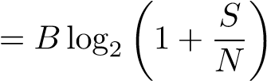 (1)
Using Superdense Coding (SDC) [1], it is possible to transmit two classical bits per qubit. Hence, the effective SDC channel capacity becomes:
CSDC = 2 × Cclassical (2)
In the proposed hybrid transmission model, only an αfraction (0 ≤ α ≤ 1) of the image blocks are transmitted via the quantum (SDC) channel, while the remaining (1 − α) fraction uses the classical channel. Therefore, the total hybrid channel capacity can be expressed as a weighted sum:
Chybrid = (1 − α)Cclassical + αCSDC
(3)
Substituting Eq. (2) into Eq. (3):
Chybrid = (1 − α)Cclassical + α(2Cclassical)
= (1 − α + 2α)C_{classical}
= (1 + α)C_{classical} (4)
Finally, substituting Eq. (1) into Eq. (4) gives the closedform expression for hybrid channel throughput:
(5)
C
hybrid
=(1+
α
)
B
log
2

1+
S
N

Example
To show the improvement achieved by our hybrid model, consider a classical channel of bandwidth B = 1 MHz and signal-to-noise ratio S/N = 15 dB, corresponding to S/N =
31.6 in linear scale.
From Eq. (1), the Shannon capacity is:
Cclassical 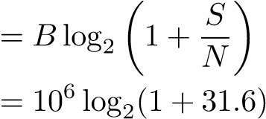
= 5.02 ≈ 5 Mbps (6)
For a quantum allocation fraction of α = 0.15 (i.e., 15% of high-entropy blocks transmitted via SDC), the hybrid capacity of Eq. (5) becomes:
Chybrid 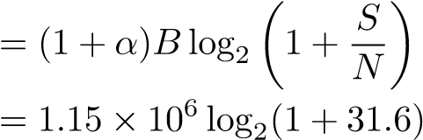
= 5.78 ≈ 5.8 Mbps (7)
Chybrid − Cclassical
× 100% = 16%
Cclassical
This capacity gain arises from the assistance of entanglement and does not contradict Shannon’s classical capacity theorem, which assumes unentangled classical channels.

A. Conceptual Framework
Our system is a hybrid transmission model that uses both classical and quantum channels. The classical channel acts as a reliable, high-throughput medium for bulk image transfer, especially for low-information or repetitive blocks. It supports well-known techniques like compression, error correction, and retransmission.
Using superdense coding (SDC), each qubit encodes two classical bits, which doubles the channel efficiency compared to the classical transfer. This division of tasks between channels is key to our approach, ensuring reliability and efficiency.

B. Workflow Overview
The overall workflow starts with image preprocessing. The image is divided into blocks of non-overlapping size B × B. Smaller blocks improve localization, while larger blocks reduce metadata overhead. For an image sized H ×W, the total number of blocks is
M = rows × cols.
Each block is scored using Shannon entropy to estimate its information content. We select the blocks with the highest entropy for SDC transmission, while the others are set for classical transfer. Shannon entropy [4], [5] :
H_{block} = −^{X}p(i)log₂ p(i).
i
where p(i) is the probability distribution of pixel intensities in the block.
Based on entropy scores, we selected the top-k of blocks with the highest information content for quantum transmission using SDC. The indices of these selected blocks were recorded in the metadata.

C. Design Choices and Policies
A key design choice in our methodology is entropy-based block selection. This approach ensures that limited quantum resources go to the most informative areas of the image, improving transmission efficiency. In our prototype, we used a top-p% selection policy, where the highest-entropy fraction of the blocks goes to the quantum channel.
In our prototype, the metadata was kept minimal but enough to reconstruct the image layout. The information is stored in a structured format with two main components:
• Global metadata fields:
- Block size used for partitioning (e.g, 8 × 8)
- Top percentage parameter indicating the fraction of blocks selected for quantum transmission
• Per-block entries:
- Row and column indices of each block
- Block type: quantum (selected high-entropy blocks) or classical (remaining blocks)
Existing quantum image representations such as FRQI [12] and NEQR [13] lack scalable classical–quantum interfaces and suffer from fundamental state-preparation and measurement limitations, which restrict their applicability largely to simulation-based studies under current hardware constraints [14].
Motivated by these limitations, a key design choice in our methodology is to retain image data in the classical domain and map classical bit streams to qubits exclusively for transmission using Superdense Coding, thereby exploiting quantum communication advantages without incurring the overhead of full quantum image encoding.

IV. PROTOTYPE DEVELOPMENT

A. Prototype Description
The system is entirely implemented in Python, combining classical image processing libraries with Qiskit for quantum simulation.
To reduce simulation runtime, we executed block-wise SDC encoding in parallel with Python multiprocessing as each block is independent of other. This allowed multiple blocks to be transmitted at the same time in Qiskit. Although this optimization speeds up the prototype, it is not necessary in real quantum hardware, where qubits are processed at the same time on the physical level.

B. Performance Evaluation
The computational cost of the proposed hybrid image transmission framework depends primarily on three stages: blockwise entropy computation, block selection, and superdense coding (SDC) simulation.
- Entropy Computation:
Each image of size H×W is divided into blocks of B×B. The number of blocks is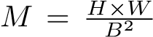. Computing Shannon entropy for each block requires scanning all B² pixels, giving a time complexity of:
O(M × B²) = O(HW)
which scales linearly with the number of pixels.
- Block Selection:
Sorting the entropy scores to select the top-p% blocks has a complexity of:
O(M logM)
Although this cost is small relative to the image size for practical block counts.
- SDC Simulation:
Each 2-bit symbol is encoded via an SDC circuit. Assuming Q qubits (or bit pairs) are processed, the quantum encoding and simulation in Qiskit have an empirical complexity of approximately:
O(Q)
per circuit generation, but with a large constant overhead due to quantum gate simulation. Parallel execution reduces effective runtime by a factor of k, the number of CPU cores used, resulting in:
O(Q/k)
for practical implementations.
The total computational complexity of the system is O(HW + M logM), dominated by image size and entropy evaluation, while the use of space scales linearly with the input.
The prototype uses circuit-level SDC simulation to approximate performance, while the full realization of such imagescale quantum transmission remains a long-term goal as qubit counts and entanglement distribution technologies continue to advance [15], [16].

V. IMPLEMENTATION
A. Encoding and Transmission:
In the prototype, pixels in high-entropy blocks are converted into binary streams. Superdense coding (SDC) maps two classical bits to one qubit, so the streams are padded for even length. The encoding process is done in Qiskit. Alice and Bob share entangled Bell pairs, and Pauli gates are used to encode 2-bit symbols into qubits. Transmission is simulated with noise models [17] .
Although the framework assumes that the remaining blocks and metadata would be sent over a classical channel, this was not included in the prototype, since classical transfer is already well established.
Algorithm 1:
Input: Input image I, block size B, top percentage p, noise parameters
Output: Received quantum bit pairs
- Load image I and divide into B sized blocks;
- Compute entropy score for each block;
- Select top-p% high-entropy blocks → quantum set;
- Mask remaining blocks to form classical image;
- Build quantum noise model and backend simulator
(Qiskit Aer);
- Prepare SDC circuits for encoding bit pairs;foreach selected block (i,j) in quantum set do
  - Convert block to bitstream, pad to even length,and chunk into 2-bit pairs;
  - Store bit pairs, block indices, and counts fortransmission; level transmission information.
- Store global metadata parameters such as block size and the fraction of blocks selected for quantum transmission.
- Iterate over all image blocks and determine whether each block belongs to the high-entropy set.
- Assign the label quantum to selected high-entropy blocks and classical to the remaining blocks.
- Record the row index, column index, and block type for each block in the metadata structure.
- Output the metadata structure for use in receiver-side reconstruction.

C. Receiver-Side Decoding
At the receiver, metadata are read first to help with reconstruction. The quantum payload is decoded from qubits back into bit strings. Both sets of blocks return to their original coordinates to reconstruct the image.

Algorithm 2: Receiver-Side Decoding and Reconstruction

Input: Received quantum bit pairs, metadata M, classical image, block size B
Output: Reconstructed image ^{Iˆ}
- Reconstruct quantum blocks from received bit pairs
using indices and counts;
- Assemble quantum image from reconstructed blockswith original shape;
- Initialize I^{ˆ}_{quantum} ← quantum image copy;

4. foreach block (i,j) in top-entropy set do
- Extract block region from quantum image;
- Apply non-local means denoising to theblock;
- Replace block in I^{ˆ}_{quantum} with denoised version;
- Combine classical and quantum blocks usingmetadata M to form I^{ˆ};
- Plot histogram of pixel-wise errors and generateheatmap;

return I^{ˆ}


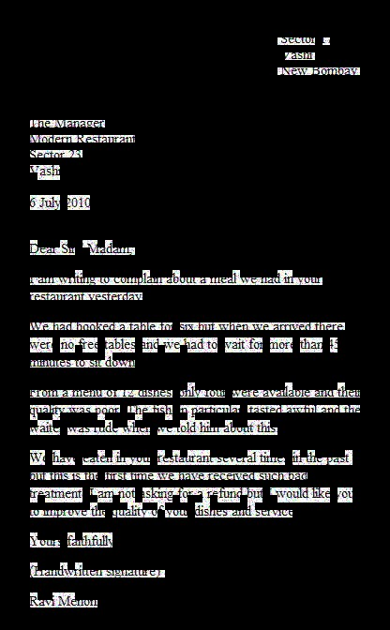
VI. RESULTS AND OUTCOMES
7
. Construct metadata
M
;
8
. Group bit pairs into batches for parallel processing;
9
. Simulate SDC transmission of all bit pairs with
noise model and record received pairs;
return
received quantum bit pairs
B.
Metadata Generation and Handling
1)
Initialize an empty metadata structure for storing block-
(
b) Image through quantum chan
-
(a) Image through classical nel

Fig. 1: Block Size 8x8
Figure 1a is for the all-classical design in which every block goes through the classical channel. Similarly, Fig 1b is for the quantum assisted design, where only the blocks with the highest entropy encoding go through SDC.
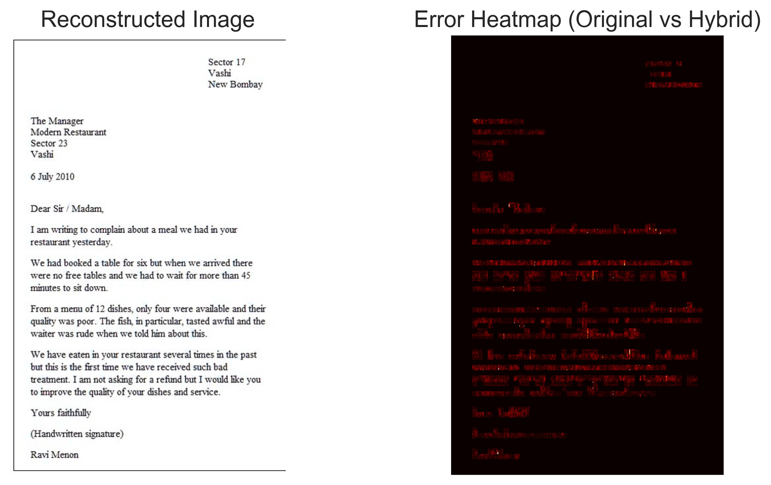
Fig. 2: Comparison of the reconstructed hybrid image and corresponding error heatmap at noise 30%.
In the right image of Fig 2, black regions indicate zero or negligible difference, while red regions represent pixel-wise differences between the original and reconstructed images. The differences are mainly observed around edges and finetextured regions, which corresponds to the blocks selected for quantum transmission.
Resolution | Block Size | PSNR (dB) | SSIM
128 × 128 | 8 × 8 | 55.59 | 0.99712
256 × 256 | 8 × 8 | 48.22 | 0.99991
512 × 512 | 8 × 8 | 48.84 | 0.99691
TABLE I: Image Reconstruction Quality for Hybrid Transmission
Table I represents the reconstruction quality achieved by the proposed hybrid framework in different image resolutions with fixed block size at noise 30%.
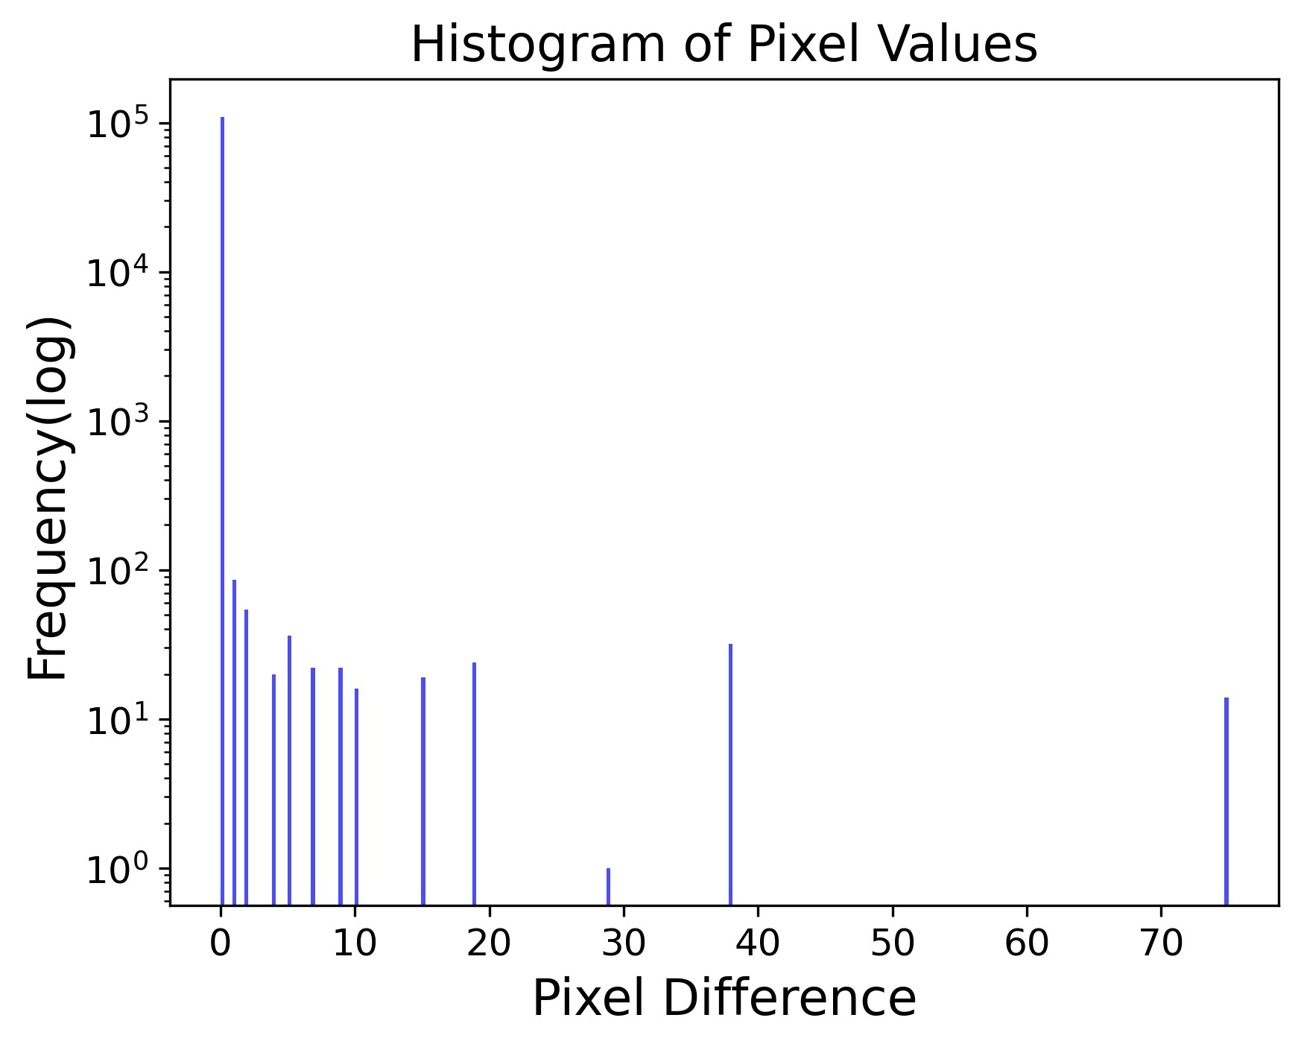
Fig. 3: The histogram of pixel-wise absolute differences between the original and reconstructed image.
Fig 3, Most of the pixel errors are located around zero, suggesting that hybrid transmission results in the retention of the majority of visual information with negligible degradation. The only high-error pixels are in detailed and high-entropy sections that simulate quantum noise.
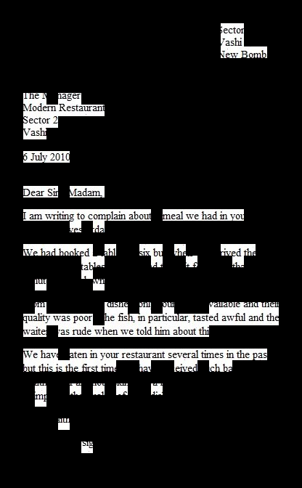
(b) Image through quantum chan-
(a) Image through classical nel

Fig. 4: Block Size 16x16
The 16x16 block size reduces the total number of image blocks, reducing metadata overhead and the number of potential quantum allocations. This block size is more suitable for images with large object regions. However, it is less suitable for images with small objects such as letters in the above image 4a.
In contrast, a smaller block size such as 8×8 increases the total number of blocks, allowing for finer differentiation of high-entropy regions. This improves localization in images containing small objects or detailed textures, as entropy variations can be captured more precisely.
Noise(%) | PSNR (dB) | SSIM
25 | 69.04 | 0.99999
30 | 48.79 | 0.99971
35 | 34.90 | 0.99392
TABLE II: PSNR and SSIM for different noise probabilities for 422x674 resolution image
As shown in Table II, the quality of the reconstructed image progressively decreases as the probability of quantum noise increases. Due to the selective quantum allocation strategy (α = 15%), the PSNR and SSIM values remain relatively high at lower noise.

VII. INNOVATION AND NOVELTY
The proposed system introduces a hybrid image transmission framework that combines classical and quantum channels. Unlike earlier efforts that focus only on classical compression or quantum communication protocols, our method uses entropy-based block selection. This approach assigns high-information content to the quantum channel and lowinformation content to the classical channel. It ensures efficient use of limited quantum resources while maintaining reliability through classical transfer.
This selective transmission strategy enables the efficient utilization of limited quantum resources while maintaining the reliability and scalability of classical communication. In contrast to SDC-only approaches, the proposed framework avoids unnecessary quantum transmission of low information regions, reducing entanglement consumption and circuit overhead.

VIII. USE CASE APPLICATIONS
The proposed hybrid framework is capable of addressing real-world problems where both efficiency and reliability are important:
- The framework supports tamper-aware image distribution by allowing authentication data, watermarks, or other critical metadata to be transmitted via the quantum channel, while large image content is delivered classically. This separation enhances data integrity without imposing the full quantum encoding overhead.
- In Voice Communication, a hybrid approach can be used where perceptually important speech features(spectral envelope and voicing information) are transmitted over a quantum channel, while the remaining audio data are sent through a classical channel.
- In bandwidth-limited environments such as deep-space or underwater communication, the hybrid transmission strategy can improve effective information throughput by selectively applying Superdense Coding to high-information image regions without increasing overall bandwidth requirements.
This hybrid allocation builds a scaling advantage and flexibility into any resource allocation strategy, ensuring quantum resources are used where they provide the most value added and classical channels provide extra stability and throughput.

IX. LIMITATIONS AND FUTURE WORK
Entropy limitation, While entropy effectively identifies information-rich regions in images with structured content and smooth backgrounds, it becomes less discriminative for images dominated by dense textures or uniformly complex patterns, such as crowd scenes. In such cases, a large fraction of blocks may exhibit similarly high entropy values, reducing the effectiveness of selective quantum allocation and limiting potential resource savings.
Quantum hardware scalability and entanglement management constitute a fundamental limitation of the proposed framework. Current quantum devices support only a limited number of qubits with short coherence times and non-negligible gate noise, which restricts the practical use of Superdense Coding for high-resolution image transmission. In addition, the reliable generation, distribution, and synchronization of entangled Bell pairs over long distances remain challenging and are largely confined to laboratoryscale or resource-intensive experimental environments. These combined constraints limit the number of image blocks that can be transmitted quantumly and hinder the scalability of hybrid image transmission systems under present-day hardware conditions.
System-level integration between classical and quantum communication channels is also underexplored. The current prototype is simulation-based and relies on Qiskit noise models rather than execution on physical quantum hardware or quantum networks. As a result, performance evaluation is limited to idealized or approximate conditions and may not fully reflect real-world network behavior. Related work on teleporting digital images demonstrates feasibility only for small-scale or toy examples, further highlighting the gap between simulation and deployment [14].
Future research can address these limitations in several directions. Scalable entanglement distribution techniques, such as quantum repeaters and entanglement purification, are essential to extend transmission distance and reliability. Dynamic block selection policies that adapt to different image data are essential for high information block selection. Experimental validation on quantum network testbeds would enable more realistic performance assessment beyond simulation.

X. CONCLUSION
This research described a hybrid approach to image transmission for efficient and reliable transmission of visual information. Based on decomposing images into entropy-defined blocks, the system encodes only the region of maximum information density with quantum transmission using the superdense coding protocol, while the remaining of the image with low-entropy and the metadata are transmitted through classical channels. This results in a bandwidth-efficient design that retains essential aspects of the image while leveraging the different strengths offered by classical and quantum communication.
An initial prototype implementation with Qiskit simulations demonstrated block-wise entropic selection and SDC encoding, followed by metadata-driven reconstruction.The hybrid transmission model achieved 16% bandwidth reduction by sending 15% of high-entropy blocks through the quantum channel through the superdense protocol. The experimental results show nearly lossless reconstruction with a PSNR of 39.3 dB, SSIM of 0.993, and Image fidelity of 99.34% by using selective allocation strategy. The hybrid approach increased throughput efficiency from 5 Mbps to approximately 5.8 Mbps (estimated) using the relation. While the time delay for quantum transmission remains limited by simulation time and existing QRNG devices, one take-away for future imaging applications, is that SDC offers the potential for secure and scalable transmission over time.

ACKNOWLEDGEMENTS
This research work was carried out under AQVH 2025 (Final) at the Quantum Innovation Center, LBRCE.

REFERENCES
- C. H. Bennett and S. J. Wiesner, “Communication via one-and twoparticle operators on einstein-podolsky-rosen states,” Physical review letters, vol. 69, no. 20, p. 2881, 1992.
- J. Yin, Y. Cao, Y.-H. Li, S.-K. Liao, L. Zhang, J.-G. Ren, W.-Q. Cai, W.Y. Liu, B. Li, H. Dai et al., “Satellite-based entanglement distribution over 1200 kilometers,” Science, vol. 356, no. 6343, pp. 1140–1144, 2017.
- J. Preskill, “Quantum computing in the nisq era and beyond,” Quantum, vol. 2, p. 79, 2018.
- C. E. Shannon, “A mathematical theory of communications,” Bell system technical journal, vol. 27, pp. 379–423, 1948.
- T. M. Cover, Elements of information theory. John Wiley & Sons, 1999.
- R. Laurenza, C. Lupo, S. Lloyd, and S. Pirandola, “Dense coding capacity of a quantum channel,” Physical Review Research, vol. 2, no. 2, p. 023023, 2020.
- X.-M. Hu, Y. Guo, B.-H. Liu, Y.-F. Huang, C.-F. Li, and G.-C. Guo, “Beating the channel capacity limit for superdense coding with entangled ququarts,” Science advances, vol. 4, no. 7, p. eaat9304, 2018.
- S. Brandhofer, I. Polian, and K. Krsulich, “Optimal qubit reuse for nearterm quantum computers,” in 2023 IEEE International Conference on Quantum Computing and Engineering (QCE), vol. 1. IEEE, 2023, pp. 859–869.
- S. Tripathy, B. Reddy, T. Agarwal, B. Samrat et al., “Multi-connectivity techniques in 5g networks: Performance analysis and optimization,” in 2025 International Conference on Automation and Computation (AUTOCOM). IEEE, 2025, pp. 736–741.
- M. Uysal and H. Nouri, “Optical wireless communications—an emerging technology,” in 2014 16th international conference on transparent optical networks (ICTON). IEEE, 2014, pp. 1–7.
- L. Boero, R. Bruschi, F. Davoli, M. Marchese, and F. Patrone, “Satellite networking integration in the 5g ecosystem: Research trends and open challenges,” Ieee Network, vol. 32, no. 5, pp. 9–15, 2018.
- P. Q. Le, F. Dong, and K. Hirota, “A flexible representation of quantum images for polynomial preparation, image compression, and processing operations,” Quantum Information Processing, vol. 10, no. 1, pp. 63–84, 2011.
- Y. Zhang, K. Lu, Y. Gao, and M. Wang, “Neqr: a novel enhanced quantum representation of digital images,” Quantum information processing, vol. 12, no. 8, pp. 2833–2860, 2013.
- M. Mastriani, “Teleporting digital images,” Optical and Quantum Electronics, vol. 55, no. 6, p. 498, 2023.
- H.-S. Zhong, H. Wang, Y.-H. Deng, M.-C. Chen, L.-C. Peng, Y.-H. Luo, J. Qin, D. Wu, X. Ding, Y. Hu et al., “Quantum computational advantage using photons,” Science, vol. 370, no. 6523, pp. 1460–1463, 2020.
- D. Awschalom, K. K. Berggren, H. Bernien, S. Bhave, L. D. Carr, P. Davids, S. E. Economou, D. Englund, A. Faraon, M. Fejer et al., “Development of quantum interconnects (quics) for next-generation information technologies,” Prx Quantum, vol. 2, no. 1, p. 017002, 2021.
- M. A. Nielsen and I. L. Chuang, Quantum computation and quantum information. Cambridge university press, 2010.
- S. Lloyd, “Capacity of the noisy quantum channel,” Physical Review A, vol. 55, no. 3, p. 1613, 1997.
- B. Schumacher and M. D. Westmoreland, “Quantum mutual information and the one-time pad,” Physical Review A—Atomic, Molecular, and Optical Physics, vol. 74, no. 4, p. 042305, 2006.
- A. Boaron, G. Boso, D. Rusca, C. Vulliez, C. Autebert, M. Caloz, M. Perrenoud, G. Gras, F. Bussieres, M.-J. Li` et al., “Secure quantum key distribution over 421 km of optical fiber,” Physical review letters, vol. 121, no. 19, p. 190502, 2018.
- Z. Wang, “Image quality assessment: Form error visibility to structural similarity,” IEEE Trans. Image Process., vol. 13, no. 4, pp. 604–606, 2004.

