1. OnlineBookShop

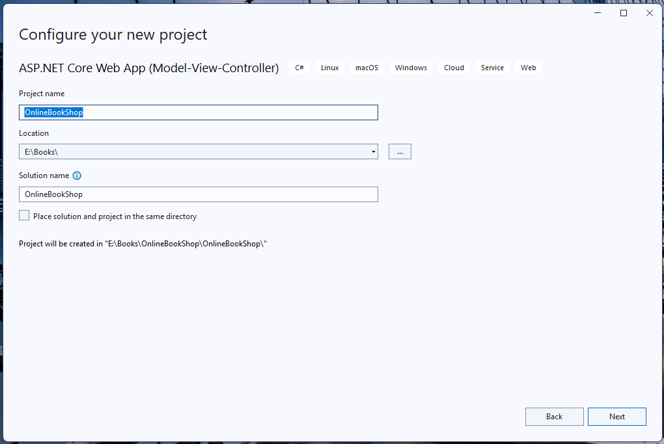

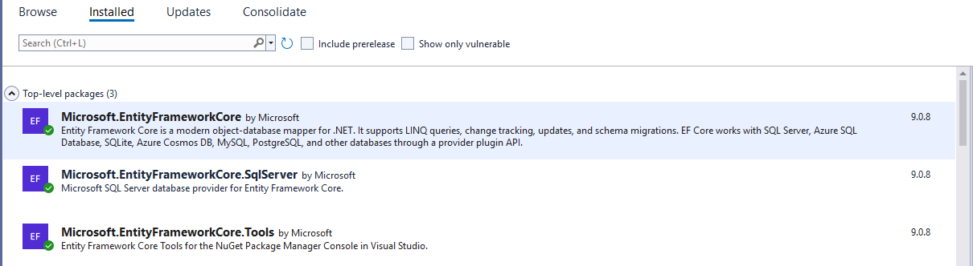

Add-migration First

Update-Database

