**Assignment: Bash Shell Basics**

**Task 1: File and Directory Manipulation**

1. Create a directory called "my_directory".
2. A screen shot of a computer

   Description automatically generated with medium confidence
3. Navigate into the "my_directory".
4. A screenshot of a computer

   Description automatically generated
5. Create an empty file called "my_file.txt".
6. A screenshot of a computer

   Description automatically generated with medium confidence
7. List all the files and directories in the current directory.
8. A screen shot of a computer

   Description automatically generated with medium confidence
9. Rename "my_file.txt" to "new_file.txt".
10. A screenshot of a computer

    Description automatically generated
11. Display the content of "new_file.txt" using a pager tool of your choice.
12. A screen shot of a computer

    Description automatically generated with medium confidence
13. Append the text "Hello, World!" to "new_file.txt".
14. 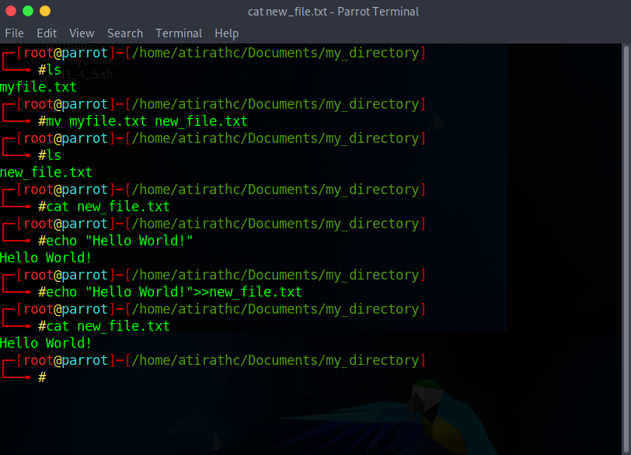
15. Create a new directory called "backup" within "my_directory".
16. A screenshot of a computer

    Description automatically generated
17. Move "new_file.txt" to the "backup" directory.
18. A picture containing text, electronics, screenshot, software

    Description automatically generated
19. Verify that "new_file.txt" is now located in the "backup" directory.
20. A picture containing text, electronics, screenshot, software

    Description automatically generated
21. Delete the "backup" directory and all its contents.
22. A picture containing text, electronics, screenshot, software

    Description automatically generated

**Task 2: Permissions and Scripting**

* Create a new file called "my_script.sh".
* A picture containing text, screenshot, font

  Description automatically generated
* Edit "my_script.sh" using a text editor of your choice and add the following lines:

**bash**

**#!/bin/bash**

**echo "Welcome to my script!"**

**echo "Today's date is $(date)."**

**Save and exit the file.**

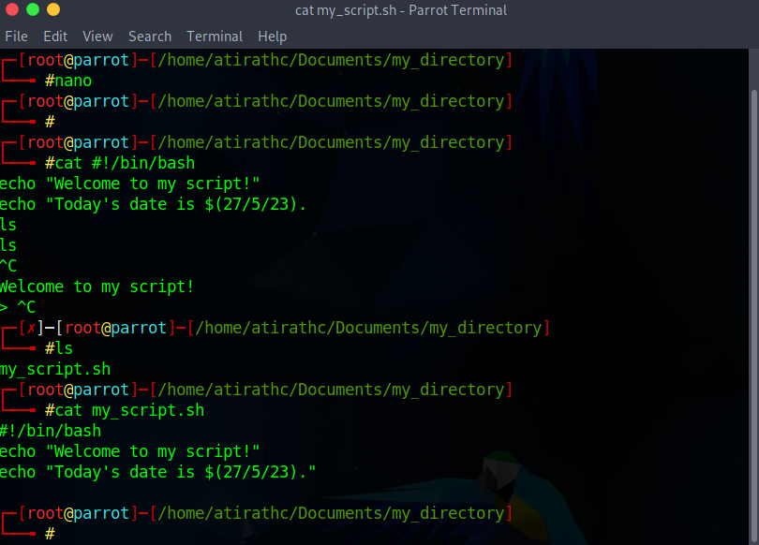

* Make "my_script.sh" executable.
* A screen shot of a computer

  Description automatically generated with medium confidence
* Run "my_script.sh" and verify that the output matches the expected result.
* A computer screen with green text

  Description automatically generated with low confidence

**Task 3: Command Execution and Pipelines**

* List all the processes running on your system using the "ps" command.
* A picture containing text, screenshot, display, software

  Description automatically generated
* Use the "grep" command to filter the processes list and display only the processes with "bash" in their name.
* A screenshot of a computer

  Description automatically generated
* Use the "wc" command to count the number of lines in the filtered output.
* A screen shot of a computer

  Description automatically generated with medium confidence

**Submission:**

Provide a document or text file containing the commands used to complete the tasks above, along with any relevant output or screenshots. Include your explanations or observations where necessary.