Engineering Mathematics & Physics Test
Q1: Define Newton's Second Law of Motion and state its SI unit.
Q2: Solve the following quadratic equation for x: $x = (-b ± √(b² - 4ac)) / 2a$
Q3: In the given circuit diagram below, calculate the equivalent resistance between terminal A and B.
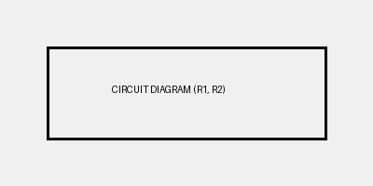

Section B: Numerical Data
Component | Value | Tolerance
Resistor R1 | 100 Ohm | ±5%
Capacitor C1 | 10 uF | ±10%

