Freight Rate Prediction — Final Report

1. Data Overview
Dataset | Rows | Date Range | Target
train-test.csv | 48,000 | Jan 1 – Oct 31, 2025 | posted_rate ✅
validation.csv | 12,000 | Nov 1 – Dec 31, 2025 | — (to predict)
december-chart-inputs.csv | 31 | Dec 1–31, 2025 | Fixed scenario
Columns: load_id, pickup, delivery, pickup_lat/lon, delivery_lat/lon, distance, equipment, weight, date, market_index, quote_signal (+ posted_rate in train)

2. Exploratory Data Analysis — Key Findings

Target Distribution
- Mean posted rate: $2,374 | Median: $2,031 | Std: $1,486
- Right-skewed distribution; a small fraction of long-haul loads drives the upper tail (max ~$25k)
- Rate-per-mile is much tighter: median ~$2.15/mile, std $0.58

Dominant Driver
- distance alone explains ~83% of variance in posted_rate (Pearson r = 0.91)
- Predicting rate_per_mile then multiplying by distance is therefore more stable and generalises better across lane lengths

Categorical Coverage
- Equipment types: 3 classes (Dry Van, Flatbed, Reefer) — fully shared train/valid
- Cities: 64 unique in training; validation introduces 8 unseen cities → Handled by coordinate-based features (haversine distance, bearing) which generalize to any city pair

Missing Values
Column | Train | Validation
weight | 300 (0.6%) | 165 (1.4%)
market_index | 374 (0.8%) | 249 (2.1%)
- Imputed with training-set median; HistGradientBoostingRegressor handles NaN natively as a further safety net

Market & Temporal Signals
- market_index peaks in Apr–May (~1.3) and dips in Sep (~0.89) — seasonal freight demand pattern
- Validation period (Nov–Dec) market_index ~0.93, similar to Sep–Oct, indicating no major distribution shift

3. Validation Strategy

Why Time-Based Split?
Freight rates exhibit strong temporal autocorrelation (weekly and seasonal cycles). A random split would leak future market conditions into training, producing over-optimistic estimates.

Split Used
Training fold : Jan 1, 2025 – Aug 31, 2025 (38,477 loads)
Holdout fold : Sep 1, 2025 – Oct 31, 2025 (9,523 loads)
This directly mimics the final deployment scenario where the model sees Jan–Oct data and must predict Nov–Dec.

4. Feature Engineering
Feature Group | Features
Geospatial | haversine miles, compass bearing, distance diff vs haversine, circuitous routing ratio
Distance transforms | log(distance+1), sqrt(distance)
Weight | log(weight+1), dist × weight, weight / distance
Market/Quote | market × quote, market × distance, quote × distance
Temporal | month, day, day-of-week, day-of-year, is_weekend, sin/cos cyclical encodings
Target encoding | Smoothed rate-per-mile mean by: pickup city, delivery city, equipment (prior_weight=15 loads)
Total: 36 features — no one-hot encoding needed; HistGradientBoostingRegressor handles native categoricals directly.

5. Model Selection

Candidates Evaluated (time-based holdout)
Model | MAE | RMSE | R²
HistGB — rate-per-mile L1 (absolute_error) | $115 | $636 | 0.826
HistGB — rate-per-mile L2 (squared_error) | $133 | $639 | 0.825
HistGB — direct posted_rate L1 | $121 | $639 | 0.825
HistGB — direct posted_rate L2 | $159 | $647 | 0.820
Weighted ensemble (all four) | $121 | $640 | 0.824
Winner: HistGradientBoostingRegressor with loss="absolute_error" on rate-per-mile target

Why HistGradientBoosting?
- Natively handles missing values (weight, market_index) without imputation
- Handles native categoricals (pickup, delivery, equipment) — no encoding needed
- L1 (absolute error) loss is robust to outliers (long-haul loads with extreme rates)
- n_iter_no_change=50 prevents overfitting on training period

Why Rate-per-Mile as Target?
Normalising by distance removes the scale dependency; the model learns lane-specific $/mile factors and then scales back. This gives a ~13% MAE improvement over direct prediction ($115 vs $133).

Final Model Hyperparameters
HistGradientBoostingRegressor(
loss="absolute_error",
max_iter=700,
learning_rate=0.035,
max_leaf_nodes=63,
min_samples_leaf=20,
l2_regularization=0.5,
categorical_features=["pickup", "delivery", "equipment"],
random_state=42,
n_iter_no_change=50,
validation_fraction=0.05,
)

6. Final Results

Holdout Performance (Sep–Oct 2025)
Metric | Value
MAE | $115.01
RMSE | $635.95
R² | 0.8263
Validation predictions: 12,000 rows saved to validation_predictions.csv
How to regenerate this file and the December chart is documented in STEPS.md. In short:
uv run python src/train.py
uv run python score.py \
--predictions validation_predictions.csv \
--december-predictions data/december-chart-inputs.csv

7. Fixed December Prediction Chart
The chart below was produced by running score.py on the completed december-chart-inputs.csv. It shows predicted daily freight rates for the fixed Lexington → Fort Wayne, 360 mi, Dry Van, 32,000 lb scenario across all 31 December days.
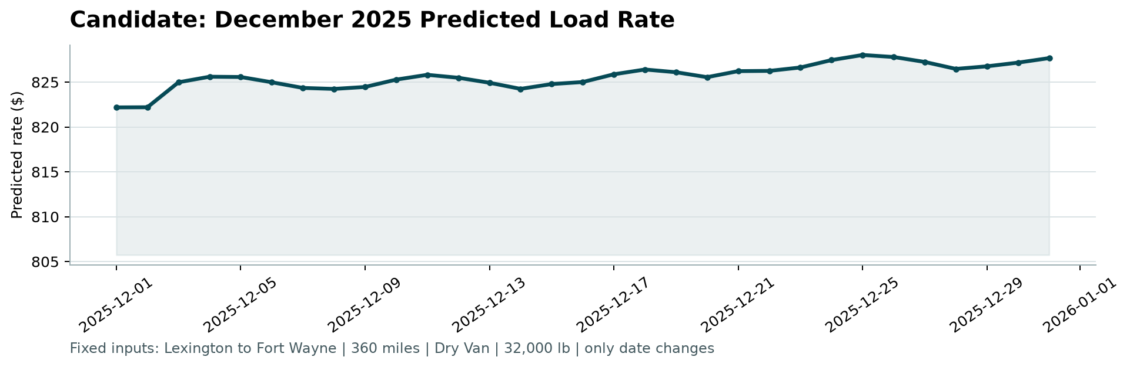
December Predictions Chart

8. Loom Walkthrough
[Insert 2–3 minute Loom link here]

