TEXAS STATE UNIVERSITY
McCOY COLLEGE OF BUSINESS
FINANCE AND ECONOMICS DEPARTMENT



Course Code: QFE 5340
Instructor: Dr. Yifan Liu
Assistant Professor Financial Econometrics
Spring Semester 2025
May 01, 2025

Submitted by:
Atisha Karki

Executive Summary
This project analyzes the dependence structure among the returns of five major cryptocurrencies — Bitcoin (BTC), Ethereum (ETH), Binance Coin (BNB), Ripple (XRP), and Dogecoin (DOGE) using high-frequency one-minute return data. The main objective is to model and forecast both the return dynamics and the evolving correlations between these assets.
First, descriptive statistics and correlation analyses were conducted, revealing that crypto returns are highly volatile, non-normally distributed, and moderately correlated with each other. A Vector Autoregressive model of order one VAR (1) was then fitted to capture the interdependencies between crypto returns. The VAR (1) results suggested that past returns of some cryptocurrencies can help predict others in the short term, though overall predictive power is modest. To model time-varying volatility and correlations, a Dynamic Conditional Correlation GARCH DCC-GARCH (1,1) model was estimated. The DCC-GARCH analysis demonstrated that correlations between cryptocurrencies are dynamic, with periods of increased co-movement, particularly during volatile market conditions.
Overall, the findings highlight the importance of accounting for both return spillovers and changing correlations when managing crypto portfolios, as diversification benefits are not constant over time.

CHAPTER 1: INTRODUCTION
- Cryptocurrencies
Cryptocurrencies are the digital or virtual currency that uses cryptography to secure the transactions. They are operated in a decentralized system—they are not controlled by the bank or authority. They exist on decentralized networks using blockchain technology distributed ledger enforced by a disparate network of computers. There are thousands of cryptocurrencies out there, but broadly speaking, we can classify them into four categories: Payment cryptocurrencies, Tokens, Stablecoins, and Central Bank Digital Currencies.
Payment Cryptocurrency is a type of digital currency designed primarily to serve as a medium of exchange, enabling peer-to-peer electronic transactions without the need for intermediaries. These cryptocurrencies typically operate on dedicated blockchains focused solely on facilitating payments, meaning they do not support smart contracts or decentralized applications (Dapps). Payment cryptocurrencies often have a capped supply, making them deflationary in nature. Notable examples include Bitcoin (BTC), Litecoin (LTC), Monero (XMR), and Dogecoin (DOGE). Token is a type of cryptographic asset that operates on an existing blockchain, rather than having its own native blockchain. They are typically created through smart contracts and serve a wide range of functions within a blockchain ecosystem. Unlike payment cryptocurrencies, tokens are usually inflationary and are used to represent utility, access, ownership, or governance within decentralized platforms. Types of tokens include utility, service, finance, government, media and government. Notable examples include Ether (ETH), Binance Coin (BNB), and Basic Attention Token (BAT). Stablecoins are the type of cryptocurrencies that are pegged to the physical currency, most commonly the US dollars or Euro. They are designed to store the value, so that investors are easily attracted to savings, trading, or transferring money without the typical fluctuations seen in other digital assets. Notable examples include Ripple (XRP). Central Bank Digital Currency is the type of cryptocurrency issued by the central bank of various countries. They are issued in a token form or with an electronic record and are normally pegged into the domestic currency of the issuing country. Among the types of cryptos five cryptocurrencies have been studied in this project - Bitcoin (BTC), Ethereum (ETH), Binance coin (BNB), Ripple (XRP), and Dogecoin (DOGE).
1.1 Bitcoin (BTC)
Bitcoin was first introduced to the public in 2008 by an unknown entity under the pseudonym of Satoshi Nakamoto. However, the use of bitcoin as a currency began in 2009, with the release of its open-source implementation. Bitcoin is the first decentralized cryptocurrency and relies on peer-to-peer software. BTC’s transactions are verified by network nodes through cryptography and are recorded in a public distributed ledger called a blockchain. Bitcoins can be used for buying goods and services online or in person, hedging against inflation, cross-border transactions or as an investment asset, and can be exchanged for cash just like any asset. BTC prices tend to follow stock market trends because they are treated the same way that investors treat other investments. Investing in bitcoin carries several risks regulatory risk, insurance risk, fraud risk, and market risk. The law around bitcoin is uncertain and may change anytime, which would potentially affect its legality and value. BTC’s are vulnerable to hacking, malware, and technical failures and are highly volatile to news, with frequent and dramatic price swings. Even though blockchain technology is secure, scams and fraudulent schemes still happen to investors of bitcoin, and they are not protected by government-backed agencies like the FDIC or SIPC, they also carry insurance risks.

1.2 Ethereum (ETH)
Ethereum was first proposed in 2013 by programmer Vitalik Buterin and officially launched in 2015 with the help of several co-founders. Unlike Bitcoin, which was designed primarily as a digital currency, Ethereum is a decentralized platform that enables the creation of smart contracts and decentralized applications using its own cryptocurrency called Ether (ETH). Ethereum operates on a peer-to-peer network and uses a public distributed ledger, also known as a blockchain—to record and verify transactions securely through cryptographic techniques. Ether can be used to pay for transactions on the Ethereum network, facilitate decentralized finance (DeFi), buy goods and services, or serve as an investment asset. ETH can also be exchanged for fiat currency similarly to other digital assets. Ethereum prices are influenced by investor sentiment, broader market trends, and the adoption of blockchain applications. Investing in Ethereum carries several risks regulatory risk, insurance risk, fraud risk, and market risk. As with Bitcoin, the legal framework for Ethereum is evolving and subject to change, which could affect its utility and value. ETH is also susceptible to hacking, bugs in smart contracts, and extreme price volatility driven by news or market speculation. While Ethereum’s blockchain is considered secure, investors may still fall victim to scams and rug pulls, and they do not have the same protection as traditional financial investments, such as FDIC or SIPC insurance, increasing the exposure to potential losses.
1.3 Binance coin (BNB)
Binance Coin (BNB) was launched in 2017 by the Binance cryptocurrency exchange, originally as an ERC-20 token on the Ethereum blockchain. It was later migrated to Binance’s own blockchain, Binance Chain, and now operates on the BNB Chain ecosystem, which includes both Binance Chain and Binance Smart Chain (BSC). BNB is a utility token used primarily to pay for trading fees on the Binance platform at discounted rates, but its use has since expanded to include payments for transaction fees, travel bookings, online services, and even financial products. BNB transactions are processed on a peer-to-peer network and recorded in a public blockchain ledger, ensuring transparency and security through cryptography. It can also be traded like other cryptocurrencies, held as an investment, or used in decentralized applications within the BNB Chain ecosystem. The price of BNB is influenced by Binance’s performance, market trends, trading volume, and periodic token burns that reduce its supply. Investing in BNB carries risks such as regulatory uncertainty, market volatility, centralization concerns, and potential platform-related vulnerabilities. Since Binance is a centralized entity, changes in its operations or legal status can directly impact BNB’s value. BNB holders are not protected by traditional financial safeguards such as FDIC or SIPC insurance, and they are exposed to risks like hacks, fraud, and abrupt changes in market sentiment. Despite being widely adopted, Binance Coin still faces scrutiny over its regulatory compliance and centralized governance, which may affect its long-term sustainability and investor confidence.
1.4 Ripple (XRP)
Ripple (XRP) is a digital currency launched in 2012 by Ripple Labs Inc., designed to enable fast, low-cost international money transfers. Unlike Bitcoin or Ethereum, XRP is pre-mined with a total supply of 100 billion tokens, and it operates on the RippleNet network, which uses a consensus protocol instead of mining. It serves as a bridge currency for banks and financial institutions, allowing real-time settlement and liquidity in cross-border transactions. Transactions are confirmed in seconds and cost just a fraction of a cent, making XRP a scalable and efficient payment solution. XRP can be used for remittances, global payments, or held as an investment. It is available on major exchanges like Binance, Coinbase, Kraken, and Bitstamp. To buy XRP, users can create an account on an exchange, verify their identity, deposit fiat currency or crypto, and purchase XRP. It can be stored in exchange wallets or moved to private wallets like XUMM or hardware wallets such as Ledger. XRP’s price is influenced by market trends, partnerships, and legal developments, particularly Ripple’s ongoing case with the SEC. Investing in XRP carries risks including regulatory uncertainty, market volatility, and lack of investor protections like FDIC or SIPC insurance. While the network is fast and secure, the centralization of XRP supply and governance remains a concern for some investors.
1.5 Dogecoin (DOGE)
Dogecoin (DOGE) is a cryptocurrency created in 2013 by Billy Markus and Jackson Palmer as a joke based on the popular “Doge” meme featuring a Shiba Inu. Despite its humorous beginnings, DOGE gained popularity for its fast transactions and strong online community. It runs on its own blockchain using a proof-of-work mechanism like Bitcoin, but with quicker block times and no supply cap, making it inflationary. DOGE is commonly used for tipping online, small transactions, and speculative investing. It can be bought on exchanges like Binance, Coinbase, Kraken, and Robinhood by creating an account, verifying identity, and depositing funds. It can be stored in exchange wallets or Dogecoin-compatible wallets like DogeChain or Ledger. Dogecoin’s price is heavily influenced by social media, celebrity support (notably Elon Musk), and internet hype. It carries risks such as volatility, limited mainstream adoption, and lack of investor protections like FDIC or SIPC insurance. While DOGE is secure and widely recognized, its long-term use as a serious financial asset remains uncertain.

CHAPTER 2: Modeling and Forecasting Crypto Return and Correlation Dynamics
2.1 Data preparation
In this project high-frequency one-minute return data on cryptocurrencies was used for forecasting returns and correlations. The original data was structured in a panel format, which was converted into a multivariate time series format, with each cryptocurrency represented as a separate column.
2.2 Descriptive statistics and preliminary results
We begin our analysis with descriptive statistics and preliminary results to better understand the distributional characteristics and dynamics of the selected cryptocurrencies.
Table 2.1 Descriptive statistics
CeC Cryptos | Observations | Mean | Std. Dev. | Skewness | Kurtosis
BTC | 100489 | 3.3686E-06 | 0.00074 | -0.93027 | 76.4975
ETH | 100489 | 2.8221E-06 | 0.00097 | -0.20109 | 15.4991
BNB | 100489 | 1.2878E-06 | 0.00094 | 0.08654 | 87.4069
XRP | 100489 | 1.56009E-05 | 0.00205 | -0.46825 | 26.8150
DOGE | 100489 | 9.5792E-06 | 0.00207 | -0.08258 | 21.7764

Table 2.1 presents descriptive statistics based on 100,489 observations for each cryptocurrency. All the cryptos have near-zero average returns, as expected from high-frequency data. Among the assets analyzed, DOGE and XRP exhibit the highest levels of volatility. In terms of skewness, all cryptocurrencies except BNB display negative skewness, indicating a tendency toward larger negative returns; BNB, however, is slightly positively skewed. Furthermore, the kurtosis values are exceptionally high for all cryptocurrencies, with BTC and BNB exhibiting particularly extreme levels, suggesting the presence of heavy tails and frequent extreme price movements.
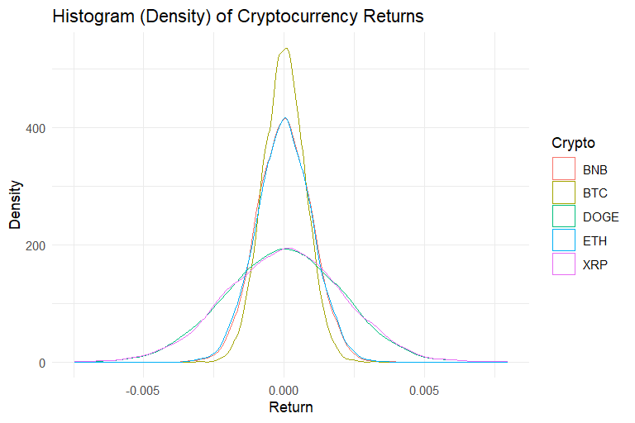
Figure 2.1. Histogram of Asset Returns: Evidence of Sharp Peaks and Fat Tails
Figure 2.1 displays the histograms of cryptocurrency returns, highlighting key distribution characteristics. The returns exhibit a sharp peak around the mean and fat tails, suggesting a higher probability of extremely positive or negative returns compared to a normal distribution. These features indicate non-normality and potential risks associated with extreme market movements.
Table 2.2 Correlation
Crypto | BTC | ETH | BNB | XRP | DOGE
BTC | 1
ETH | 0.7690 | 1
BNB | 0.6282 | 0.7121 | 1
XRP | 0.4691 | 0.5153 | 0.5153 | 1
DOGE | 0.6558 | 0.6657 | 0.6130 | 0.4786 | 1
Notes: This table presents the correlation for all cryptocurrencies.
Table 2.2 presents the correlation coefficients among the cryptocurrencies. A strong positive correlation is observed between BTC and ETH (0.7690), suggesting closely related price movements. BNB also exhibits moderate-to-strong correlations with BTC (0.6282) and ETH (0.7121). XRP and DOGE show comparatively weaker correlations with BTC and ETH, with XRP being the least correlated overall.
2.3 Vector Autoregressive (VAR) Model
It is an econometric model used to capture linear interdependence among the multiple time series. It is also known as the multivariate version of the autoregressive model (AR).
$$y_{t}=A_{1}y_{t-1}+………………………………….. +A_{p}y_{t-p}+∈_{t}$$
Table 2.3 VAR (1) Estimation Results
Cryptos | BTC_l1 | ETH_l1 | BNB_l1 | XRP_l1 | DOGE_l1
BTC | 0.0195*  (0.015) | -0.0029  (0.664) | -0.0225***  (0.000) | 0.000002  (0.999) | 0.0091***  (0.000)
ETH | 0.0202*  (0.050) | 0.0103  (0.224) | -0.0212**  (0.007) | 0.0016  (0.540) | 0.0094***  (0.000)
BNB | 0.0190*  (0.038) | 0.0243**  (0.001) | -0.0175*  (0.013) | 0.0015  (0.528) | 0.0086***  (0.000)
XRP | 0.0625**  (0.003) | 0.0026  (0.878) | -0.0080  (0.621) | 0.0033  (0.535) | 0.0008  (0.874)
DOGE | 0.1707***  (0.000) | -0.0064  (0.767) | 0.0380  (0.064) | -0.0063  (0.348) | -0.0009  (0.897)
Here, $A_{i}$ is a $K X K$ coefficient matrix for $i=1,….,p$ and $∈_{t}$ is a K-dimensional vector of shocks with $E\left(∈_{t}\right)=0$ and time invariant positive definite covariance matrix $E\left(∈_{t}∈_{t}^{T}\right)=Σ_{∈}$ (white noise).
***indicates the significance at 1% level; ** indicates the significance at 5% level; * indicates the significance at 10 % level. In parentheses, we present the probability value.
Table 2.3 presents the VAR (1) model, where each cryptocurrency is regressed on the lagged values of all five variables, including its own past values. In the BTC equation, BNB_l1 negatively and significantly impacts BTC, while DOGE_l1 has a very strong positive effect. The lagged value of BTC is weakly significant, indicating a mild self-influence. In the ETH equation, both BNB_l1 and DOGE_l1 significantly affect ETH, with BNB_l1 having a negative and significant impact, and DOGE_l1 showing a very significant positive effect. ETH_l1 is almost significant but falls short of the typical threshold. For the BNB equation, all cryptocurrencies significantly influence BNB, with DOGE_l1 having a strong positive impact and BNB_l1 negatively influencing its own value. In the XRP equation, only BTC_l1 significantly affects XRP positively, while other variables have no significant impact. Finally, in the DOGE equation, BTC_l1 significantly influences DOGE with a strong positive coefficient, and the constant term is significant, while most other lags are insignificant.
2.3.1 Diagnostic Tests of the VAR Model
To validate the adequacy of the estimated VAR model, several diagnostic tests were conducted:
2.4 Diagnostic Tests of the VAR Model
Test | Chi-squared | P-value
Portmanteau Test | 1025, df = 375 | < 2.2e-16
ARCH LM Test | 49,110, df = 1,125 | < 2.2e-16
Jarque-Bera Test (Overall) | 21,288,607, df = 10 | < 2.2e-16
Jarque-Bera Test (Skewness) | 50,159, df = 5 | < 2.2e-16
Jarque-Bera Test (Kurtosis) | 21,238,448, df = 5 | < 2.2e-16
The diagnostic tests reveal that VAR residuals exhibit autocorrelation, heteroskedasticity, and non-normality. Therefore, a model capable of handling time-varying volatility, such as the DCC-GARCH model, is more appropriate for further analysis.
Forecasting: Figure 2.2 shows the forecasted returns for the five cryptocurrencies for the next ten minutes. Each sub-plot represents the one step ahead forecasted return for that series across time (up to observation 45,000). The forecasts are very close to zero which indicates that the VAR (1) model captures short-term dynamics without any large deviations and these cryptocurrencies’ returns exhibit mean-reversion behavior and relatively low predictability. As the XRP and DOGE demonstrate larger forecast dispersion, they are more volatile and are likely to influence from the shocks.
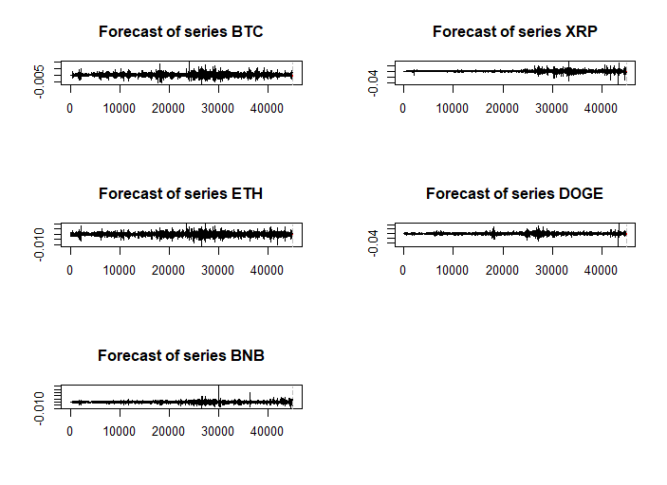
Figure 2.2. Forecast of Series (VAR Model Predictions)
2.3.2 Forecast Error Variance Decomposition (FEVD)
FEVD tells us how much of the variation in a variable’s forecast can be attributed to the shocks in the other variables in the VAR model. It focuses on understanding the long-term contribution of each variable to the error variance in forecasting other variables.
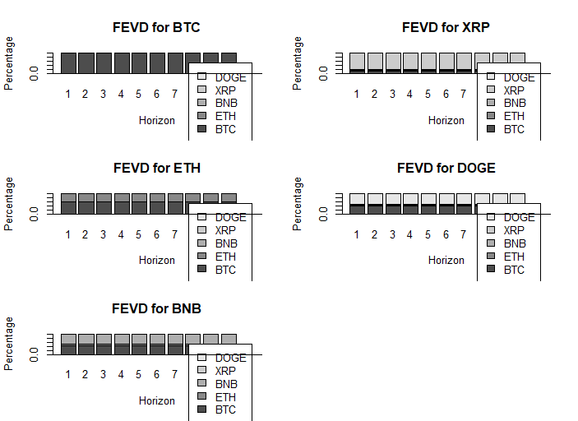
Figure 2.3. Forecast Error Variance Decomposition (FEVD)

Interpretation: Figure 2.3 illustrates the extent to which each cryptocurrency’s forecast error is influenced by its own past values and by the shocks from other cryptocurrencies across eight forecast horizons. Bitcoin (BTC) is predominantly driven by its own price dynamics, with minimal spillover effects from other assets. In contrast, Ethereum (ETH) is primarily influenced by its own past values, though there is some degree of impact from Bitcoin (BTC) and Binance Coin (BNB), highlighting a moderate dependency on these assets. Dogecoin (DOGE) demonstrates a stark contrast, with its forecast error being predominantly driven by Bitcoin’s price movements, while Ethereum’s influence remains comparatively smaller. Finally, XRP exhibits a high degree of correlation with the broader market, suggesting that it is largely reactive to the movements of other cryptocurrencies, with limited autonomy in its price dynamics.
2.3.3 Impulse Response Function (IRF)
It estimates how one cryptocurrency reacts over time after a one-unit shock to another. IRF provides insights into the magnitude and duration of these effects, helping to understand the spillover effects and interdependencies between the assets in the cryptocurrency market. By analyzing the IRFs, we can observe the extent to which each cryptocurrency is influenced by shocks from others and how long those effects persist, providing valuable information on their price dynamics and market relationships.
Interpretation: Figure 2.4 reveals distinct dynamics across different cryptocurrency shocks. When XRP is shocked, DOGE shows a significant positive reaction at lag 1, peaking at a value of $1.98*{10}^{-4}$, but the effect decays quickly, disappearing by lag 3. This suggests that DOGE responds significantly to XRP shocks in the short term. In contrast, BTC reacts with a small, delayed response to XRP's shock, peaking at lag 2, but the confidence interval includes zero, indicating that the response is not statistically significant. For ETH's shock on BNB, there is a strong and statistically significant positive response at lag 1, with an immediate impact of $2.81*{10}^{-4}$, followed by a rapid decay within 2–3 periods. This suggests BNB is highly sensitive to ETH shocks, but the effect is short-lived. Similar IRF analyses were conducted for all other cryptocurrencies, confirming that the interactions between these digital assets follow distinct patterns, with some showing strong and immediate reactions to shocks, while others exhibit minimal and short-lived impacts. In summary, XRP significantly influences DOGE, ETH significantly impacts BNB, but XRP does not significantly affect BTC in the short term.
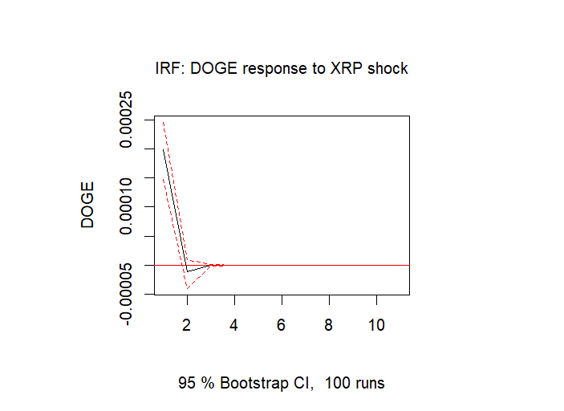 | 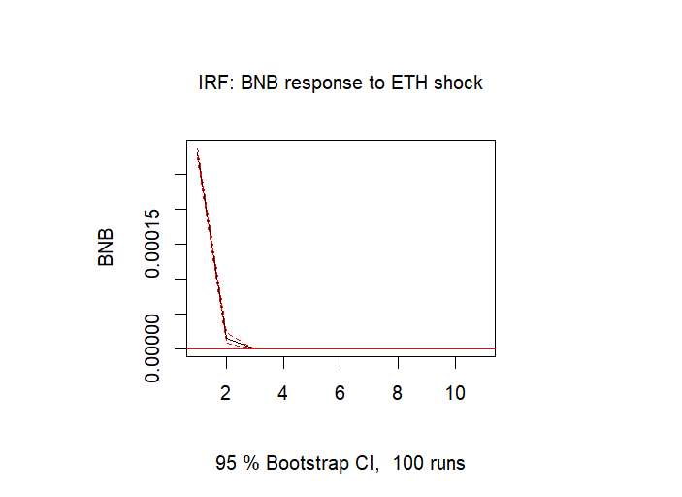
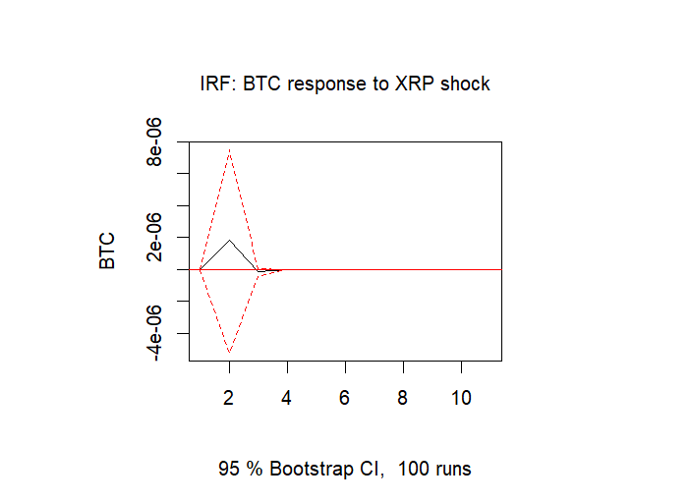
Figure 2.4. Impulse Response Function ( DOGE, XRP, BNB, ETH, BTC)
2.4 Dynamic Conditional Correlation Generalized Autoregressive Conditional Heteroskedasticity (DCC-GARCH) Model
DCC-GARCH Model is a multivariate volatility model designed to efficiently model time-varying correlations between multiple financial assets. This model consists of two main components - The first step is to model each cryptocurrency using a univariate GARCH (1,1) model to model the volatility for each asset separately. The second step is DCC (1,1) model to estimate time-varying correlations between the cryptos. For the DCC-GARCH model analysis, we first converted the original one-minute cryptocurrency returns into hourly returns to reduce noise and better capture meaningful price dynamics. Using the hourly data, we applied the DCC-GARCH model to estimate the time-varying correlations among the five cryptocurrencies.
Table 2.3 DCC-GARCH Model Parameters Estimation Results
Cryptos | BTC | ETH | BNB | XRP | DOGE
ω | 0.000002*  (0.077) | 0.000002  (0.597) | 0.000001  (0.809) | 0.000001  (0.524) | 0.000004  (0.402)
α | 0.1640***  (0.000) | 0.0835***  (0.000) | 0.0972  (0.240) | 0.0869***  (0.000) | 0.1060***  (0.000)
ᵦ | 0.7778***  (0.000) | 0.8790***  (0.000) | 0.8944***  (0.000) | 0.9121***  (0.000) | 0.8803***  (0.000)
***indicates the significance at 1% level; ** indicates the significance at 5% level; * indicates the significance at 10 % level. In parentheses, we present the probability value.
Table 2.3 summarizes the estimated parameters for the DCC-GARCH model applied to five cryptocurrencies. The ω (base level volatility in the market) is close to zero and not statistically significant for all cryptocurrencies, which indicates that the base volatility (volatility that persists in the market even without recent shocks) is very low or not significant enough to affect the overall volatility dynamics significantly. The model relies more heavily on the α (which captures the effect of past shocks) and β (which captures the persistence of volatility) parameters. For Bitcoin, Ethereum, XRP, and Dogecoin, the past volatility shocks (α) significantly affect current volatility, and volatility tends to persist over time (β). While BTC, ETH, XRP, and DOGE demonstrate significant α and β parameters, BNB shows weaker results, particularly with insignificant α, which indicates that past market shocks do not influence BNB volatility as strongly as the others.
.

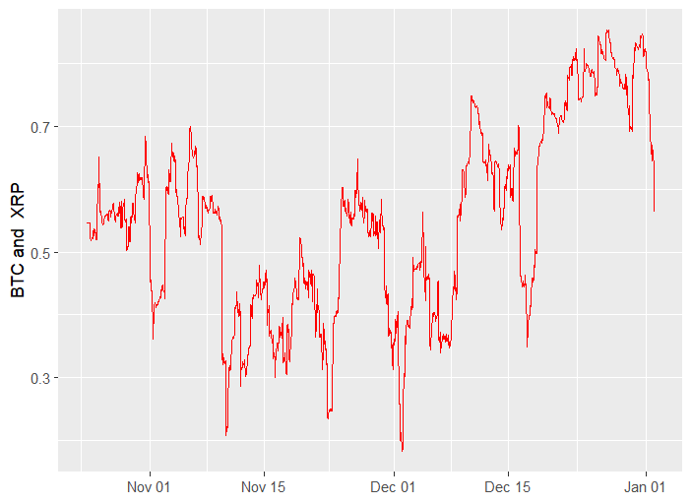
Figure 2.6 BTC and XRP Dynamic Conditional Correlation (DCC)
In figure 2.6, BTC and XRP are positively correlated, but the strength of their relationship changes over time. The correlation between BTC and XRP fluctuates between approximately 0.25 and 0.75. In December the correlation increases sharply, and in earlier periods (November) the relation is lower and more volatile correlations.
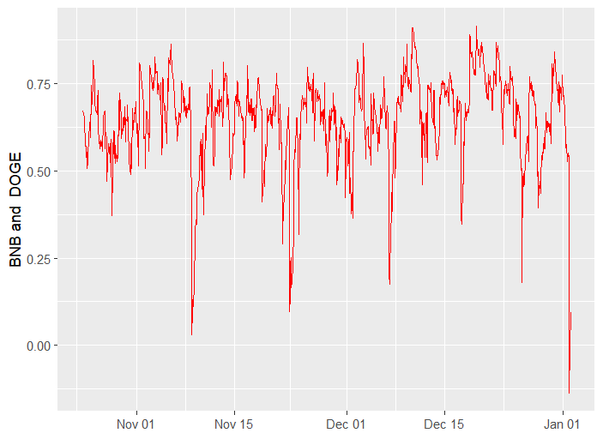
Figure 2.7. BNB and DOGE Dynamic Conditional Correlation (DCC)
In figure 2.7, BNB and DOGE are generally positively correlated, but the relationship is less stable compared to BTC and XRP. The correlation is mostly high, hovering around 0.5–0.8. The sharp drops during November and January indicate moments when BNB and DOGE moved independently of each other, suggesting that specific shocks/events temporarily weakened their relationship.
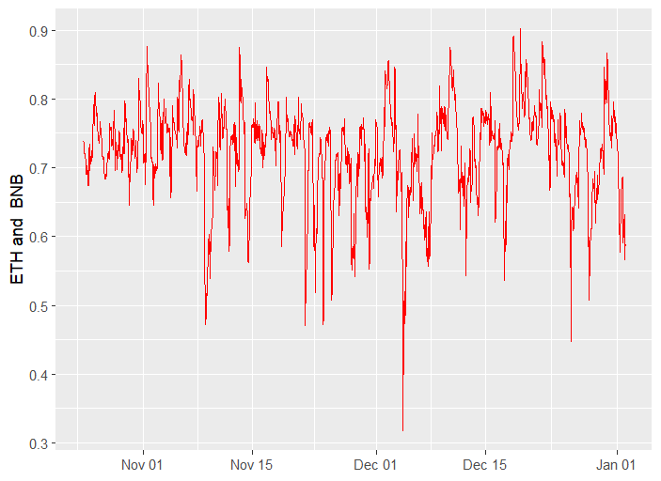
Figure 2.8. ETH and BNB Dynamic Conditional Correlation (DCC)
In Figure 2.8, ETH and BNB exhibit a strong and stable correlation, with only minor fluctuations observed during December, suggesting that both cryptocurrencies tend to respond similarly to broader trends in the crypto market.
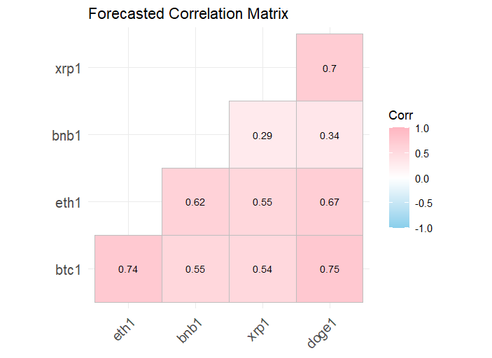
Figure 2.5. Forecasted Correlation Matrix
Results: In figure 2.5 all five cryptocurrencies — BTC, ETH, BNB, XRP, and DOGE, are positively correlated, meaning they are expected to move in the same direction in the short-term forecast. The strongest relationships are observed between BTC and DOGE (0.75), BTC and ETH (0.74), and XRP and DOGE (0.70), suggesting these pairs are highly synchronized and likely to react similarly to market events. ETH and DOGE also show a strong correlation (0.670), reinforcing the tight link among major coins. In contrast, BNB has weaker correlations, especially with XRP (0.286) and DOGE (0.336), indicating that BNB's price movements are more independent compared to others. Overall, while the major coins (BTC, ETH, DOGE, XRP) move closely together, BNB is less correlated with the other coins, especially with XRP and DOGE, suggesting it could offer some diversification benefits within a crypto portfolio.

