Stock Price Prediction using Linear Regression
Input Section (Entering Data)
1. Input Overview
In this project, the system takes historical stock price data as input to predict future prices.
- The data is automatically downloaded using yfinance
- Example stock used: Alphabet Inc. (GOOG)
The model uses past prices to predict the next few days.

2. Input Parameters
The system uses a few important parameters:
- Stock Ticker – Example: GOOG
- Date Range – From 2010 to 2024
- Forecast Days (forecast_out) – Number of future days to predict (5 days)
- Test Size (test_size) – 20% data used for testing
These parameters control how the model learns and predicts.

3. Data Collection & Preprocessing
- Stock data is downloaded using yfinance
- Only the closing price is selected
- Missing values are removed
After that, the system prepares the data for prediction.

4. Feature Creation (Entering Model Input)
Instead of directly using raw data, the model creates lag features:
- Previous 5 days’ prices are used
- Example:
  - Day 1 → uses past 5 days
  - Day 2 → uses next 5 days
This helps the model understand patterns over time.

5. Data Splitting & Scaling
- Data is divided into:
  - Training set (80%)
  - Testing set (20%)
- Data is scaled using StandardScaler
Scaling ensures all values are on the same level, improving model performance.

6. Graph Input (How Graph Data is Created)
The graph is generated from:
- Actual stock prices (historical data)
- Predicted future prices (model output)
These values are used to plot the final graph.

Output Section (Results & Graphs)
1. Output Overview
After processing, the system provides:
- Model performance scores
- Error values
- Future price predictions
- A visual graph comparing actual and predicted values

2. Model Used
The prediction is done using Linear Regression
- It finds a relationship between past and future prices
- Simple and effective for basic forecasting

3. Output Values
The system calculates:
- Train R² Score – Accuracy on training data
- Test R² Score – Accuracy on unseen data
- MAE (Mean Absolute Error) – Average prediction error
- RMSE (Root Mean Squared Error) – Measures large errors

4. Prediction Output
The system predicts the next 5 days of stock prices.
Example output:
- Next 5-day prediction: [value1, value2, value3, value4, value5]

5. Graphical Output
📈 Stock Price Prediction Graph
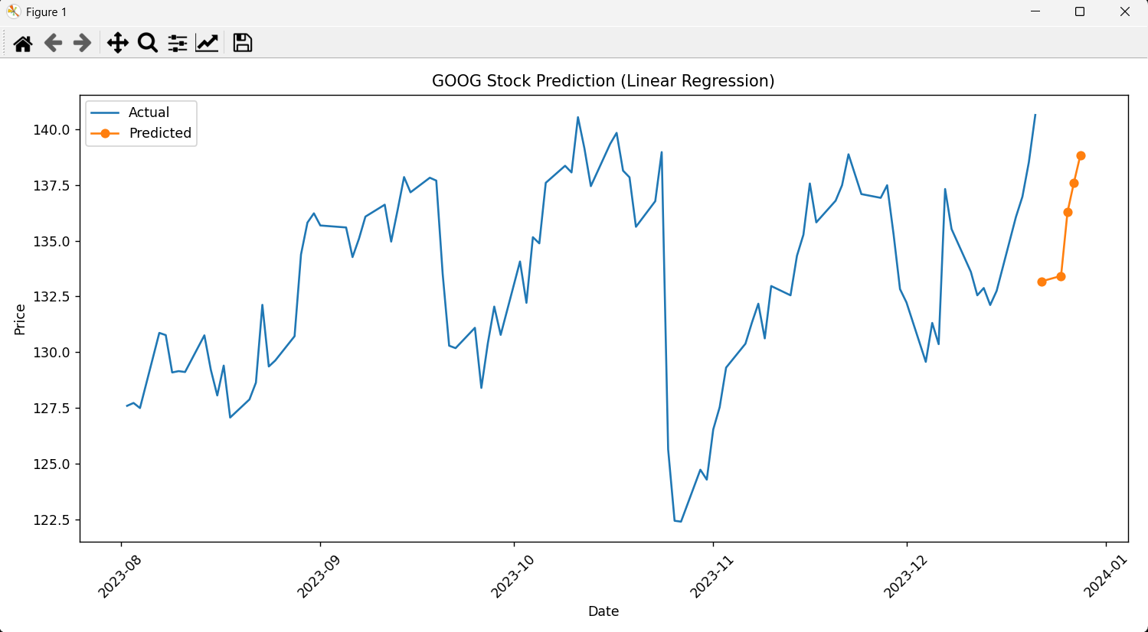
The graph shows:
- Actual Prices → Historical stock data
- Predicted Prices → Future forecast
Interpretation:
- A smooth continuation → good prediction
- Large gap → model needs improvement

6. Final Output Example
- Train R²: 0.95
- Test R²: 0.90
- MAE: 12.45
- RMSE: 18.32
- Prediction: Next 5 days prices
