Task1 Electrical Dept.

Report

The motor calculations done in the initial stages during designing phase gave an estimated value of 7 to 8.5 kgcm motor with an rpm of around 350. On looking through the team inventory we found four 10kgcm motors (fully working) and four 5kgcm motors. On suggestions, we found that four 5kgcm motors were enough to drive the bot so we chose to use 5kgcm and 150 rpm motors as the time was still not an issue for the task. During the testing of the motors all the motors had an rpm of around 115 which was quite enough for the bot to drive.

Motor driver that we chose was cytron MDD10A for two reasons although there was always an option to use L298n

1)Better speed control and easier to use.

2)High current rating.

The testing of motors and motor drivers was success we decided to continue mounting of motors on Saturday. Till night we had everything mounted. The mechanical guys drill slots through the bot’s body for the wires which was very handy during the wiring the bot in a clean and neat way. The motors were then tested through the buttons on the motor driver and it worked like a charm.

On the next day, there was some problem with the gripper mechanism of the bot which required a little bit of extra support and welding because of which we had to remove all the wires and motors again. The pins of the motor were too brittle to handle any more stress and because of this we had to solder wires again to a little exposed part of motors. It took a lot of concentration and time but at the end a little bit of mseal and soldering gave the desired results. We were again mounting the motors on Tuesday night we were back to saturday.

Mounting the mosfet boards for all the four pneumatics was the next important job. We had to make sure each wire was soldered properly insulated properly with heat shrinks and the power supply was proper with proper of each of the boards.

Using mosfets as a switch for controlling solenoid valve

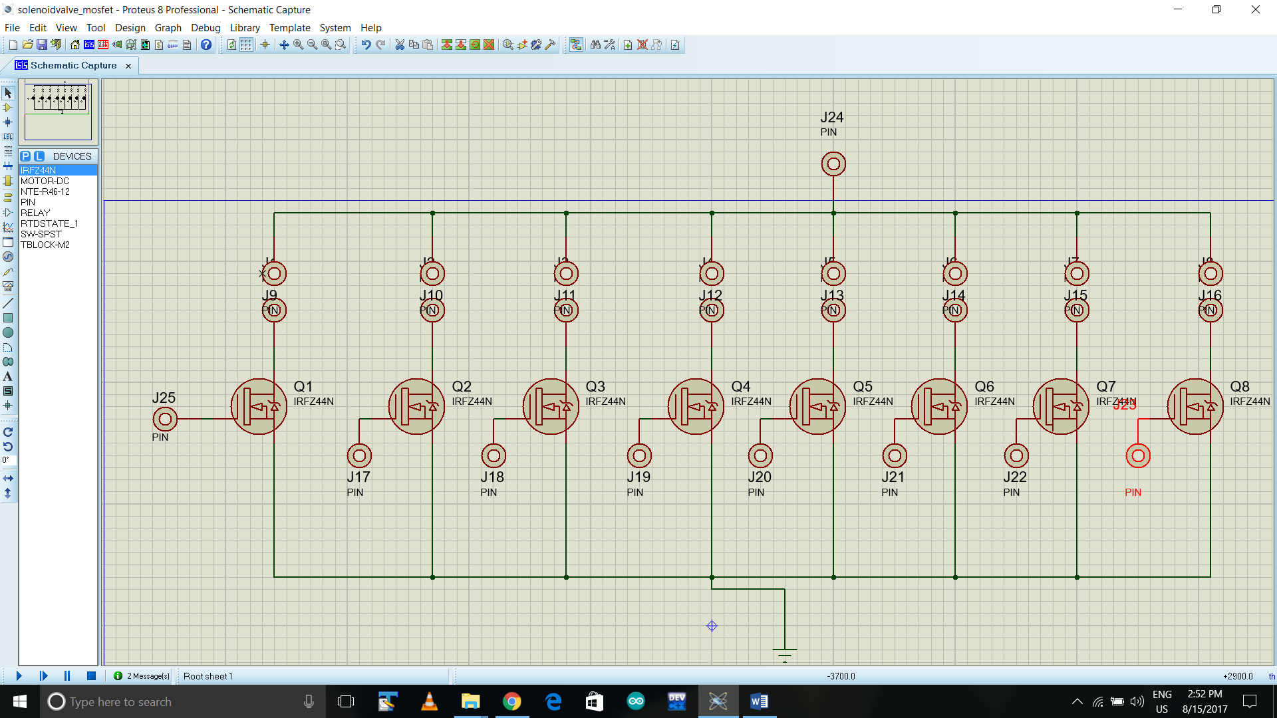Circuit Schema:

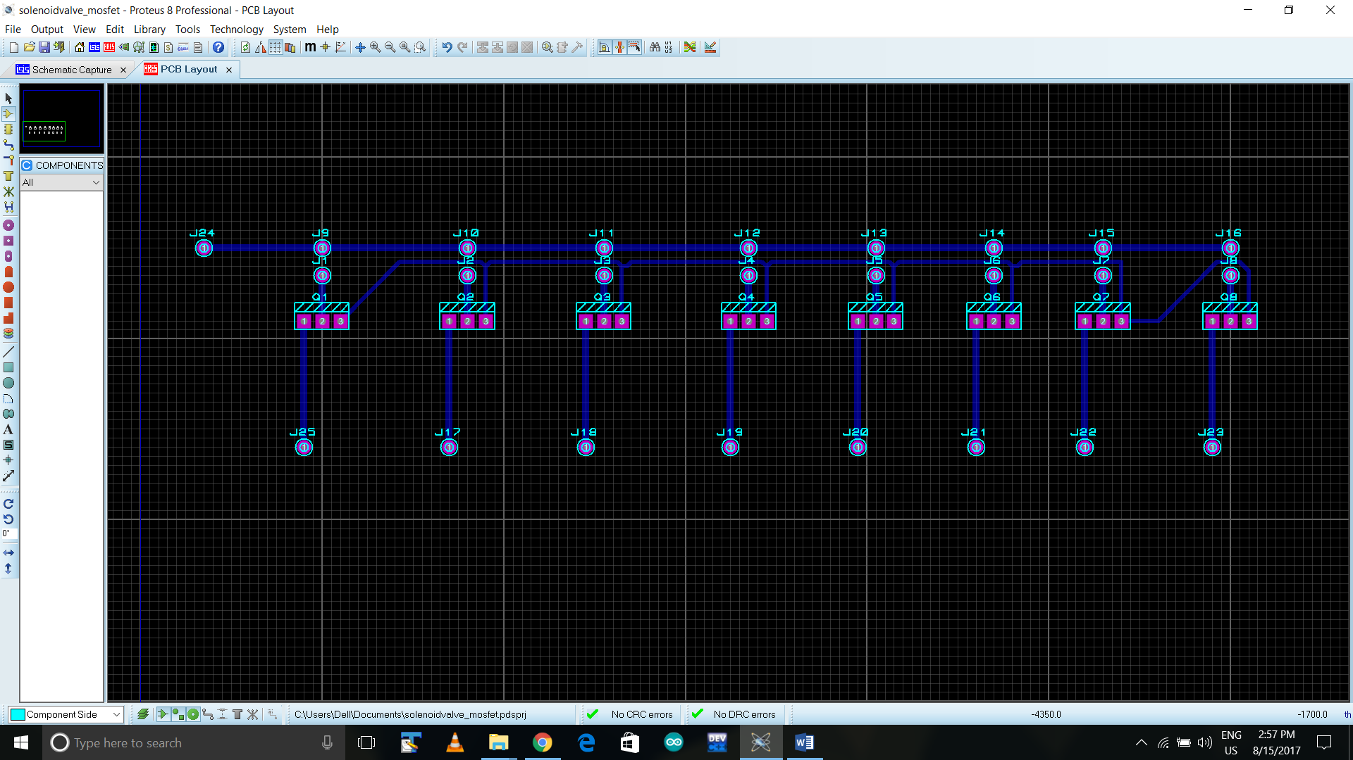PCB layout:

* We have used IRFZ44N power mosfets to control solenoids using Arduino board(5v output).
* The digital pin of the Arduino is connected to gate of the mosfet.
* The solenoid is placed between the 12 v power supply and drain of the mosfet where positive terminal of the mosfet is connect to 12 v and negative terminal is connected to the drain.
* The negative terminal of the 12 v power supply and gnd pin are connect to the source of mosfet thus providing common ground.
* When the digital pin of the Arduino gives low signal the drain-source channel acts as an open circuit.
* When we the digital pin of Arduino gives high signal(5V) the drain source channel acts as a short circuit.

The circuit for the boards was simple the source was grounded the drain goes to the solenoids negative and the solenoids positive to the +12V supply. The board was already tested with solenoids and all the different DCVs. It was ready to be mounted on the bot. We mounted one of the boards on the gripper extension tower and soldered the wires to it and power supply the other mosfet board to control the other half of the pneumatics system.

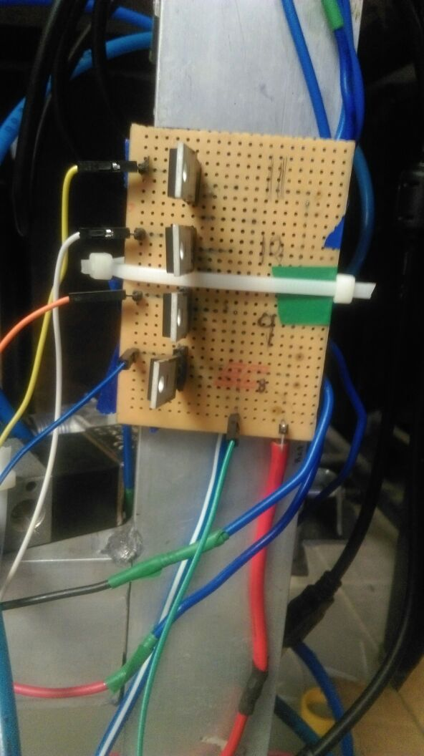

The mosfet board was tested next day and the following problem was seen, a broken jumper, a bad mosfet. We did the testing again and it was working like a anything. The mosfets were heating a little but turning them off solved the problem maybe it was because the mosfets were on which caused the heating.

Powering everything up

There were the following things to power up

1)Two motor drivers

2)2 MOSFET boards

3)2 Arduinos

4)A RASPBERRYPi

5)LSA08

For motor drivers we used a lipo(11.1V) to power it up the current rating of the battery was 2.2Ah which was sufficient to run the motors for required time. The Kill Switch was placed in the load and source for a single switch power control. The max current rating was 1A for the motors so for four motors the total maximum current that can be drawn was 4A and the other components like solenoids had a rating of 129mA which will not effect much to battery drainage. So this battery would be enough to run the bot for half an hour on extensive use. Mosfets were powered using the lipo only

Arduinos were powered from the 9V of the power boards .

This is a 4 channel powerboard to step down the 12v supply from the battery to smaller voltages like 5v, 9v etc required for driving the sensors.

Components used are7809,7805,header pins, 15 A Wires, Solder Lead.

Problems Faced:

1.While designing and selecting the component we realised that the max current ratings of a 7809 is 500Ma, and it can give out at max 1A for 10 seconds before blasting out,

Solution:

We decided to make a universal board with many regulators so that we can split up the current load on a regulator while wiring to avoid losses and also prevent burning off.

2. While making the PCB Schematic it was quite difficult to make 4 channel board .

Solution:

We used Proteus to simplify the pcb schematic and make the circuit easy to make the breadboard and used some designing techniques as specified on the web to make a simplified board.

3.Solder Burning issue- When we apply a high voltage like 12v and it draws too much current the solder might burn off easily, so to avoid this we made a thicker line for the 12v and the ground to prevent the burning.

4.Common Grounding Issue-

While testing the mosfets and some of the sensors we were not getting the desired output when the power board was used so we used a common ground to the battery and the microcontrollers and sensor which solved the problem greatly and the same was the issue with our mosfet board.

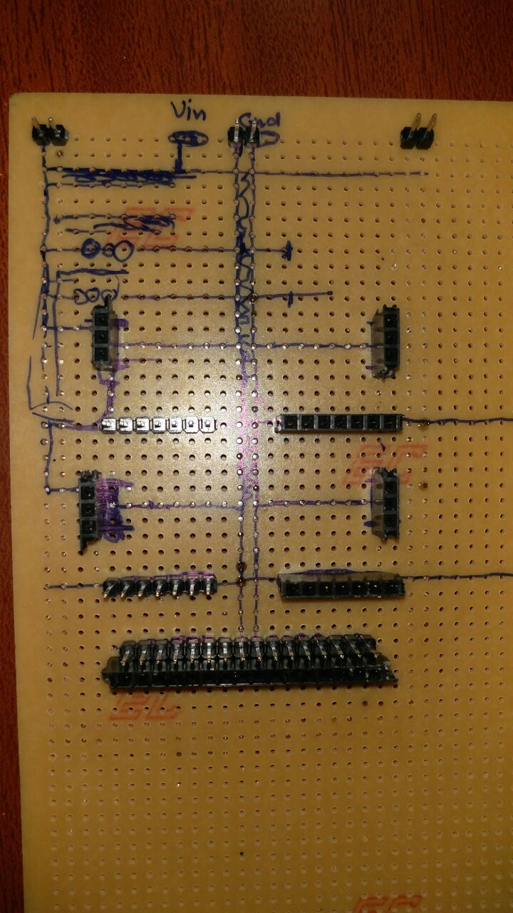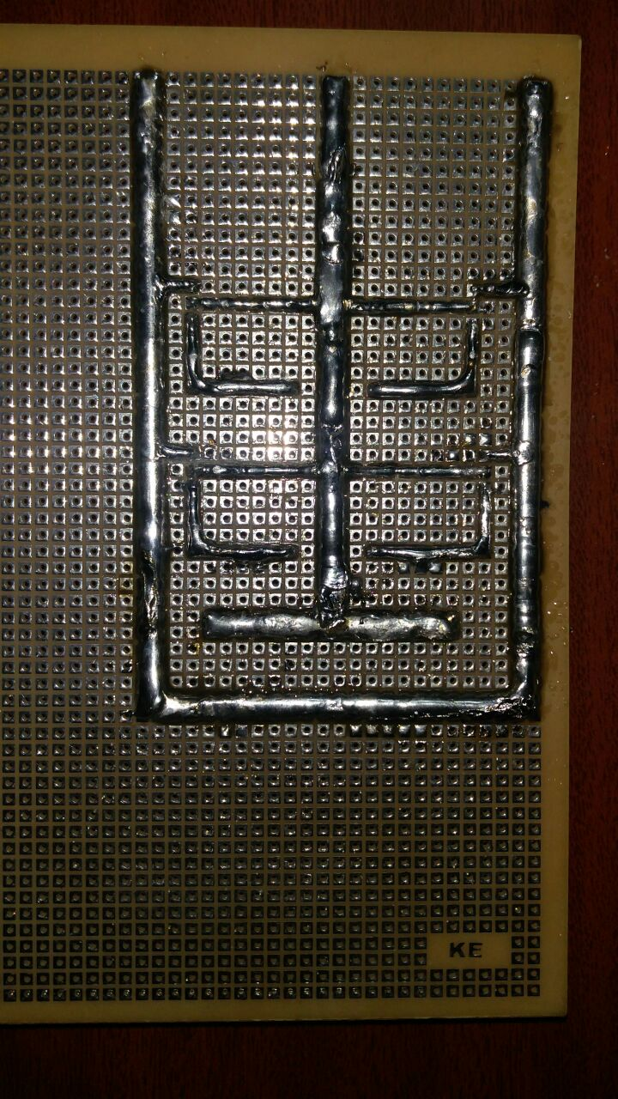

Raspberry pi we used power bank

LSA08 we used a 9V radio transistor battery.