If your database does not get connected (since it is hosted on localhost) please create a database using following specifications to view the entire application.

1. Employee_info database: Make sure to create a table as shown below: Make sure to see the Employee_id and Employee_post are of this type and that owner has employee_id as 0.

These specifications are to be followed since at the start of the application it asks for login, and you won’t be able to access the rest of the application if you cannot login successfully.

And Owner’s id has to be zero since he has special previleges in the app and you will only be able to access that using this id.

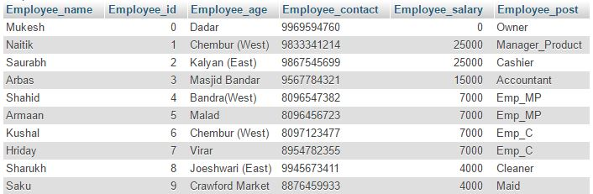

1. Customer_info database:

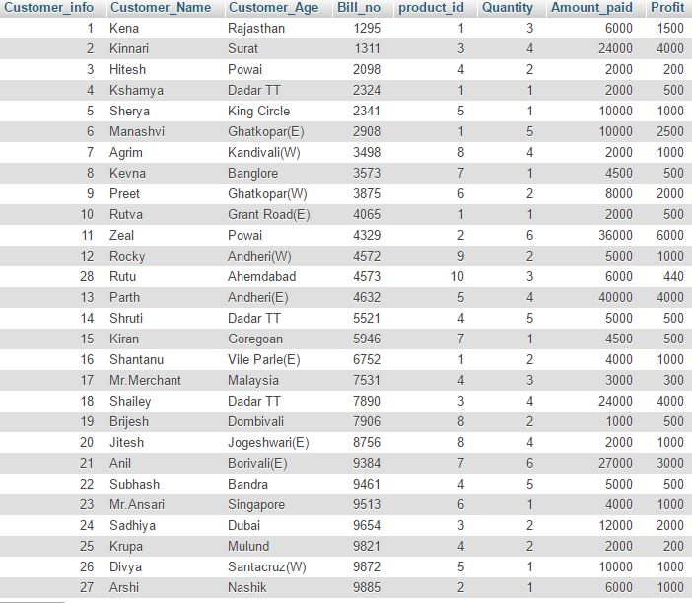

1. Product_info database:

