**How to use the Address Book Code:**

Address book has been developed using Atom IDE, HTML, CSS & JAVASCRIPT

To run the app please unzip the folder and right click to the .html file and select **copy full path option** and paste it to the new tab! It will allow you to run the app!

* The app can store the data into browser’s local database using JSON
* It can create(Add), delete and update the entry.
* I have put the validation that will stop adding new data if all the form fields are not entered.

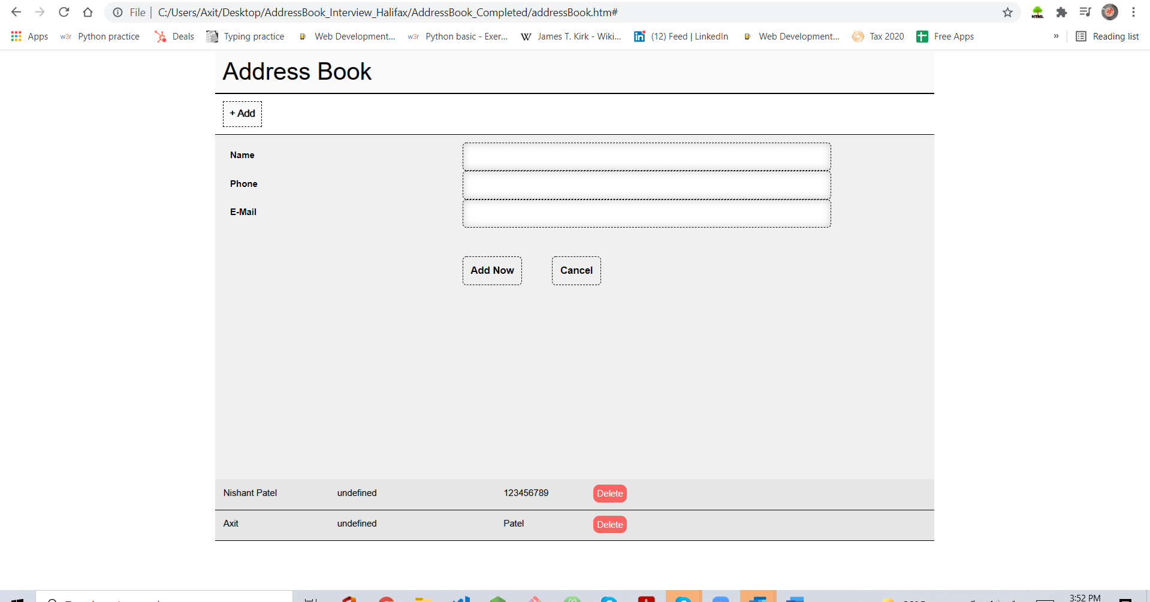

* **Adding the new data with name Prakash Patel** 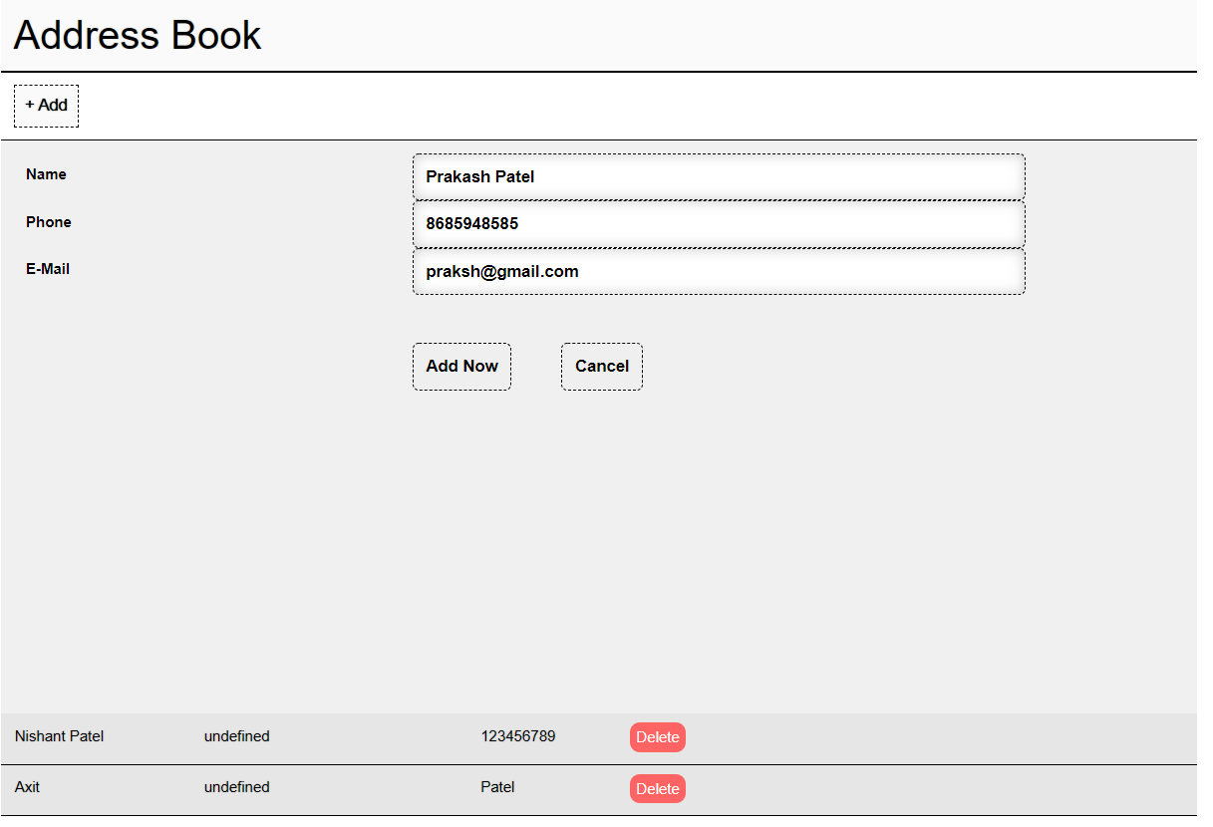

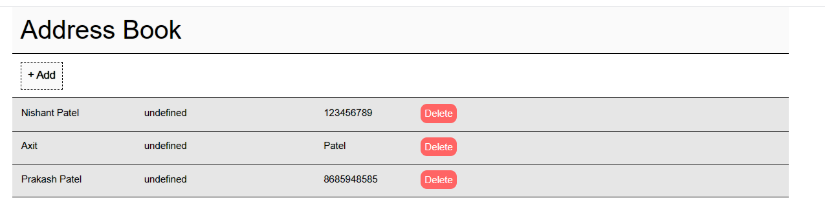

* **Deleting the data Prakash**