Atiyha Haripersadh

ST10440871

<https://github.com/Atiyha/TheWeatherApp.git>

In this Practicum I started off by creating in introduction page which leads to the main usage page.

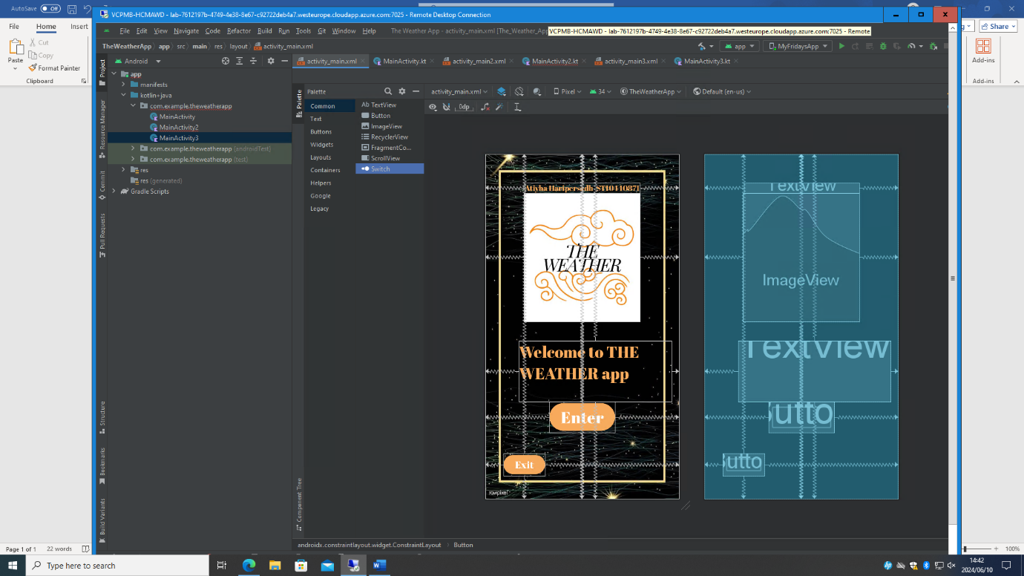

I then designed and coded for the Main page

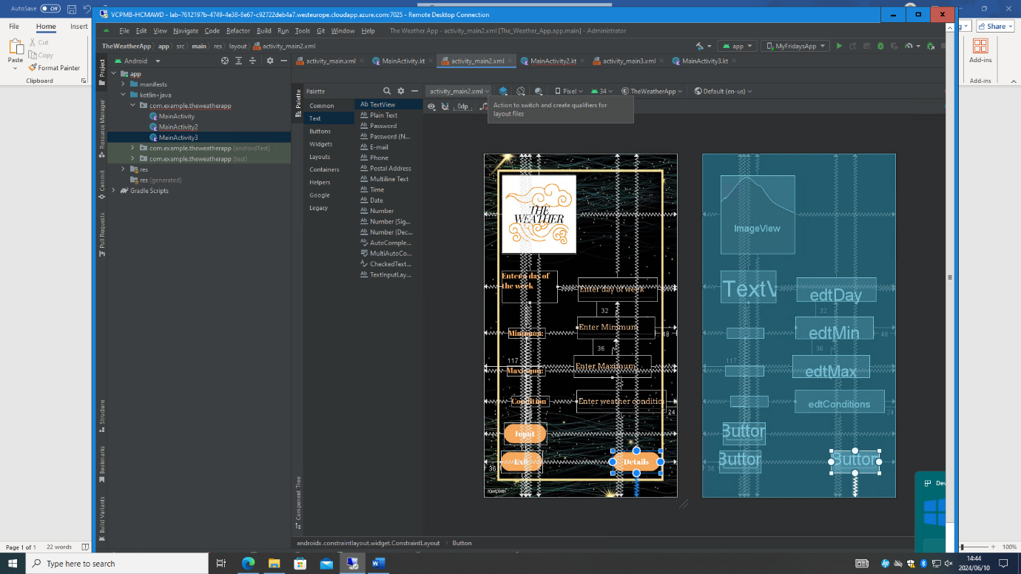

I made sure to design it in a way that made it look sophisticated. I ensured that there were multiple ways to input the specific forms of data needed.

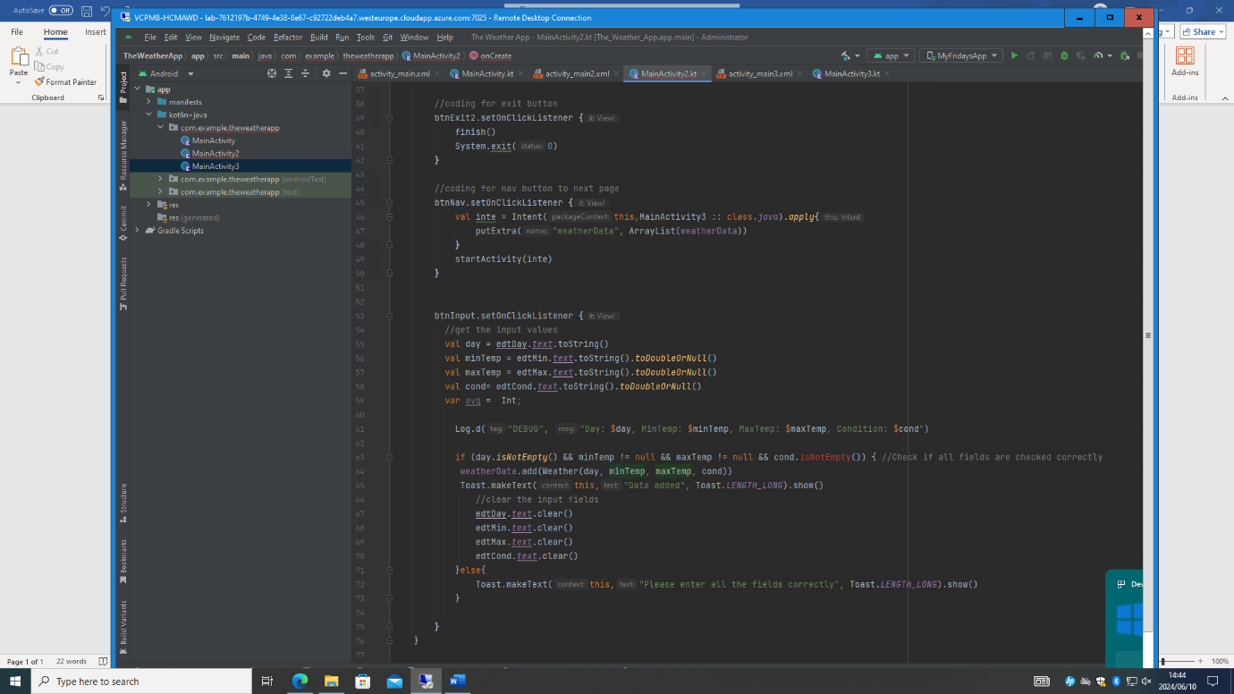

By declaring the properties as private, it allows for it to be easily assessed within the class.

I also created a data class with properties for day minimum temperature, maximum temperature and it implements the ‘serializable interface

I then further went on to create the last screen mainly used for displaying.

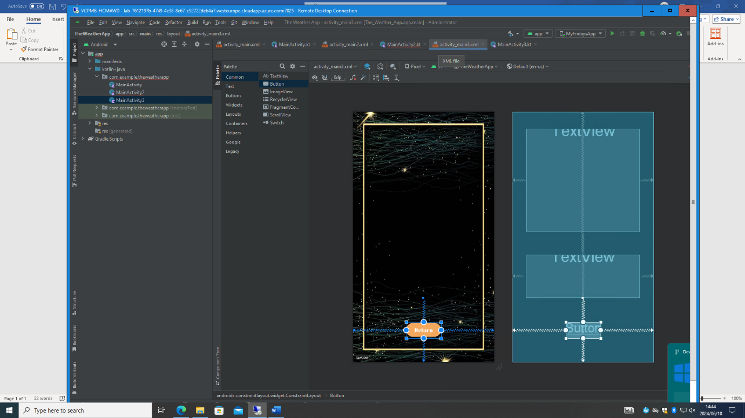

Here I displayed weather data. It retrieves weather data from the previous activity through an intent. It also calculates the maximum and minimum temperatures. It updates two Text Views simultaneously.

1. Start
2. Declare variables for page 1
3. Initialize UI elements
4. Link to page two
5. Declare variables for page 2
6. Initialize UI elements
7. Initialize ‘weatherData’ list
8. Retrieve input values
9. Validate input values
10. Add weather data to list
11. Show success or error message
12. Clear input fields
13. Create intent to start display activity
14. Put ‘weatherData’ list as an extra intent
15. Start display Activity (Linking to page 3)
16. Define weather data class
17. On page 3, import statements
18. Set content view
19. Initialize the TextViews
20. Get weatherData from intent
21. Check if weatherData is not Null
22. Initialize variables
23. Display
24. Stop