Atkelar – Christmas Ornament

What YOU need
...a bit of mechanical and electronic knowledge. This is a simple project but I’ll not explain how to solder and/or how to use heat shrink tubes...

Parts required
# | Name | P/l | Comment
1 | Arduino (NG) | 1 | Any 5V ATMega based Arduino should do. Others might need adjustment in the code/pins/circuit.
2 | LED 20mA | 8 | Yellow, 3mm
3 | LED 2mA | 6 | Yellow, 3mm
4 | Resistor, 100 Ohm | 4 | For the 20mA LEDs
5 | Resistor, 1kOhm | 3 | For the 2mA LEDs
6 | Print spacer (M3 threads) | 2 | From main board mounting sets
7 | Screw | 2 | To fit print spacer
8 | Wire | ~1m | Length depends on topology.
9 | 4mm plywood | ~A4 | If printed 1:1
10 | Wood glue | A dab | For mounting the stand
11 | Spray glue | A bit | To hold down the template and later the printout
12 | Paint (black or white) | A bit | To cover the plywood
13 | Jumper pins | 8 | To connect to the Arduino
14 | Shrink tube ~5mm | ~20cm | To cover resistors
15 | Shrink tube ~3mm | ~25cm | To cover solder points

Tools required
Tool | Use
Scrollsaw or jigsaw | Plywood cutting
Drill 3mm | For the LEDs
Drill 3.5mm (or 4mm) | To recess LEDs
Drill 2.5mm | For the print spacer threads
Sandpaper (120) | To clean up the edges
Brush | To apply paint to plywood
Awl or nail | To mark drilling holes

The Mechanical Build
Print out the “cutout” and the “picture” page using the same printer settings. This should yield a perfect overlay of the LED positions (check against a light to make sure).
Use the spray glue to glue the cutout plan to the plywood. Make sure to use any straight edge your material has for the straight edges in the plan! It will save you a lot of headache in getting them level afterwards! Especially the glued edge of the stand and the bottom edge of the baseboard would benefit from a machine cut edge.
After drying, cut out the base board and the stand around the edges.
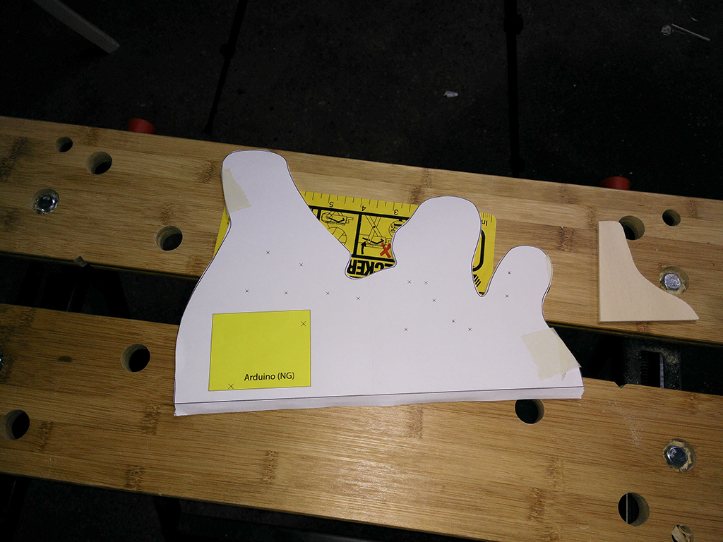
Sand the edges to make them smooth to the touch and remove any splinters.
Use your awl or nail to mark (center punch) the holes on the baseboard as precisely as possible.
Drill the LED holes front-to-back with the 3mm drill (the back end usually looks ugly with plywood) and sand down the front.
Drill the mounting holes for the Arduino (2.5mm) all the way through.
Drill the LED holes HALFWAY through from the back with the 3.5mm (or 4mm) drill to make room for the raised edge of the LED.
Remove the paper from the boards.
Give everything a final sanding and remove any dust.

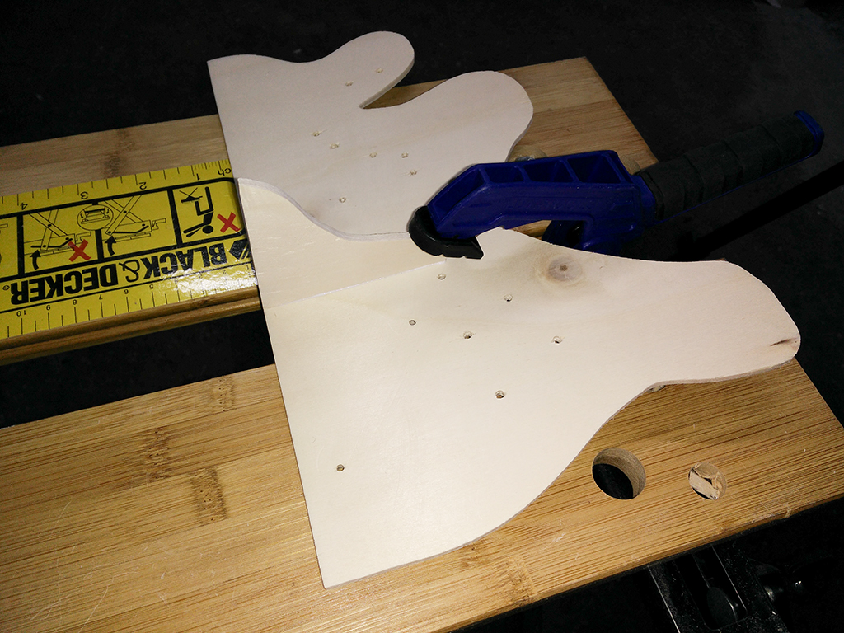
Glue the stand to the base board. The 4mm plywood might not bond too good, so you can use some scraps glued into the corners between the stand and the baseboard to get a larger glue surface.
Let the glue dry.
Paint the board/stand.
Let the paint dry.
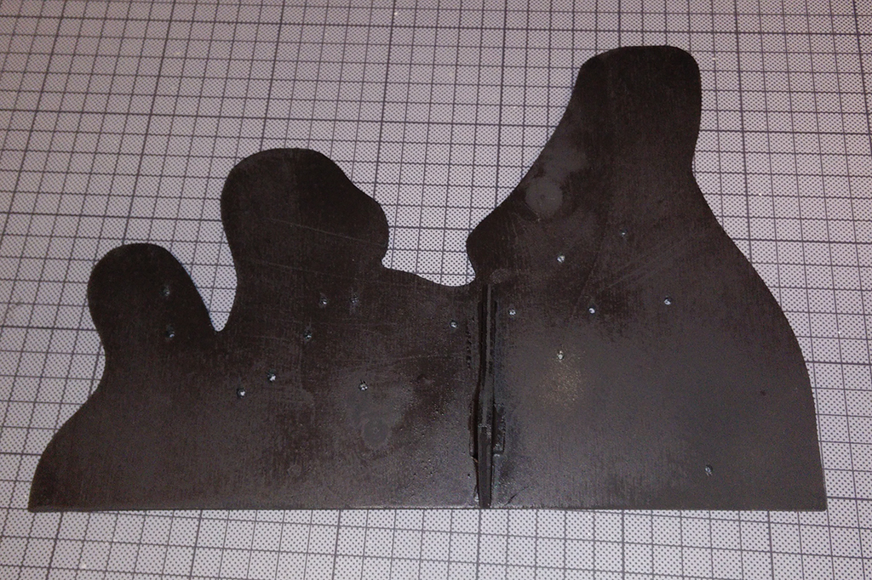
Screw in the print spacers to the Arduino mounting holes. Depending on your accuracy (and compatibility of your Arduino board with mine) you might need to “tweak” the spacers into their exact position using a pair of pliers. They should also not protrude on the front. Usually the threads are short enough but you can add a washer or two to get the distance required.
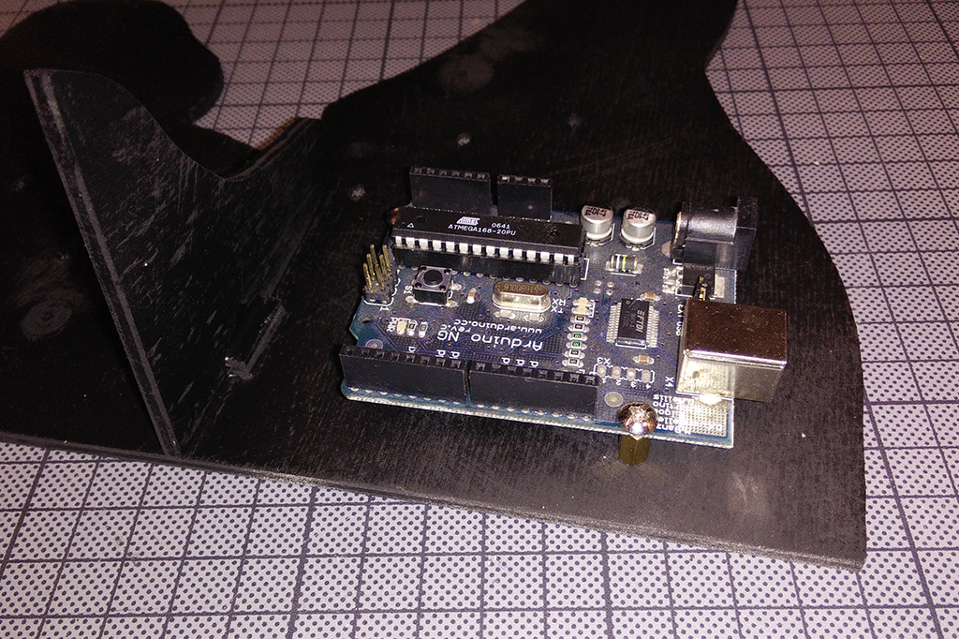
Put in the LEDs, make notes on which LED is 20mA and which is 2mA – also make sure to point all the anodes in one direction only and write it down as well! Soldering will be much easier that way.
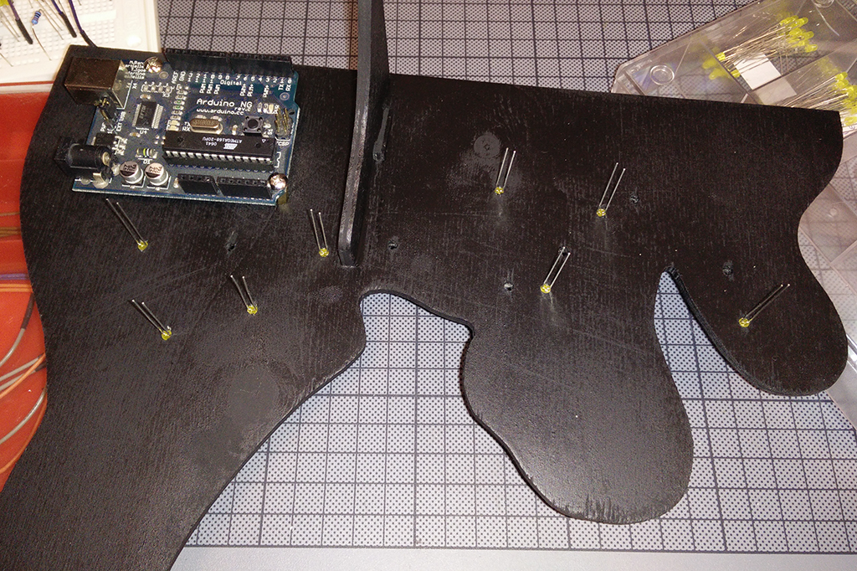

The electrical build
If you want to try the circuit first, use a breadboard and your Arduino.
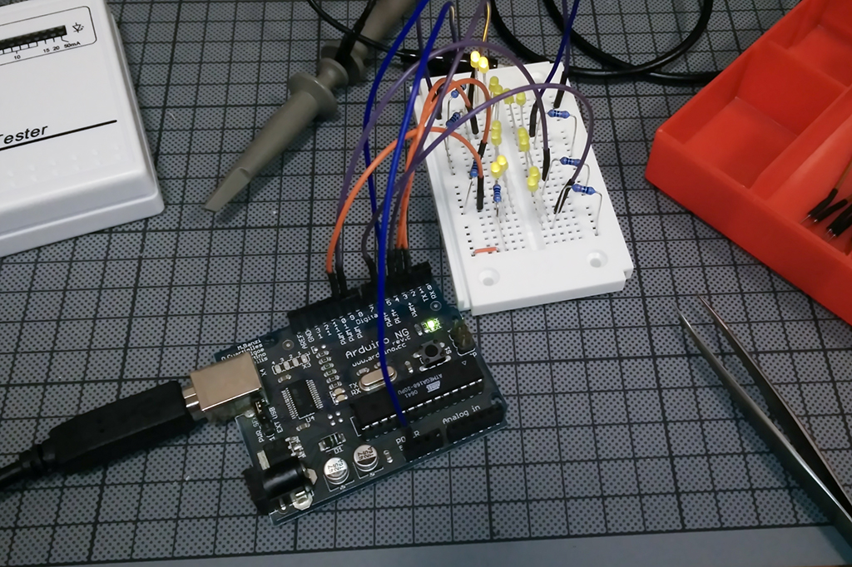
You can program the sketch using Arduino Studio. The LEDs should flash randomly (with the exception of IO pin 2, which should morse “SOS”)
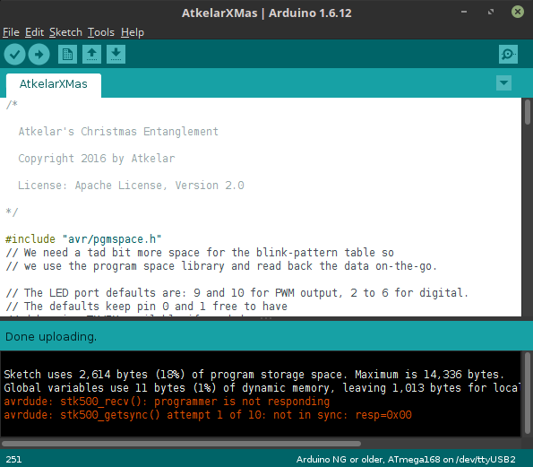

If you are comfortable with the circuit, solder the jumper pins to the wires, the wires to the LEDs and resistors, the resistors to the LEDs and then connect the LEDs. Make sure to follow the schematic and get the right LEDs (20 vs. 2 mA) connected in series!
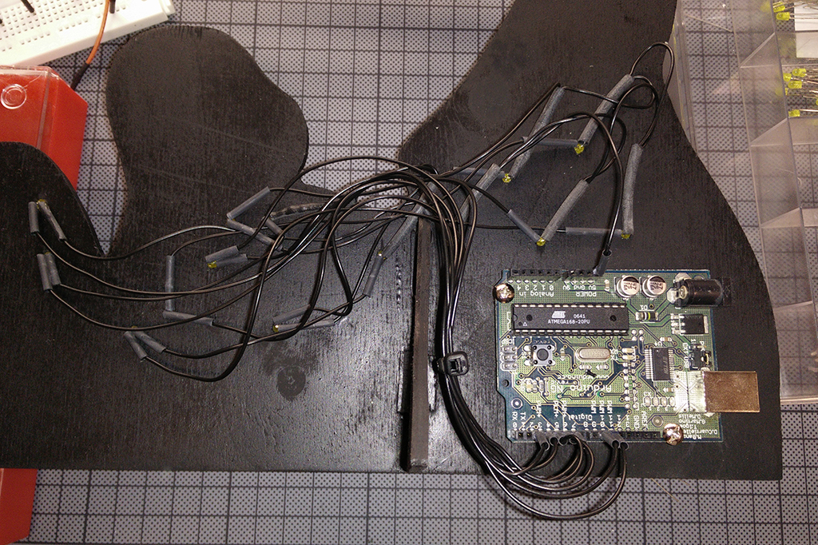
Also: each wire has TWO ends that need heat shrink! Don’t forget that little detail :)

Decoration
When everything above is done, the LEDs should blink in the new frame already. Now cut out the printed (and colored) picture (don’t forget the little LED holes).
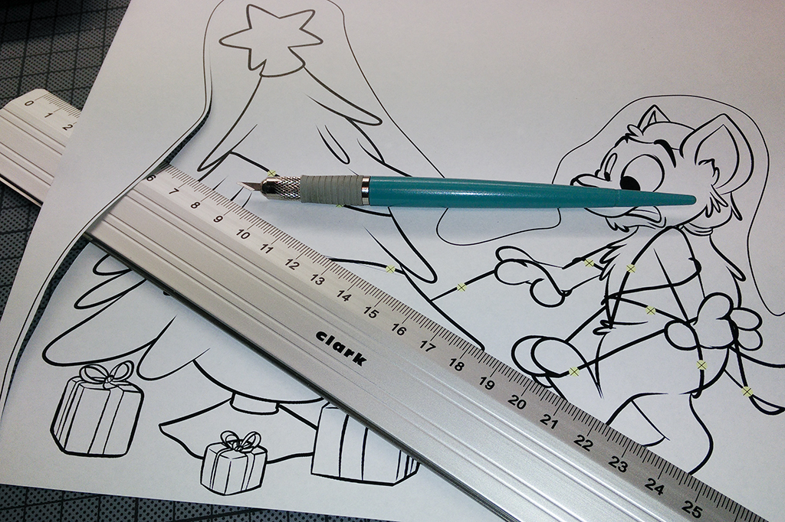
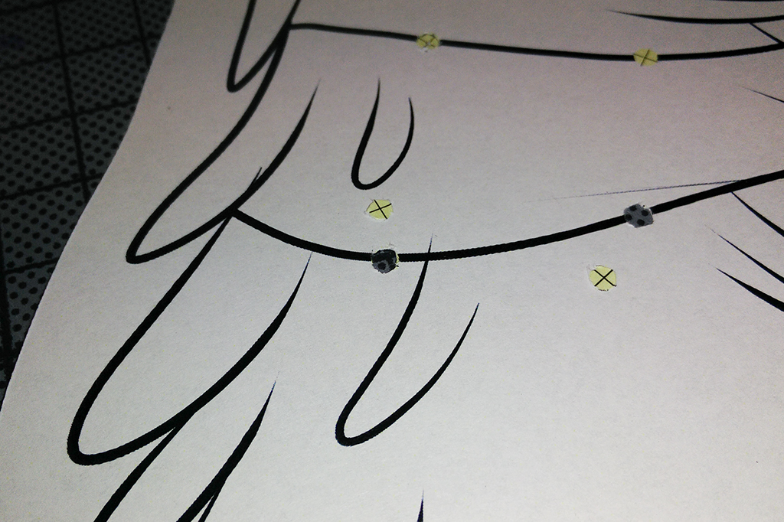

Use either spray glue or double sided tape to glue it to the front, with the LEDs poking through.

