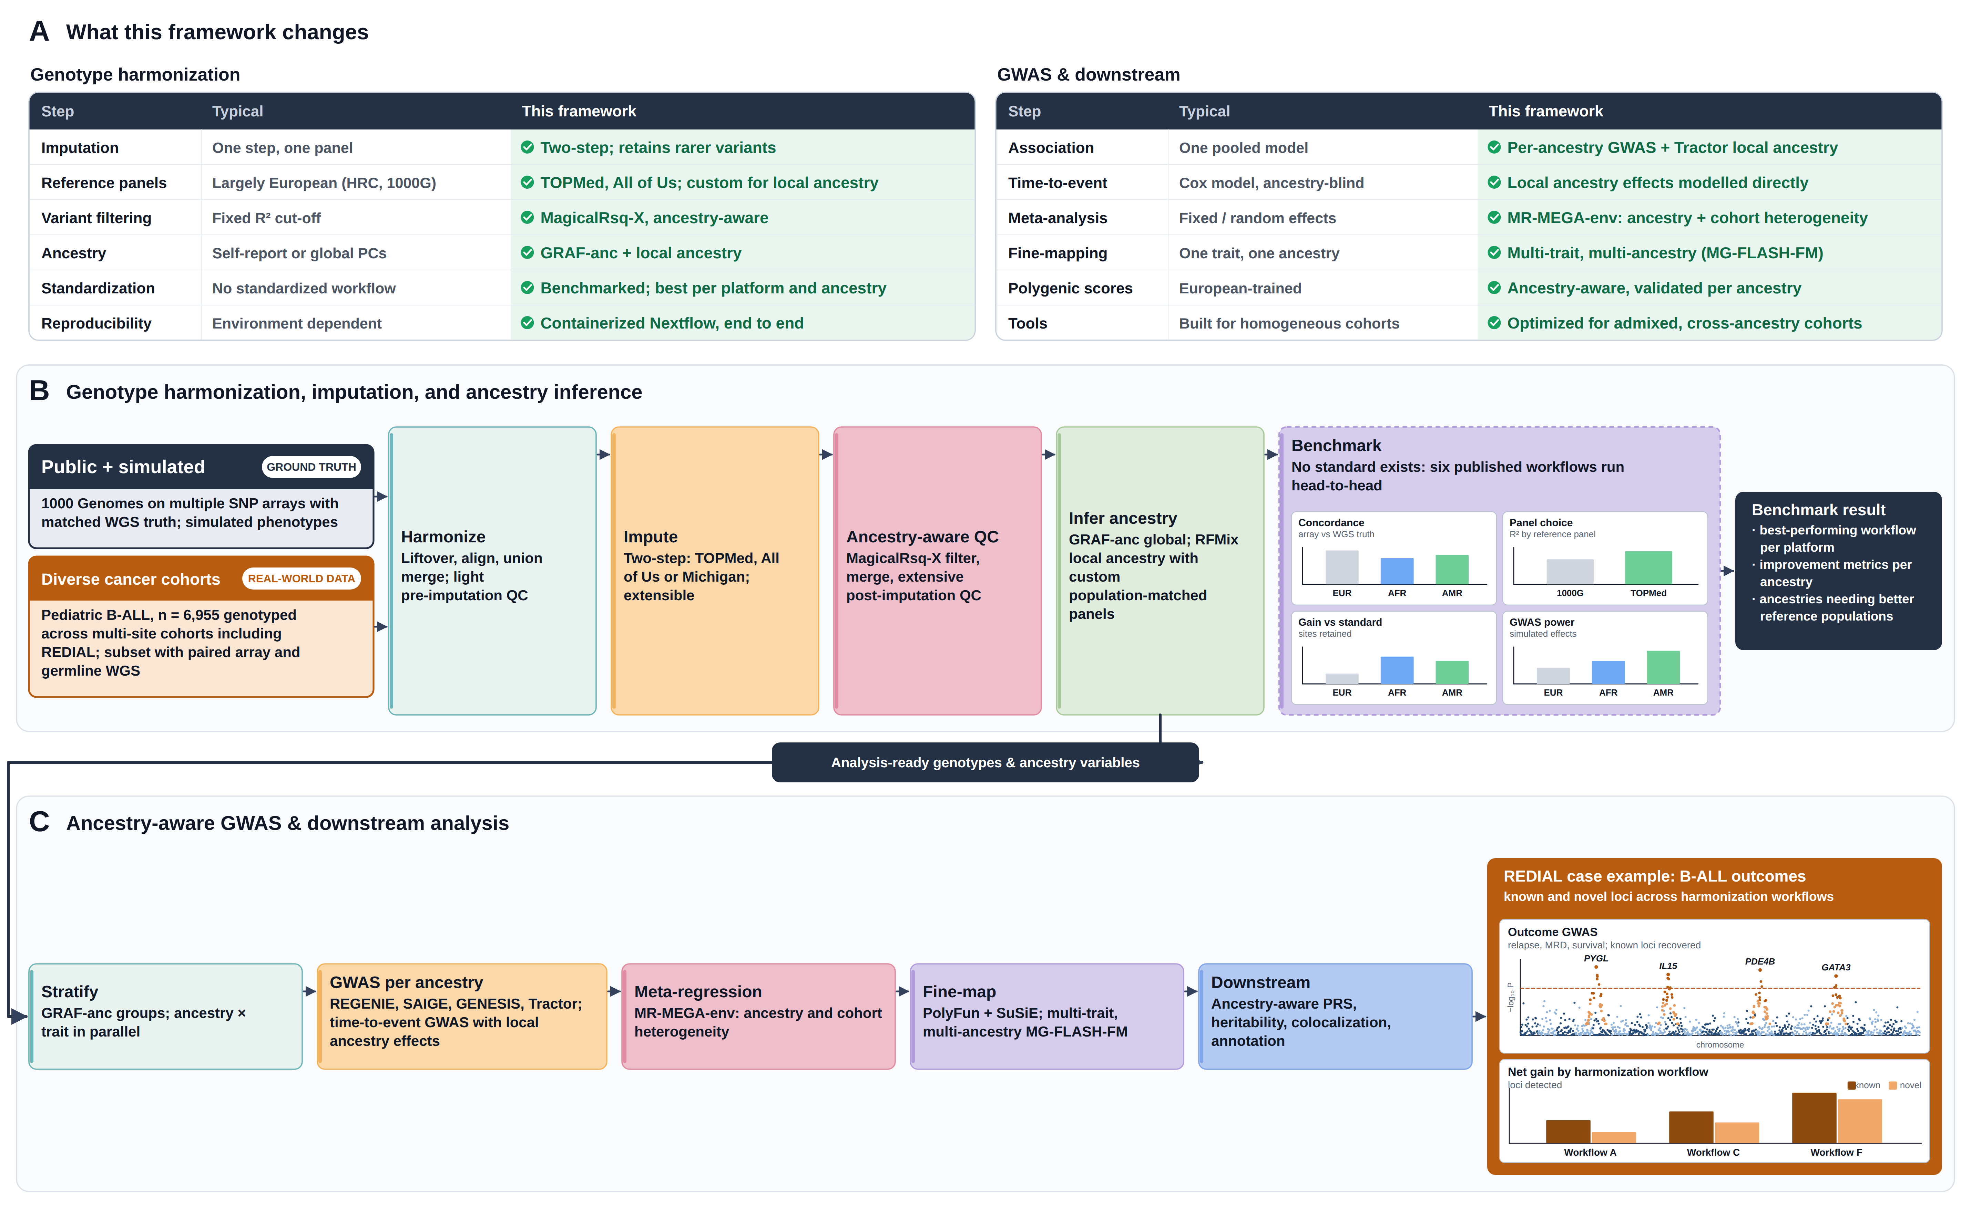
Figure 1. A modular, ancestry-aware framework for germline genotype harmonization and GWAS, applied to pediatric B-cell acute lymphoblastic leukemia (B-ALL). (A) Key differences from a typical GWAS workflow, for harmonization and for association and downstream analysis. (B) Two data streams enter one pipeline: 1000 Genomes samples on multiple SNP arrays with matched whole-genome sequencing (WGS) truth plus simulated phenotypes, and diverse multi-site pediatric B-ALL cohorts (n = 6,955 with genotyping) including REDIAL (Reducing Ethnic Disparities in Acute Leukemias; n = 1,870), a subset with paired array and germline WGS data. The default workflow applies light pre-imputation quality control, two-step imputation, ancestry-aware MagicalRsq-X filtering in place of a fixed R² cut-off, extensive post-imputation quality control, and global (GRAF-anc) plus local (RFMix) ancestry inference; population-matched reference panels can be supplied for local ancestry, where panel match strongly affects accuracy. Because no standardized harmonization workflow exists, six published workflows are run head-to-head and scored by concordance with WGS truth, reference panel, sites retained relative to standard practice, and simulated GWAS power, identifying the best workflow per platform and its gain and cost within each ancestry group (insets illustrative). (C) Harmonized genotypes are stratified by ancestry and analysed with REGENIE, SAIGE, GENESIS or Tractor, including time-to-event GWAS that models local ancestry effects (overall survival, disease-free survival, relapse, minimal residual disease, toxicity), then combined by MR-MEGA-env meta-regression, fine-mapped within and across ancestries and traits (PolyFun + SuSiE, MG-FLASH-FM), and carried into ancestry-aware polygenic scores, heritability, colocalization and annotation. REDIAL is the real-world test case: germline associations with minimal residual disease (IL15, GATA3) and relapse (PYGL, PDE4B) are established and differ in risk allele frequency across ancestries, so workflows are judged by the net gain in known and novel loci detected — converting an upstream methodological choice into measurable discovery in diverse and admixed cohorts. Every step is an independent, containerized Nextflow entry point; dashed outlines mark optional steps.

Alternative layout 1: landscape, no cohort streams
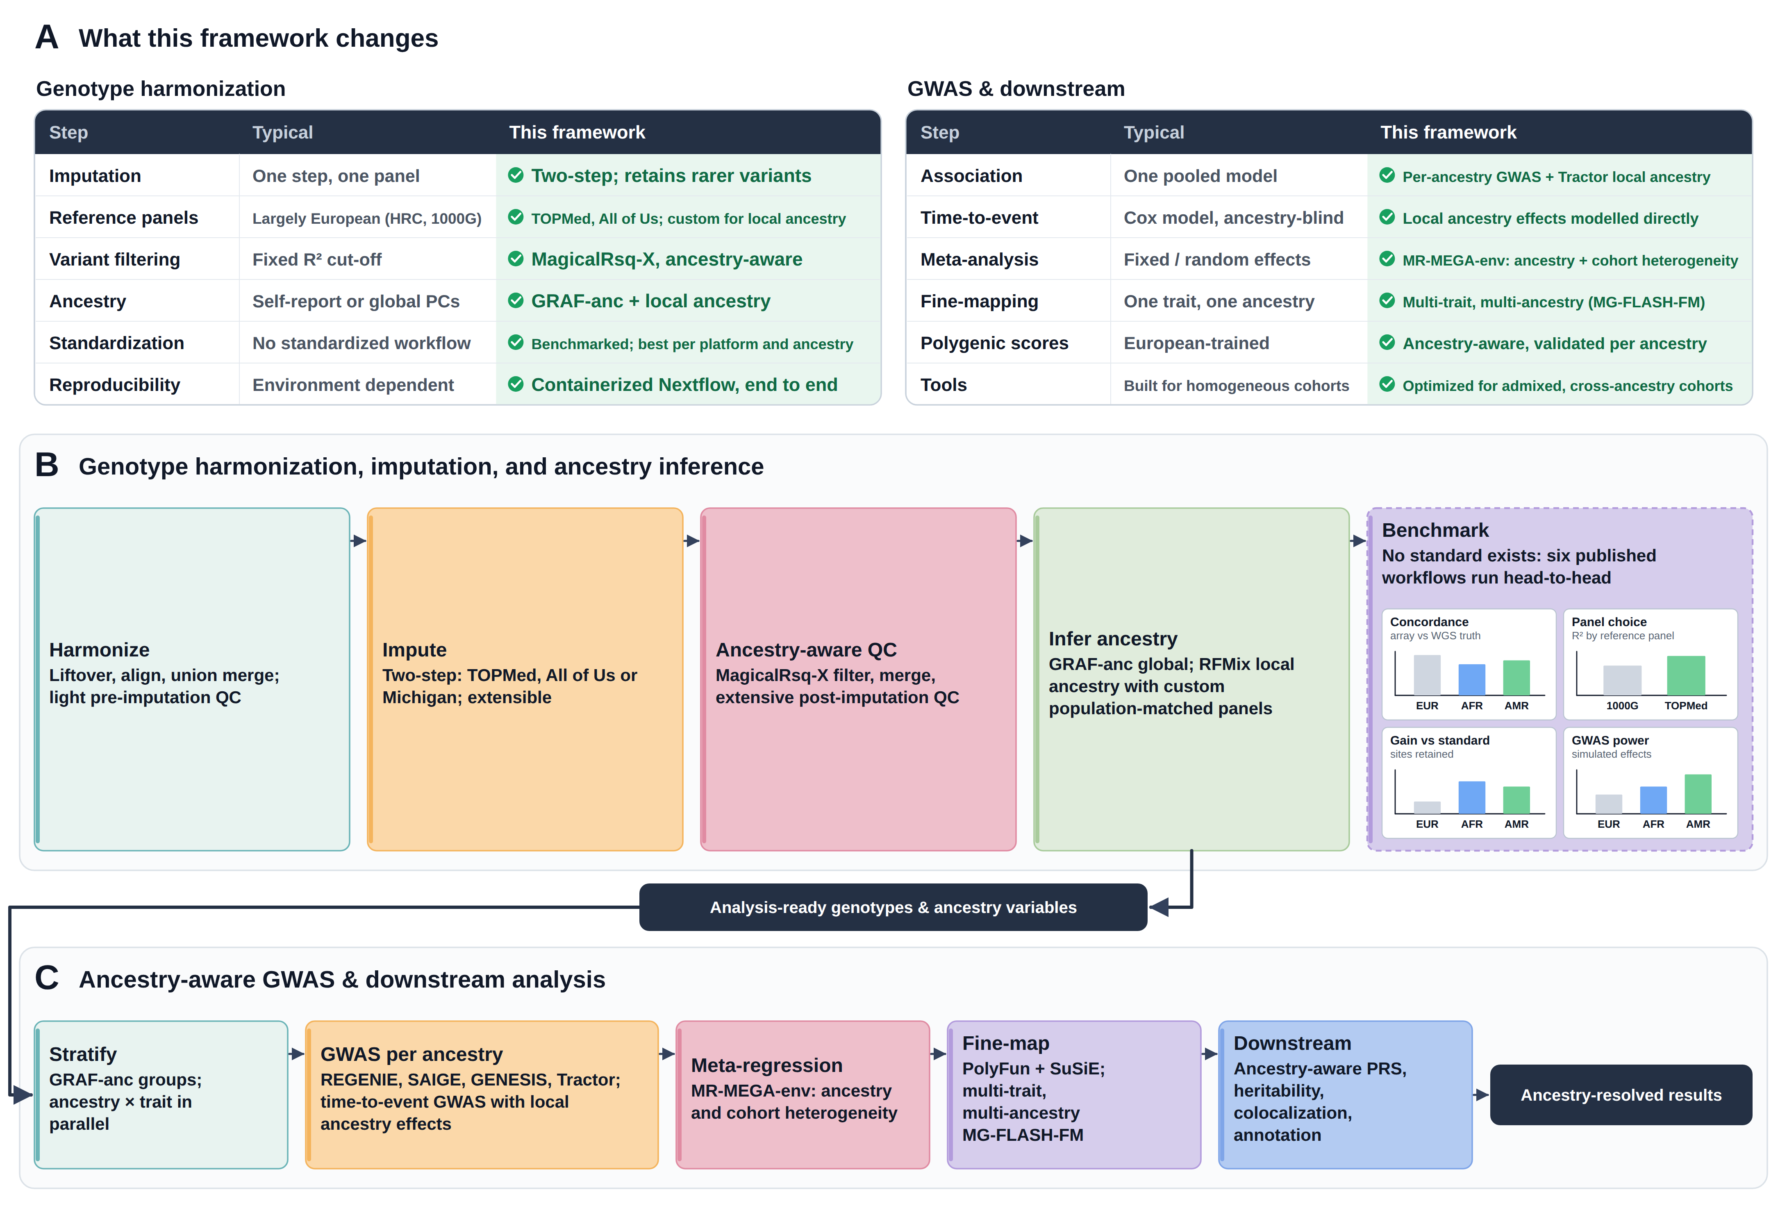
Figure 1. A modular, ancestry-aware framework for genotype harmonization and GWAS.
(A) Key differences from a typical GWAS workflow, for genotype harmonization and for association and downstream analysis.
(B) Genotype harmonization, QC and ancestry inference (Nextflow_Genotype_Pipeline). Genotypes from multiple arrays, batches and genome builds are lifted over, aligned and union-merged, imputed on the TOPMed, Michigan and All of Us servers through automated job handling, filtered with the ancestry-aware MagicalRsq-X metric instead of a fixed R² cut-off, merged and passed through final QC. Global ancestry (GRAF-anc) and local ancestry tracts (RFMix) are inferred, and an optional benchmarking module compares imputed genotypes with whole-genome sequencing truth and simulates GWAS power by ancestry (insets illustrative).
(C) Ancestry-aware GWAS and downstream analyses (Nextflow_GWAS_pipeline). Harmonized genotypes are stratified into GRAF-anc ancestry groups, which resolve finer than continental labels and include Amerindigenous and admixed groups, and analysed in parallel per ancestry and trait with REGENIE, SAIGE, GENESIS or Tractor, including time-to-event GWAS that incorporates local ancestry. Group results are combined by MR-MEGA-env meta-regression, which models ancestry-related and cohort-specific heterogeneity, fine-mapped within ancestry (PolyFun + SuSiE) and across traits and ancestries (MG-FLASH-FM for related traits), and carried into ancestry-aware polygenic scores, heritability, colocalization and functional annotation. Every step is an independent Nextflow entry point, so the framework runs end to end or step by step; dashed outlines mark optional steps.

Alternative layout 2: portrait
