Donald Tran

Alec Shunnarah

Data Flow and Organizational Analysis

Data Flow Diagrams

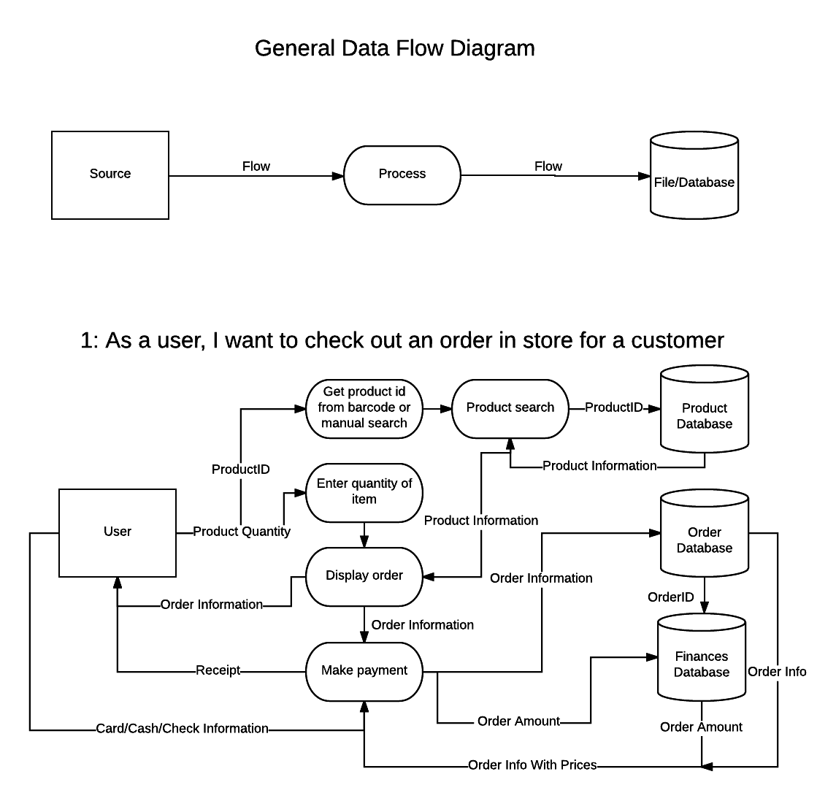

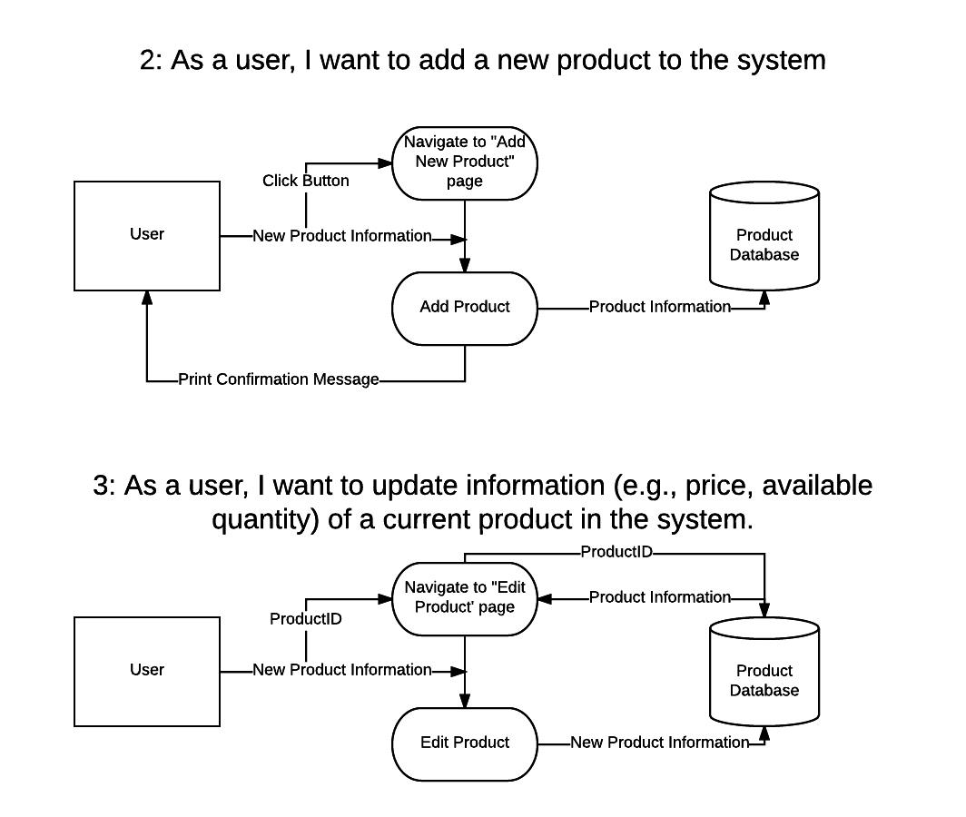

Entity Relationship Diagram

Data Samples

